Hi,

I want to start using Strawberry Pearl, downloaded it to my

* HP Compaq nx9420 with Windows 7 Enterprise
* Lenovo L512 with Windows 7 Professional

With BOTH computer, I run the MSI for Strawberry Perl 5.12.2.0 (latest).

I get the following error on _*both*_bachines:

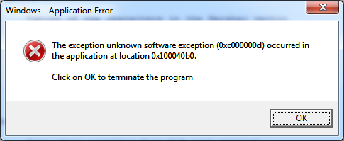

“The exception unknown software exception (oxc000000d) occurred in  
The application at location 0x100040b0.  
Click on OK to terminate the program”

The installation seems fine then… That means I could run some PERL scripts I found on the web. I don’t have the expertise yet to see if

Functionality is lacking. Though I think the installer should not be ended in this way..