Test produces coredump on AIX 5.1

(Getting failure on 'CPAN-style versions' test in version-0.49)
(relevant excerpt follows)
# testing CPAN-style versions
dubious
Test returned status -1 (wstat 139, 0x8b)
DIED. FAILED tests 86-107
#################################################################

/CPAN/Language_Extensions>uname -a
AIX prc-srv-3 1 5 0001BCBF4C00
#################################################################

/CPAN/Language_Extensions>perl -v
This is perl, v5.8.7 built for aix-thread-multi
#################################################################

(Following is the full text from the failure)
removing version-0.49
/bin/rm -rf version-0.49
extracting code from version-0.49.tar.gz
gzcat version-0.49.tar.gz | tar xf -
creating version-0.49/Makefile
cd version-0.49 && export MAKEFLAGS=&&export MFLAGS=&&time perl Build.PL
Creating custom builder _build/lib/version/Builder.pm in _build/lib/version
Checking whether your kit is complete...
Looks good
Creating new 'Build' script for 'version' version '0.49'

real 0m1.36s
user 0m0.76s
sys 0m0.34s
compiling version-0.49
cd version-0.49 && export MAKEFLAGS=&&export MFLAGS=&&time ./Build
cc_r -I./vutil -I/opt/app/perl/testbuild/lib/5.8.7/aix-thread-multi/CORE -c -D_ALL_SOURCE -D_ANSI_C_SOURCE -D_POSIX_SOURCE -qmaxmem=-1 -qnoansialias -DUSE_NATIVE_DLOPEN -DNEED_PTHREAD_INIT -I/usr/local/include -q32 -D_LARGE_FILES -qlonglong -O -o ./vutil/vutil.o ./vutil/vutil.c
lib/version.pm -> blib/lib/version.pm
lib/version/vxs.pm -> blib/lib/version/vxs.pm
lib/version/vxs.xs -> lib/version/vxs.c
/opt/app/perl/testbuild/bin/perl "-I/opt/app/perl/testbuild/lib/5.8.7/aix-thread-multi" "-I/opt/app/perl/testbuild/lib/5.8.7" "/opt/app/perl/testbuild/lib/5.8.7/ExtUtils/xsubpp" -noprototypes -typemap "/opt/app/perl/testbuild/lib/5.8.7/ExtUtils/typemap" "lib/version/vxs.xs"cc_r -I./vutil -I/opt/app/perl/testbuild/lib/5.8.7/aix-thread-multi/CORE -c -D_ALL_SOURCE -D_ANSI_C_SOURCE -D_POSIX_SOURCE -qmaxmem=-1 -qnoansialias -DUSE_NATIVE_DLOPEN -DNEED_PTHREAD_INIT -I/usr/local/include -q32 -D_LARGE_FILES -qlonglong -O -o lib/version/vxs.o lib/version/vxs.c
ExtUtils::Mkbootstrap::Mkbootstrap('lib/version/vxs')
ExtUtils::Mksymlists::Mksymlists('lib/version/vxs')
xlc_r -bhalt:4 -bexpall -G -bnoentry -lpthreads -lc -L/usr/local/lib -o blib/arch/auto/version/vxs/vxs.so lib/version/vxs.o ./vutil/vutil.o
lib/version.pod -> blib/lib/version.pod
Manifying blib/lib/version.pod -> blib/libdoc/version.3

real 0m5.48s
user 0m3.52s
sys 0m1.14s
cd version-0.49 && export MAKEFLAGS=&&export MFLAGS=&&time ./Build test
t/01base.......# Tests with base class
# tests with bare numbers
# tests with quoted numbers
# tests with stringify
# test illegal formats
# tests with self
# tests with non-objects
# tests with objects
# numeric tests with non-objects
# numeric tests with objects
# numeric tests with numbers
# Tests with extended decimal versions
# tests with alpha-style non-objects
# numeric tests with alpha-style non-objects
# tests with alpha-style objects
# tests with alpha-style objects
# tests with alpha-style objects with same subversion
# test implicit [in]equality
# forbidden operations
# testing qv
# create new from existing version
# testing CVS Revision
# testing CPAN-style versions
dubious
Test returned status -1 (wstat 139, 0x8b)
DIED. FAILED tests 80-96
Failed 17/96 tests, 82.29% okay
t/02derived....# Tests with empty derived class
Subroutine main::qv redefined at t/02derived.t line 18.
# tests with bare numbers
# tests with quoted numbers
# tests with stringify
# test illegal formats
# tests with self
# tests with non-objects
# tests with objects
# numeric tests with non-objects
# numeric tests with objects
# numeric tests with numbers
# Tests with extended decimal versions
# tests with alpha-style non-objects
# numeric tests with alpha-style non-objects
# tests with alpha-style objects
# tests with alpha-style objects
# tests with alpha-style objects with same subversion
# test implicit [in]equality
# forbidden operations
# testing qv
# create new from existing version
# testing CVS Revision
# testing CPAN-style versions
dubious
Test returned status -1 (wstat 139, 0x8b)
DIED. FAILED tests 86-107
Failed 22/107 tests, 79.44% okay
Failed Test Stat Wstat Total Fail Failed List of Failed
-------------------------------------------------------------------------------
t/01base.t -1 139 96 34 35.42% 80-96
t/02derived.t -1 139 107 44 41.12% 86-107
Failed 2/2 test scripts, 0.00% okay. 39/203 subtests failed, 80.79% okay.

real 0m3.71s
user 0m1.18s
sys 0m1.39s
Gmake[2]: *** [test] Error 255
Gmake[2]: Leaving directory `/roaming/clearcase/vobs/perlbuild/CPAN/Language_Extensions'
Gmake[1]: *** [all] Error 2
Gmake[1]: Leaving directory `/roaming/clearcase/vobs/perlbuild/CPAN/Language_Extensions'
Gmake: *** [LANG_EXTS.make] Error 2

perl -V

Summary of my perl5 (revision 5 version 8 subversion 7) configuration:
Platform:
osname=aix, osvers=5.1.0.0, archname=aix-thread-multi
uname='aix prc-srv-3 1 5 0001bcbf4c00 '
config_args='-d -e'
hint=previous, useposix=true, d_sigaction=define
usethreads=define use5005threads=undef useithreads=define usemultiplicity=define
useperlio=define d_sfio=undef uselargefiles=define usesocks=undef
use64bitint=undef use64bitall=undef uselongdouble=undef
usemymalloc=n, bincompat5005=undef
Compiler:
cc='cc_r', ccflags ='-D_ALL_SOURCE -D_ANSI_C_SOURCE -D_POSIX_SOURCE -qmaxmem=-1 -qnoansialias -DUSE_NATIVE_DLOPEN -DNEED_PTHREAD_INIT -DDEBUGGING -I/usr/local/include -q32 -D_LARGE_FILES -qlonglong',
optimize='-g',
cppflags='-D_ALL_SOURCE -D_ANSI_C_SOURCE -D_POSIX_SOURCE -qmaxmem=-1 -qnoansialias -DUSE_NATIVE_DLOPEN -DNEED_PTHREAD_INIT -DDEBUGGING -I/usr/local/include -D_ALL_SOURCE -D_ANSI_C_SOURCE -D_POSIX_SOURCE -qmaxmem=-1 -qnoansialias -DUSE_NATIVE_DLOPEN -DNEED_PTHREAD_INIT -DDEBUGGING -I/usr/local/include -q32 -D_LARGE_FILES -qlonglong'
ccversion='5.0.2.0', gccversion='', gccosandvers=''
intsize=4, longsize=4, ptrsize=4, doublesize=8, byteorder=4321
d_longlong=define, longlongsize=8, d_longdbl=define, longdblsize=8
ivtype='long', ivsize=4, nvtype='double', nvsize=8, Off_t='off_t', lseeksize=8
alignbytes=8, prototype=define
Linker and Libraries:
ld='xlc_r', ldflags =' -brtl -bdynamic -bmaxdata:0x80000000 -L/usr/local/lib -b32'
libpth=/usr/local/lib /lib /usr/lib /usr/ccs/lib
libs=-lbind -lnsl -ldbm -ldl -lld -lm -lcrypt -lpthreads -lc -lbsd
perllibs=-lbind -lnsl -ldl -lld -lm -lcrypt -lpthreads -lc -lbsd
libc=/lib/libc.a, so=a, useshrplib=false, libperl=libperl.a
gnulibc_version=''
Dynamic Linking:
dlsrc=dl_aix.xs, dlext=so, d_dlsymun=undef, ccdlflags=' -bE: /opt/app/perl/testbuild/lib/5.8.7/aix-thread-multi/CORE/perl.exp -bE:/opt/app/perl/testbuild/lib/5.8.7/aix-thread-multi/CORE/perl.exp'
cccdlflags=' ', lddlflags='-bhalt:4 -bexpall -G -bnoentry -lpthreads -lc -L/usr/local/lib'

Characteristics of this binary (from libperl):
Compile-time options: DEBUGGING MULTIPLICITY USE_ITHREADS
USE_LARGE_FILES PERL_IMPLICIT_CONTEXT
Built under aix
Compiled at Oct 24 2005 17:55:50
@INC:
/opt/app/perl/testbuild/lib/5.8.7/aix-thread-multi
/opt/app/perl/testbuild/lib/5.8.7
/opt/app/perl/testbuild/lib/site_perl/5.8.7/aix-thread-multi
/opt/app/perl/testbuild/lib/site_perl/5.8.7
/opt/app/perl/testbuild/lib/site_perl
.

I dumped the core file’s stack using dbx
Type 'help' for help.
reading symbolic information ...
[using memory image in core]

Segmentation fault in move at 0xd0158148 ($t1)
0xd0158148 (move+0x30) 901e0000 stw r0,0x0(r30)
(dbx) dump
move(??, ??) at 0xd0158148

The problem occurs when Perl_vnumify() calls pow() at vutil.c : line 391.
You can see the call stack (etc.) in more detail in this screenshot from the xldb debugger:

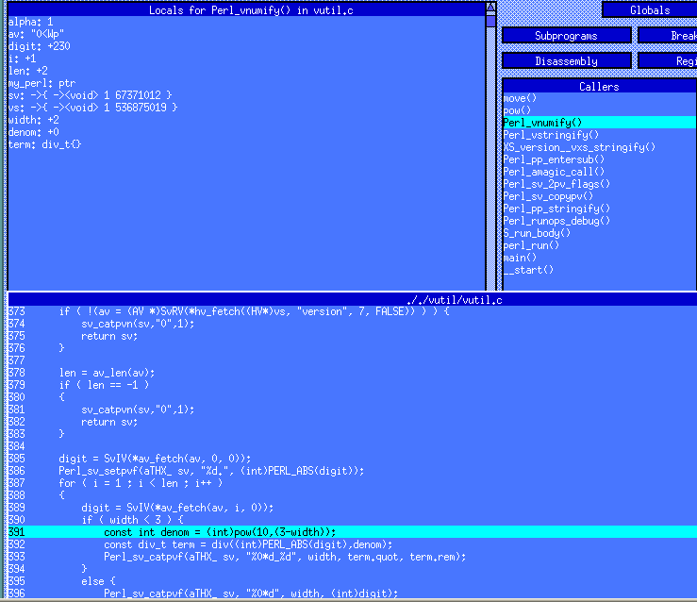

The path to pow() on AIX is […/src/bos/usr/ccs/lib/libbsd/pow.c]

