EVIDENCIAS – CLOUDERA

Treinamento Cloudera - Servidores AWS

srvlnxhdpmaster
ssh -i "CDH_RTM.pem" centos@ec2-18-216-235-20.us-east-2.compute.amazonaws.com

IP Public: 18.216.235.20
IP Private: 172.31.30.147

srvlnxhdpedge
ssh -i "CDH_RTM.pem" centos@ec2-18-221-226-182.us-east-2.compute.amazonaws.com

IP Public: 18.221.226.182
IP Private: 172.31.24.87

srvlnxhdpwrk01
ssh -i "CDH_RTM.pem" centos@ec2-13-58-11-6.us-east-2.compute.amazonaws.com

IP Public: 13.58.11.6
IP Private: 172.31.31.242

srvlnxhdpwrk02
ssh -i "CDH_RTM.pem" centos@ec2-18-217-95-45.us-east-2.compute.amazonaws.com

IP Public: 18.217.95.45
IP Private: 172.31.19.76

srvlnxhdpwrk03
ssh -i "CDH_RTM.pem" centos@ec2-18-217-130-243.us-east-2.compute.amazonaws.com

IP Public: 18.217.130.243
IP Private: 172.31.18.153

[root@ip-172-31-24-87 ~]# hostname && echo && cat /proc/sys/vm/swappiness && echo && cat /etc/sysctl.conf && echo && mount -v && echo && ifconfig && echo && getent hosts && echo && systemctl status nscd.service && echo && systemctl status ntpd.service && echo && ls -lahtr /usr/share/java/mysql-connector-java.jar
ip-172-31-24-87.us-east-2.compute.internal

1

# sysctl settings are defined through files in
# /usr/lib/sysctl.d/, /run/sysctl.d/, and /etc/sysctl.d/.
#
# Vendors settings live in /usr/lib/sysctl.d/.
# To override a whole file, create a new file with the same in
# /etc/sysctl.d/ and put new settings there. To override
# only specific settings, add a file with a lexically later
# name in /etc/sysctl.d/ and put new settings there.
#
# For more information, see sysctl.conf(5) and sysctl.d(5).
vm.swappiness = 1

sysfs on /sys type sysfs (rw,nosuid,nodev,noexec,relatime,seclabel)
proc on /proc type proc (rw,nosuid,nodev,noexec,relatime)
devtmpfs on /dev type devtmpfs (rw,nosuid,seclabel,size=8112696k,nr_inodes=2028174,mode=755)
securityfs on /sys/kernel/security type securityfs (rw,nosuid,nodev,noexec,relatime)
tmpfs on /dev/shm type tmpfs (rw,nosuid,nodev,seclabel)
devpts on /dev/pts type devpts (rw,nosuid,noexec,relatime,seclabel,gid=5,mode=620,ptmxmode=000)
tmpfs on /run type tmpfs (rw,nosuid,nodev,seclabel,mode=755)
tmpfs on /sys/fs/cgroup type tmpfs (ro,nosuid,nodev,noexec,seclabel,mode=755)
cgroup on /sys/fs/cgroup/systemd type cgroup (rw,nosuid,nodev,noexec,relatime,xattr,release_agent=/usr/lib/systemd/systemd-cgroups-agent,name=systemd)
pstore on /sys/fs/pstore type pstore (rw,nosuid,nodev,noexec,relatime)
cgroup on /sys/fs/cgroup/cpuset type cgroup (rw,nosuid,nodev,noexec,relatime,cpuset)
cgroup on /sys/fs/cgroup/hugetlb type cgroup (rw,nosuid,nodev,noexec,relatime,hugetlb)
cgroup on /sys/fs/cgroup/freezer type cgroup (rw,nosuid,nodev,noexec,relatime,freezer)
cgroup on /sys/fs/cgroup/blkio type cgroup (rw,nosuid,nodev,noexec,relatime,blkio)
cgroup on /sys/fs/cgroup/cpu,cpuacct type cgroup (rw,nosuid,nodev,noexec,relatime,cpuacct,cpu)
cgroup on /sys/fs/cgroup/pids type cgroup (rw,nosuid,nodev,noexec,relatime,pids)
cgroup on /sys/fs/cgroup/net_cls,net_prio type cgroup (rw,nosuid,nodev,noexec,relatime,net_prio,net_cls)
cgroup on /sys/fs/cgroup/memory type cgroup (rw,nosuid,nodev,noexec,relatime,memory)
cgroup on /sys/fs/cgroup/devices type cgroup (rw,nosuid,nodev,noexec,relatime,devices)
cgroup on /sys/fs/cgroup/perf_event type cgroup (rw,nosuid,nodev,noexec,relatime,perf_event)
configfs on /sys/kernel/config type configfs (rw,relatime)
/dev/xvda1 on / type xfs (rw,relatime,seclabel,attr2,inode64,noquota)
rpc_pipefs on /var/lib/nfs/rpc_pipefs type rpc_pipefs (rw,relatime)
selinuxfs on /sys/fs/selinux type selinuxfs (rw,relatime)
systemd-1 on /proc/sys/fs/binfmt_misc type autofs (rw,relatime,fd=23,pgrp=1,timeout=0,minproto=5,maxproto=5,direct,pipe_ino=11128)
mqueue on /dev/mqueue type mqueue (rw,relatime,seclabel)
hugetlbfs on /dev/hugepages type hugetlbfs (rw,relatime,seclabel)
debugfs on /sys/kernel/debug type debugfs (rw,relatime)
nfsd on /proc/fs/nfsd type nfsd (rw,relatime)
binfmt_misc on /proc/sys/fs/binfmt_misc type binfmt_misc (rw,relatime)
tmpfs on /run/user/0 type tmpfs (rw,nosuid,nodev,relatime,seclabel,size=1626672k,mode=700)
cm_processes on /run/cloudera-scm-agent/process type tmpfs (rw,relatime,seclabel,mode=751)
tmpfs on /run/user/1000 type tmpfs (rw,nosuid,nodev,relatime,seclabel,size=1626672k,mode=700,uid=1000,gid=1000)

eth0: flags=4163<UP,BROADCAST,RUNNING,MULTICAST> mtu 9001
inet 172.31.24.87 netmask 255.255.240.0 broadcast 172.31.31.255
inet6 fe80::44a:46ff:fea2:44be prefixlen 64 scopeid 0x20<link>
ether 06:4a:46:a2:44:be txqueuelen 1000 (Ethernet)
RX packets 336195 bytes 78942200 (75.2 MiB)
RX errors 0 dropped 0 overruns 0 frame 0
TX packets 248217 bytes 51827078 (49.4 MiB)
TX errors 0 dropped 0 overruns 0 carrier 0 collisions 0

lo: flags=73<UP,LOOPBACK,RUNNING> mtu 65536
inet 127.0.0.1 netmask 255.0.0.0
inet6 ::1 prefixlen 128 scopeid 0x10<host>
loop txqueuelen 1 (Local Loopback)
RX packets 194005 bytes 122644296 (116.9 MiB)
RX errors 0 dropped 0 overruns 0 frame 0
TX packets 194005 bytes 122644296 (116.9 MiB)
TX errors 0 dropped 0 overruns 0 carrier 0 collisions 0

127.0.0.1 localhost localhost.localdomain localhost4 localhost4.localdomain4
127.0.0.1 localhost localhost.localdomain localhost6 localhost6.localdomain6
172.31.30.147 ip-172-31-30-147.us-east-2.compute.internal
172.31.24.87 ip-172-31-24-87.us-east-2.compute.internal
172.31.31.242 ip-172-31-31-242.us-east-2.compute.internal
172.31.19.76 ip-172-31-19-76.us-east-2.compute.internal
172.31.18.153 ip-172-31-18-153.us-east-2.compute.internal

● nscd.service - Name Service Cache Daemon
Loaded: loaded (/usr/lib/systemd/system/nscd.service; enabled; vendor preset: disabled)
Active: active (running) since Thu 2017-12-07 11:07:05 UTC; 6h ago
Process: 579 ExecStart=/usr/sbin/nscd $NSCD_OPTIONS (code=exited, status=0/SUCCESS)
Main PID: 591 (nscd)
CGroup: /system.slice/nscd.service
└─591 /usr/sbin/nscd

Dec 07 11:07:05 ip-172-31-24-87.us-east-2.compute.internal nscd[591]: 591 monitoring file `/etc/services` (6)
Dec 07 11:07:05 ip-172-31-24-87.us-east-2.compute.internal nscd[591]: 591 monitoring directory `/etc` (2)
Dec 07 11:07:05 ip-172-31-24-87.us-east-2.compute.internal nscd[591]: 591 disabled inotify-based monitoring for file `/etc/netgroup': No such file or directory
Dec 07 11:07:05 ip-172-31-24-87.us-east-2.compute.internal nscd[591]: 591 stat failed for file `/etc/netgroup'; will try again later: No such file or directory
Dec 07 11:07:05 ip-172-31-24-87.us-east-2.compute.internal nscd[591]: 591 Access Vector Cache (AVC) started
Dec 07 11:07:05 ip-172-31-24-87.us-east-2.compute.internal systemd[1]: Started Name Service Cache Daemon.
Dec 07 11:07:08 ip-172-31-24-87.us-east-2.compute.internal nscd[591]: 591 monitored file `/etc/resolv.conf` was written to
Dec 07 11:07:08 ip-172-31-24-87.us-east-2.compute.internal nscd[591]: 591 monitoring file `/etc/resolv.conf` (5)
Dec 07 11:07:08 ip-172-31-24-87.us-east-2.compute.internal nscd[591]: 591 monitoring directory `/etc` (2)
Dec 07 11:07:24 ip-172-31-24-87.us-east-2.compute.internal nscd[591]: 591 checking for monitored file `/etc/netgroup': No such file or directory

● ntpd.service - Network Time Service
Loaded: loaded (/usr/lib/systemd/system/ntpd.service; enabled; vendor preset: disabled)
Active: active (running) since Thu 2017-12-07 17:07:14 UTC; 19s ago
Process: 9195 ExecStart=/usr/sbin/ntpd -u ntp:ntp $OPTIONS (code=exited, status=0/SUCCESS)
Main PID: 9196 (ntpd)
CGroup: /system.slice/ntpd.service
└─9196 /usr/sbin/ntpd -u ntp:ntp -g

Dec 07 17:07:14 ip-172-31-24-87.us-east-2.compute.internal ntpd[9196]: Listen and drop on 0 v4wildcard 0.0.0.0 UDP 123
Dec 07 17:07:14 ip-172-31-24-87.us-east-2.compute.internal ntpd[9196]: Listen and drop on 1 v6wildcard :: UDP 123
Dec 07 17:07:14 ip-172-31-24-87.us-east-2.compute.internal ntpd[9196]: Listen normally on 2 lo 127.0.0.1 UDP 123
Dec 07 17:07:14 ip-172-31-24-87.us-east-2.compute.internal ntpd[9196]: Listen normally on 3 eth0 172.31.24.87 UDP 123
Dec 07 17:07:14 ip-172-31-24-87.us-east-2.compute.internal ntpd[9196]: Listen normally on 4 lo ::1 UDP 123
Dec 07 17:07:14 ip-172-31-24-87.us-east-2.compute.internal ntpd[9196]: Listen normally on 5 eth0 fe80::44a:46ff:fea2:44be UDP 123
Dec 07 17:07:14 ip-172-31-24-87.us-east-2.compute.internal ntpd[9196]: Listening on routing socket on fd #22 for interface updates
Dec 07 17:07:14 ip-172-31-24-87.us-east-2.compute.internal ntpd[9196]: 0.0.0.0 c016 06 restart
Dec 07 17:07:14 ip-172-31-24-87.us-east-2.compute.internal ntpd[9196]: 0.0.0.0 c012 02 freq_set kernel 100.822 PPM
Dec 07 17:07:21 ip-172-31-24-87.us-east-2.compute.internal ntpd[9196]: 0.0.0.0 c615 05 clock_sync

-rw-r--r--. 1 root root 864K Jun 10 2014 /usr/share/java/mysql-connector-java.jar

[root@ip-172-31-24-87 ~]# /usr/bin/mysql_secure_installation
NOTE: RUNNING ALL PARTS OF THIS SCRIPT IS RECOMMENDED FOR ALL MariaDB
SERVERS IN PRODUCTION USE! PLEASE READ EACH STEP CAREFULLY!

In order to log into MariaDB to secure it, we'll need the current
password for the root user. If you've just installed MariaDB, and
you haven't set the root password yet, the password will be blank,
so you should just press enter here.

Enter current password for root (enter for none):
OK, successfully used password, moving on...

Setting the root password ensures that nobody can log into the MariaDB
root user without the proper authorisation.

Set root password? [Y/n] yes
New password:
Re-enter new password:
Password updated successfully!
Reloading privilege tables..
... Success!

[root@ip-172-31-24-87 ~]# systemctl status mariadb
● mariadb.service - MariaDB database server
Loaded: loaded (/usr/lib/systemd/system/mariadb.service; enabled; vendor preset: disabled)
Active: active (running) since Thu 2017-12-07 11:07:15 UTC; 6h ago
Process: 909 ExecStartPost=/usr/libexec/mariadb-wait-ready $MAINPID (code=exited, status=0/SUCCESS)
Process: 867 ExecStartPre=/usr/libexec/mariadb-prepare-db-dir %n (code=exited, status=0/SUCCESS)
Main PID: 908 (mysqld_safe)
CGroup: /system.slice/mariadb.service
├─ 908 /bin/sh /usr/bin/mysqld_safe --basedir=/usr
└─1415 /usr/libexec/mysqld --basedir=/usr --datadir=/var/lib/mysql --plugin-dir=/usr/lib64/mysql/plugin --log-error=/var/log/mariadb/mariadb.log --pid-fil...

Dec 07 11:07:09 ip-172-31-24-87.us-east-2.compute.internal systemd[1]: Starting MariaDB database server...
Dec 07 11:07:09 ip-172-31-24-87.us-east-2.compute.internal mariadb-prepare-db-dir[867]: Database MariaDB is probably initialized in /var/lib/mysql already, noth...done.
Dec 07 11:07:09 ip-172-31-24-87.us-east-2.compute.internal mariadb-prepare-db-dir[867]: If this is not the case, make sure the /var/lib/mysql is empty before ru...-dir.
Dec 07 11:07:09 ip-172-31-24-87.us-east-2.compute.internal mysqld_safe[908]: 171207 11:07:09 mysqld_safe Logging to '/var/log/mariadb/mariadb.log'.
Dec 07 11:07:09 ip-172-31-24-87.us-east-2.compute.internal mysqld_safe[908]: 171207 11:07:09 mysqld_safe Starting mysqld daemon with databases from /var/lib/mysql
Dec 07 11:07:15 ip-172-31-24-87.us-east-2.compute.internal systemd[1]: Started MariaDB database server.
Hint: Some lines were ellipsized, use -l to show in full.

MariaDB [(none)]> show SLAVE STATUS \G
*************************** 1. row ***************************
Slave_IO_State: Waiting for master to send event
Master_Host: ip-172-31-30-147.us-east-2.compute.internal
Master_User: replicador
Master_Port: 3306
Connect_Retry: 10
Master_Log_File: mysql_binary_log.000008
Read_Master_Log_Pos: 1134842
Relay_Log_File: mariadb-relay-bin.000002
Relay_Log_Pos: 536
Relay_Master_Log_File: mysql_binary_log.000007
Slave_IO_Running: Yes
Slave_SQL_Running: No
Replicate_Do_DB:
Replicate_Ignore_DB:
Replicate_Do_Table:
Replicate_Ignore_Table:
Replicate_Wild_Do_Table:
Replicate_Wild_Ignore_Table:
Last_Errno: 0
Last_Error:
Skip_Counter: 0
Exec_Master_Log_Pos: 15697046
Relay_Log_Space: 5040963
Until_Condition: None
Until_Log_File:
Until_Log_Pos: 0
Master_SSL_Allowed: No
Master_SSL_CA_File:
Master_SSL_CA_Path:
Master_SSL_Cert:
Master_SSL_Cipher:
Master_SSL_Key:
Seconds_Behind_Master: NULL
Master_SSL_Verify_Server_Cert: No
Last_IO_Errno: 0
Last_IO_Error:
Last_SQL_Errno: 0
Last_SQL_Error:
Replicate_Ignore_Server_Ids:
Master_Server_Id: 1

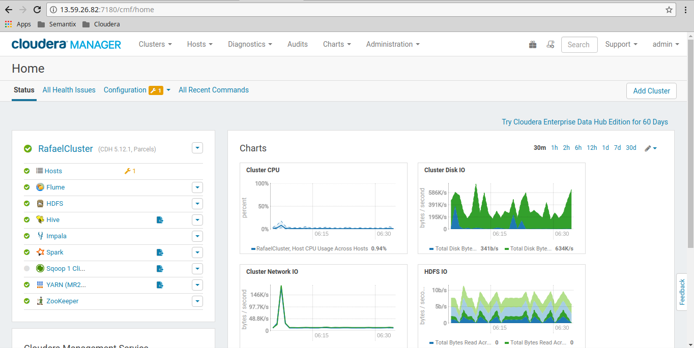
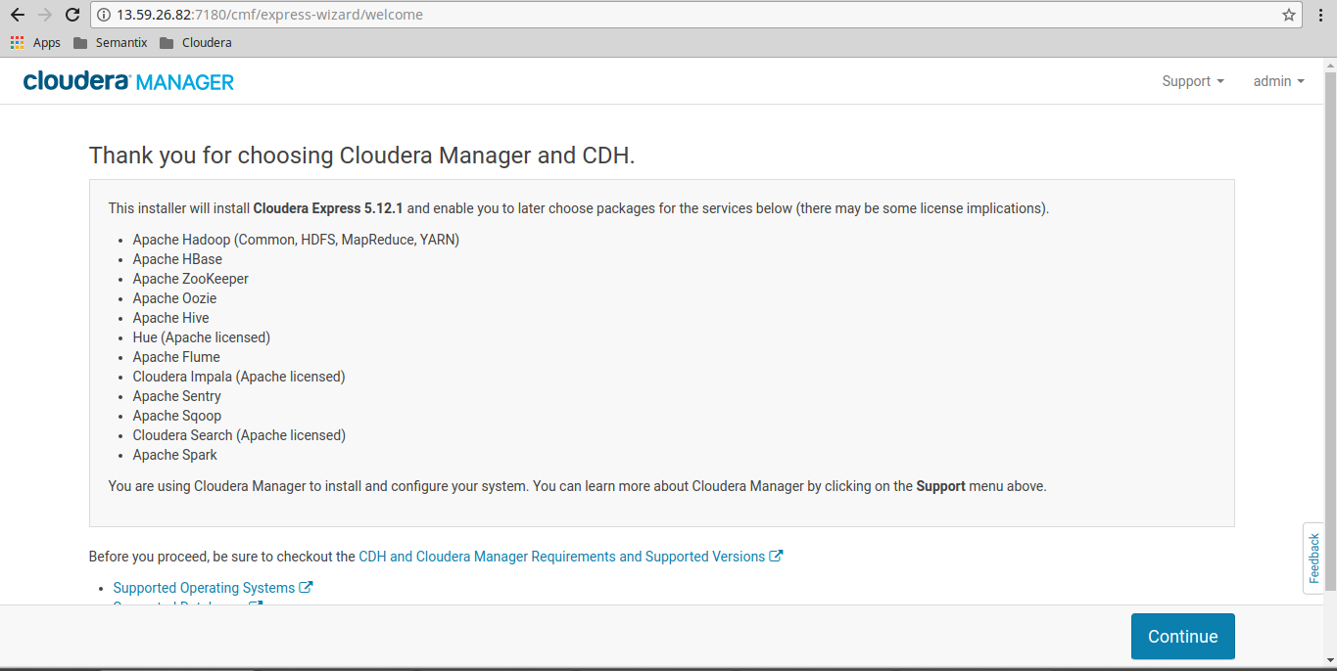
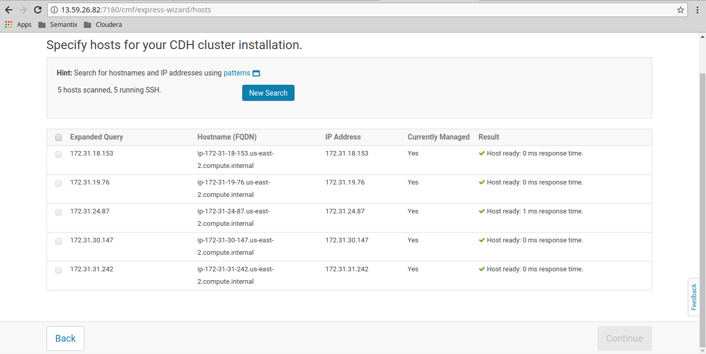
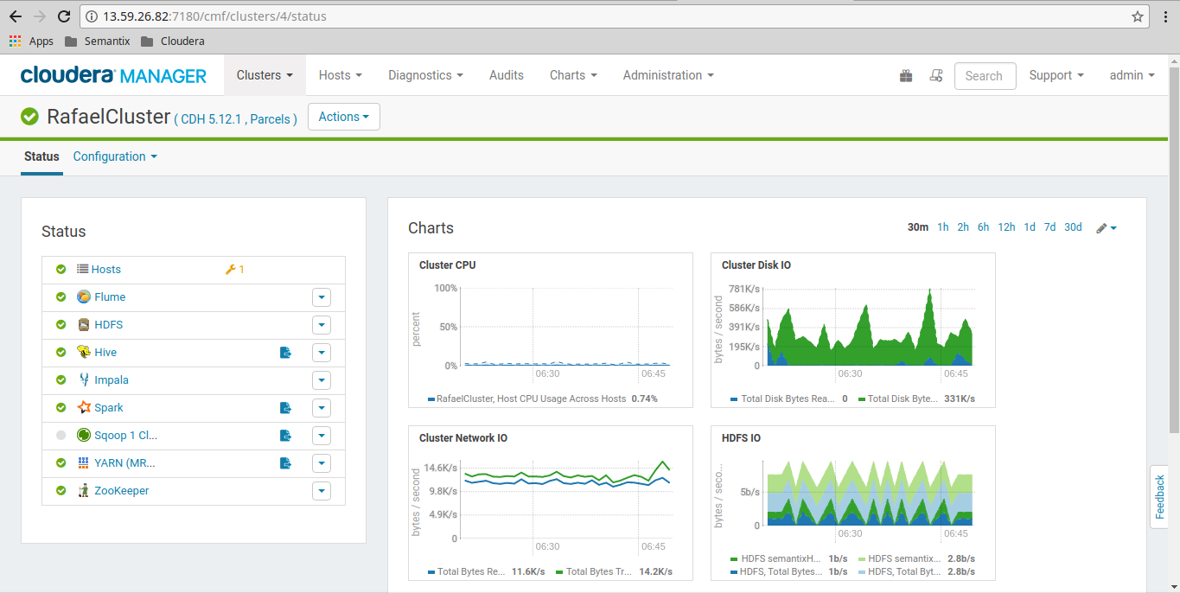

[hdfs@ip-172-31-30-147 ~]$ time hadoop jar /opt/cloudera/parcels/CDH-5.12.1-1.cdh5.12.1.p0.3/jars/hadoop-examples.jar teragen 1024000 /input
17/12/07 20:00:36 INFO terasort.TeraGen: Generating 1024000 using 2
17/12/07 20:00:36 INFO mapreduce.JobSubmitter: number of splits:2
17/12/07 20:00:36 INFO mapreduce.JobSubmitter: Submitting tokens for job: job_1512669756012_0012
17/12/07 20:00:36 INFO impl.YarnClientImpl: Submitted application application_1512669756012_0012
17/12/07 20:00:36 INFO mapreduce.Job: The url to track the job: http://ip-172-31-24-87.us-east-2.compute.internal:8088/proxy/application_1512669756012_0012/
17/12/07 20:00:36 INFO mapreduce.Job: Running job: job_1512669756012_0012
17/12/07 20:00:41 INFO mapreduce.Job: Job job_1512669756012_0012 running in uber mode : false
17/12/07 20:00:41 INFO mapreduce.Job: map 0% reduce 0%
17/12/07 20:00:47 INFO mapreduce.Job: map 50% reduce 0%
17/12/07 20:00:48 INFO mapreduce.Job: map 100% reduce 0%
17/12/07 20:00:49 INFO mapreduce.Job: Job job_1512669756012_0012 completed successfully
17/12/07 20:00:50 INFO mapreduce.Job: Counters: 31
File System Counters
FILE: Number of bytes read=0
FILE: Number of bytes written=301990
FILE: Number of read operations=0
FILE: Number of large read operations=0
FILE: Number of write operations=0
HDFS: Number of bytes read=167
HDFS: Number of bytes written=102400000
HDFS: Number of read operations=8
HDFS: Number of large read operations=0
HDFS: Number of write operations=4
Job Counters
Launched map tasks=2
Other local map tasks=2
Total time spent by all maps in occupied slots (ms)=7747
Total time spent by all reduces in occupied slots (ms)=0
Total time spent by all map tasks (ms)=7747
Total vcore-milliseconds taken by all map tasks=7747
Total megabyte-milliseconds taken by all map tasks=7932928
Map-Reduce Framework
Map input records=1024000
Map output records=1024000
Input split bytes=167
Spilled Records=0
Failed Shuffles=0
Merged Map outputs=0
GC time elapsed (ms)=181
CPU time spent (ms)=3210
Physical memory (bytes) snapshot=490229760
Virtual memory (bytes) snapshot=5577486336
Total committed heap usage (bytes)=574095360
org.apache.hadoop.examples.terasort.TeraGen$Counters
CHECKSUM=2200811862478544
File Input Format Counters
Bytes Read=0
File Output Format Counters
Bytes Written=102400000

real 0m16.208s
user 0m5.573s
sys 0m0.233s
[hdfs@ip-172-31-30-147 ~]$

[hdfs@ip-172-31-30-147 ~]$ time hadoop jar /opt/cloudera/parcels/CDH-5.12.1-1.cdh5.12.1.p0.3/jars/hadoop-examples.jar terasort /input /output
17/12/07 20:01:11 INFO terasort.TeraSort: starting
17/12/07 20:01:12 INFO input.FileInputFormat: Total input paths to process : 2
Spent 102ms computing base-splits.
Spent 2ms computing TeraScheduler splits.
Computing input splits took 105ms
Sampling 2 splits of 2
Making 6 from 100000 sampled records
Computing parititions took 395ms
Spent 502ms computing partitions.
17/12/07 20:01:13 INFO mapreduce.JobSubmitter: number of splits:2
17/12/07 20:01:13 INFO mapreduce.JobSubmitter: Submitting tokens for job: job_1512669756012_0013
17/12/07 20:01:13 INFO impl.YarnClientImpl: Submitted application application_1512669756012_0013
17/12/07 20:01:13 INFO mapreduce.Job: The url to track the job: http://ip-172-31-24-87.us-east-2.compute.internal:8088/proxy/application_1512669756012_0013/
17/12/07 20:01:13 INFO mapreduce.Job: Running job: job_1512669756012_0013
17/12/07 20:01:18 INFO mapreduce.Job: Job job_1512669756012_0013 running in uber mode : false
17/12/07 20:01:18 INFO mapreduce.Job: map 0% reduce 0%
17/12/07 20:01:24 INFO mapreduce.Job: map 100% reduce 0%
17/12/07 20:01:30 INFO mapreduce.Job: map 100% reduce 33%
17/12/07 20:01:31 INFO mapreduce.Job: map 100% reduce 100%
17/12/07 20:01:32 INFO mapreduce.Job: Job job_1512669756012_0013 completed successfully
17/12/07 20:01:32 INFO mapreduce.Job: Counters: 50
File System Counters
FILE: Number of bytes read=44352937
FILE: Number of bytes written=89941583
FILE: Number of read operations=0
FILE: Number of large read operations=0
FILE: Number of write operations=0
HDFS: Number of bytes read=102400202
HDFS: Number of bytes written=102400000
HDFS: Number of read operations=24
HDFS: Number of large read operations=0
HDFS: Number of write operations=12
Job Counters
Launched map tasks=2
Launched reduce tasks=6
Data-local map tasks=1
Rack-local map tasks=1
Total time spent by all maps in occupied slots (ms)=7803
Total time spent by all reduces in occupied slots (ms)=22557
Total time spent by all map tasks (ms)=7803
Total time spent by all reduce tasks (ms)=22557
Total vcore-milliseconds taken by all map tasks=7803
Total vcore-milliseconds taken by all reduce tasks=22557
Total megabyte-milliseconds taken by all map tasks=7990272
Total megabyte-milliseconds taken by all reduce tasks=23098368
Map-Reduce Framework
Map input records=1024000
Map output records=1024000
Map output bytes=104448000
Map output materialized bytes=44368702
Input split bytes=202
Combine input records=0
Combine output records=0
Reduce input groups=1024000
Reduce shuffle bytes=44368702
Reduce input records=1024000
Reduce output records=1024000
Spilled Records=2048000
Shuffled Maps =12
Failed Shuffles=0
Merged Map outputs=12
GC time elapsed (ms)=644
CPU time spent (ms)=15940
Physical memory (bytes) snapshot=2585100288
Virtual memory (bytes) snapshot=22413561856
Total committed heap usage (bytes)=2824339456
Shuffle Errors
BAD_ID=0
CONNECTION=0
IO_ERROR=0
WRONG_LENGTH=0
WRONG_MAP=0
WRONG_REDUCE=0
File Input Format Counters
Bytes Read=102400000
File Output Format Counters
Bytes Written=102400000
17/12/07 20:01:32 INFO terasort.TeraSort: done

real 0m22.156s
user 0m6.212s
sys 0m0.268s
[hdfs@ip-172-31-30-147 ~]$

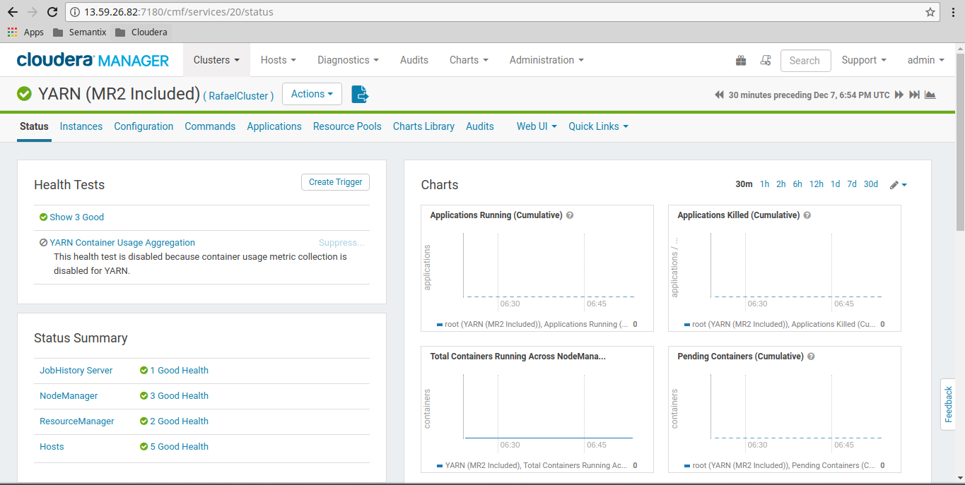
[hdfs@ip-172-31-30-147 tmp]$ sh -x yarntest.sh
+ MR=/opt/cloudera/parcels/CDH/lib/hadoop-0.20-mapreduce
+ HADOOP=/opt/cloudera/parcels/CDH/bin
++ date
+ echo Testing loop started on Thu Dec 7 19:30:06 UTC 2017
Testing loop started on Thu Dec 7 19:30:06 UTC 2017
+ for i in 8
+ for j in 1
+ for k in 512 1024
++ echo '(512*0.8)/1'
++ bc
+ MAP_MB=409
++ echo '(512*0.8)/1'
++ bc
+ RED_MB=409
+ /opt/cloudera/parcels/CDH/bin/hadoop jar /opt/cloudera/parcels/CDH/lib/hadoop-0.20-mapreduce/hadoop-examples.jar teragen -Dmapreduce.job.maps=8 -Dmapreduce.map.memory.mb=512 -Dmapreduce.map.java.opts.max.heap=409 51200000 /tmp/tg-10GB-8-1-512

real 0m56.034s
user 0m5.607s
sys 0m0.265s
+ /opt/cloudera/parcels/CDH/bin/hadoop jar /opt/cloudera/parcels/CDH/lib/hadoop-0.20-mapreduce/hadoop-examples.jar terasort -Dmapreduce.job.maps=8 -Dmapreduce.job.reduces=1 -Dmapreduce.map.memory.mb=512 -Dmapreduce.map.java.opts.max.heap=409 -Dmapreduce.reduce.memory.mb=512 -Dmapreduce.reduce.java.opts.max.heap=409 /tmp/tg-10GB-8-1-512 /tmp/ts-10GB-8-1-512

real 2m1.053s
user 0m6.787s
sys 0m0.288s
+ /opt/cloudera/parcels/CDH/bin/hadoop fs -rm -r -skipTrash /tmp/tg-10GB-8-1-512
Deleted /tmp/tg-10GB-8-1-512
+ /opt/cloudera/parcels/CDH/bin/hadoop fs -rm -r -skipTrash /tmp/ts-10GB-8-1-512
Deleted /tmp/ts-10GB-8-1-512
+ for k in 512 1024
++ echo '(1024*0.8)/1'
++ bc
+ MAP_MB=819
++ echo '(1024*0.8)/1'
++ bc
+ RED_MB=819
+ /opt/cloudera/parcels/CDH/bin/hadoop jar /opt/cloudera/parcels/CDH/lib/hadoop-0.20-mapreduce/hadoop-examples.jar teragen -Dmapreduce.job.maps=8 -Dmapreduce.map.memory.mb=1024 -Dmapreduce.map.java.opts.max.heap=819 51200000 /tmp/tg-10GB-8-1-1024

real 0m50.155s
user 0m5.509s
sys 0m0.251s
+ /opt/cloudera/parcels/CDH/bin/hadoop jar /opt/cloudera/parcels/CDH/lib/hadoop-0.20-mapreduce/hadoop-examples.jar terasort -Dmapreduce.job.maps=8 -Dmapreduce.job.reduces=1 -Dmapreduce.map.memory.mb=1024 -Dmapreduce.map.java.opts.max.heap=819 -Dmapreduce.reduce.memory.mb=1024 -Dmapreduce.reduce.java.opts.max.heap=819 /tmp/tg-10GB-8-1-1024 /tmp/ts-10GB-8-1-1024

real 2m0.864s
user 0m6.642s
sys 0m0.275s
+ /opt/cloudera/parcels/CDH/bin/hadoop fs -rm -r -skipTrash /tmp/tg-10GB-8-1-1024
Deleted /tmp/tg-10GB-8-1-1024
+ /opt/cloudera/parcels/CDH/bin/hadoop fs -rm -r -skipTrash /tmp/ts-10GB-8-1-1024
Deleted /tmp/ts-10GB-8-1-1024
++ date
+ echo Testing loop ended on Thu Dec 7 19:36:01 UTC 2017
Testing loop ended on Thu Dec 7 19:36:01 UTC 2017
[hdfs@ip-172-31-30-147 tmp]$

