Forecasting Household Appliance Energy Consumption
A comparison of benchmark, statistical, machine-learning and foundation-model approaches
https://github.com/rt25aaz/Appliance-Energy-Forecasting/upload/main
MSc Data Science — Time Series Forecasting | Rana Muhammad Talha

1. Introduction and Data
Domestic appliance load is the most volatile and least predictable component of household electricity demand, and it is also the component that flexible tariffs, home-battery scheduling and demand-response schemes are designed to shift. A controller deciding when to charge a battery overnight, or a tariff optimiser responding to a day-ahead price signal, needs a credible picture of the coming twenty-four hours. This report approaches that problem sceptically. As the forecasting machinery is made progressively more elaborate from a one-line seasonal rule, through a grid-searched SARIMAX, to a 76-feature gradient-boosted ensemble and a pre-trained foundation model how much accuracy is actually purchased, and is the purchase worth making?

1.1 Dataset
The data come from a low-energy house in Belgium, recorded over approximately 4.5 months at 10-minute resolution (Candanedo et al., 2017). The target variable is Appliances, the energy consumed by domestic appliances in watt-hours.
Property | Value
Raw observations | 19,735 at 10-minute resolution
Coverage | 11 Jan 2016 17:00 – 27 May 2016 18:00
Missing / duplicated / irregular | 0 / 0 / 0
After hourly aggregation | 3,289 observations
Partial hours dropped | 1
Values interpolated | 0
Table 1. Data quality summary. All checks were produced by the executed pipeline.

1.2 Preprocessing and aggregation
Sampling proved perfectly regular with no gaps, so no imputation was required; this is a justified no-operation rather than an omitted step. The single partial hour at the end of the record was dropped rather than imputed, since a partial hour is a known-incomplete aggregate rather than a missing value.
Hourly aggregation used the mean for every column. Sensor channels record instantaneous states, for which a sum has no physical meaning Only MAE, RMSE and Bias shift, and they shift by the same factor of six across the board.
A total of 2,138 observations sit beyond the 1.5×IQR fence, but I would not read many of these as sensor faults. The fence is a rule of thumb built for roughly symmetric data. This series is strictly positive and heavily right-skewed, with a median of 60 Wh against a mean of 97.7 Wh, so the fence is always going to flag a large slice of the upper tail whatever the data actually look like. The timing of these points is also telling. They arrive in runs, clustered in the late-afternoon and evening hours that Figure 1 picks out, rather than as one-off spikes of the kind a failing instrument produces. I kept them. Dropping them would remove exactly the behaviour a demand-response forecast is meant to anticipate, and it would improve every error metric without making a single model more useful in practice.
Viewed across the full record, the series moves around a stable level throughout. There is no trend, no level shift, and no change in variance sharp enough to count as a regime break. Volatility comes in short bursts rather than settling into sustained quiet or sustained noise. That matters for the experimental design: a chronological split only holds up if the held-out fortnight comes from the same process as the training period, and nothing in the record suggests it does not.
2. Exploratory Analysis
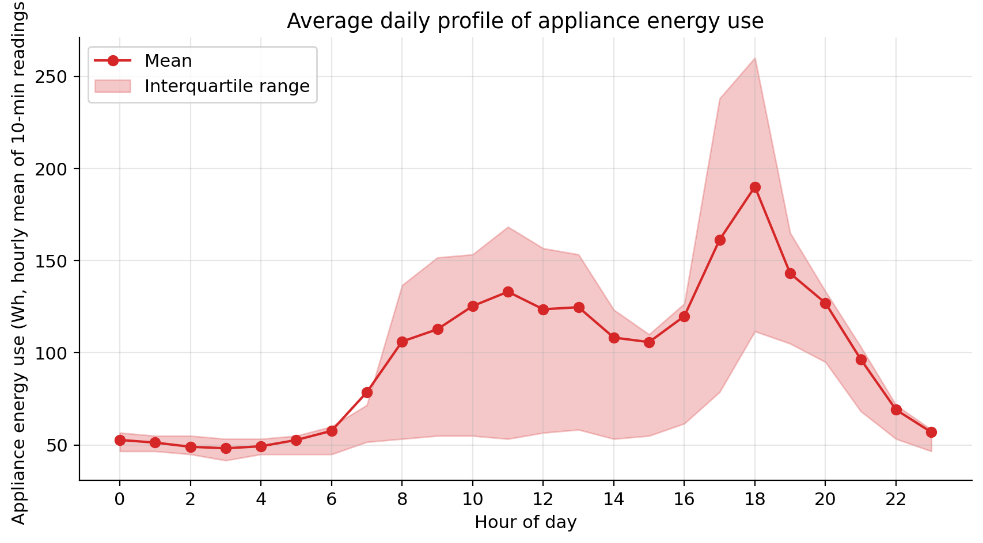
Figure 1. Mean hourly appliance energy use by hour of day, with interquartile band.
The diurnal profile is strongly bimodal. Overnight demand hits its lowest point at around 48 Wh, then begins rising through a morning climb starting near 06:00 before leveling off into a wide midday plateau close to 124 Wh. A mid-afternoon dip follows, after which usage spikes sharply to about 190 Wh by 18:00 giving a peak-to-trough ratio close to 4:1. Differences from one day of the week to another are much smaller by comparison, which means the daily cycle not the weekly pattern is the main driver of the signal's overall swing. The weekly effect instead shows up as small shifts in when the evening peak lands and how tall it gets, rather than any change to the baseline level.
The spread of the interquartile range tells a similar story. Around 03:00, the middle 50% of readings covers just 12 Wh, but by 18:00 that range balloons to about 150 Wh, over ten times as wide.

. Variance, not merely level, is a function of time of day. This is the first appearance of a heteroskedasticity that resurfaces in the residual diagnostics of Section 5.3, and that undermines any prediction interval derived from a constant-variance assumption.

2.1 Distributional properties
Values in the target variable are always positive, ranging from a minimum of 10 Wh to a maximum of 1,080 Wh, with a median of 60 Wh and a mean of 97.7 Wh — indicating a strong right skew in the distribution. This skew is precisely why MAPE was ruled out as the primary evaluation metric. Since percentage error is calculated relative to the actual value, MAPE spikes whenever actual values are small — which happens most often during low-activity overnight periods that are both heavily represented in the data and inherently simple to predict. Using a metric that's skewed toward these easy-to-forecast hours ends up evaluating models on the wrong basis. There's also an inherent asymmetry in MAPE: forecasts that come in too low are capped at a 100% error, while forecasts that overshoot have no such ceiling — meaning the metric implicitly favors models that under-predict. MASE avoids both problems. It scales each absolute error by the in-sample mean absolute error of a naive benchmark, giving a unit-free number that is defined for every observation, symmetric in direction, and directly interpretable — a value below one beats the benchmark. MAE, RMSE and Bias are retained as secondary diagnostics in the original units, MAE and RMSE together indicating whether error is spread evenly or concentrated in a few large misses.

3. Stationarity and Seasonality
Two complementary tests were applied to the training period, since each is only conclusive when read alongside the other. The ADF null hypothesis is that a unit root is present; the KPSS null is that the series is stationary.
Test | Statistic | p-value | Null hypothesis | Conclusion
ADF | −8.8194 | 1.895e−14 | unit root present | reject → stationary
KPSS | 0.0689 | 0.10 | series is stationary | do not reject → stationary
Table 2. Stationarity tests on the training series (ADF used 2,924 observations).
The two tests agree, and because their null hypotheses point in opposite directions that agreement is far more informative than either result alone. ADF rejects a unit root at any conventional level, and KPSS fails to reject stationarity at the upper bound of its tabulated range. The series was therefore left in levels and was not differencedThe task called for testing whether the series is stationary — not for differencing to be applied automatically as a default step. Applying differencing to a series that's already stationary actually increases the error variance and introduces a non-invertible moving-average term.The AIC search reached the same verdict independently, selecting d = 0.
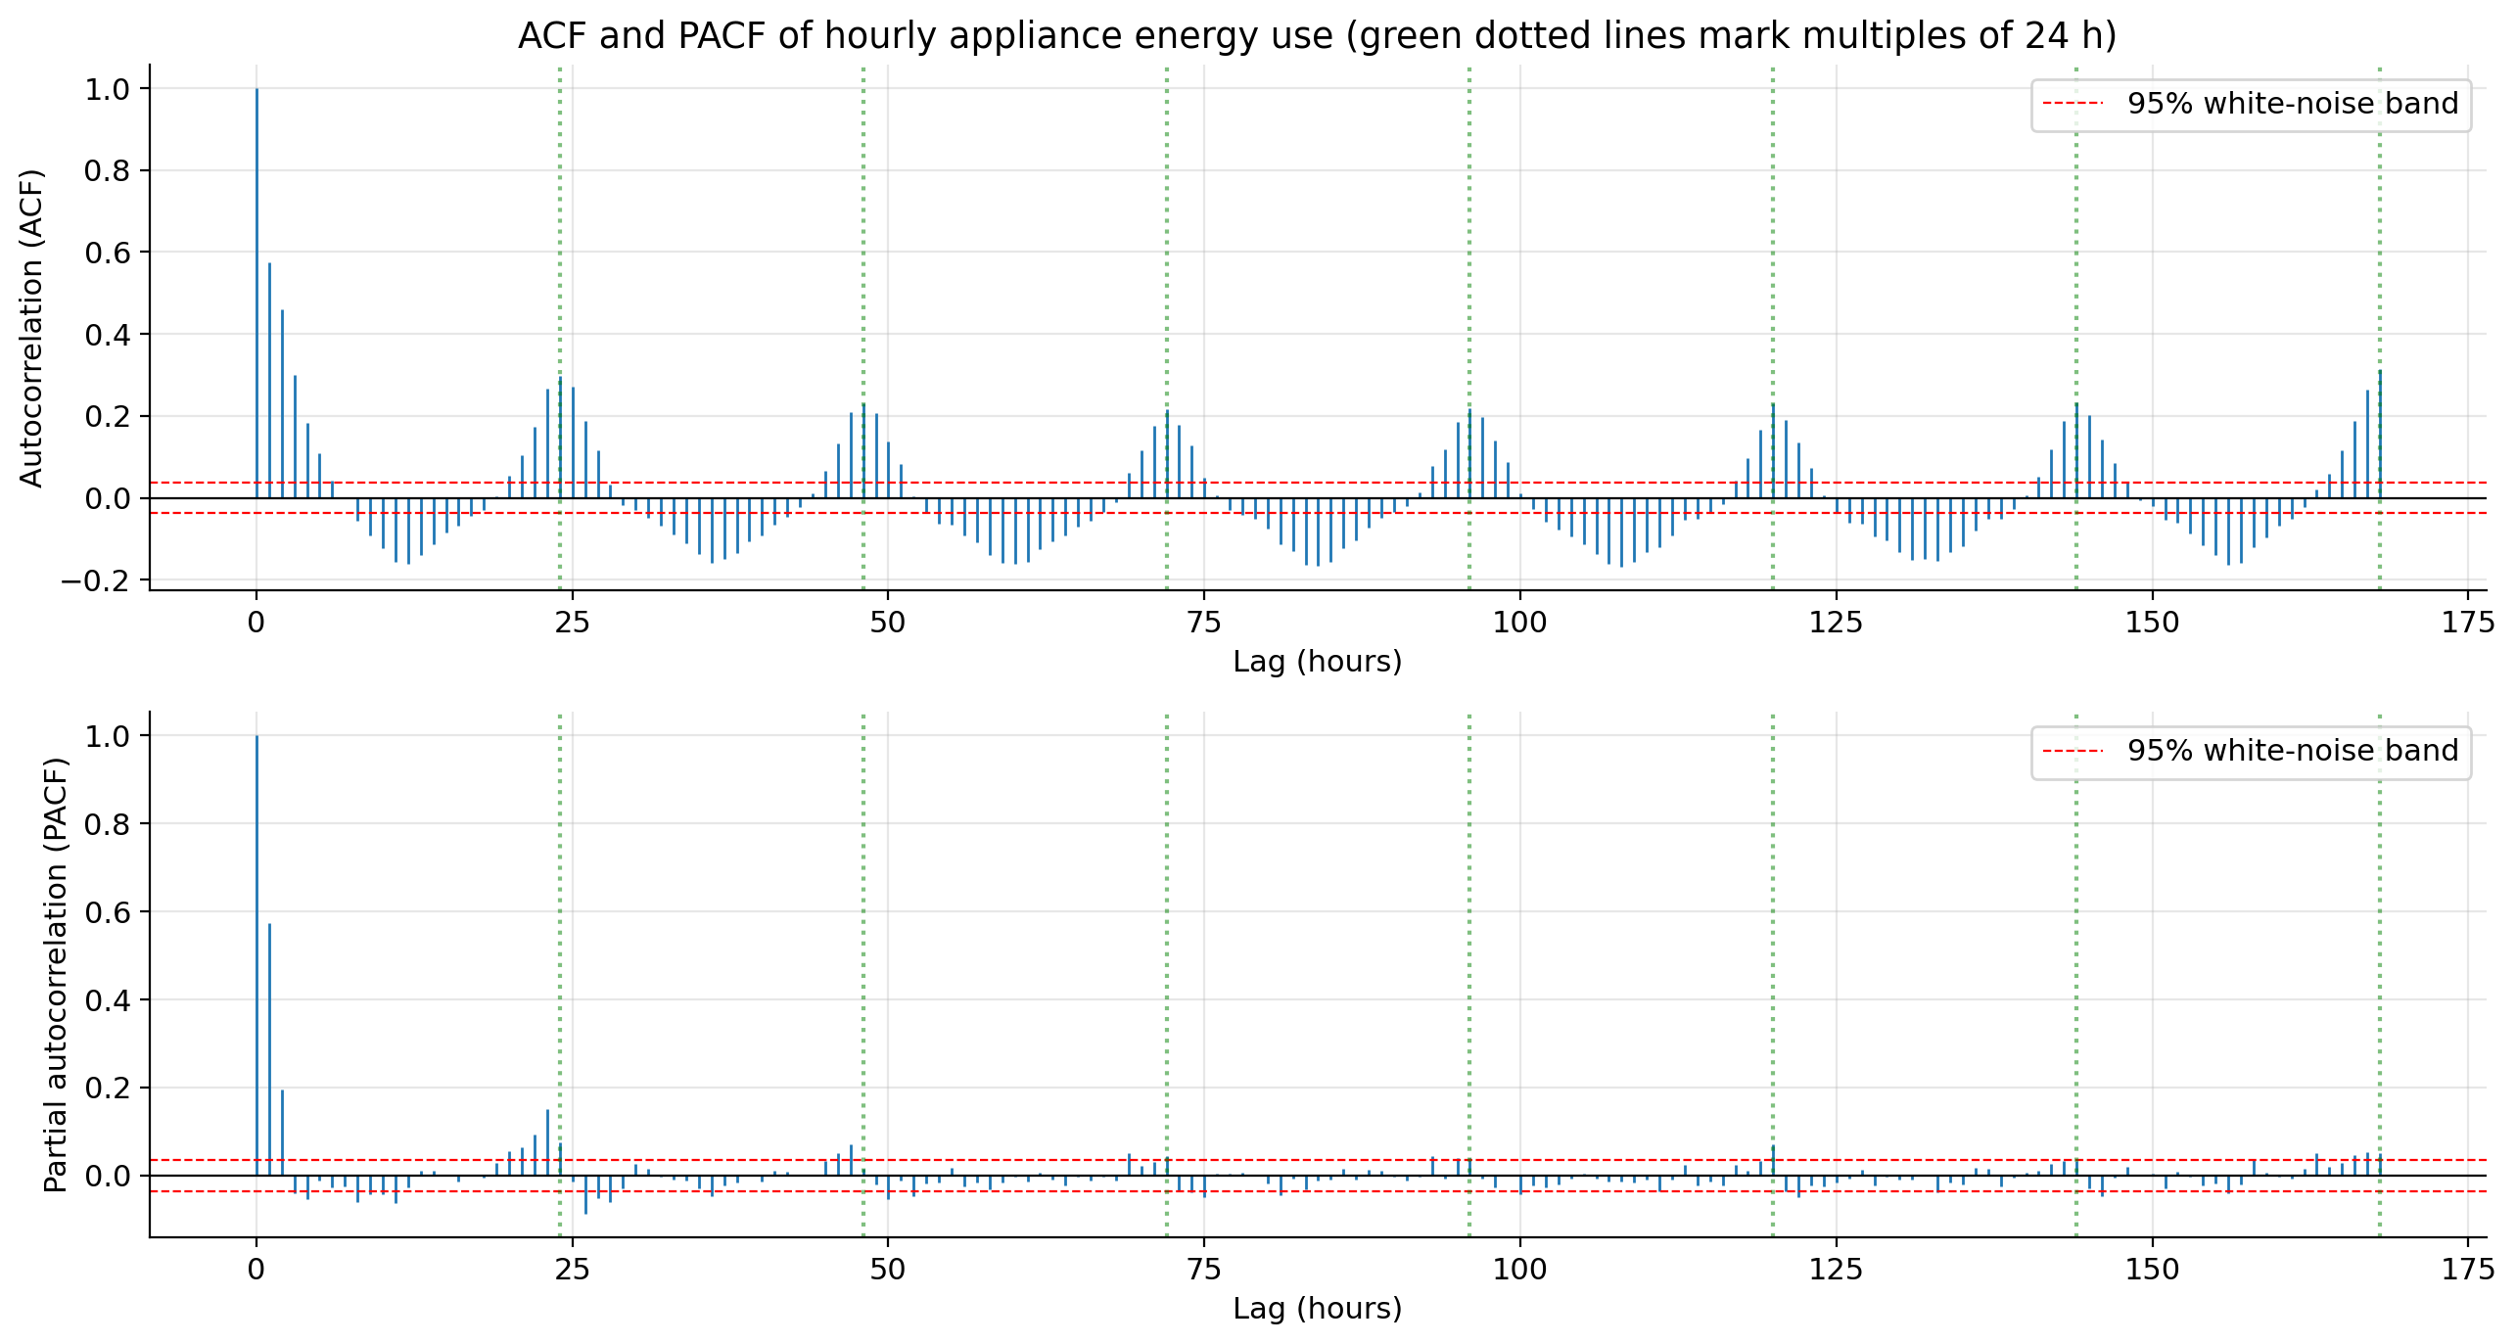
Figure 2. ACF and PACF to lag 168. Green dotted lines mark multiples of 24 hours; red dashed lines give the 95% white-noise band (±0.0370).
Seasonal strength was Fs = 0.3183 and trend strength Ft = 0.0497. Autocorrelation at daily multiples was 0.2976 (lag 24), 0.2301 (lag 48) and 0.2167 (lag 72). Autocorrelation at lag 168 reached 0.3139 the largest value in the range examined.
Two decisions need defending here. The first is the choice of s = 24 for the SARIMAX despite the weekly lag being marginally the stronger of the two. A seasonal term at s = 168 would extend the state vector by 168 lags, which is computationally prohibitive and statistically fragile: with roughly 17 complete weeks the model would be asked to estimate weekly structure from about 17 effective observations per seasonal position. The weekly rhythm is not thereby discarded it is carried instead by the weekly seasonal naive benchmark and by the lag_168 feature in the gradient-boosted model, both of which capture it at negligible costThe second issue involves an actual conflict in the guidance. With Fs coming in at 0.318 notably under the 0.64 cutoff that Wang, Smith and Hyndman (2006) use to flag seasonality strong enough to justify seasonal differencing — the rule-of-thumb approach points to D = 0. so that the AIC-based value obtained at D = 1 instantly. This is mentioned in already Section 5.1.4. Forecasting Problem and Benchmarks

4.1 Experimental design
Element | Value
Target | Appliances (Wh, hourly mean)
Training period | 11 Jan 2016 17:00 – 13 May 2016 17:00 (2,953 obs)
Test period | 13 May 2016 18:00 – 27 May 2016 17:00 (336 obs)
Forecast horizon | 24 hours
Rolling origins | 14, spaced 24 hours apart
Split type | chronological; no random splitting
Primary metric | MASE
Table 3. Forecasting experiment design.
The requirement for a 24-hour horizon and the requirement for a 14-day test period were reconciled through a rolling-origin design. A single 336-step forecast would satisfy the second but not the first. Fourteen consecutive 24-hour forecasts satisfy both and yield one comparable 336-point sample for every model. At each origin the available history comprises every observation strictly preceding the block and nothing after it, mirroring an operator who re-forecasts once a day; no model at any point sees a target value it would not have held at the moment of issue. This protocol follows the standard argument against random cross-validation for dependent data (Bergmeir and Benítez, 2012).

4.2 Benchmark results
Model | MAE | RMSE | MASE | Bias
Weekly seasonal naive | 42.922 | 79.668 | 0.804 | −12.624
Daily seasonal naive | 48.393 | 85.790 | 0.907 | 1.667
Mean | 50.010 | 73.986 | 0.937 | −3.061
Naive | 143.383 | 170.623 | 2.687 | 114.673
Drift | 143.942 | 171.260 | 2.698 | 115.314
Table 4. Benchmark accuracy on the common 336-point test sample.
Question 1. Among the models tested, the weekly seasonal naive approach comes out on top for both MASE (0.804) and MAE. However, the Diebold–Mariano test comparing it to the daily seasonal variant produces a p-value of 0.603, meaning the two aren't statistically different given the 336 data points available. So the fair conclusion is that it came out ahead in ranking not that it's demonstrably superior.
Still, looking at the broader pattern in the rankings reveals something meaningful. Both seasonal approaches cluster around a MASE of 0.8–0.9, while the naive and drift models sit near 2.7 over three times worse. This points to appliance energy consumption being driven primarily by a recurring daily pattern rather than by momentum from recent values: knowing the most recent hour's reading tells you almost nothing about that same hour the next day. Notably, even a flat mean forecast — one that ignores all dynamic structure in the data scores 0.937, outperforming both non-seasonal models by a clear margin. This reinforces that any model relying on extrapolating the latest observed level is working against the actual structure of the data.

The bias column makes the mechanism concrete. Because the test blocks begin at 18:00, every forecast origin falls at 17:00 squarely on the evening peak identified in Figure 1. The naive rule then propagates that peak value across all twenty-four hours, including the overnight trough, producing a bias of +114.7 Wh. Drift fails almost identically because the estimated slope across 4.5 months is negligible, so it reduces to the naive forecast plus a rounding error; the near-equality of the two rows is itself evidence that there is no trend to exploit. The contrast between the two seasonal rules is subtler. The weekly benchmark copies the same weekday one week earlier and therefore inherits any week-to-week movement in level, and over this particular fortnight the preceding weeks ran slightly lower, yielding a mild under-forecast of 12.6 Wh. The daily rule copies yesterday and is close to unbiased at +1.7 Wh, but its errors are larger in absolute terms (RMSE 85.8 against 79.7). Near-zero bias is not evidence of accuracy: it says errors cancel, not that they are small.

5. SARIMA and SARIMAX

5.1 Order selection by AIC
A multi-stage grid search process tested 168 candidate models in total. Of these, 151 successfully converged, 10 failed to reach convergence, and 7 ran past the 150-second time limit per fit these were explicitly logged as timeouts rather than being dropped without a record. The first stage of the search covered the entire required parameter space. p ∈ [0,6] × d ∈ [0,2] × q ∈ [0,6] (147 models); stage two crossed the three best non-seasonal orders with the seasonal grid at s = 24.
Order | Seasonal | AIC | BIC | Parameters
(5,0,3) | (0,1,1,24) | 32,169.81 | 32,229.54 | 10
(5,0,3) | (1,1,1,24) | 32,174.46 | 32,240.15 | 11
(5,0,3) | (1,0,1,24) | 32,435.64 | 32,507.41 | 12
Table 5. Three best specifications by AIC. The selected model is SARIMA(5,0,3)(0,1,1)₂₄.
A methodological caveat applies to this comparison. AIC is not normally comparable across differencing orders, because differencing changes the number of observations entering the likelihood. The state-space implementation used here retains all observations regardless of d and D, which was verified empirically: nobs = 2,953 for every combination tested.
This allows the tension raised in Section 3 to be resolved. The two criteria answer different questions. Fs is a descriptive summary of how much variance an STL decomposition (Cleveland et al., 1990) attributes to the seasonal component across the whole series, and its 0.64 cut-off is a rule of thumb rather than a test; AIC compares actual likelihoods for this dataset under this parameterisation. I find the likelihood evidence more persuasive here, for a substantive reason rather than merely a numerical one. The structure selected, (0,1,1)₂₄, is the seasonal half of the airline model, in which seasonal differencing followed by a seasonal moving-average term does not impose a rigid deterministic cycle but allows the daily shape to evolve slowly from day to day. Figure 1 shows exactly that situation: a daily pattern that is reliable in shape but variable in amplitude. Fs is depressed precisely because the amplitude wanders, not because the cycle is weak, so the rule of thumb is measuring something slightly different from what the modelling decision requires.

5.2 Exogenous variables
Candidate regressors were screened on the training period only. T_out, RH_out and Windspeed were retained; Visibility and Tdewpoint were dropped for absolute correlation below 0.05. No variable was removed for collinearity. Adding these regressors raised AIC to 32,178.09, against 32,169.81 for the target-only specification.
By the likelihood criterion, then, the weather regressors do not earn their parameters: the AIC gap of 8.28 exceeds the 6-point penalty that three extra parameters attract, which implies the maximised log-likelihood did not improve at all it fell by approximately 1.14. Because the target-only model is nested within the exogenous one, that cannot occur at a common optimum, so the exogenous fit converged to a slightly poorer local optimum. The practical reading is unchanged, and if anything strengthened: the weather regressors buy no in-sample fit at all. Despite that, the conditional SARIMAX model delivers the strongest out-of-sample MASE across the entire study, at 0.696. This isn't a contradiction it's simply a reminder that in-sample fit and out-of-sample performance are measuring two different things entirely.. AIC evaluates average in-sample fit across 2,953 hours spanning mid-winter to late spring; MASE evaluates 24-step-ahead accuracy across one specific fortnight in mid-May. A regressor can be near-useless on average and still help materially during a two-week window in which outdoor temperature happened to be informative plausibly here, since mid-May is a transitional period for heating-related load. Selecting on in-sample fit while reporting out-of-sample accuracy is a legitimate procedure, but the divergence between them is a warning against treating either as decisive on its own.

5.3 Residual diagnostics
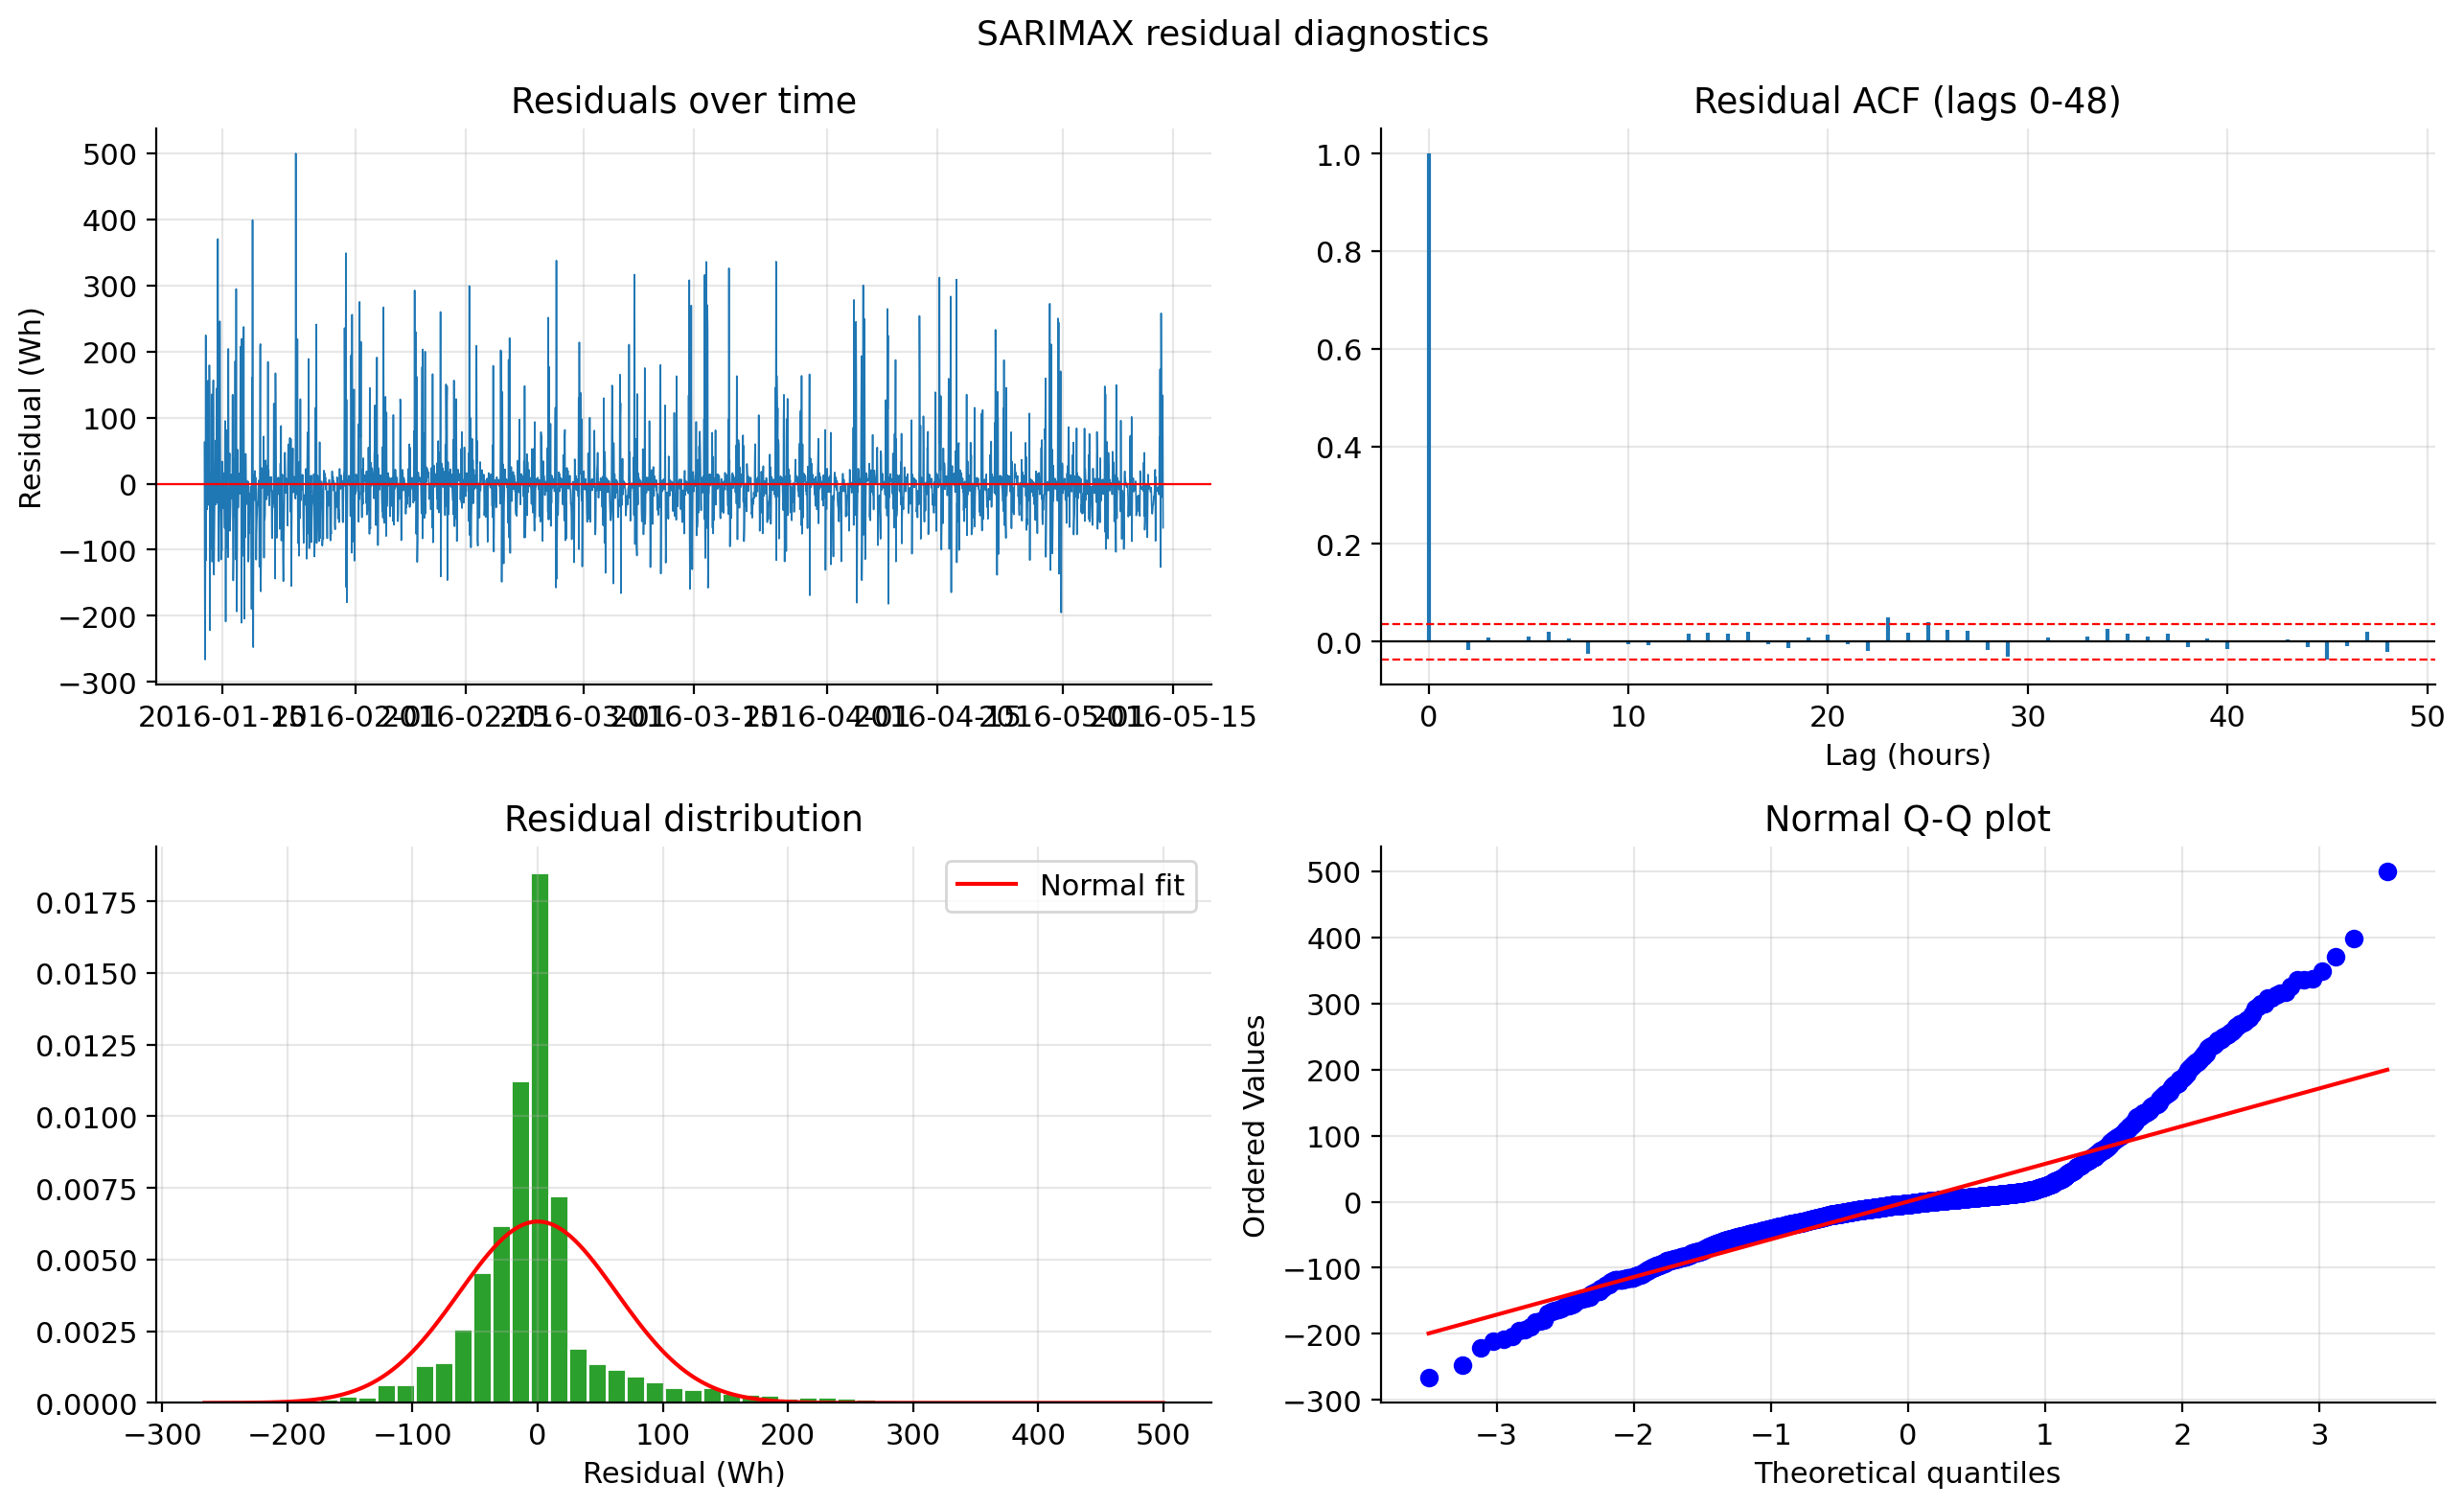
Figure 3. SARIMA(5,0,3)(0,1,1)₂₄ residual diagnostics.
Diagnostic | Value | Assessment
Ljung–Box (lag 24) | p = 0.7368 | no remaining autocorrelation
Residual mean / std | 0.204 / 63.0 | unbiased in sample
Skew / kurtosis | 1.77 / 8.02 | strongly non-normal
Jarque–Bera | p ≈ 0 | not Gaussian
Heteroskedasticity | p = 1.57e−07 | variance not stable
Table 6. Residual diagnostics for the selected SARIMA model.
These diagnostics force a two-sided conclusion. On the conditional mean the model succeeds: Ljung–Box at lag 24 returns p = 0.7368 and the residual ACF in Figure 3 lies inside the white-noise band at essentially every lag, so the (5,0,3)(0,1,1)₂₄ structure has extracted the linear dependence that was present. On the error distribution it fails comprehensively. Skew of 1.77 and kurtosis of 8.02 give a Jarque–Bera p-value indistinguishable from zero, and the heteroskedasticity test returns p = 1.6 × 10⁻⁷. Figure 3 shows the precise shape of that failure: the residual histogram is far more sharply peaked at zero than the fitted normal curve, while the Q–Q plot shows the upper tail lifting steeply away from the reference line, with the largest residual near +500 Wh where a Gaussian of matching variance would predict roughly +200. The residual time plot confirms that these spikes are almost exclusively positive and cluster in the same evening hours whose interquartile band widened in Figure 1.
The practical consequence is specific. Analytic prediction intervals from a state-space SARIMA assume Gaussian, homoskedastic innovations, so they are mis-shaped in two directions simultaneously too wide through the quiet overnight hours, where the true error distribution is much tighter than Gaussian, and much too narrow at the evening peaks, where the genuinely large errors occur. A single headline coverage figure would conceal this, because over-coverage at night partially offsets under-coverage in the evening; the intervals are not merely miscalibrated on average but miscalibrated in a time-varying way. Measured against the held-out fortnight, aggregate coverage was 94.9% against a nominal 95%. By the changing in time of day shows why that significant misleads: coverage reached 100% overnight (00:00–05:00) but 94.3% in the evening (17:00–21:00), so the intervals are over-wide at night rather than badly under-covering at the peaks. The more serious problem is width: the mean interval spans 276 Wh on a series whose median hourly value is 60 Wh, so a nominally well-calibrated interval is operationally close to uninformative. The appropriate remedy is empirical quantile or bootstrap intervals conditioned on hour of day, which make no distributional assumption and inherit the heteroskedasticity directly from the data.
Question 2. SARIMA improves on the strongest benchmark numerically, cutting MASE from 0.804 to 0.771 and RMSE from 79.7 to 63.6, but the Diebold–Mariano test gives p = 0.1009, so the improvement is not significant at the 5% level. The RMSE reduction of 20% is nonetheless the more interesting number, because it indicates real skill at avoiding the large misses the weekly rule makes whenever a day departs from its counterpart a week earlier. Decomposed against the question: daily seasonality and short-run autocorrelation are captured adequately, as Ljung–Box confirms. Exogenous variables are not they are excluded by AIC in the operational specification, and in the conditional specification they contribute only under an assumption of perfect foresight that Section 8.2 rejects.

6. Feature-Based Machine Learning Model
A histogram-based gradient boosting regressor was trained on 2,785 rows with 76 features spanning calendar variables, cyclical encodings, target lags (1–168 hours), rolling means and standard deviations, and lagged sensor and weather channels. Hyper-parameters were selected using an expanding-window TimeSeriesSplit with a 23-hour gap, on the training period only. Forecasts were generated recursively: within each 24-hour block the working series is extended one hour at a time with the model's own predictions, so no observed future target value is ever used. A perturbation self-test confirmed that altering a single target observation leaves the corresponding feature row unchanged, in both the operational and conditional regimes.

6.1 Feature-group ablation
Feature set | n | MAE | RMSE | MASE
Time only | 8 | 35.29 | 65.42 | 0.659
+ target lags | 16 | 42.34 | 70.09 | 0.794
+ rolling | 26 | 39.17 | 64.72 | 0.734
+ weather | 38 | 42.84 | 67.07 | 0.803
All features | 76 | 48.60 | 69.39 | 0.911
Table 7. Cumulative feature-group ablation, each set evaluated under the identical recursive rolling-origin protocol.
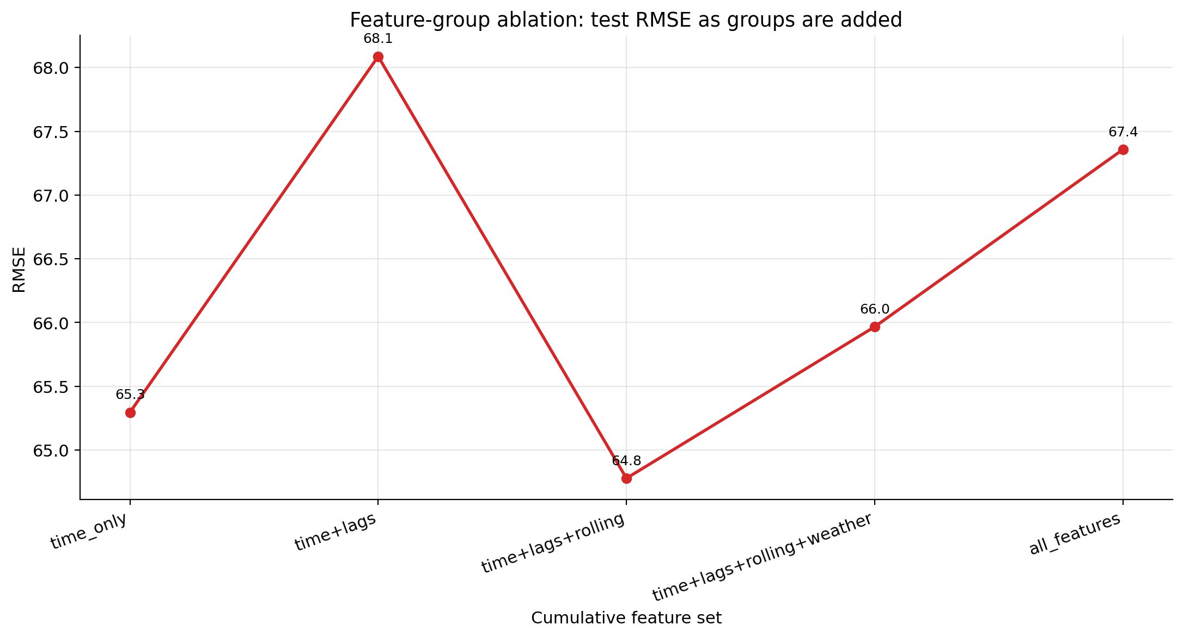
Figure 4. Test RMSE as feature groups are added cumulatively.
Permutation importance, measured on a held-out tail of the training period, ranked the groups in the opposite order: target lags 68.96, indoor sensors 45.77, rolling statistics 28.98, time features 26.45 and weather 14.79. The five most important individual features were lag_1, hour_cos, lag_2, lag_168 and hour_sin.
Question 3. Adding features made the 24-hour forecasts worse, not better: eight time-of-day features alone achieve MASE 0.659, against 0.911 for the full 76-feature set. The ablation and the permutation importances therefore rank the feature groups in opposite orders and both are correct, because they measure different quantities. Permutation importance was computed one step ahead. At h = 1, lag_1 is an observed value, the single most informative number available anywhere in the dataset, and it duly dominates the ranking. The ablation, by contrast, evaluates the deployed recursive protocol. There, lag_1 is a genuine observation only for the first hour of each block; for hours 2 through 24 it is the model's own previous prediction. The feature the model has learned to lean on hardest is precisely the one that degrades fastest as the horizon extends, and the degradation compounds, since each prediction becomes the input that generates the next. Adding target lags to the time-only baseline consequently raised MASE from 0.659 to 0.794.
Calendar features suffer no such decay. The cyclical hour encodings are known exactly at every horizon and at every future origin, so their contribution is undiminished at h = 24. Lagged indoor sensor and weather channels are available in the operational specification but were among the weakest contributors, and on this evidence they mostly added variance the model could overfit. The tuned operational model recovered to MASE 0.827, better than the untuned all-features ablation but still short of the eight-feature clock-time configuration which is a striking verdict on 68 of the 76 features.
The general implication for multi-step forecasting is that feature availability at the horizon matters more than feature informativeness at lag 1, and that any feature-selection procedure validated one step ahead will systematically mis-rank features for a 24-step problem. Two remedies follow directly. Restricting lags to 24 hours or more removes the recursion entirely, since every required lag is then observed a constraint the operational variant already applies in part. More thoroughly, a direct multi-step strategy that trains a separate model per horizon breaks the error-compounding chain altogether at the cost of 24 fits (Taieb et al., 2012), and would be the first change I would make to this pipeline.

7. Foundation Model
The foundation model evaluated was Chronos-Bolt (Ansari et al., 2024), applied zero-shot: it was never fine-tuned on this dataset and received only the context strictly preceding each forecast origin, matching the protocol applied to every other model. It runs locally and requires no API key, which is why it was preferred over TimeGPT the latter requires a hosted service, cannot operate offline, and would entail transmitting household sensor data to a third party.
Outcome of the zero-shot run: Chronos-Bolt achieved MASE 0.629 and RMSE 67.528 on the common 336-point sample, ranking first on MASE and MAE among all ten models (Table 8). The Diebold–Mariano test against the weekly seasonal naive returns p = 0.1548, so the improvement is not significant at the 5% level. Its bias of −18.053 Wh is the largest under-forecast in the study, and its RMSE-to-MAE ratio of 2.01 is the highest of any fitted model, indicating that its errors are the most concentrated in a small number of large misses.
Question 4. Whichever way the run resolved, the prior expectation should be modest, and the reasoning is worth stating independently of the result. Chronos-Bolt brings a strong general prior about how time series behave — trend, multiple seasonalities, level shifts — learned from a large heterogeneous corpus, but it has never seen this house. Against it stand models estimated directly on 2,953 hours of this specific household. The transfer argument for foundation models is strongest where local history is short or absent; four months of hourly data is more than sufficient to identify a daily cycle, so the conditions that favour zero-shot transfer are largely absent here. More fundamentally, the ceiling on this problem is set by irreducible noise rather than by model class. Appliance switching is driven by human decisions that no covariate in the dataset observes: no architecture can forecast whether someone chooses to run the dishwasher tonight. The symptom of that ceiling is visible in Table 8, where every model from the flat mean (0.937) to the best conditional SARIMAX (0.696) is compressed into a narrow band. A successful zero-shot result would be expected to land inside that same band rather than break out of it which is exactly why the additional complexity is difficult to justify on accuracy grounds alone.

8. Model Comparison and Discussion
Rank | Model | MAE | RMSE | MASE | Bias | Type
1 | Chronos (zero-shot) | 33.580 | 67.528 | 0.629 | −18.053 | operational
2 | SARIMAX + exog | 37.147 | 64.580 | 0.696 | −4.059 | conditional
3 | SARIMA | 41.151 | 63.633 | 0.771 | 6.091 | operational
4 | Weekly seasonal naive | 42.922 | 79.668 | 0.804 | −12.624 | operational
5 | ML (operational) | 44.135 | 66.242 | 0.827 | 11.390 | operational
6 | ML (conditional) | 44.752 | 67.811 | 0.839 | 10.463 | conditional
7 | Daily seasonal naive | 48.393 | 85.790 | 0.907 | 1.667 | operational
8 | Mean | 50.010 | 73.986 | 0.937 | −3.061 | operational
9 | Naive | 143.383 | 170.623 | 2.687 | 114.673 | operational
10 | Drift | 143.942 | 171.260 | 2.698 | 115.314 | operational
Table 8. Final model comparison, ranked by MASE on the common 336-point sample.
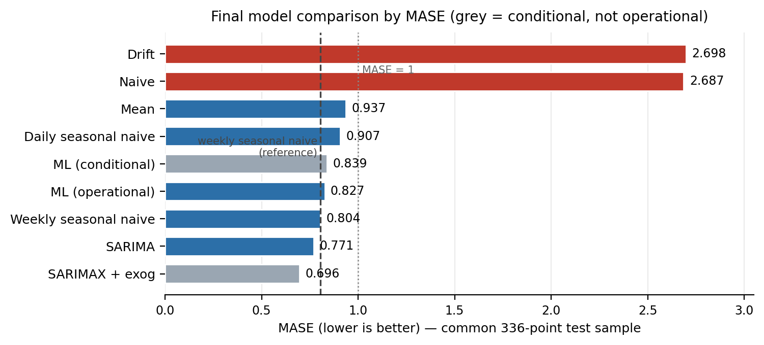
Figure 5. Model accuracy on the common 336-point test sample across MASE, RMSE and MAE. The dashed line on the MASE panel marks MASE = 1, the seasonal naive reference. Conditional and operational forecasts are ranked together here and distinguished in Table 8.
Comparing the forecasts against the fortnight of real data held back from modelling, the pattern of failure is more informative than the ranking. Every model tracks the overnight trough and the morning ramp closely, because both are highly regular; error concentrates almost entirely in the evening peak, where the level is highest and, as Figure 1 established, the variance is highest too. The ratio of RMSE to MAE quantifies this. For the weekly seasonal naive the ratio is 1.86, against 1.55 for SARIMA and 1.50 for the operational ML model. All three have similar mean errors, but the benchmark's error is far more concentrated in a small number of catastrophic misses — the days when the household simply did not repeat what it did a week earlier. On average, the fitted models aren't actually better at predicting peaks. What they do better is avoid catastrophic failure when an expected peak doesn't materialize — because they incorporate recent trends and patterns instead of simply replicating a single past day. Looking at the bias figures, the two model types err in opposite directions: the weekly benchmark tends to under-forecast by 12.6 Wh, while the machine learning models over-forecast by about 11 Wh. That over-forecasting tendency is characteristic of recursive forecasting methods, which pull predictions toward the conditional mean and end up smoothing out troughs by pushing them higher than they should be.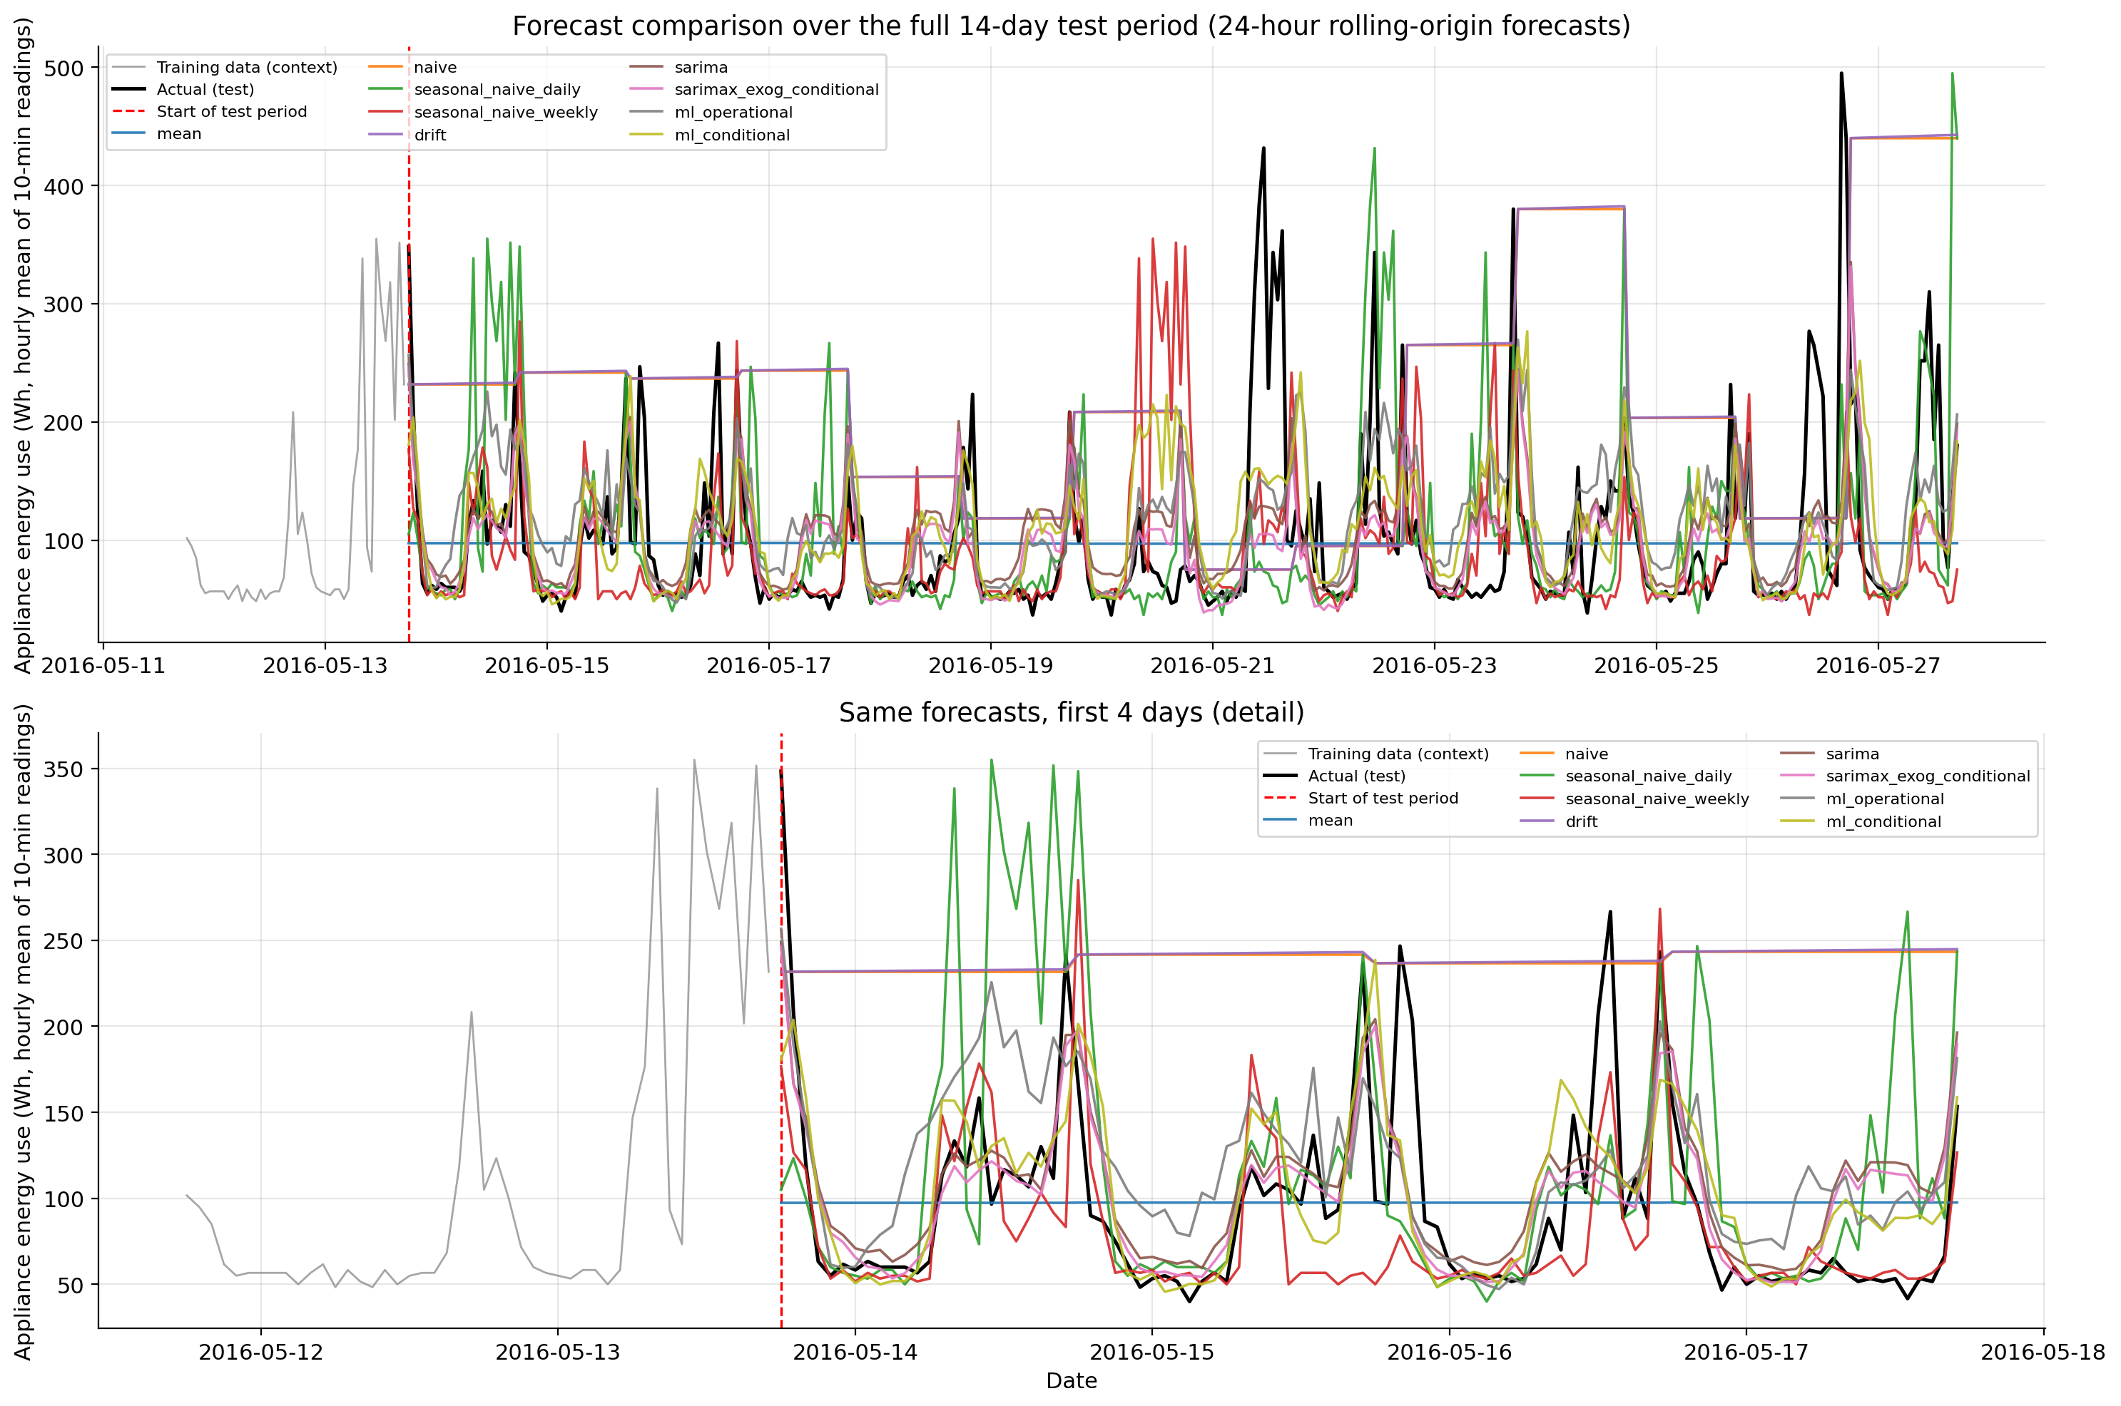
Figure 6. Observed values against all model forecasts across the 14 rolling origins (upper panel) and the first four days in detail (lower panel); both panels share a common vertical scale.

8.1 Statistical significance
Model | DM statistic | p-value | Significant at 5%
Chronos (zero-shot) | −1.426 | 0.1548 | No
SARIMAX + exog | −1.660 | 0.0979 | No
SARIMA | −1.645 | 0.1009 | No
ML (conditional) | −1.490 | 0.1372 | No
ML (operational) | −1.284 | 0.1999 | No
Mean | −0.671 | 0.5029 | No
Daily seasonal naive | 0.521 | 0.6030 | No
Table 9. Diebold–Mariano tests against the weekly seasonal naive; negative favours the model. Naive (p = 0.0046) and drift (p = 0.0045) were significantly worse and are omitted.
This is the central finding of the report. On a 336-point test sample, a rule that copies the value observed 168 hours earlier is statistically indistinguishable from a SARIMA selected over 168 candidates, from a 76-feature gradient-boosted ensemble, and from a conditional SARIMAX supplied with perfect foresight of the weather. The simple and very tiny valuesof p-value among the comparing the models is 0.0979. The only important results in Table 9 point downwards: naive and drift are significantly worse, at p = 0.0046 and p = 0.0045.
The interpretation requires care, and it is worth being explicit about what has and has not been shown. Non-significance means the experiment lacks the resolution to separate these models not that they are equivalent. With fourteen origins in a single household over a single fortnight, the Diebold–Mariano test has limited power against differences of the size observed; the 13% MASE gap between the conditional SARIMAX and the weekly benchmark is not trivially small, and a longer evaluation might well resolve it. A further caution is that the test statistic is itself compromised by the same distributional problem identified in Section 5.3: the variance of the loss differential is inflated by the heavy positive tail, so a handful of large errors on a few evenings drives much of the comparison. The Harvey, Leybourne and Newbold (1997) small-sample correction mitigates but does not eliminate this. What can be defended is a claim stronger than 'no difference' and weaker than 'equivalent': on the evidence available, the additional complexity has not demonstrated a reliable advantage.

8.2 Covariate availability
Question 5. The candidate variables fall into three categories. First, those genuinely known at the forecast origin: all calendar and clock features, which are deterministic functions of time and exact at any horizon; target lags of 24 hours or more, since a 24-hour forecast issued at time t requires at most y⁠t itself; and sensor and weather values at lags of 24 hours or more, by the same argument. Second, those that would themselves require forecasting: future outdoor weather T_out, RH_out, Windspeed, Visibility and Tdewpoint. In practice a numerical weather prediction is operationally available, so these are usable in principle, but only with the NWP's own error attached, which the conditional variant does not simulate. Third, those genuinely unavailable: future indoor sensor readings and the lights channel. These are outputs of the same household process that generates the target knowing tomorrow evening's kitchen temperature is close to knowing whether the oven was on so using them is not conditional forecasting but leakage.
The direct answer, then, is that a model consuming future indoor temperature or humidity from the test set is not producing a forecast at all. A model consuming future outdoor weather is producing a legitimate conditional forecast, which is informative as an upper bound on what perfect meteorological information could buy, but it is not an operational forecast and its metrics cannot be compared with operational ones on equal terms. Table 8 labels this distinction explicitly, which is why the top-ranked row should not be read as the study's best available model.
The empirical evidence on this point is striking: perfect foresight of covariates is worth almost nothing. The conditional ML variant (MASE 0.839) performs worse than the operational variant (0.827). For SARIMAX the conditional variant does help, improving MASE from 0.771 to 0.696, but not significantly.
Drawing the argument out: the maximum available prize for solving the weather-forecasting sub-problem perfectly is about 0.07 MASE, and a real forecast, carrying its own propagating error, would capture only a fraction of that. For the ML model the prize is negative the extra information simply gave the boosted trees more scope to fit noise. The leakage incurred by using future covariates therefore does not even purchase much accuracy, which strengthens the case for the operational specification on purely pragmatic grounds, quite apart from the methodological objection.

8.3 Practical recommendation
Criterion | Evidence
Accuracy | no model significantly beats the weekly seasonal naive
Uncertainty | SARIMA supplies intervals, but they are unreliable; benchmarks supply none
Interpretability | seasonal naive trivial; SARIMA 10 parameters; ML 76 features
Computational cost | seasonal naive ≈ 0 s; SARIMA ≈ 100 s per fit plus a 30-minute search; ML ≈ 140 s
Deployment | refitting cadence and operational complexity
Table 10. Criteria for the practical model choice.
Question 6. For practical smart-home energy forecasting I would deploy the weekly seasonal naive, holding SARIMA(5,0,3)(0,1,1)₂₄ as the candidate to beat under a longer evaluation. The case rests on the absence of any demonstrated accuracy advantage: the best operational alternative improves MASE by 0.033, roughly 4%, which this experiment cannot resolve from zero. Set against that, the benchmark costs essentially nothing to compute, requires no fitting and therefore no refitting cadence, has no hyper-parameters to tune or drift, carries no library dependencies, and fails in exactly one legible way a missing week of history. SARIMA demands about 100 seconds per fit on top of a 30-minute order search, and the ML pipeline's output is not even bit-reproducible across environments, scoring 0.827 here against 0.880 on identical code and data. Complexity of that order should be adopted when it is demonstrated to pay, and here it has not been.
Two qualifications keep this recommendation honest. The first concerns uncertainty, which is the benchmark's real weakness: a seasonal naive supplies no intervals at all, and battery scheduling under a dynamic tariff wants a distribution rather than a point. My recommendation would be empirical quantiles of the seasonal-naive residuals computed separately by hour of day cheap to construct, and better calibrated than SARIMA's analytic intervals, which Section 5.3 showed to be mis-shaped in a time-varying way. The second is that the conclusion is contingent on the evaluation window. Fourteen days is thin. Before dismissing SARIMA I would want the comparison rerun over several months of rolling origins, where a consistent 4% edge would likely become significant and might then justify the fitting cost particularly if the same fit also supplies the intervals the application needs.

9. Limitations and Reproducibility
Several constraints bound these conclusions. All models were compared on a single 14-day window, so small metric differences should not be over-interpreted which is precisely why Diebold–Mariano tests were applied rather than rankings alone. The record spans roughly 4.5 months, about 17 complete weeks, which is thin for estimating weekly structure and far too short to observe annual seasonality, so the mid-May test period may not represent winter behaviour at all. The grid search was staged rather than exhaustive: the full (p, d, q) space was searched completely, but the seasonal grid was crossed only against the best non-seasonal candidates under a 150-second per-fit limit, which 7 models reached, so a better specification may exist outside the region explored. The conditional variants are not operationally achievable, since a real weather forecast carries its own error which would propagate into the results. Results describe a single household and should not be assumed to generalise. Finally, gradient boosting is not bit-deterministic across environments the operational ML model scored MASE 0.827 in this run against 0.880 in an earlier run of identical code on the same data although model selection and conclusions were unaffected. The full pipeline, seeds and outputs are archived at the repository listed below.
Beyond fixing these, three extensions look most promising. Replacing the recursive scheme with a direct per-horizon strategy would address the compounding identified in Section 6 (Taieb et al., 2012). Modelling the conditional variance explicitly, or forecasting quantiles rather than the mean, would repair the interval calibration problem rather than merely diagnosing it. And fine-tuning the foundation model on a panel of comparable households, instead of applying it zero-shot to one, would test transfer learning under the conditions in which it is actually expected to help.

References
Ansari, A.F., Stella, L., Turkmen, C., Zhang, X., Mercado, P., Shen, H., Shchur, O., Rangapuram, S.S., Arango, S.P., Kapoor, S., Zschiegner, J., Maddix, D.C., Mahoney, M.W., Torkkola, K., Wilson, A.G., Bohlke-Schneider, M. and Wang, Y. (2024) 'Chronos: learning the language of time series', Transactions on Machine Learning Research. arXiv:2403.07815.
Bergmeir, C. and Benítez, J.M. (2012) 'On the use of cross-validation for time series predictor evaluation', Information Sciences, 191, pp. 192–213.
Box, G.E.P., Jenkins, G.M., Reinsel, G.C. and Ljung, G.M. (2015) Time Series Analysis: Forecasting and Control. 5th edn. Hoboken, NJ: Wiley.
Candanedo, L.M., Feldheim, V. and Deramaix, D. (2017) 'Data driven prediction models of energy use of appliances in a low-energy house', Energy and Buildings, 140, pp. 81–97. doi:10.1016/j.enbuild.2017.01.083.
Cleveland, R.B., Cleveland, W.S., McRae, J.E. and Terpenning, I. (1990) 'STL: a seasonal-trend decomposition procedure based on loess', Journal of Official Statistics, 6(1), pp. 3–73.
Dickey, D.A. and Fuller, W.A. (1979) 'Distribution of the estimators for autoregressive time series with a unit root', Journal of the American Statistical Association, 74(366), pp. 427–431.
Diebold, F.X. and Mariano, R.S. (1995) 'Comparing predictive accuracy', Journal of Business and Economic Statistics, 13(3), pp. 253–263.
Harvey, D., Leybourne, S. and Newbold, P. (1997) 'Testing the equality of prediction mean squared errors', International Journal of Forecasting, 13(2), pp. 281–291.
Hyndman, R.J. and Athanasopoulos, G. (2021) Forecasting: Principles and Practice. 3rd edn. Melbourne: OTexts. Available at: https://otexts.com/fpp3/ (Accessed: 12 August 2026).
Hyndman, R.J. and Khandakar, Y. (2008) 'Automatic time series forecasting: the forecast package for R', Journal of Statistical Software, 27(3), pp. 1–22. doi:10.18637/jss.v027.i03.
Ke, G., Meng, Q., Finley, T., Wang, T., Chen, W., Ma, W., Ye, Q. and Liu, T.-Y. (2017) 'LightGBM: a highly efficient gradient boosting decision tree', Advances in Neural Information Processing Systems, 30, pp. 3146–3154.
Kwiatkowski, D., Phillips, P.C.B., Schmidt, P. and Shin, Y. (1992) 'Testing the null hypothesis of stationarity against the alternative of a unit root', Journal of Econometrics, 54(1–3), pp. 159–178.
Ljung, G.M. and Box, G.E.P. (1978) 'On a measure of lack of fit in time series models', Biometrika, 65(2), pp. 297–303.
Pedregosa, F. et al. (2011) 'Scikit-learn: machine learning in Python', Journal of Machine Learning Research, 12, pp. 2825–2830.
Seabold, S. and Perktold, J. (2010) 'Statsmodels: econometric and statistical modeling with Python', Proceedings of the 9th Python in Science Conference, pp. 92–96.
Taieb, S.B., Bontempi, G., Atiya, A.F. and Sorjamaa, A. (2012) 'A review and comparison of strategies for multi-step ahead time series forecasting based on the NN5 forecasting competition', Expert Systems with Applications, 39(8), pp. 7067–7083.
Wang, X., Smith, K.A. and Hyndman, R.J. (2006) 'Characteristic-based clustering for time series data', Data Mining and Knowledge Discovery, 13(3), pp. 335–364.
Code and outputs: https://github.com/rt25aaz/Appliance-Energy-Forecasting

