Knowledge Discovery

and

Management

Assignment (LAB-4)

Initially we have to create a maven project, see to it that mahout is installed in prior as we have installed mahout in our lab 3. I have directly created the project

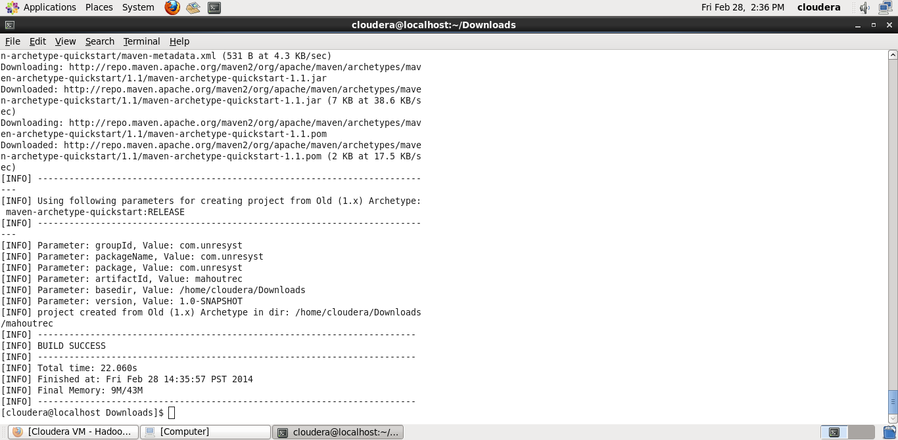

Next step is to execute the project

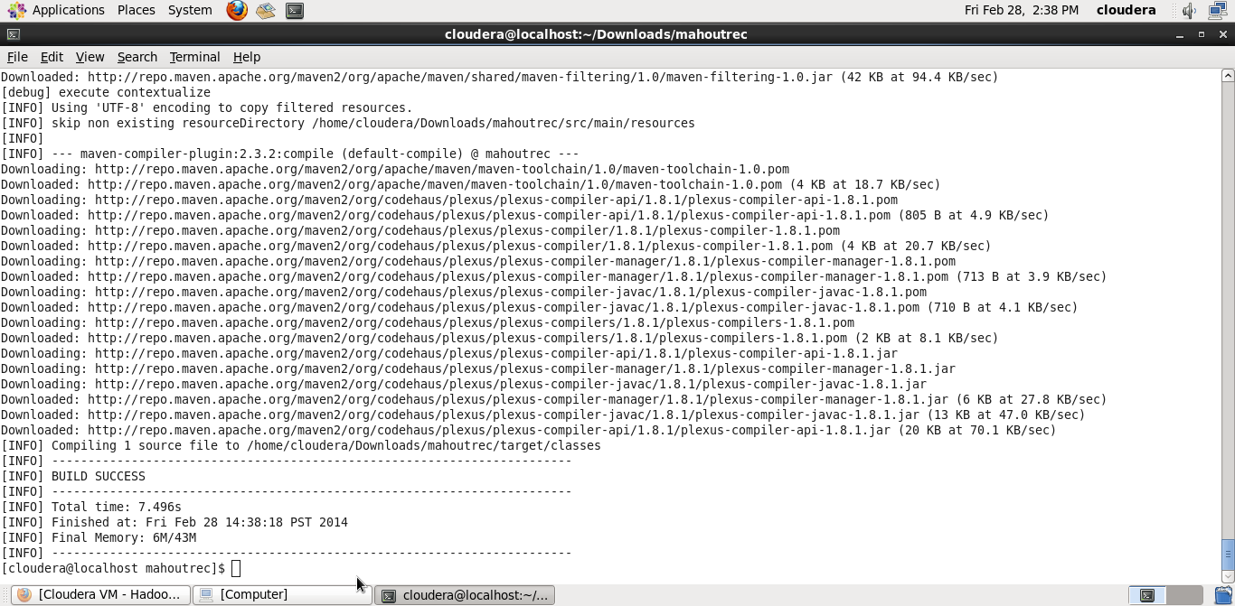

After execution once we run the program we get the “Hello World” message as the output

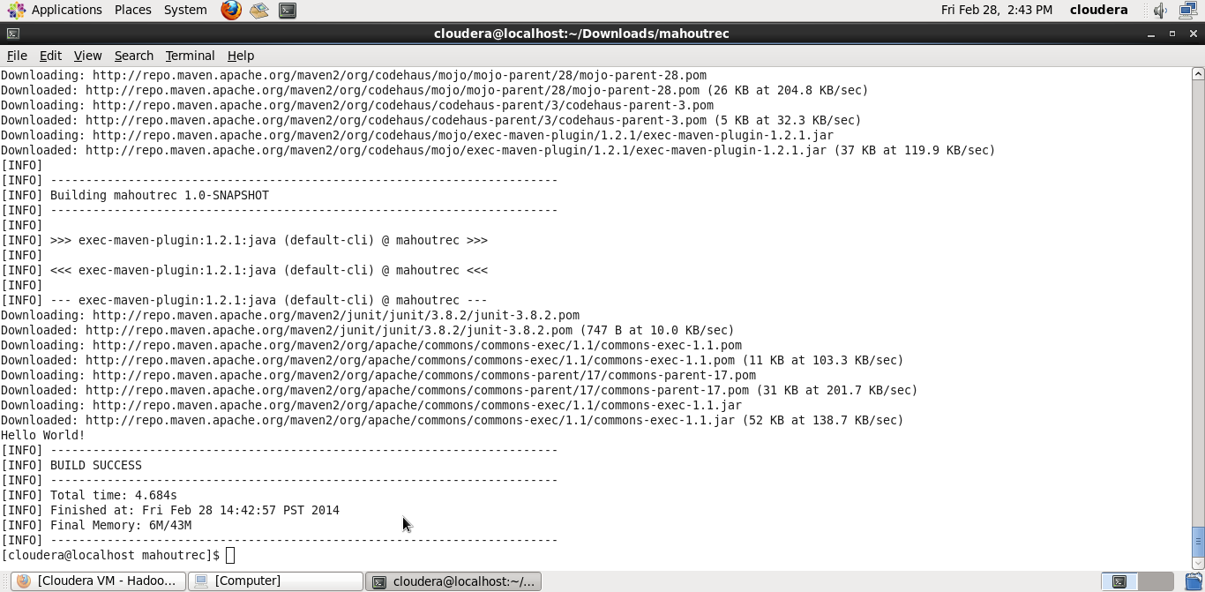

We now have to make changes in the XML file and then add a java code and add the default datasets in the maven project. Once added we have to compile the project again.

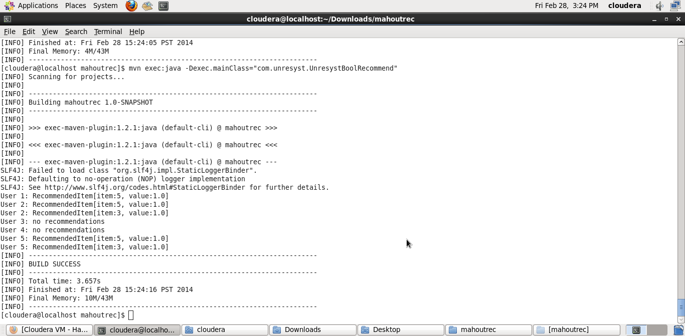

After adding our own data sets it gives a different result as follows

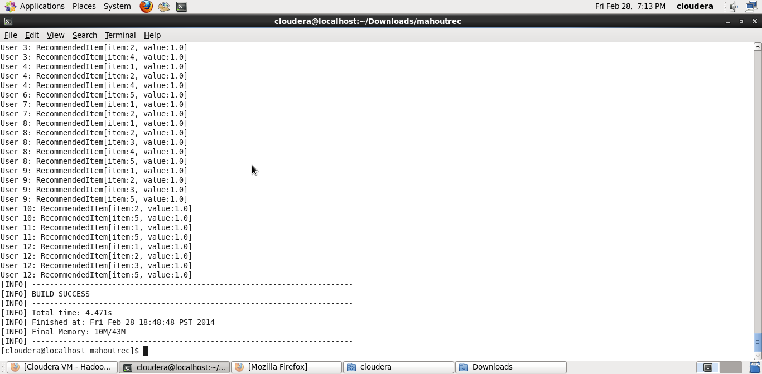

Successfully installed Solr

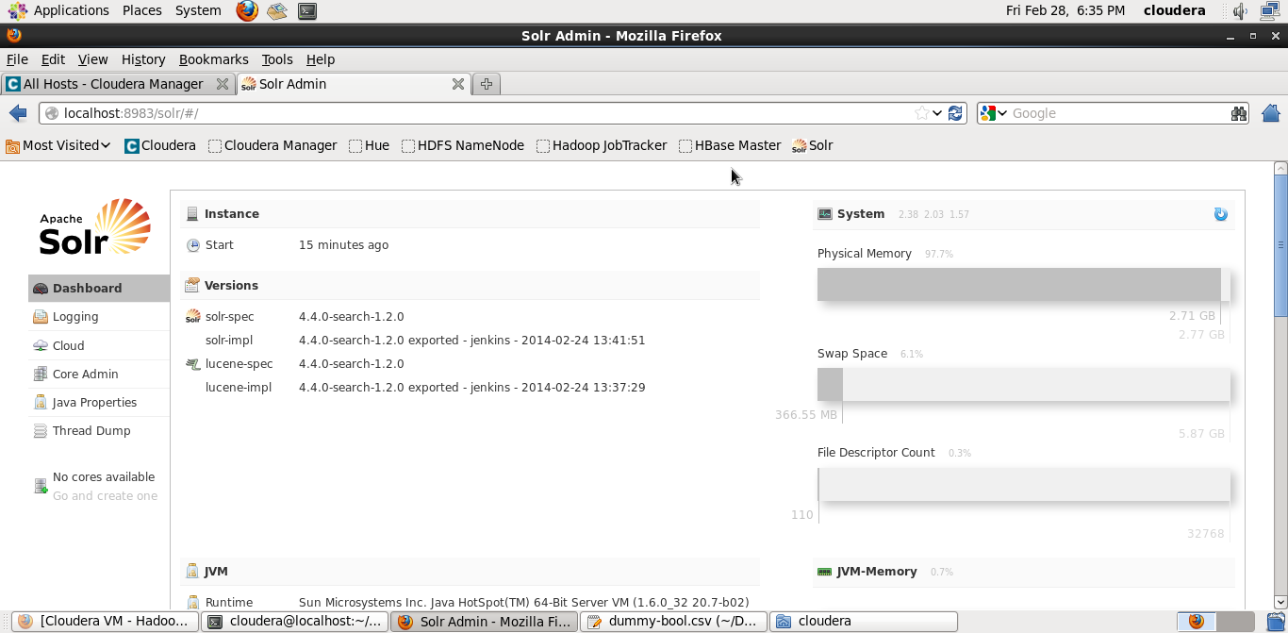

Data sets in Solr

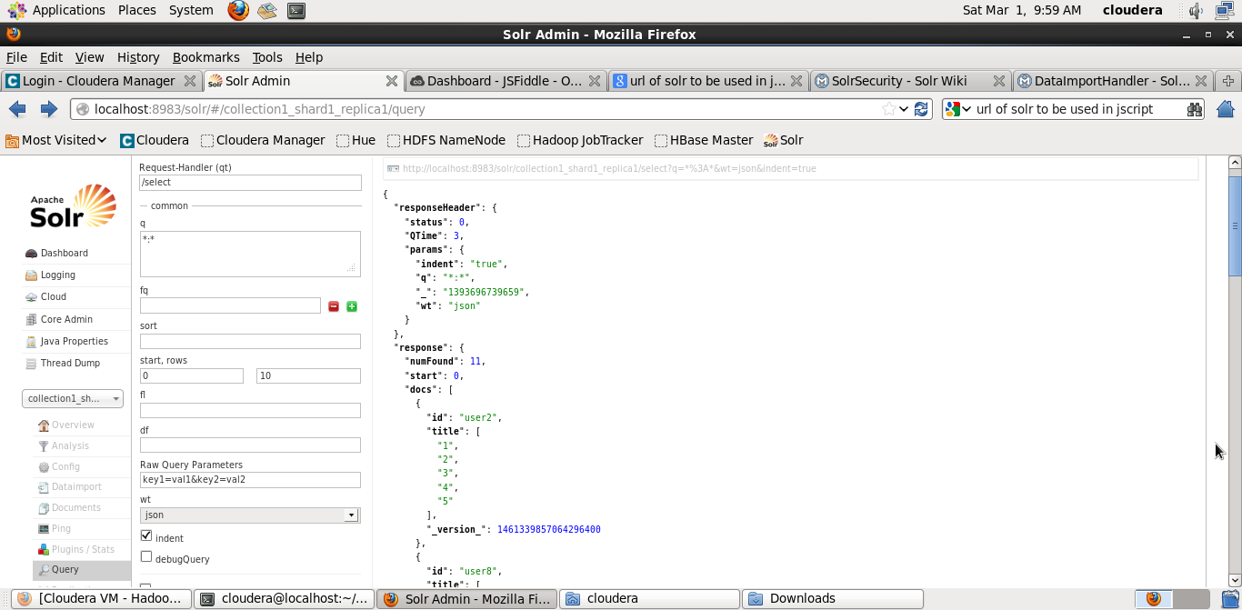

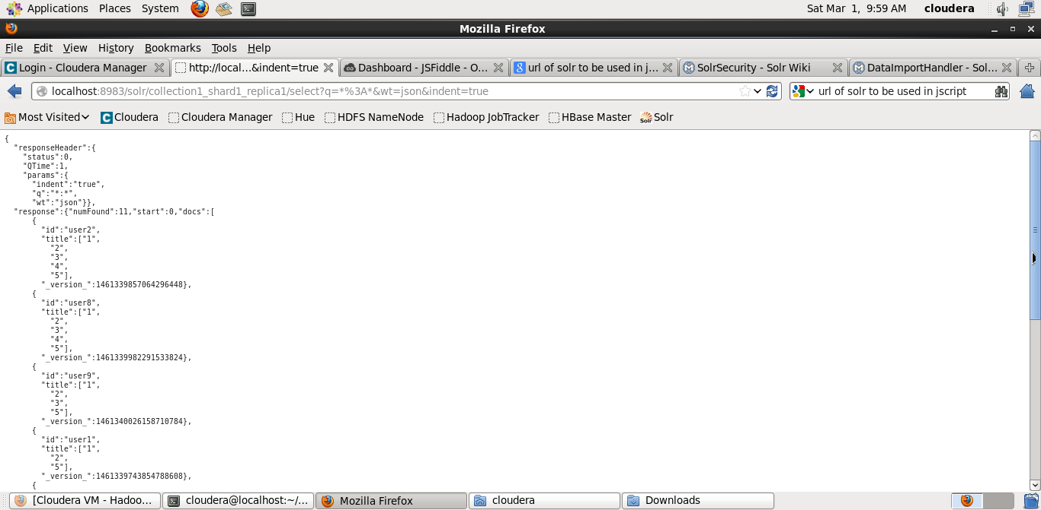

I then created a web page on jsfiddle with a text box which takes user Id as input and then gives the recommender values as output.

