Knowledge Discovery

and

Management

Assignment (LAB1)

**1: ER Diagram and Class Diagram**

ClassDiagram :

In the class diagram let us think a family has a person and that person has few males and females so they are in aggregation relationship .Further the males and females has fathers and mothers which are also in aggregation .They both depend on each other after getting married so there is an dependency relationship. The Child gets inherited from father and mother so it has a inheritance relationship



**ER Diagram:**

The below ER diagram can be used to solve the given problem. The main entity from where the ER schema starts is the Person entity which has Name, Gender, PersonId, DateofBirth as its own attributes . Person can be defined as Male and Female whose relationship is many to many . Males can be further defined as father similar to females where that can be derived as Mother and become as parent after giving birth to a child. For each father and mother they can have many children so the relationship is 1 to many (1:m) . In most of the cases only one Marriage occurs between a male and female so the relationship is 1to1.



(2). **Create a GitHub account:**

**My Github Main Page:**

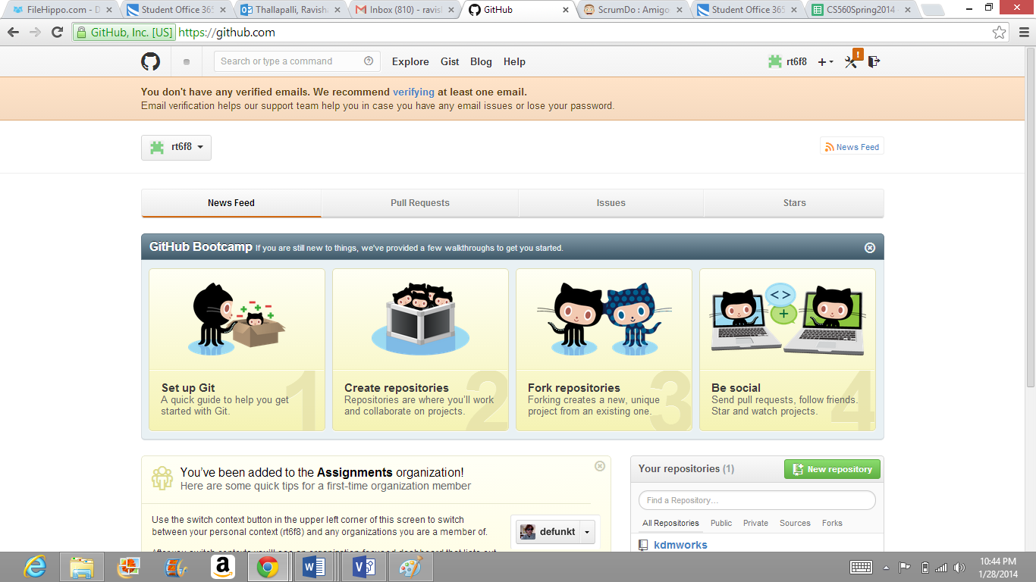

**GITHUB-LOCAL REPOSITORY:**

The below screenshot describes the necessary files that are shared in GITHUB .

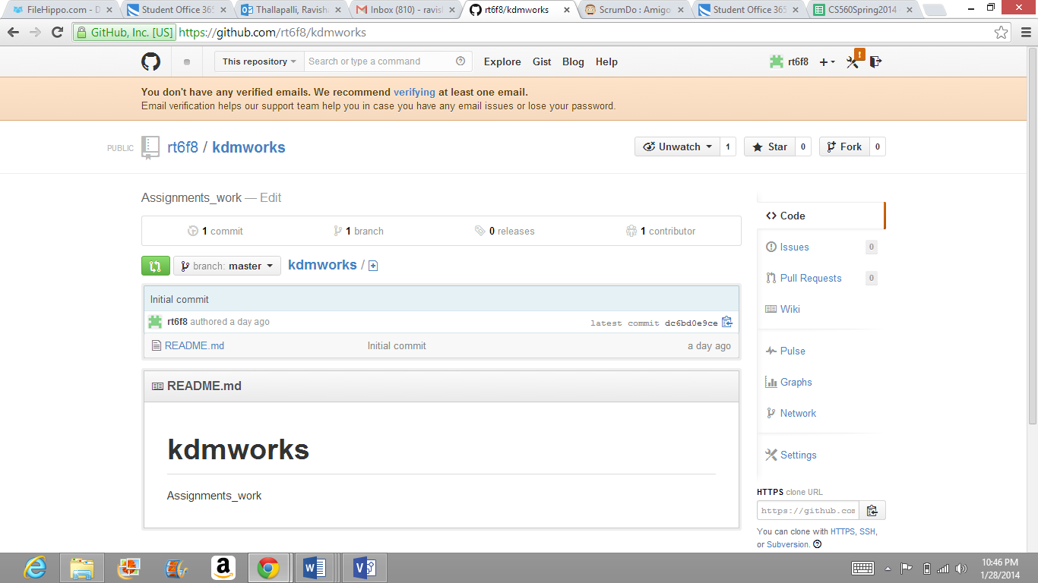

**GITHUB-ORGANIZATION:**

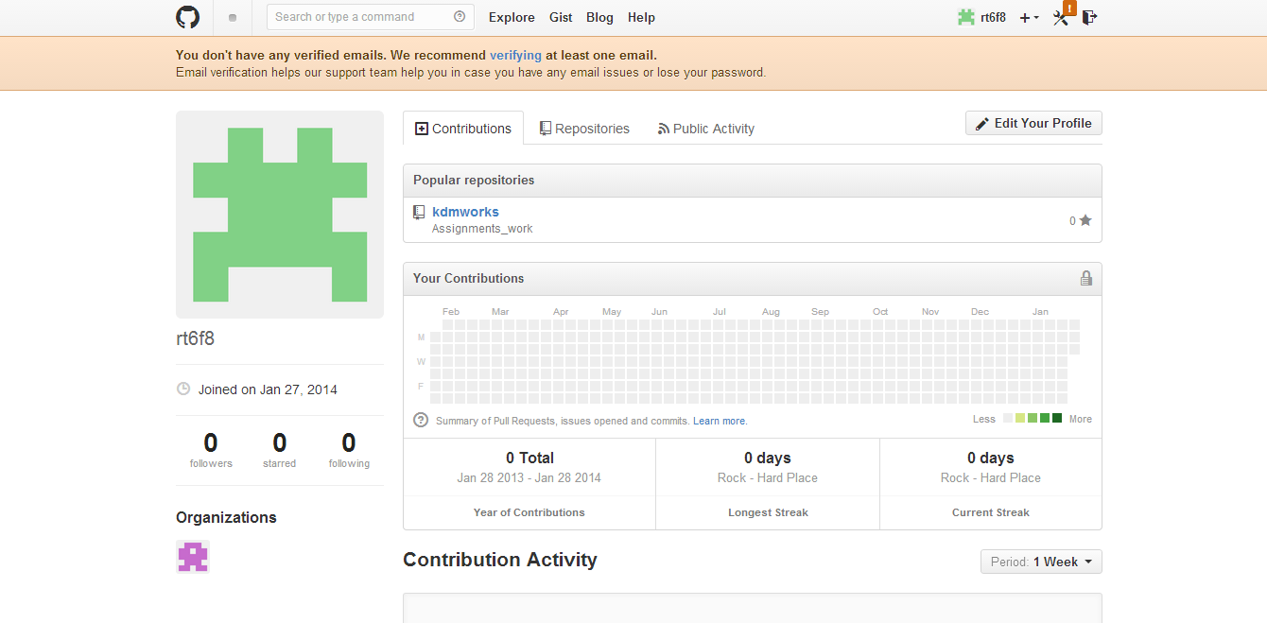

(3). **Create a ScrumDo account and define task/plan/delivery for your lab 1 assignment:**

**1. ScrumDo account page:**

Created a Srumdo account and created a project in it. These are the different tasks which can be done in scrumdo.

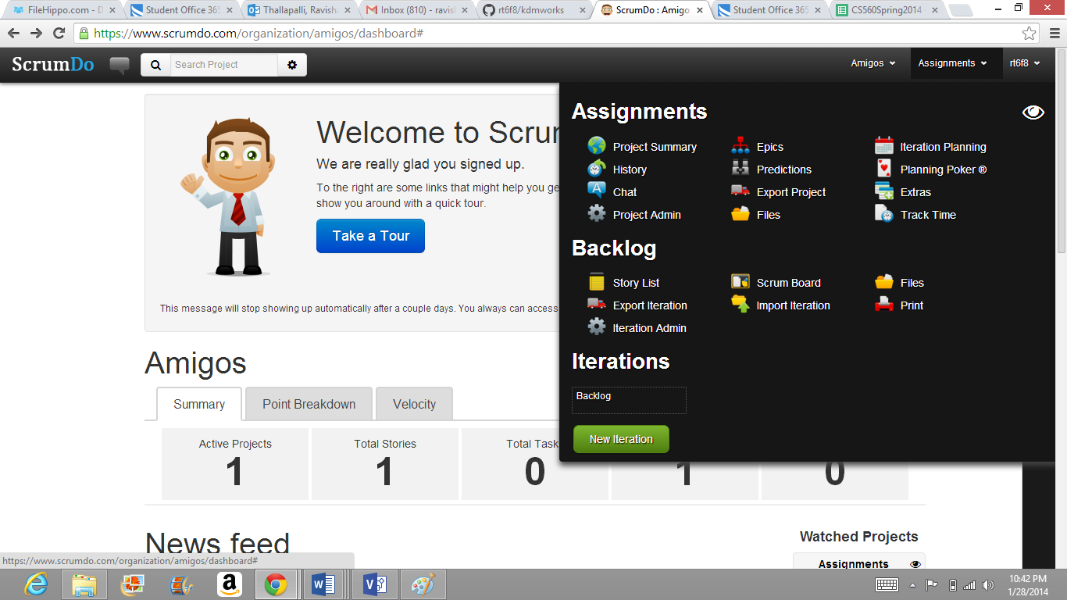

**(2) Scrum-do Iteration Page**

Completed the scrum project task which goes throudh the following stages.

