Knowledge Discovery

and

Management

Assignment (LAB2)

1. **Coding**

**HTML Code**

<div data-role="page" id="page1">

<div data-role="header" data-theme="b" class="hn-wrapper ui-bar-b" style="color:purple" >

<h1> Easy Search </h1>

</div>

<div style="width:50%; float:left">

<a href="#Images" data-transition="flow"><button >Images</button></a>

<a href="#Videos" data-transition="flow"><button>Videos</button></a>

</div>

<div style="width:50%;float:right">

<a href="#Location" data-transition="flow"><button>Location</button></a>

<a href="#Graphics"data-transition="flow"><button>Graphics</button></a>

</div>

</div>

<div data-role="page" id="Images">

<div data-role="header" data-theme="b" class="hn-wrapper ui-bar-b" style="color:black" >

<h1> Images </h1>

<a data-rel="back" data-icon="home">Home</a>

</div>

<br>

<br>

<br> <a href="#UMKC" data-rel="popup">

<center><img src="http://cdn0.sbnation.com/imported_assets/627405/logo-umkc-kangaroos-350.s600x600.jpg" width="200" height="100"/></center>

<p><center>UMKC</center></p>

</a>

<div data-role="popup" id="UMKC" >

<iframe src="http://cdn0.sbnation.com/imported_assets/627405/logo-umkc-kangaroos-350.s600x600.jpg" width="497" height="398" >

</iframe>

</div>

<a href="#UmkcCampus" data-rel="popup">

<center><img src="http://www.umkc.edu/finadmin/cfm/images/campus-aerial.JPG"width="200" height="100"/></center>

<p><center>UMKC Campus</center></p>

</a>

<div data-role="popup" id="UmkcCampus" >

<iframe src="http://www.umkc.edu/finadmin/cfm/images/campus-aerial.JPG" width="497" height="398" >

</iframe>

</div>

</div>

<div data-role="page" id="Videos">

<div data-role="header" data-theme="b" class="hn-wrapper ui-bar-b" style="color:purple" >

<h1> Videos </h1>

<a data-rel="back" data-icon="home">Home</a>

</div>

<p>Windows 8

<br/>

</p>

<embed

width="420" height="345"

src="http://youtu.be/aoSzDTmOlgM"

type="application/x-shockwave-flash">

</embed>

</div>

</div>

</div>

<div data-role="page" id="Location">

<div data-role="header" data-theme="b" class="hn-wrapper ui-bar-b" style="color:purple" >

<h1> Location </h1>

<a data-rel="back" data-icon="home">Home</a>

</div>

<script type="text/javascript" src="http://maps.google.com/maps/api/js?sensor=false"></script>

<script type="text/javascript" src="http://google-maps-utility-library-v3.googlecode.com/svn/trunk/infobox/src/infobox.js"></script>

<script type="text/javascript">

function initialize() {

var loc, map, marker, infobox;

loc = new google.maps.LatLng(-33.890542, 151.274856);

map = new google.maps.Map(document.getElementById("map"), {

zoom: 12,

center: loc,

mapTypeId: google.maps.MapTypeId.ROADMAP

});

marker = new google.maps.Marker({

map: map,

position: loc,

visible: true

});

infobox = new InfoBox({

content: document.getElementById("infobox"),

disableAutoPan: false,

maxWidth: 150,

pixelOffset: new google.maps.Size(-140, 0),

zIndex: null,

boxStyle: {

background: "url('http://google-maps-utility-library-v3.googlecode.com/svn/trunk/infobox/examples/tipbox.gif') no-repeat",

opacity: 0.75,

width: "280px"

},

closeBoxMargin: "12px 4px 2px 2px",

closeBoxURL: "http://www.google.com/intl/en_us/mapfiles/close.gif",

infoBoxClearance: new google.maps.Size(1, 1)

});

google.maps.event.addListener(marker, 'click', function() {

infobox.open(map, this);

map.panTo(loc);

});

}

google.maps.event.addDomListener(window, 'load', initialize);

</script>

<title>Creating and Using an InfoBox</title>

</head>

<body>

<div id="map" style="width: 100%; height: 300px"></div>

<br>

InfoBox as an easily customizable replacement for an InfoWindow. Click on the marker to see the infobox generated with custom html &amp; css.

<div class="infobox-wrapper">

<div id="infobox">

The contents of your info box. It's very easy to create and customize.

</div>

</div>

</div>

<div data-role="page" id="Weather">

<div data-role="header" data-theme="b" class="hn-wrapper ui-bar-b" style="color:purple" >

<h1> Weather </h1>

<a data-rel="back" data-icon="home">Home</a>

</div>

</div>

<div data-role="page" id="Graphics">

<div data-role="header" data-theme="b" class="hn-wrapper ui-bar-b" style="color:purple" >

<h1> Animation</h1>

<a data-rel="back" data-icon="home">Home</a>

<div class="star">★<br /><span>click me</span></div>

</div>

</div>

**JQuery**

----Animation

$('a').buttonMarkup({ icon: "star" });

-----header color

$('.ui-bar-b').css('background-image', '-moz-linear-gradient(top,

#00009d,

#00578e);');

**CSS**

keyframes 'bg-animation' {

0% {

background: #C9C9C9;

}

50% {

background: #61BE50;

}

100% {

background: #C9C9C9;

}

}

@-webkit-keyframes 'bg-animation' {

0% {

background: #C9C9C9;

}

50% {

background: #61BE50;

}

100% {

background: #C9C9C9;

}

}

.star {

font-size: 40px;

background: #C9C9C9;

padding: 20px;

width: 100px;

text-align: center;

border-radius: 6px;

margin: 0 auto;

cursor: pointer;

line-height: 20px;

}

.star:hover {

background: #959595;

color: #FFF;

animation-name: 'bg-animation';

animation-duration: 2s;

animation-iteration-count: infinite;

-webkit-animation-name: 'bg-animation';

-webkit-animation-duration: 2s;

-webkit-animation-iteration-count: infinite;

}

.star span {

font-size: 16px;

font-weight: bold;

}

.infobox-wrapper {

display:none;

}

#infobox {

border:2px solid black;

margin-top: 8px;

background:#333;

color:#FFF;

font-family:Arial, Helvetica, sans-serif;

font-size:12px;

padding: .5em 1em;

-webkit-border-radius: 2px;

-moz-border-radius: 2px;

border-radius: 2px;

text-shadow:0 -1px #000000;

-webkit-box-shadow: 0 0 8px #000;

box-shadow: 0 0 8px #000;

}

.infobox-wrapper {

display:none;

}

#infobox {

border:2px solid black;

margin-top: 8px;

background:#333;

color:#FFF;

font-family:Arial, Helvetica, sans-serif;

font-size:12px;

padding: .5em 1em;

-webkit-border-radius: 2px;

-moz-border-radius: 2px;

border-radius: 2px;

text-shadow:0 -1px #000000;

-webkit-box-shadow: 0 0 8px #000;

box-shadow: 0 0 8px #000;

}

1. **Screen shots**

Home page

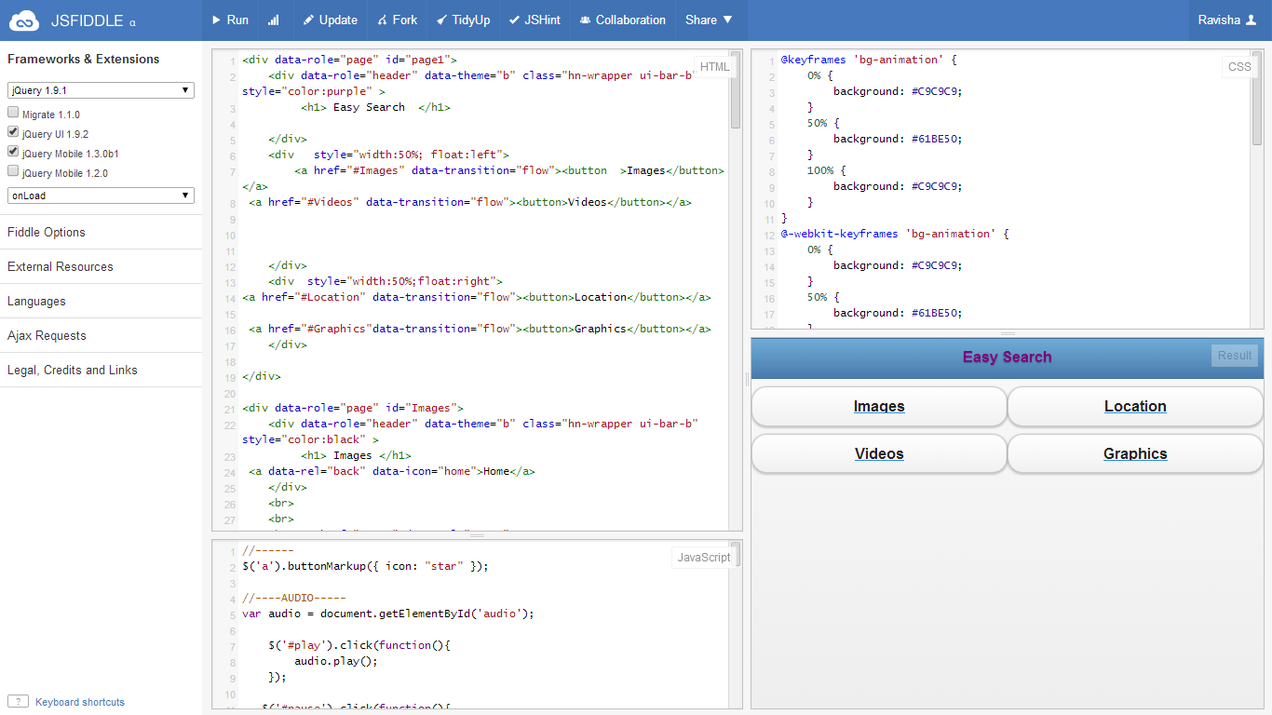

Images Page

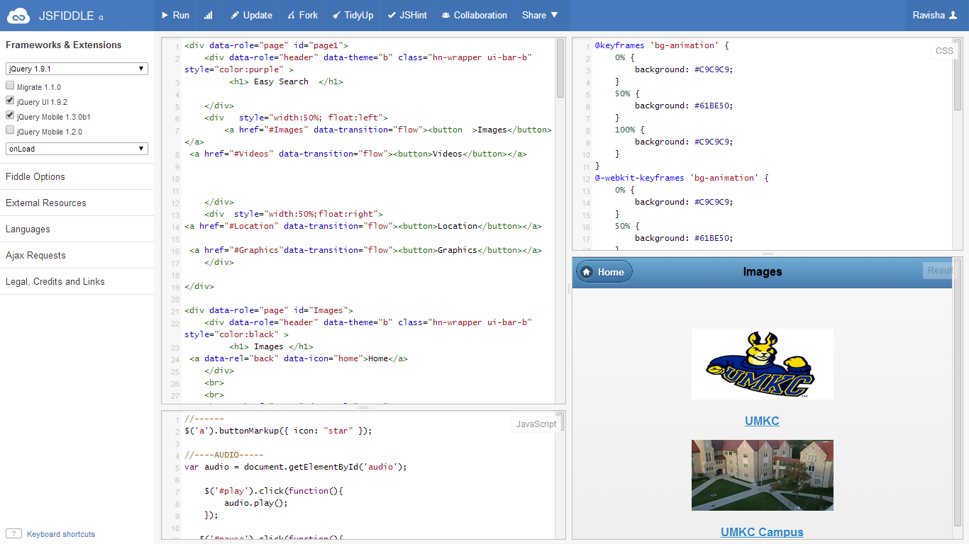

Location Page

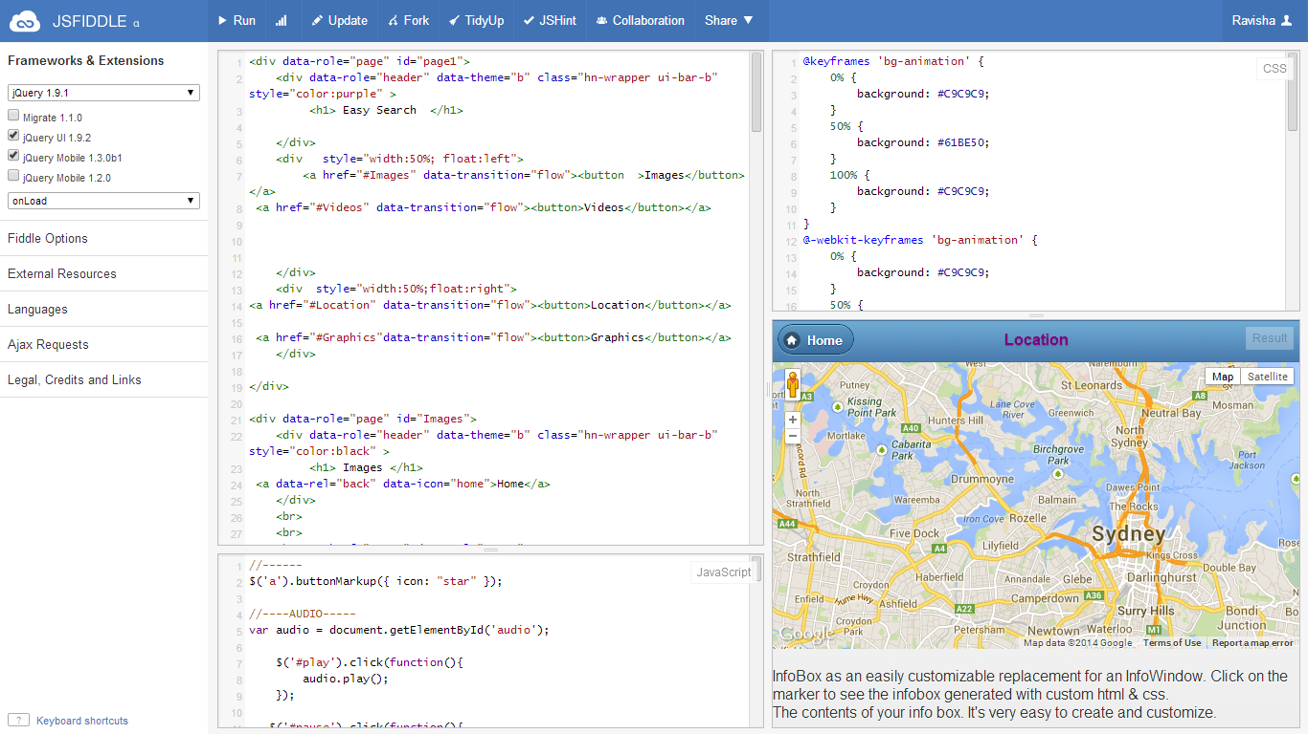

**Graphics Page**

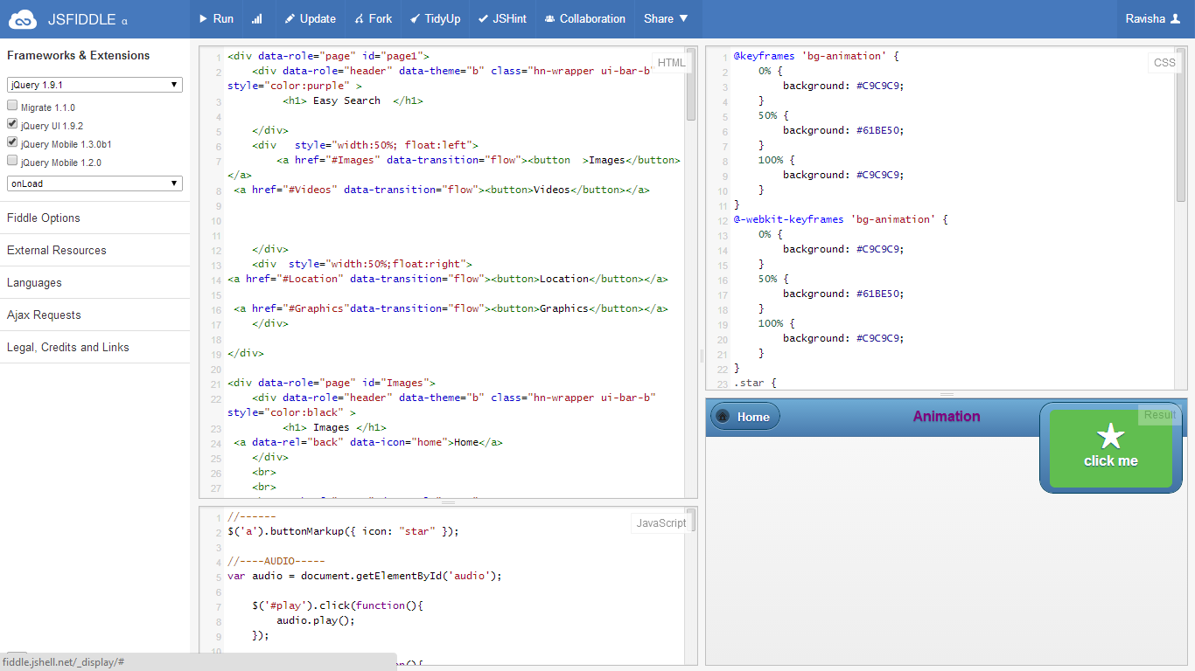

Videos Page

