**Module 4: Critical Thinking**

**Common Personality Traits**

Ryan Thompson

Colorado State University - Global

CSC 505

Dr. Gonzalez

9 July 2024

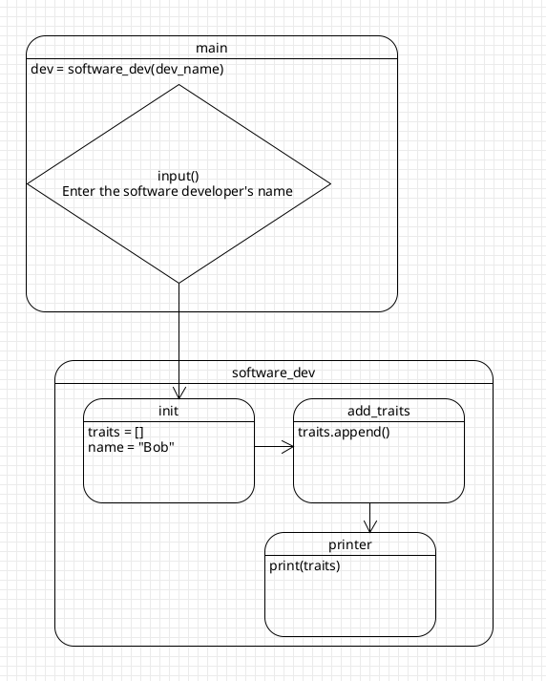

*Traits UML Diagram*

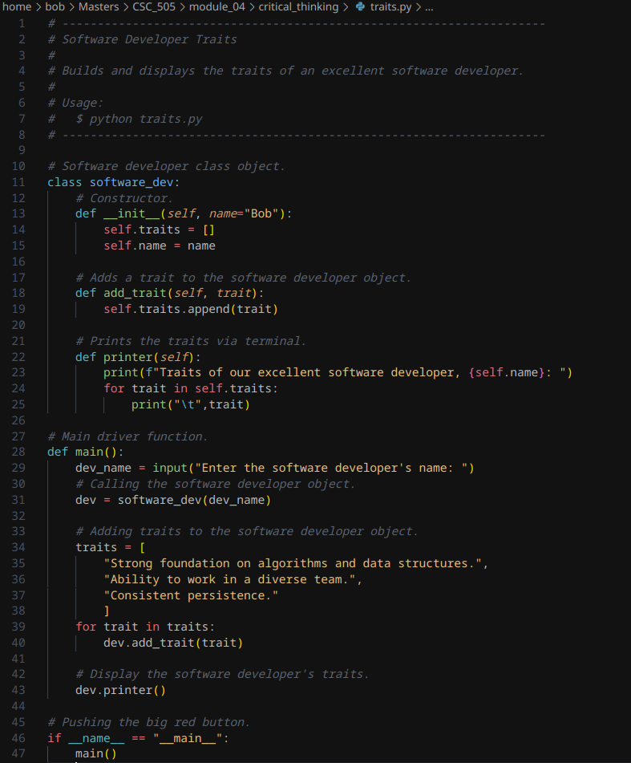

*Traits Python Script*

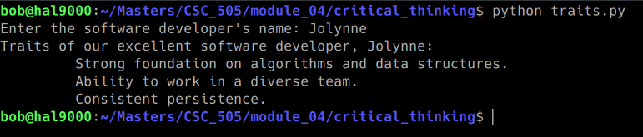

*Traits Script Output*

**References**

*Top characteristics of a software engineer*. RSS. (n.d.). https://www.wearedevelopers.com/magazine/characteristics-of-a-software-engineer-strengths-and-traits

Tikayatray, L. (2023, September 24). *6 powerful traits that can make any software developer successful*. lokajittikayatray. https://www.lokajittikayatray.com/post/6-powerful-traits-that-can-make-any-software-developer-successful