**Module 8: Portfolio Project**

Ryan Thompson

Colorado State University - Global

CSC 505

Dr. Gonzalez

4 August 2024

**Lessons Learned Reflection**

This course, Principles of Software Development, has been a foundational pillar in my journey through computer science. As I reflect on the lessons learned from this class, it is clear that it has not only broadened my technical skills but also reshaped my approach to problem-solving and logical reasoning.

One of the primary lessons from this course was the importance of grasping fundamental programming concepts. Before diving into complex algorithms or advanced programming languages, this course emphasized the need to build a strong foundation. Concepts such as variables, control structures, data types, and functions were introduced in a structured manner, thus allowing myself to see how these building blocks fit together to create functional code. This approach underscored the significance of understanding the basics before progressing to more complex topics.

This course highlighted that programming is fundamentally about problem-solving. Through various assignments and projects, I learned to break down complex problems into smaller, manageable parts. The emphasis on algorithmic thinking and logical flow taught me to approach problems methodically. For instance, exercises involving sorting and searching algorithms illustrated how different approaches can impact performance and efficiency. These lessons reinforced the idea that finding the right solution often requires a thoughtful and systematic approach.

Another critical lesson from this course was the importance of debugging and testing. Initially, encountering errors and bugs in my code was a source of frustration. However, the course taught me that debugging is not merely about fixing errors but about understanding why they occurred in the first place. Through iterative testing and debugging practices, I learned to identify, isolate, and resolve issues more effectively. This process has improved my patience and attention to detail, skills that are invaluable in any programming task.

Documentation emerged as a key takeaway from the course. Writing clear and concise documentation for code not only facilitates understanding for others but also helps in maintaining and updating the code in the future. Through various assignments, I learned that well-documented code is an essential practice that enhances readability and usability. This lesson will undoubtedly influence my approach to coding in future projects, as I now appreciate how good documentation can prevent confusion and errors.

As I move forward in my studies and career, the lessons from this Principles of Software Development course will serve as a guiding framework. The foundational knowledge and problem-solving skills I've developed will be instrumental as I tackle more advanced topics and real-world programming challenges. The course has not only equipped me with technical skills but has also fostered a mindset of continuous learning and improvement.

In conclusion, this Principles of Software Development course has been a transformative experience. It has provided me with a solid grounding in programming fundamentals, improved my problem-solving abilities, and taught me the importance of debugging, documentation, and ethical considerations. These lessons will undoubtedly shape my approach to programming and contribute to my growth as a developer.

**Synopsis**

The source code or script found in this folder provides a basic terminal-based ATM simulation. I would like to add a graphical user interface, however, the simulation is currently only running via terminal. The script takes in and stores a PIN, entered by the user. Then moves on to check if the given PIN is valid. Finally, depending if the PIN is valid or not, the ATM pulls up the account balance or displays the message “Incorrect PIN”. If the user has not had too many failed login attempts, the ATM will essentially restart and ask the user to enter a PIN. If the user enters an incorrect PIN too many times, then the account is blocked.

**Figures**

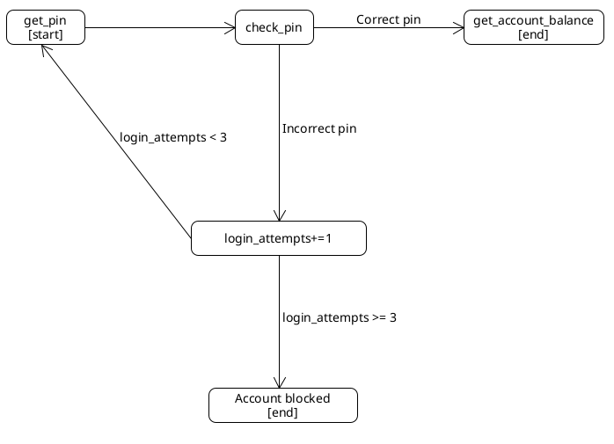

*ATM UML Diagram*

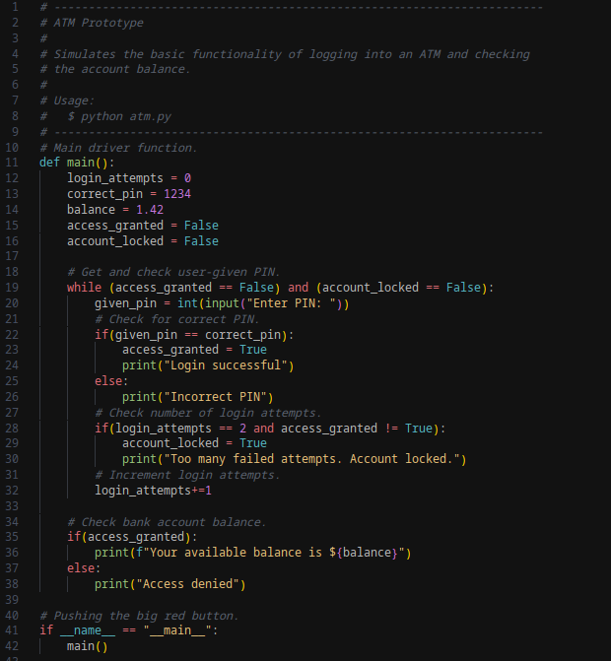

*ATM Python Script*

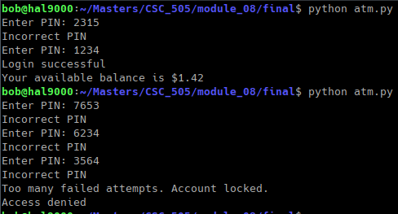

*ATM Script Output*

**References**

Panchal, H. (2023, May 25). *The benefits of coding: How it enhances problem-solving skills*. LinkedIn. https://www.linkedin.com/pulse/benefits-coding-how-enhances-problem-solving-skills-hemant-panchal/

Sonmez, J. (2018, January 10). *How to solve programming problems*. Simple Programmer. https://simpleprogrammer.com/solving-problems-breaking-it-down/

*16 basic principles of coding every programmer must know - hapy co*. A Product Building Agency. (2024, June 28). https://hapy.co/journal/principles-of-coding/

*UML diagrams: What are they and how to use them*. MiroBlog. (2024, July 17). https://miro.com/blog/uml-diagram/#:~:text=Most%20commonly%2C%20a%20UML%20diagram,UML%20diagram%20is%20incredibly%20helpful.