**Module 1: Critical Thinking**

**Linear Search**

Ryan Thompson

Colorado State University - Global

CSC 506

Dr. Holbert

1 September 2024

**Linear Search**

The linear search algorithm is one of the simplest and most straightforward methods for searching through a list of elements. It operates by sequentially checking each element in the list until the target element is found or the list is exhausted. Despite its simplicity, linear search has practical applications in various scenarios, especially when dealing with small or unsorted data sets.

The primary purpose of the linear search algorithm is to locate a specific value within a list. It is a fundamental algorithm used in scenarios where data is not organized in a specific order, or when the overhead of more complex algorithms is not justified. Linear search is particularly useful for certain lists, datasets, and simple implementations. When the data is not sorted in a given unsorted list, linear search is often the only straightforward approach. For small datasets, or small lists, the performance overhead of more advanced algorithms may not be necessary. Due to linear search’s ease of implementation makes it a good educational tool for understanding basic search principles.

The linear search algorithm follows a few simple steps. Linear search starts at the beginning. At which point, it initializes a position at the start of the list. Then continues to sequentially check each of the elements, comparing the current element with the target value. Once the element with the target value is located, the algorithm returns the position or index of the element. If the target value is not found after checking all elements, it returns an indication that the value is not present in the list.

In conclusion, the linear search algorithm, while simple and sometimes inefficient for large datasets, plays a crucial role in the study and application of search algorithms. Its straightforward nature makes it an excellent starting point for understanding more complex algorithms and their applications.

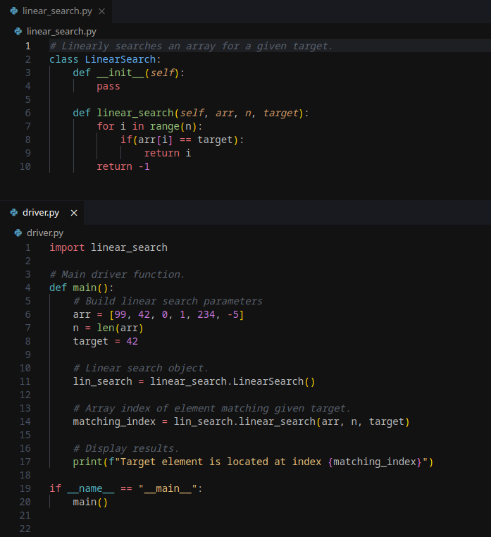

*Linear Search Source Code*

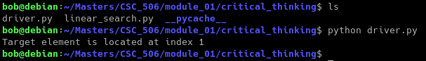*Linear Search Program Output*

**References**

Cormen, T. H., Leiserson, C. E., Rivest, R. L., & Stein, C. (2009). *Introduction to Algorithms* (3rd ed.). MIT Press.

Knuth, D. E. (1998). *The Art of Computer Programming, Volume 1: Fundamental Algorithms* (3rd ed.). Addison-Wesley.