**Module 3: Critical Thinking**

**Bubble Sort & Merge Sort**

Ryan Thompson

Colorado State University - Global

CSC 506

Dr. Holbert

14 September 2024

When comparing bubble sort and merge sort, two fundamental sorting algorithms, it is essential to examine their efficiency, complexity, and practical applicability to understand their respective strengths and weaknesses.

Bubble sort is a straightforward comparison-based algorithm known for its simplicity. The algorithm repeatedly steps through the list to be sorted, compares adjacent elements, and swaps them if they are in the wrong order. This process continues until the list is sorted (Weiss, 2014). Despite its ease of implementation, bubble sort has significant limitations. Its time complexity is O(n²), where n is the number of elements to be sorted (Knuth, 1998). This quadratic complexity arises because, in the worst case, it requires a number of comparisons and swaps proportional to the square of the number of elements. As a result, bubble sort becomes inefficient for large datasets, making it impractical for use in scenarios where performance is critical. However, bubble sort has the advantage of being an in-place algorithm, meaning it requires only a small, constant amount of additional memory space, and it can be optimized to stop early if the list becomes sorted before all passes are completed (Sedgewick & Wayne, 2011).

In contrast, merge sort is a more advanced, divide-and-conquer algorithm with superior efficiency. The algorithm works by recursively dividing the list into two halves until each sublist contains a single element or is empty, then merging these sublists in a sorted manner to produce the final sorted list (Cormen et al., 2009). Merge sort has a time complexity of O(n log n), which is significantly more efficient than bubble sort for large datasets. This logarithmic factor arises from the way merge sort splits the list and the linear time required to merge sorted sublists. Merge sort's performance advantage makes it a preferred choice for applications involving large datasets or where predictable performance is crucial (Sedgewick & Wayne, 2011). However, merge sort is not an in-place algorithm; it requires additional space proportional to the size of the input list for the temporary storage of sublists during the merging process (Knuth, 1998).

In summary, while bubble sort is conceptually simpler and more suited for educational purposes or small datasets, its inefficiency with larger datasets limits its practical use. Merge sort, on the other hand, offers a robust and efficient solution for sorting large lists, albeit with a higher memory requirement. The choice between these algorithms depends largely on the specific needs of the application, including the size of the data set and memory constraints.

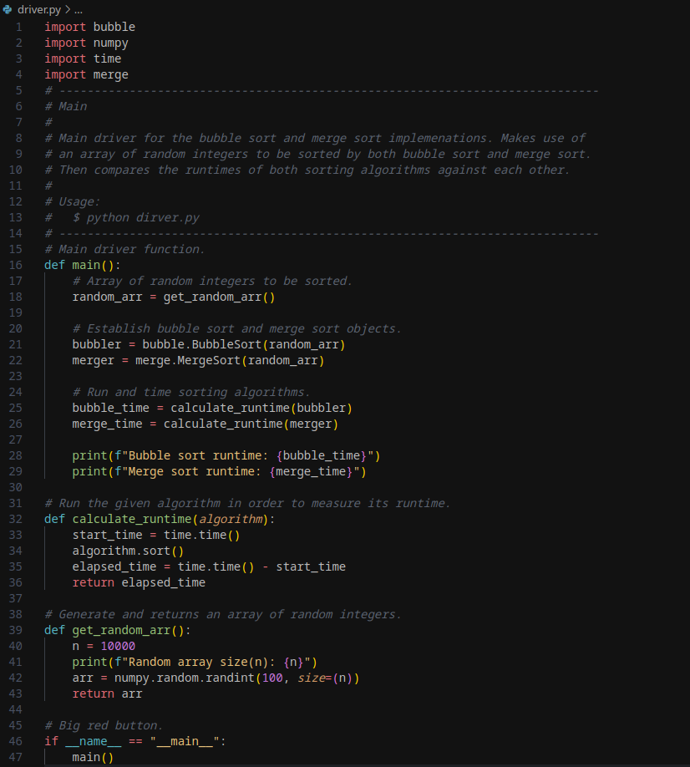

*Main Driver Script*

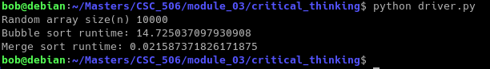

*Program Output*

**References**

Cormen, T. H., Leiserson, C. E., Rivest, R. L., & Stein, C. (2009). Introduction to Algorithms (3rd ed.). MIT Press.

Knuth, D. E. (1998). The Art of Computer Programming, Volume 3: Sorting and Searching (2nd ed.). Addison-Wesley.

Sedgewick, R., & Wayne, K. (2011). Algorithms (4th ed.). Addison-Wesley.

Weiss, M. A. (2014). Data Structures and Algorithm Analysis in C++ (4th ed.). Pearson.