**Module 6: Portfolio Milestone**

**Sorting Algorithms**

Ryan Thompson

Colorado State University - Global

CSC 506

Dr. Holbert

20 September 2024

**Sorting Algorithms**

Sorting algorithms are fundamental to computer science, enabling efficient data organization for search and retrieval operations. This paper analyzes the time and space complexity of five common sorting algorithms: Bubble Sort, Merge Sort, Quick Sort, Insertion Sort, and Selection Sort, highlighting their strengths and weaknesses.

### **Time Complexity**

Time complexity refers to the amount of time an algorithm takes to complete as a function of the length of the input. The algorithms in question exhibit distinct time complexities, influencing their performance in different scenarios.

Bubble Sort is a simple comparison-based algorithm with a worst-case time complexity of $O(n^{2})$. This occurs because, in the worst case, the algorithm makes $n-1$ passes over the array, comparing adjacent elements. The average-case complexity remains $O(n^{2})$, making Bubble Sort inefficient for large datasets. However, its best-case scenario, where the array is already sorted, achieves $O(n)$ due to the ability to terminate early if no swaps are made during a pass.

Insertion Sort also has a worst-case time complexity of $O(n^{2})$, which arises when elements are sorted in reverse order. Its best-case time complexity is $O(n)$ as well, occurring when the elements are already sorted or nearly sorted. Insertion Sort is particularly efficient for small datasets or lists that are almost sorted, as it builds the sorted list incrementally.

Selection Sort, like the previous two, has a time complexity of $O(n^{2})$ for the worst, average, and best cases. This is due to its method of selecting the smallest (or largest) element from the unsorted portion of the list and placing it at the beginning. Although it performs fewer swaps than Bubble Sort, it remains inefficient for large datasets.

Merge Sort introduces a significant improvement with a time complexity of $O(n log(n))$ in all cases (worst, average, and best). This divide-and-conquer algorithm recursively divides the array into halves, sorts each half, and then merges them back together. Its consistent performance makes it a preferred choice for larger datasets.

Quick Sort also boasts an average and best-case time complexity of $O(n log(n))$. However, its worst-case complexity is $O(n^{2})$, which occurs when the pivot selection is poor (e.g., always picking the smallest or largest element in a sorted array). By utilizing techniques like randomized pivot selection or median-of-three, Quick Sort can typically mitigate this issue, making it one of the fastest sorting algorithms in practice.

### **Space Complexity**

Space complexity measures the amount of memory an algorithm uses in relation to the input size. Bubble Sort, Insertion Sort, and Selection Sort all exhibit $O(1)$ space complexity since they sort the array in place and require only a constant amount of additional memory for variables. This characteristic makes them advantageous in environments with limited memory.

In contrast, Merge Sort has a space complexity of $O(n)$ due to the need for additional arrays to hold the divided elements during the merge process. This increased space requirement can be a disadvantage in memory-constrained situations.

Quick Sort has a space complexity of $O(log(n))$ when using an in-place partitioning method. However, in the worst-case scenario, it may require $O(n)$ space if the recursion depth is equal to the number of elements. This makes Quick Sort relatively efficient regarding space compared to Merge Sort, especially when the algorithm is optimized.

### **Strengths and Weaknesses**

Each sorting algorithm possesses distinct strengths and weaknesses. Bubble Sort, while easy to implement and understand, is largely impractical for anything beyond small datasets due to its inefficiency. Its best-case scenario provides some merit in specific cases where input data is nearly sorted.

Insertion Sort is efficient for small lists or partially sorted datasets, making it useful in practice despite its $O(n^{2})$ time complexity in the worst case. It is often used in conjunction with more complex algorithms for smaller subarrays.

Selection Sort is straightforward and has a predictable execution time; however, its $O(n^{2})$ time complexity limits its use to smaller datasets. It is less efficient than Insertion Sort in practical scenarios.

Merge Sort stands out for its consistent $O(n log(n))$ performance across different scenarios, making it suitable for large datasets. Its main drawback is the $O(n)$ space complexity, which can be prohibitive.

Quick Sort, with its average-case efficiency, is often the go-to algorithm for large datasets. Its adaptive nature allows for optimizations that can significantly enhance performance. However, its worst-case scenario can lead to inefficiencies, which necessitates careful implementation to avoid.

### **Conclusion**

In summary, the choice of sorting algorithm depends on the specific requirements of the task at hand, including the size of the dataset and the constraints on time and space. While simpler algorithms like Bubble, Insertion, and Selection Sort have their places, they are generally outperformed by more complex algorithms like Merge and Quick Sort for larger datasets. Understanding the nuances of each algorithm is crucial for effective implementation and optimization in various applications.

[*Program Demo*](https://drive.google.com/file/d/1hjg3O-vby36z2rD1E-urjGOYBf0k7jNK/view?usp=drive_link)

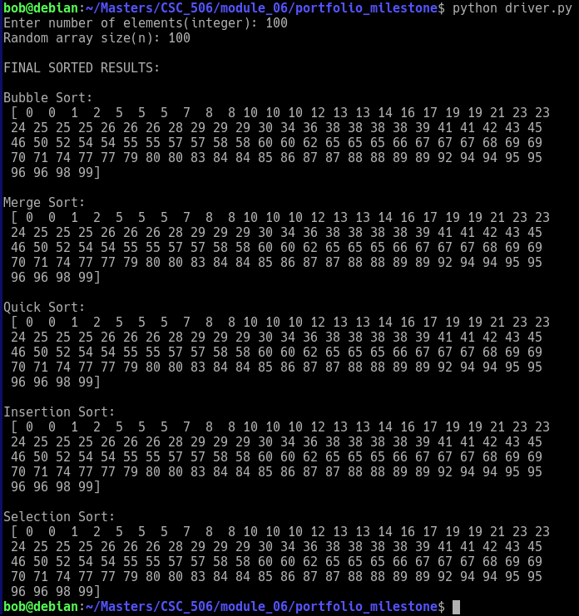

*Program Output*

### 

### **References**

Cormen, T. H., Leiserson, C. E., Rivest, R. L., & Stein, C. (2009). *Introduction to Algorithms* (3rd ed.). MIT Press.

Knuth, D. E. (1998). *The Art of Computer Programming, Volume 3: Sorting and Searching* (2nd ed.). Addison-Wesley.

Sedgewick, R., & Wayne, K. (2011). *Algorithms* (4th ed.). Addison-Wesley.