Module 8: Portfolio Project

Ryan Thompson

Colorado State University - Global

CSC 506

Dr. Holbert

6 October 2024

### Introduction

### Sorting algorithms are fundamental to computer science and data management, as they provide efficient ways to arrange data in a specified order. Whether in searching algorithms, databases, or real-time systems, understanding the strengths and weaknesses of different sorting methods is critical. This project focused on the implementation and analysis of five widely-known sorting algorithms: Bubble Sort, Merge Sort, Insertion Sort, Quick Sort, and Selection Sort. The main objectives were to evaluate their time complexity, and efficiency. By understanding how each algorithm functions and performs, this project aimed to highlight which algorithms are best suited for particular data structures and problem contexts.

### Project Goals

### The primary goal of this project was to examine the design and performance characteristics of five distinct sorting algorithms. These algorithms were chosen for their simplicity and diverse approaches to sorting, ranging from simple comparison-based methods to more complex divide-and-conquer strategies. The project sought to compare these algorithms across several dimensions, such as time complexity and execution time.

### Methodology

### The project began with the selection of five sorting algorithms, each representing a different approach to sorting data. Bubble Sort, Merge Sort, Insertion Sort, Quick Sort, and Selection Sort were chosen based on their popularity and the distinct ways in which they tackle the problem of sorting.

### The first step in the methodology was implementing each sorting algorithm in Python. The algorithms were implemented using standard methods, which ensured consistency across implementations and allowed for a fair comparison. Bubble Sort, a simple comparison-based algorithm, was chosen for its educational value, even though it is inefficient for large datasets. Merge Sort, known for its divide-and-conquer strategy, was included due to its efficient $O(n log(n))$ time complexity. Insertion Sort, which builds the final sorted list incrementally, was chosen for its efficiency on small datasets. Quick Sort, also a divide-and-conquer algorithm, was included because of its generally good performance on average cases. Finally, Selection Sort, which repeatedly selects the smallest (or largest) element from the unsorted part of the array, was included for its simplicity and ease of understanding.

### Once the algorithms were implemented, they were tested on three different types of datasets: sorted data, reverse-sorted data, and random data. These datasets allowed for a comprehensive evaluation of the algorithms' performance in various scenarios. To measure performance, both time complexity analysis and actual execution times were recorded. Time complexity was analyzed theoretically, while execution times were recorded.

### Analysis

### The results of the analysis revealed significant differences in performance among the five algorithms. Each algorithm performed differently based on the nature of the input data, particularly in terms of time complexities.

### Bubble Sort, which has a time complexity of $O(n^{2})$ in both the average and worst-case scenarios, performed poorly, especially on large datasets. The simple mechanism of repeatedly swapping adjacent elements results in unnecessary comparisons, leading to inefficient sorting. In contrast, Merge Sort, with a time complexity of $O(n log(n))$ in all cases, consistently outperformed Bubble Sort, even on large datasets. Merge Sort’s divide-and-conquer approach efficiently handles large datasets, but it requires additional memory for the temporary arrays created during the merging process, which was a noted drawback.

### Insertion Sort performed best when the data was nearly sorted. Its best-case time complexity of $O(n)$ occurs when the data is already ordered, making it efficient for small datasets or nearly sorted data. However, like Bubble Sort, its time complexity grows quadratically in the average and worst cases. Quick Sort, while also a divide-and-conquer algorithm, showed significant variability in performance depending on the pivot selection strategy. When the pivot is chosen well, Quick Sort performs at $O(nlog(n))$, but in the worst case, it can degrade to $O(n^{2})$. Despite this, Quick Sort was often faster in practice due to its efficient partitioning strategy and in-place sorting, which reduces memory overhead.

### Selection Sort, like Bubble Sort, is a simple algorithm with a time complexity of $O(n^{2})$. Despite its simplicity, it was inefficient for large datasets and was slower than Merge and Quick Sort. However, one advantage of Selection Sort over Bubble Sort is that it does not require additional memory, making it an in-place sorting algorithm. This makes it useful when memory resources are limited, but its performance is still generally poor when compared to more advanced algorithms.

### Outcome

### The project revealed that no single sorting algorithm is optimal for all scenarios. For small datasets, Insertion Sort and Selection Sort may be sufficient, especially when memory usage is a concern. However, for larger datasets, Merge Sort and Quick Sort are preferable due to their superior time complexities and more efficient handling of data. Merge Sort is stable and consistent, making it ideal when the preservation of input order is crucial. Quick Sort, on the other hand, is generally faster in practice due to its in-place sorting, though its performance can degrade without a good pivot strategy.

### Bubble Sort and Selection Sort, while simple, are generally not suitable for practical use on large datasets due to their quadratic time complexities. Nonetheless, these algorithms are useful for educational purposes, as they help to demonstrate basic sorting principles.

### In conclusion, this project provided valuable insights into the practical performance of various sorting algorithms and their trade-offs. Understanding the theoretical time complexities and practical efficiencies of these algorithms helps guide their application in potential real-world scenarios.

[*Program Demo*](https://drive.google.com/file/d/1t53JTOSu2otmt2_SXPgJ16abScYLjoC8/view?usp=sharing)

*Program Output*

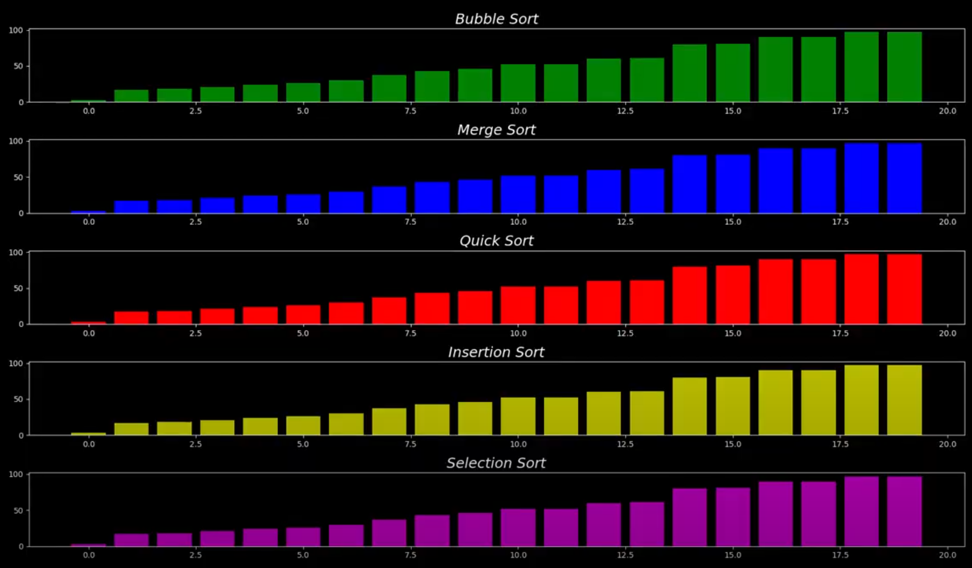

### 

### References

*Knuth, D. E. (1998). The Art of Computer Programming: Volume 3: Sorting and Searching (2nd ed.). Addison-Wesley.*

*Sedgewick, R., & Wayne, K. (2011). Algorithms (4th ed.). Addison-Wesley.*

*Sedgwick, R. (1983). Algorithms in C, Parts 1-4 (3rd ed.). Addison-Wesley.*