Module 1: Critical Thinking

Ryan Thompson

Colorado State University - Global

CSC 507

Dr. Farr

13 October 2024

Introduction

Various linux terminal emulator or shell commands can be used to display hardware information on your linux personal computer. In this case we will be using a BASH powered linux terminal. Therefore, the commands will be BASH commands as opposed to ZSH or other terminal shell commands.

Outputs

The *screenfetch* command displays the operating system, cpu, gpu, ram, software, and some simple storage statistics.

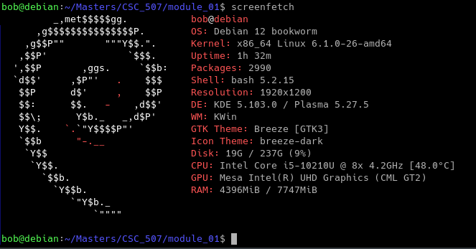

*screenfetch*

The *htop* command can be used to display informative cpu, io, general hardware/software, and ram statistics.

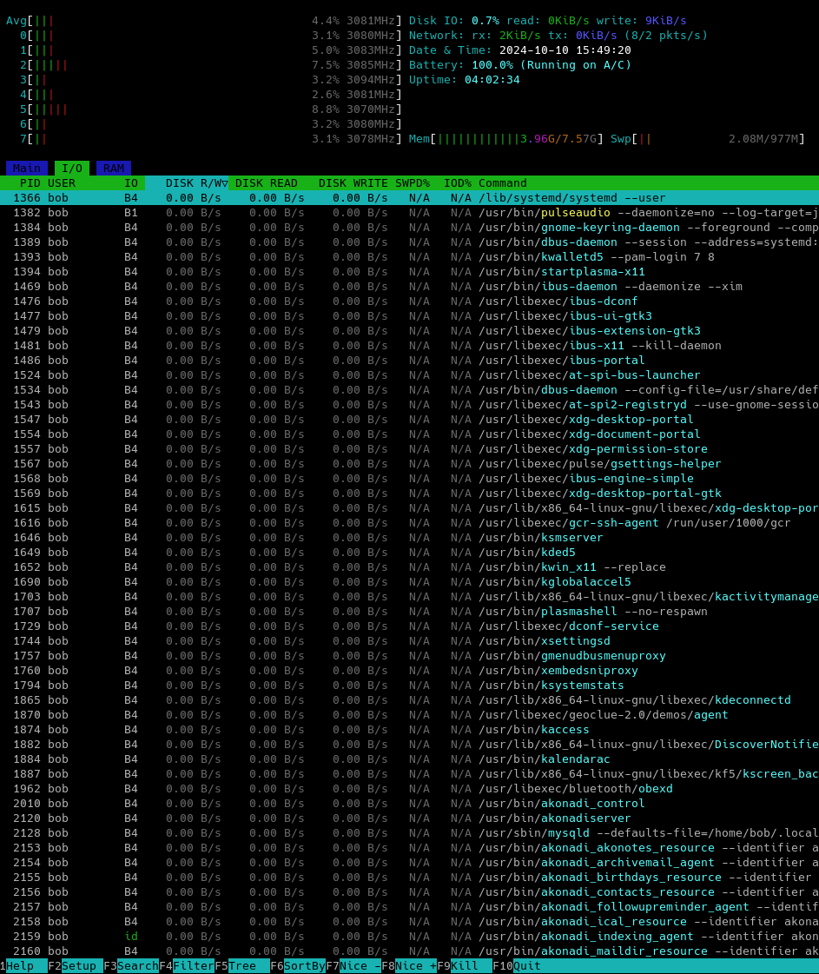

*htop*

The *lsblk* command displays an overview of storage partition statistics.

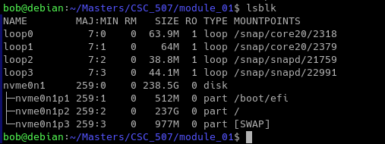

*lsblk*

### The *pydf* command is also useful for displaying a simple output of overall storage statistics.

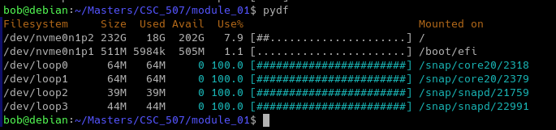

*pydf*

Another useful tool is Make. With Make you can create a Makefile in order to automate several BASH commands with a single Makefile command. This particular Makefile automatically runs the *htop*, *screenfetch, lsblk,* and *pydf* commands. This is executed by running the command *make all,* or simply, *make.* Screenshots of the Makefile source code and its static output is displayed below.

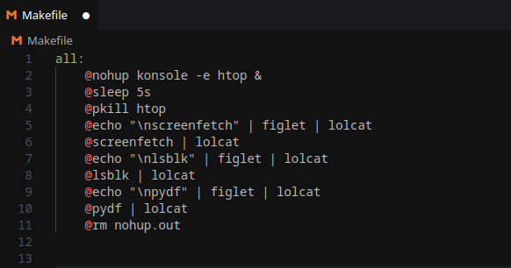

*Makefile Source Code*

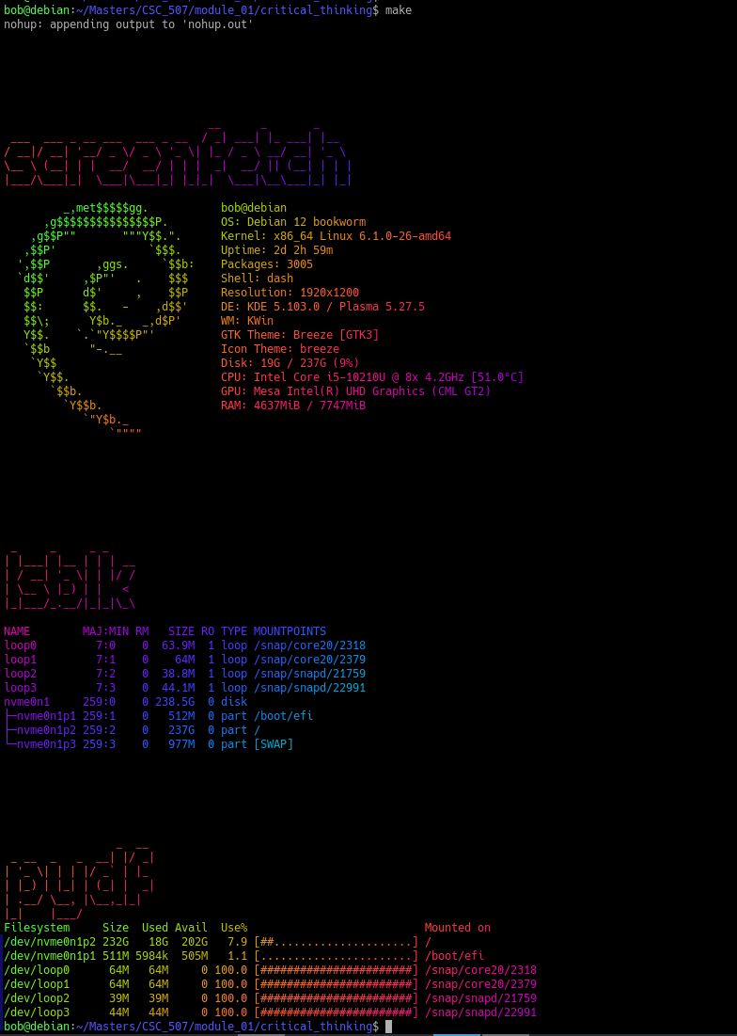

*Makefile Output*

### References

Debian Documentation Project. (2023). *Debian Reference*. Retrieved from https://www.debian.org/doc/manuals/debian-reference/

Pope, C. (2021). *The Linux Command Line: A Complete Introduction* (2nd ed.). No Starch Press.

Ramey, B. (2020). *Linux Bash Scripting Cookbook: Over 100 recipes for bash scripting, with practical examples and real-world usage*. Packt Publishing.