Module 2: Portfolio Milestone

Ryan Thompson

Colorado State University - Global

CSC 507

Dr. Farr

16 October 2024

Portfolio Milestone 1

In this initial portfolio milestone, random number generators were built using both BASH and Python. Each of the two produce essentially the same outputs, simply with different random integers and storage files. The BASH output is stored in file1.txt and the Python output is stored in file2.txt. Furthermore, a Makefile was used to automate the commands to run the programs, display the results, and clean up the directory. Screenshots of the source code and their outputs, via Makefile, can be seen below.

Listed below is the BASH script source code used to generate one thousand random integers and store them on their own lines in a file called file1.txt. The BASH script can be run all together with the Python script and Makefile by using the command *make all*. If you want to only run the BASH script by itself, this can be done by using the Makefile command *make bash* or straight into the terminal with the command *chmod +x numbers.sh && ./numbers.sh.*

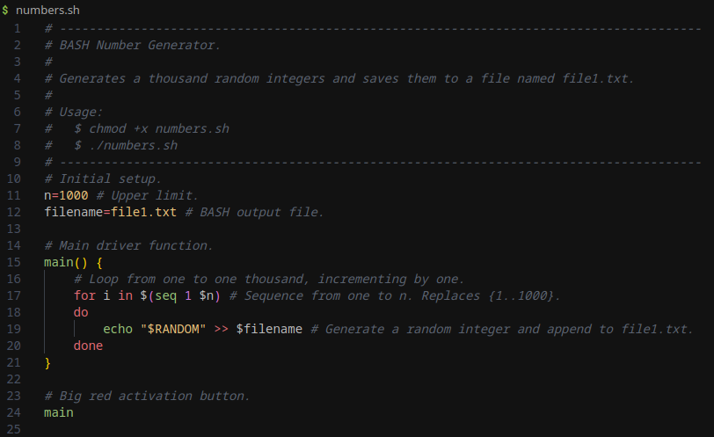

*BASH Source Code*

Underneath is the Python script source code used to generate one thousand random integers and store them on their own lines in a file called file2.txt. The Python script can be run all together with the BASH script and Makefile by using the command *make all*. If you want to only run the Python script by itself, this can be done by using the Makefile command *make python* or straight into the terminal with the command *python numbers.py.*

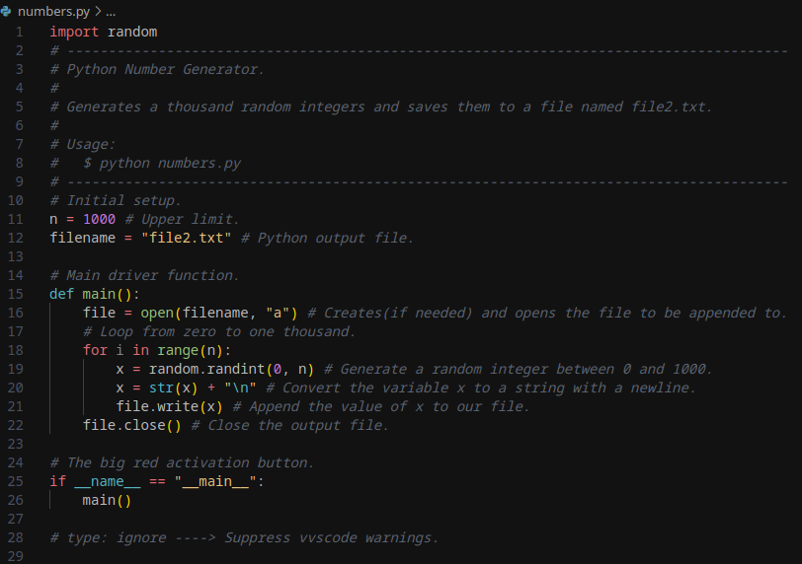

*Python Source Code*

Below is the Makefile source code used to automate the random number generation, display the results, and store the results in their output files*.* All of the targets can be executed by using the command *make all,* or simply, *make*. If a single target is desired it can be executed by using the following command pattern, *make <target>*. For example, if I only wanted to run the Python target I would execute the, *python numbers.py*, command. The only issue is the display and clean targets will only work correctly if the BASH and Python scripts have been executed in order to produce their storage txt files.

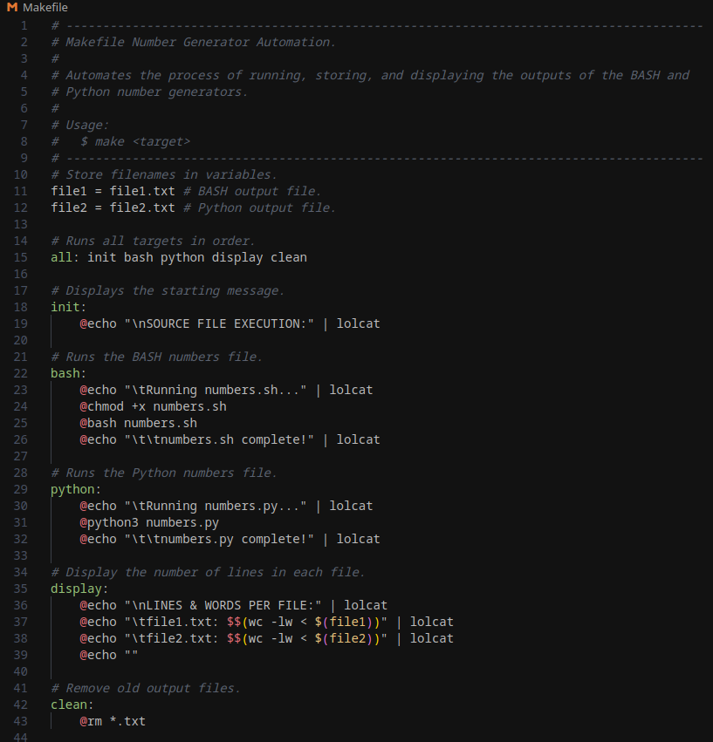

*Makefile Source Code*

Finally, here are the final results from the BASH script and the Python script via Makefile automation. This final output was generated simply by running the command *make*. I attempted to spice up the terminal results display by using the *lolcat* package.

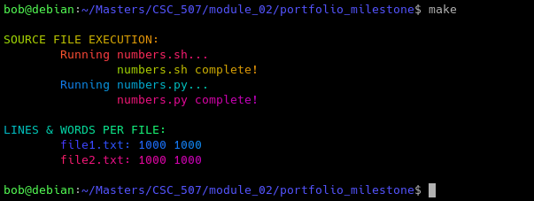

*Makefile Automation Output - Final Results*