Module 4: Critical Thinking

Ryan Thompson

Colorado State University - Global

CSC 507

Dr. Farr

24 November 2024

### First Fit Memory Allocation

Memory allocation is an important aspect of operating systems. Memory allocation is important because it determines how efficiently resources are managed for processes. Among the various strategies, the First Fit and Best Fit algorithms are two common methods used for dynamic memory allocation. These algorithms manage how memory is assigned to processes, and they differ in their approach to choosing which memory block to allocate.

Firstly, the First Fit algorithm allocates memory by scanning through a list of empty memory blocks and selecting the first one that is large enough to accommodate the process. Once a suitable block is found, the process is assigned to it. During which, any leftover space in the block is either split into a smaller free block or ignored. The primary advantage of First Fit is its simplicity and speed. It requires no sorting or complex operations. However, one drawback is that First Fit can lead to fragmentation. Over time, as memory is allocated and deallocated, small gaps of unused memory can accumulate, reducing overall memory efficiency.

On the other hand, the Best Fit algorithm selects the smallest available block that can fit the process. This approach aims to minimize wasted space within the allocated block. Which, theoretically reduces fragmentation. However, the algorithm requires scanning all available memory blocks to find the best match, which can make it slower than First Fit. This added complexity can be problematic in systems with a large amount of memory allocations.

The key difference between First Fit and Best Fit lies in their trade-offs between speed and memory efficiency. First Fit offers faster memory allocation because it stops searching once it finds the first suitable block. However, it may leave larger unused gaps. Whereas the Best Fit algorithm, while slower due to the need to check all blocks, tends to minimize unused space within allocated blocks, potentially reducing fragmentation.

Both algorithms also suffer from internal fragmentation, where a block larger than the required process size is allocated, leaving unused space inside the block. While First Fit might create larger gaps of unused memory, Best Fit's tighter allocation might create smaller gaps that can not be used by other processes.

In conclusion, the First Fit and Best Fit algorithms offer different advantages depending on the system's needs. First Fit is fast and simple, making it ideal for systems where allocation speed is crucial. Best Fit, while slower, can optimize memory usage by minimizing wasted space. The choice between these two algorithms depends on the specific requirements of the operating system.

Screenshots

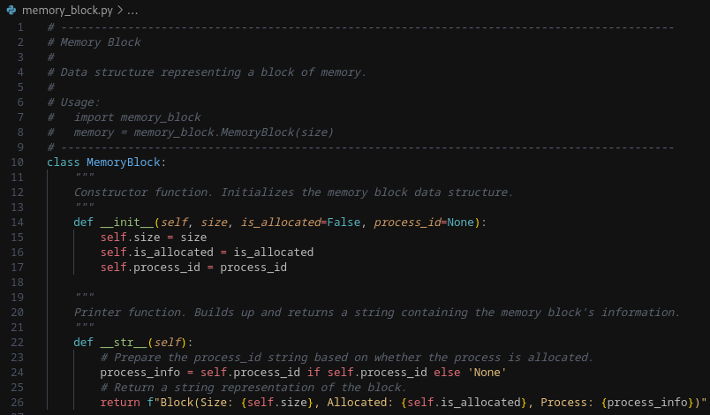

*Memory block data structure source code*

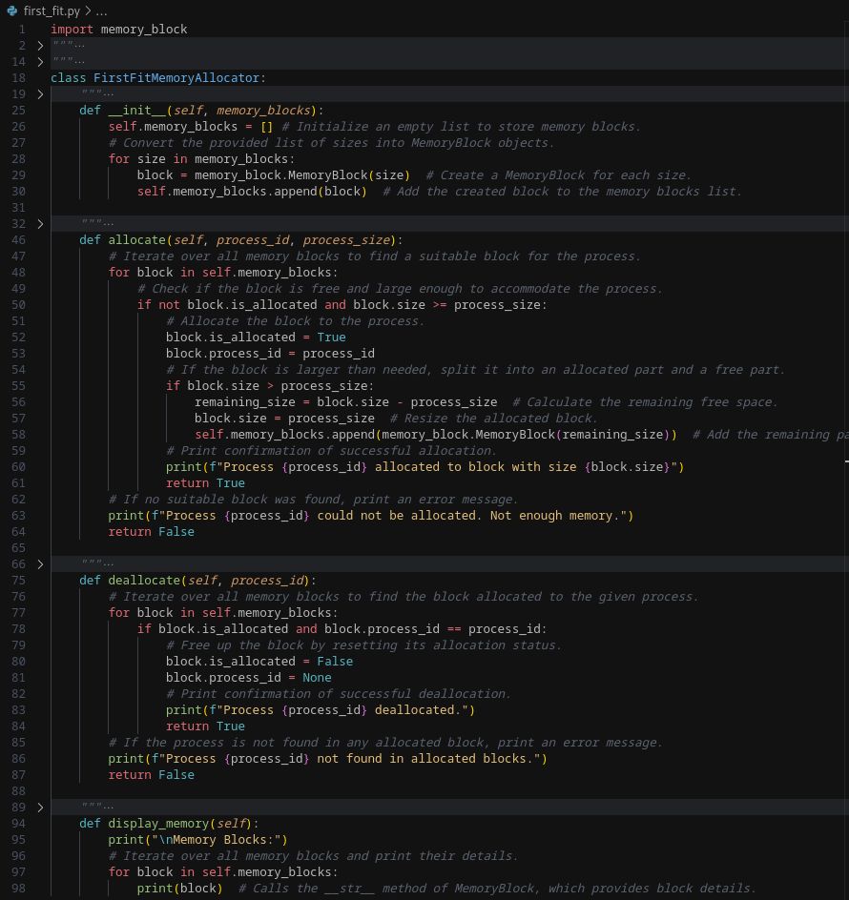

*First Fit implementation*

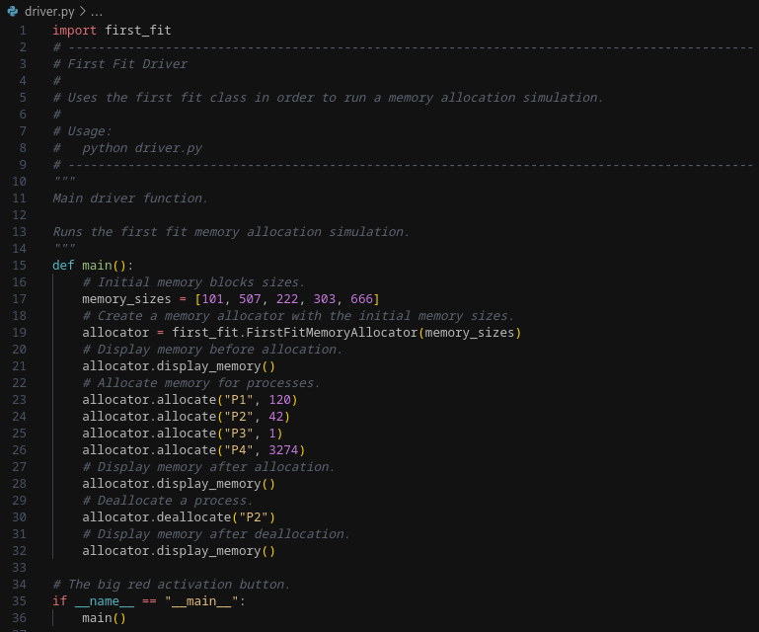

*Main driver source code*

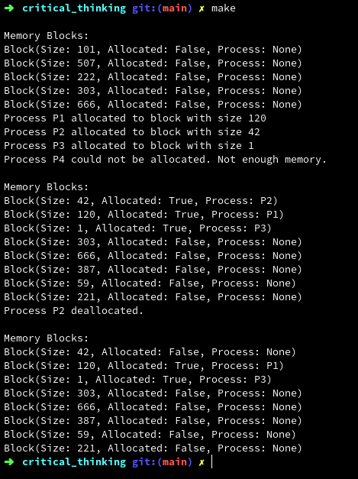

*Program output*

References

Silberschatz, A., Galvin, P. B., & Gagne, G. (2018). *Operating System Concepts* (9th ed.). Wiley.

Tanenbaum, A. S., & Bos, H. (2015). *Modern Operating Systems* (4th ed.). Pearson.

Stallings, W. (2018). *Operating Systems: Internals and Design Principles* (9th ed.). Pearson.