Module 3: Critical Thinking

Linear Regression Using TensorFlow

Ryan Thompson

Colorado State University - Global

CSC 580

Dr. Farr

26 June 2025

**Linear Regression Using TensorFlow**

Linear regression is a foundational machine learning algorithm that models the relationship between an independent and a dependent variable by fitting a straight line through the data points (James et al., 2021). The included Python script demonstrates the implementation of a simple linear regression model using TensorFlow and Keras. The model is built with synthetic data generation and visualization. This example begins by generating synthetic data with added noise to simulate real-world variability, then scales the data for improved training efficiency. The model itself consists of a single dense layer optimized using stochastic gradient descent and mean squared error loss. The script includes functionality to train the model, monitor training progress, and plot the resulting fitted regression line over the original data.

TensorFlow is an open source deep learning framework developed by Google. Which provides powerful tools for building and training machine learning models (Abadi et al., 2016). Keras, integrated within TensorFlow, simplifies the process of constructing neural networks through its user-friendly API (Chollet, 2018). By integrating data generation, model construction, training, and evaluation into a single workflow, this code serves as a practical introduction to machine learning using modern deep learning libraries.

**Program Outputs**

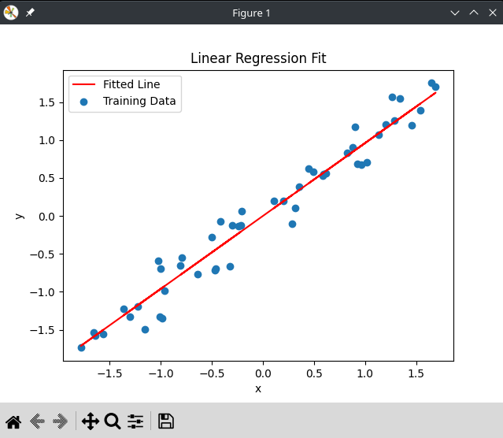

*The red prediction line over the training data.*

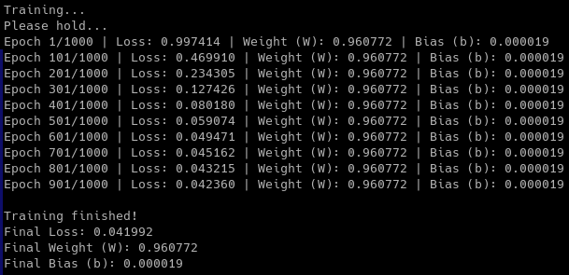

*Program’s terminal output.*

### 

### **References**

Abadi, M., Barham, P., Chen, J., Chen, Z., Davis, A., Dean, J., ... & Zheng, X. (2016). *TensorFlow: A system for large-scale machine learning*. In 12th USENIX Symposium on Operating Systems Design and Implementation (OSDI 16) (pp. 265-283).

Chollet, F. (2018). *Deep learning with Python*. Manning Publications.

James, G., Witten, D., Hastie, T., & Tibshirani, R. (2021). *An introduction to statistical learning: with applications in R* (2nd ed.). Springer.