Module 4: Critical Thinking

Logistic Regression with TensorFlow

Ryan Thompson

Colorado State University - Global

CSC 580

Dr. Farr

June 2025

**Logistic Regression with TensorFlow**

The logistic regression model implemented using TensorFlow performs binary classification on synthetic two-dimensional data. The dataset consists of two normally distributed clusters centered at [−1,−1][-1, -1] and [1,1][1, 1], making it ideal for a linear decision boundary. After training over 1,000 iterations with the Adam optimizer, the model uses a sigmoid activation followed by thresholding at 0.5 to classify the inputs as either class 0 or class 1.

To evaluate performance, the most appropriate metric is classification accuracy, calculated as the number of correct predictions divided by the total number of predictions. This metric is suitable because the dataset is balanced, containing equal samples from both classes. Accuracy provides a simple yet effective way to assess how well the model distinguishes between the two groups (Powers, 2011). It can be computed with the following expression, accuracy = np.mean(y_pred_np == y_np).

Although the code does not directly print this metric, visual inspection of the prediction plot and expected convergence behavior indicate high classification accuracy. The use of sigmoid cross entropy loss is well justified, as it effectively penalizes incorrect predictions and encourages probabilistic outputs (Goodfellow et al., 2016). This, combined with low noise and linear separability in the data, allows the model to perform near optimally.

In more complex or imbalanced scenarios, additional metrics such as precision and recall would be necessary. However, for this controlled experiment, accuracy is both sufficient and informative. The model successfully demonstrates the core mechanics of logistic regression using TensorFlow, offering a foundational example for binary classification tasks.

**Program Outputs**

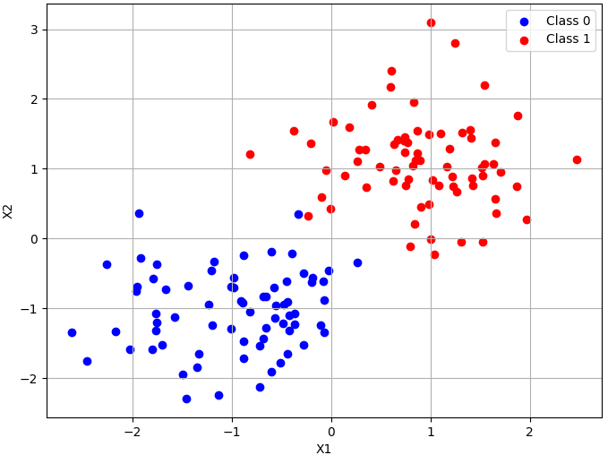

*Dividing the data into separate classes.*

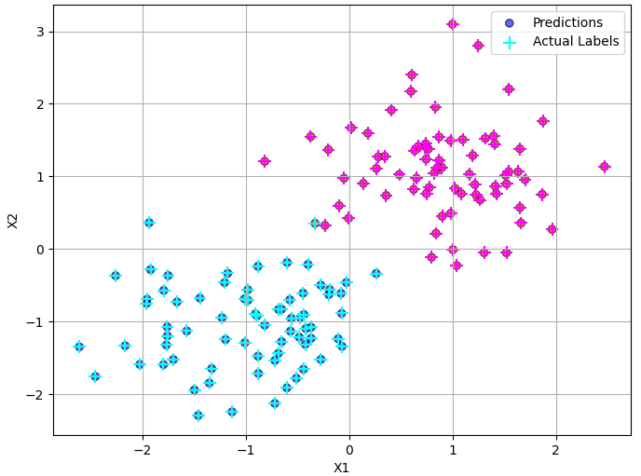

*Predictions vs actual data labels.*

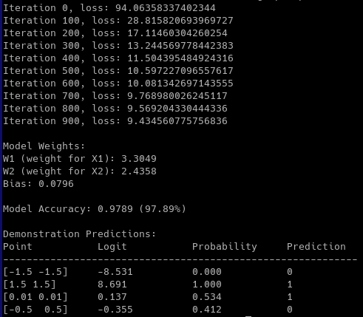

*Program’s terminal output*

**References**

Powers, D. M. (2011). Evaluation: From precision, recall and F-measure to ROC, informedness, markedness and correlation. *Journal of Machine Learning Technologies*, *2*(1), 37–63.

Goodfellow, I., Bengio, Y., & Courville, A. (2016). *Deep learning*. MIT Press.