Module 4: Portfolio Milestone

Option #1: Implementing Facial Recognition

Ryan Thompson

Colorado State University - Global

CSC 580

Dr. Farr

30 June 2025

**Implementing Facial Recognition**

This Python code implements a facial recognition system to check if a specific person appears in a group photo using the face_recognition and cv2 libraries. It loads and encodes a person’s image into a unique face encoding, detects and encodes all faces in a group photo, and compares the person’s encoding against each face in the group using a specified tolerance. If requested, it visually displays the results by showing the individual’s image followed by the group image, outlining detected faces in green if a match is found and red if not. The main() function provides a clear entry point, automatically running the check with sample images (matt_damon.jpg and matt_damon_group.png), making it a practical tool for verifying presence in group photos using facial recognition.

**Program Output**

Listed below are a few screenshots from successfully executing the program, facial_recognition.py.

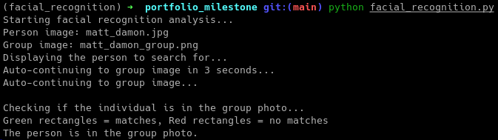

*Terminal program output.*

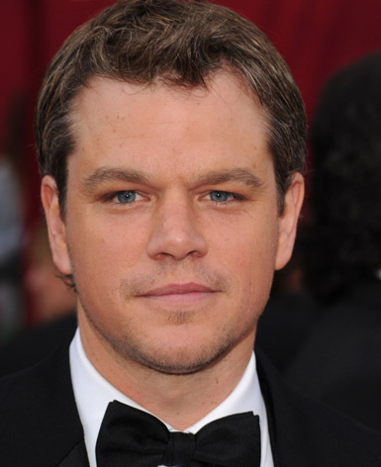

*Single person image (in this case, Matt Damon).*

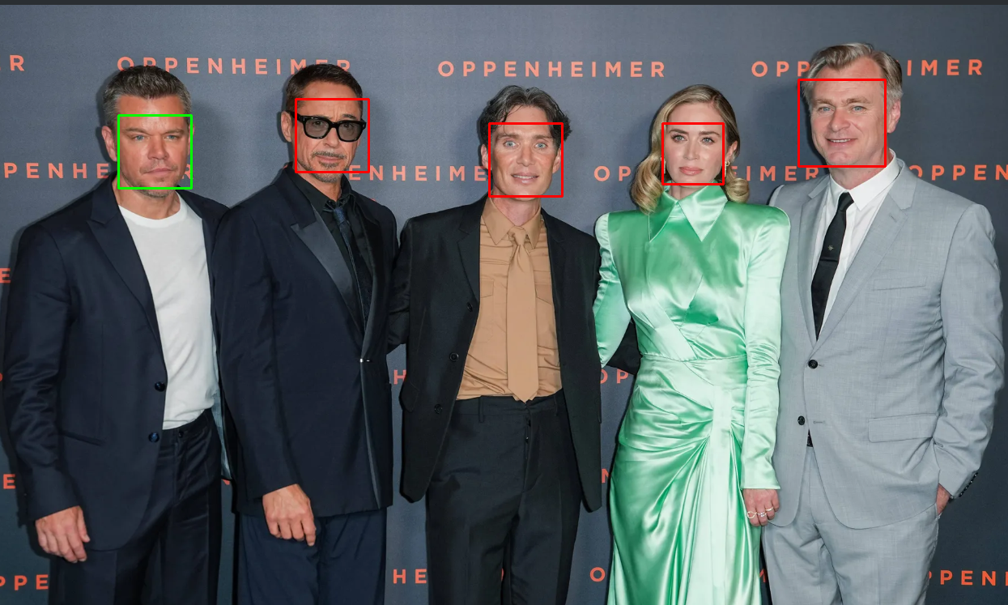

*Group photo matching Matt Damon from the previous image.*