Module 6: Critical Thinking

Option #2: Distinguishing Dogs and Cats

Ryan Thompson

Colorado State University - Global

CSC 580

Dr. Farr

9 July 2025

Distinguishing Dogs and Cats

Deep learning models have made image classification tasks, like distinguishing cats from dogs, highly accessible. This analysis reviews the reliability of a modular convolutional neural network (CNN) for binary classification, with a focus on model strengths, limitations, and practical improvements.

The project leverages TensorFlow and Keras to create a well structured pipeline, including balanced data loading, augmentation, and multiple neural network architectures. Images are resized and normalized, and data augmentation (such as random flips and rotations) helps reduce overfitting and improve generalization. Both a dense neural network and a deeper CNN are implemented, with the CNN using multiple convolutional and pooling layers, batch normalization, and dropout.

Model training incorporates callbacks for early stopping and learning rate reduction, which further improve reliability. Evaluation uses metrics such as accuracy, AUC, and confusion matrices. The results generally show high accuracy, though some misclassifications occur, reflecting typical challenges in visual similarity and dataset variability. Analytical tools like Pearson correlation and scatter plot analysis provide further validation of the model’s predictive capability.

To enhance model accuracy and robustness, expanding the dataset with more varied images would be beneficial. Applying advanced augmentation strategies and leveraging transfer learning with pre-trained models could also boost performance. Further, systematic hyperparameter tuning and cross validation would provide a more reliable assessment of model generalizability. Integrating explainable AI tools can increase transparency, while targeted error analysis can help address recurring model weaknesses.

The current cat vs dog classifier demonstrates effective deep learning practices and produces strong validation performance. Continued efforts to increase data diversity, apply advanced modeling strategies, and emphasize explainability will further enhance the classifier’s accuracy and reliability in practical use.

Program Outputs

Listed below are some screenshots from successfully executing the program. The program outputs and predictions are generated by the trained model.

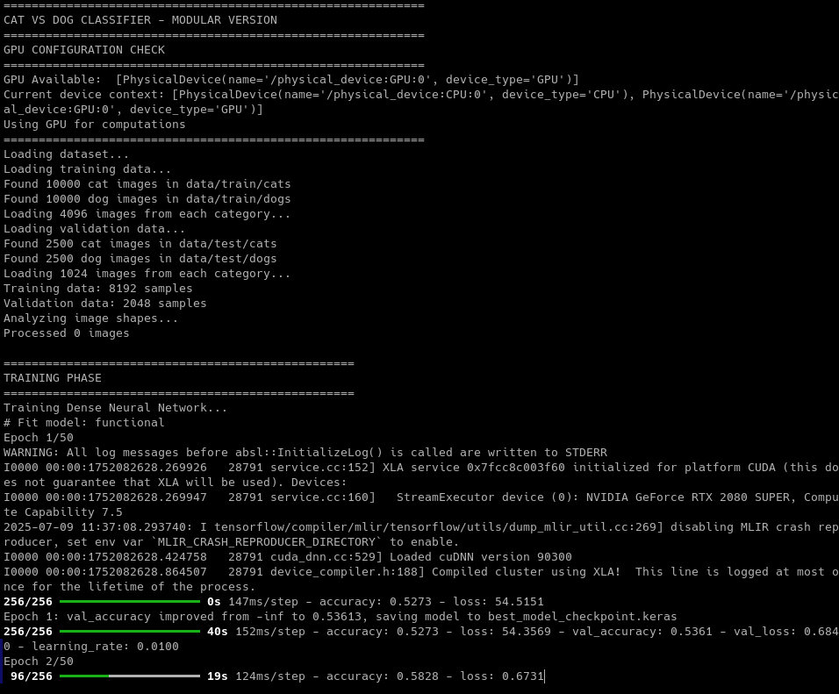

*Initial model training*

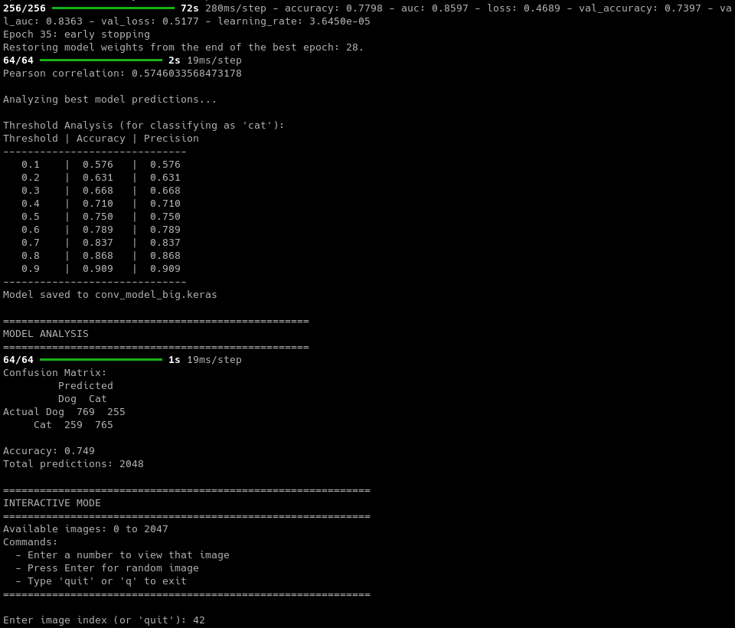

*Model Training Completed*



*Sample Test Image*

*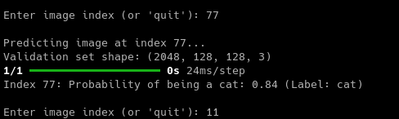*

*Sample Test Image’s Prediction*

*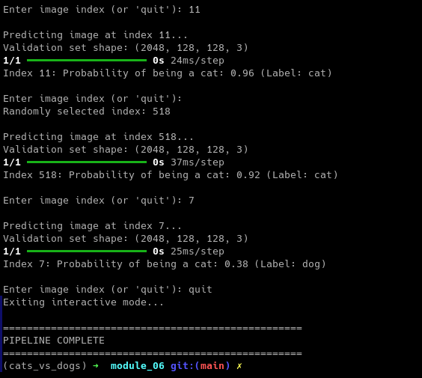*

*Final Program Output*

References

Krizhevsky, A., Sutskever, I., & Hinton, G. E. (2017). ImageNet classification with deep convolutional neural networks. Communications of the ACM, 60(6), 84-90. https://doi.org/10.1145/3065386

Selvaraju, R. R., Cogswell, M., Das, A., Vedantam, R., Parikh, D., & Batra, D. (2017). Grad-CAM: Visual Explanations from Deep Networks via Gradient-based Localization. In Proceedings of the IEEE International Conference on Computer Vision (pp. 618–626).

Shorten, C., & Khoshgoftaar, T. M. (2019). A survey on Image Data Augmentation for Deep Learning. Journal of Big Data, 6(1), 1–48. https://doi.org/10.1186/s40537-019-0197-0

Yun, S., Han, D., Oh, S. J., Chun, S., Choe, J., & Yoo, Y. (2019). CutMix: Regularization Strategy to Train Strong Classifiers with Localizable Features. In Proceedings of the IEEE/CVF International Conference on Computer Vision (pp. 6023–6032).