This project will use an Arduino Nano Every, along with a single button and an OLED display, to create a digital D20 dice roller. We’ll also look at some opportunities to make the hardware and software better and discuss the security of the included “anti-cheat” system. Finally, we will use the D20 to play Backdoors & Breaches.

**Part 1: Hardware Setup**

1. Check your kit to make sure you have all the items shown (and maybe some extras):  
   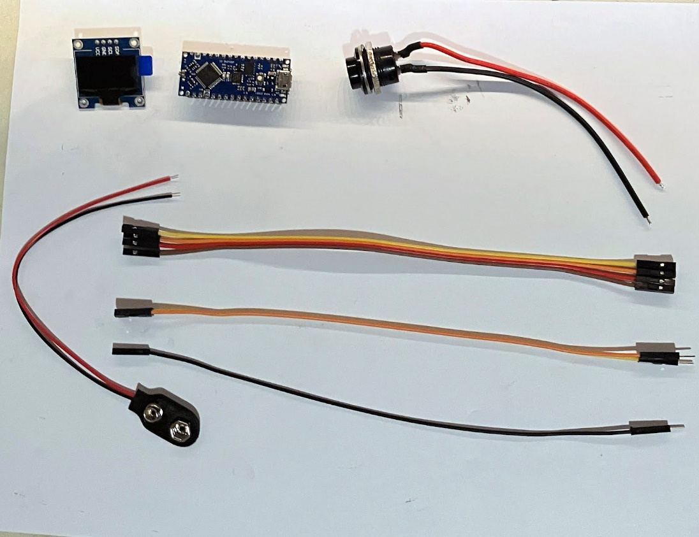
2. If your Arduino did not come with its header pins already soldered on, you’ll need to do that first. Insert the short legs of the headers up through the bottom of the board, then carefully solder the pins to the board on the top side. When finished, it should look like the following.  
   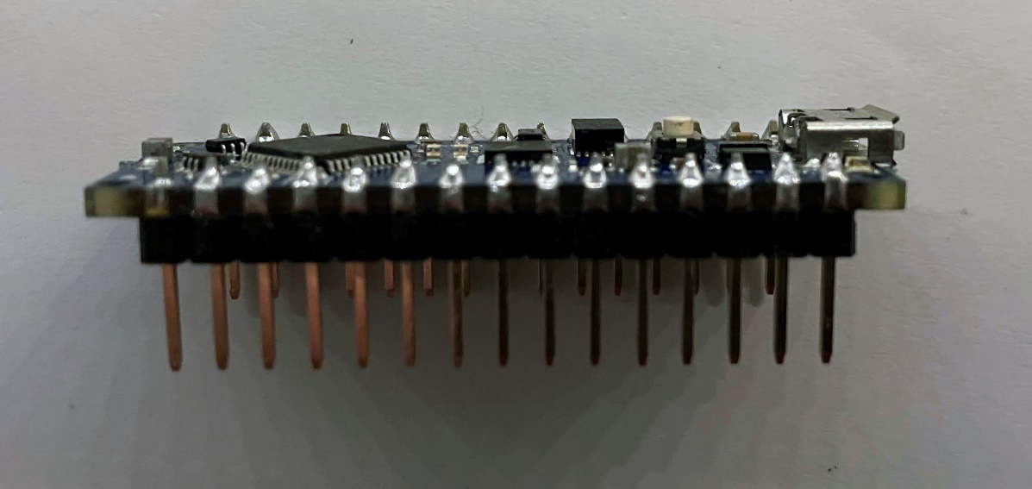
3. Now we need to solder wires/connectors onto the components.
   1. First, cut and remove the heat shrink tubing off of the connectors on the push button.  
      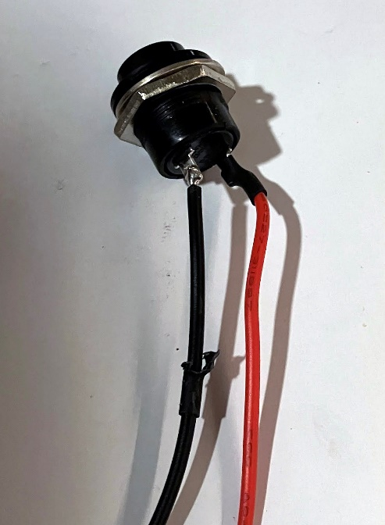
   2. Use your soldering iron to heat up the solder holding the wires onto the button and then pull the wires off. You can use your solder sucker to clean the remaining solder off the terminals.  
      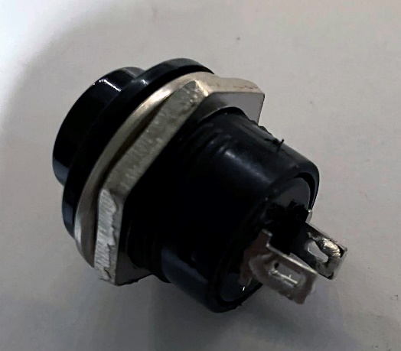
   3. Take one of the male-female jumper wires included in the kit and cut off the male connector. Strip some of the insulator away to revile about a ¼ inch of wire. Solder this wire to one of the terminals on the button.
   4. Take another of the male-female jumper wires included in the kit and cut off the male connector. Strip some of the insulation away to reveal about a ¼ inch of wire. Cut a small section of the heat shrink tubing included in the kit and slide it over the wire and all the way down to the other end. Solder this wire to the positive (red) wire coming out of the 9v battery connector. Once the solder joint cools, slide the heat shrink section up over the solder joint and use a lighter or hot air gun to shrink the tubing into place.
   5. Take the last of the male-female jumper wires included in the kit and cut off the male connector. Strip some of the insulator away to reveal about a ¼ inch of wire. Take this wire and lightly twist it together with the negative wire (black) coming from the 9v battery connector. Solder both of these wires together to the open terminal on the button. Once complete, you should have something that looks like this:  
      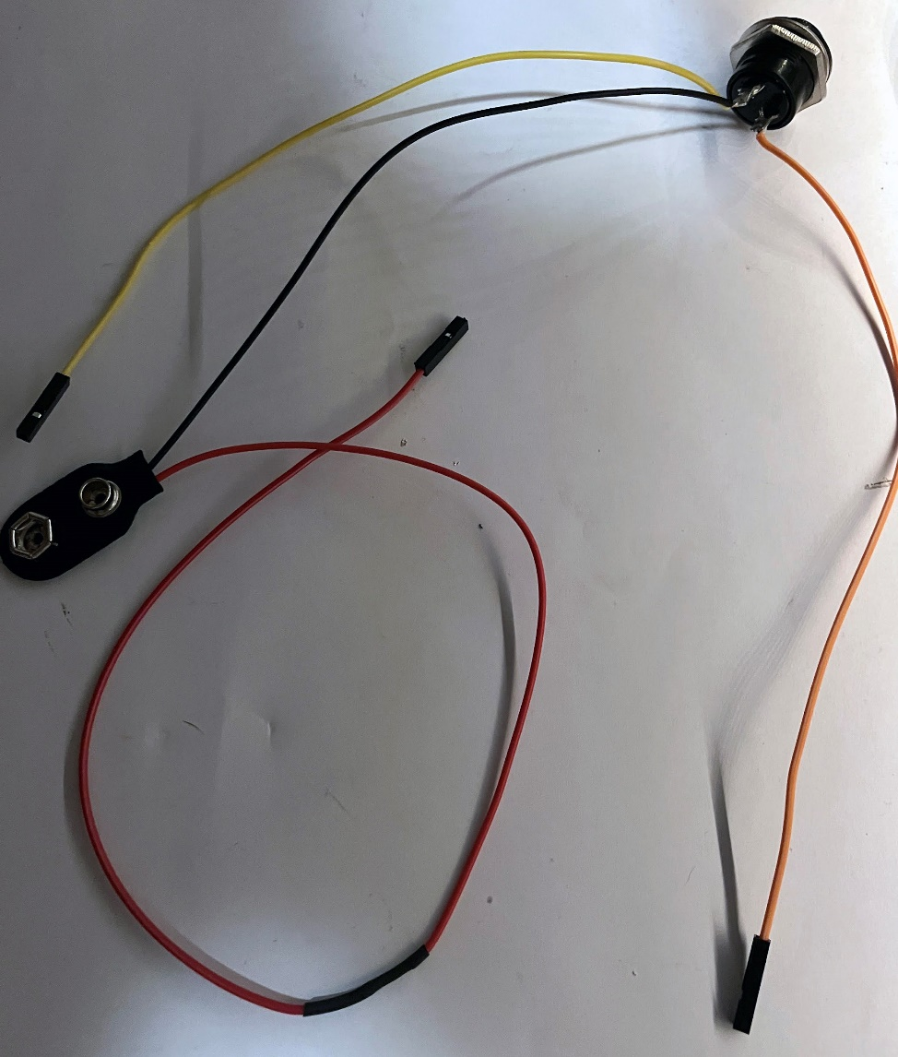
4. We now need to connect all the components together. The female connectors on the jumper wires will simply push on to the headers we soldered onto the Arduino in step 2. Reference the pinout diagram of the Arduino Nano Every and the mapping of which components connect to which pins.  
   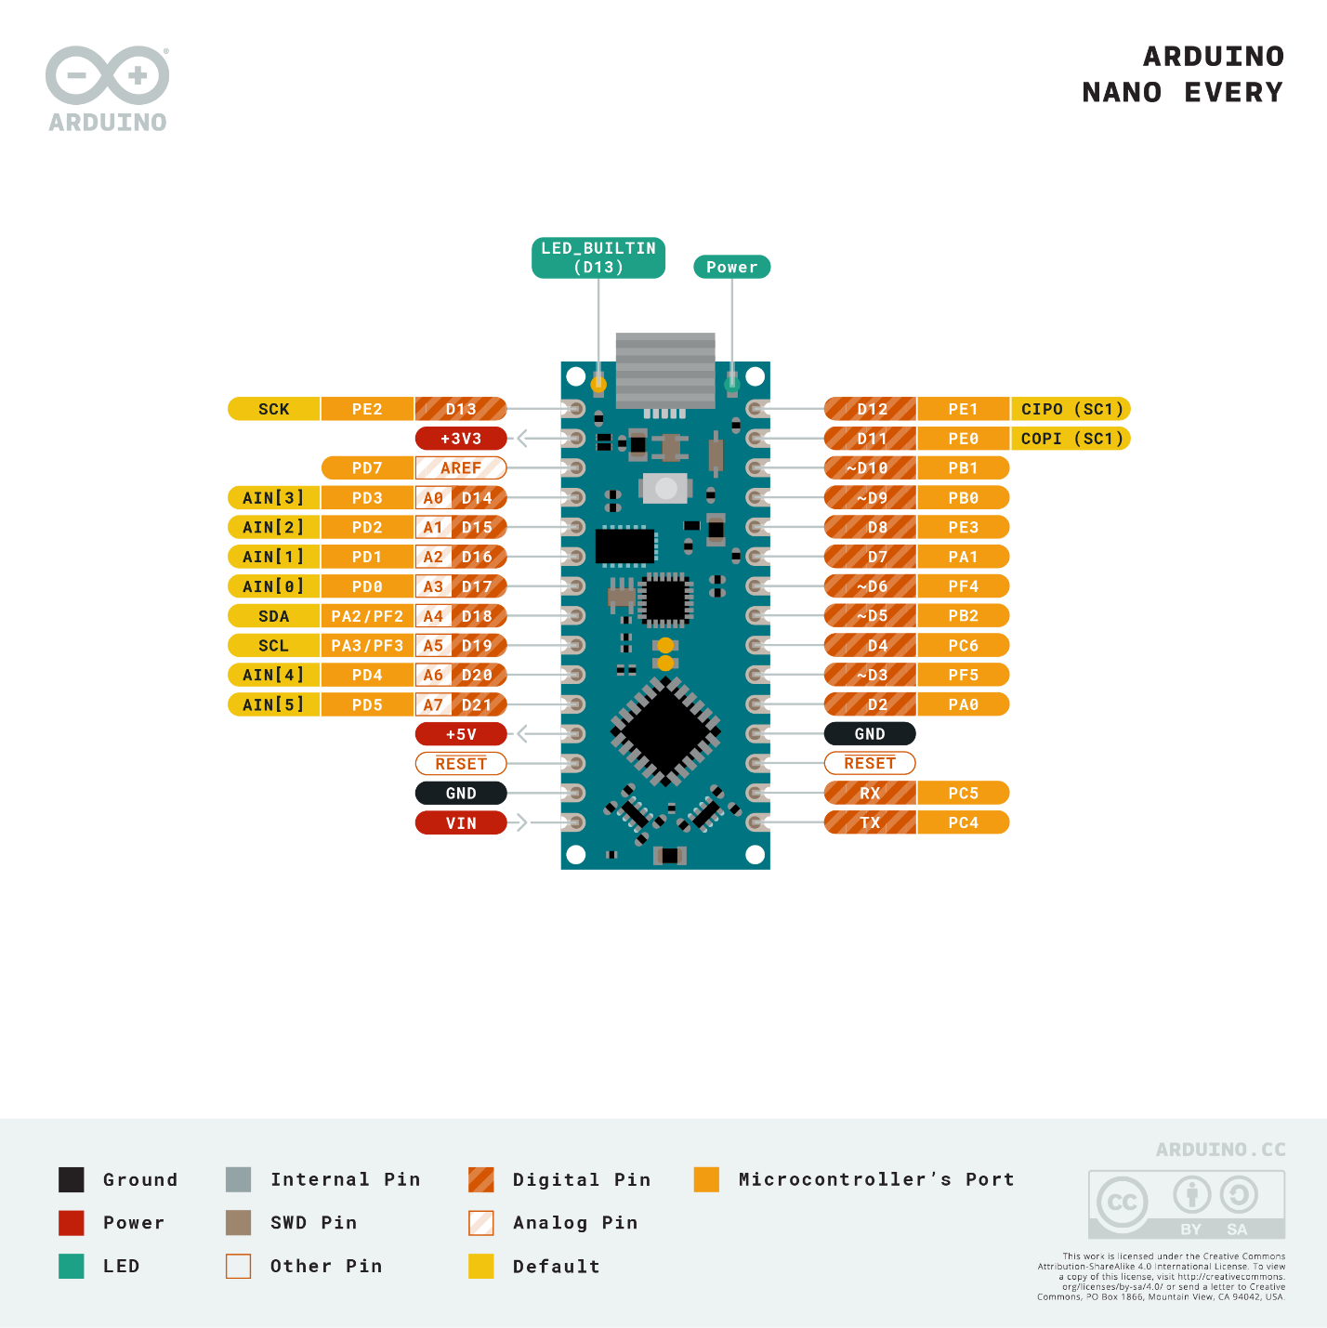
   1. +5v out (Nano) <-> VCC (display)
   2. GND (Nano) <-> GND (display)
   3. SDA (Nano) <-> SDA (display)
   4. SCL (Nano) <-> SCL (display)
   5. D7 (Nano) <-> Switch
   6. Switch <-> GND (Nano)
   7. 9v + (Battery) <-> VIN (Nano)
   8. 9v – (Battery) <-> GND (Nano)
5. I shipped all of the Arduinos with a basic program loaded on them. At this point, all that is left to do is connect the Arduino to power. You can either power it from a computer USB port using the included USB cable (which we will also use to program the Arduino) or by connecting a 9v battery to the 9v battery connector we attached. Do not connect both power sources at the same time. **As we will be using the USB connection for programming, I suggest using that one. As the USB connection is built in, it is also safer (less likely to be mis-wired or have a short circuit). Before connecting a 9v battery in the future, be sure to double check all your wiring.** Once you have power connected, you should see the LCD turn on a message displayed. Pressing the button should result in a die roll. If things aren’t working, disconnect the Arduino from your computer and doublecheck all your wiring.

**Part 2: Initial Arduino Software**

1. Install GitHub desktop if you don’t already have it
2. Clone the repository from <https://github.com/rtadams89/PetSmartD20>
3. Download and install v 1.8.x of the Arduino IDE from <https://downloads.arduino.cc/arduino-1.8.19-windows.exe>
   1. Choose to install drivers when prompted
4. Open the Arudio IDE
   1. Go to Tools -> Board ->Boards Manager
   2. Search for “Arudino Nano Every” and install the matching board package
   3. Go to Tools -> Manage Libraries
   4. Search for and install the following libraries:
      1. Adafruit_SSD1306
      2. Adafruit_GFX
5. Close Arduino IDE
6. Connect (or remove and reconnect) the Arduino Nano Every to your computer with the USB cable
7. Open the sketch downloaded in step 2 with Arduino IDE
8. From the Tools menu, ensure the correct Board, Processor, and Port are set
9. Click the Upload button and wait for the upload to finish (progress will be shown in the lower left of the Arduino IDE window)
10. The digital dice should still be working the same as before.

**Part 3: Checksum Code**

1. Roll the die and note you also get a roll # and checksum code.
2. Run the PowerShell script included in the repository and enter in your die value, roll number, and checksum. It should pass validation
3. Roll the die again a few times, and attempt to “cheat” by entering a false roll of “20” into the PowerShell script. It should fail validation.

**Part 4: Follow-up Items**

* Walkthrough of code
* “anti-cheat” system
  + Pitfalls
  + Improvements
* Improvements
  + Button debounce
  + Random number generator
  + Multiple dice
  + Better graphics
  + Interconnected dice
* Other project ideas
  + Take a look in the Arduino IDE under File -> Examples to see some starter examples.
  + Visit <https://store-usa.arduino.cc/> to see some other Arudino board models and hardware peripherals you can add

**Part 5: Backdoors & Breaches**

Included with your kit is the v2 version of Backdoors & Breaches + the Expansion Deck. All you need to play this in person is a D20 die and these cards. There is also a printable instruction guide at <https://www.blackhillsinfosec.com/wp-content/uploads/2020/05/BB-Visual-Guide-PRINT.pdf>

For easy of use today, we will be using the free web version available at <http://play.backdoorsandbreaches.com/>