* Modify test\config\environment.properties to location where your clearcase project for this module exists by modifying C:\cc7\t833602_crdmgtSH_3.0._dev to your location
* Copy app-config\CrdDecisioningService to test\data\ folder
* Modify logLocation under data/common/env-crdmgt.xml: property: *entCrdPrflDataMgtService*
* Modify ficoCrdaAsmtConfigDir under data/common/env-crdmgt.xml: property: *ficoCrdaAsmtConfigDir* appropriately

Add following dirs to the classpath.

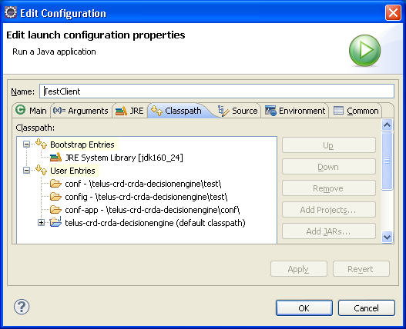

Run TestClient