1. To build a docker file run the below command it will give service-app name to the image.

docker build -f Dockerfile -t service-app .

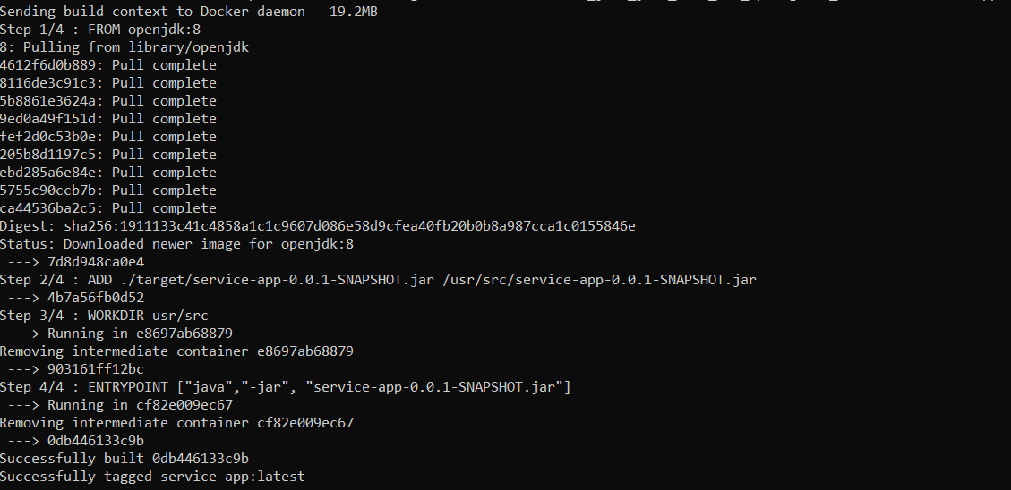  
  
docker run -d -p 80:80 service-app

Creating the ECS cluster using the below command: -

$eksctl create cluster --name myDemoeks --region us-east-2 –fargate

$kubectl cluster-info

$kubectl logs podname