Wasserlos (Waterless) in the Land of 10,000 Lakes

The Wasserlos Gruppe is an ad-hoc gathering of owners of German air-cooled automobiles. We are organizing a drive to unique locations in Minnesota for the purpose of photographing your vintage car. We have secured a professional photographer for this unique experience. the cost to participate is just $35.00, participation is limited to 30. All participants will be provided the pictures of their cars (a USB drive).

Imagine your car pictured in this setting.

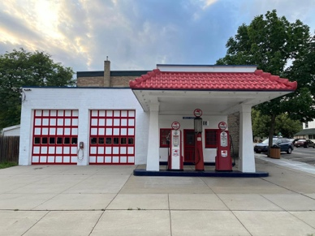

This is a collaborative experiment in automotive photojournalism.

The Wasserlos Gruppe is an independent, ad-hoc gathering of owners of vintage cars. We are not affiliated with any established car club. In fact, we are not a car club nor a registered business entity. We are simply test-marketing a concept and will rely on those that participate for direction. We are currently in the planning stage and want to determine the level of interest.

