Midway into your office rotation the tree needs to be watered. Maybe the Friday of your first week or Monday of your second week.

You will find a water tray and a cup in my second drawer.

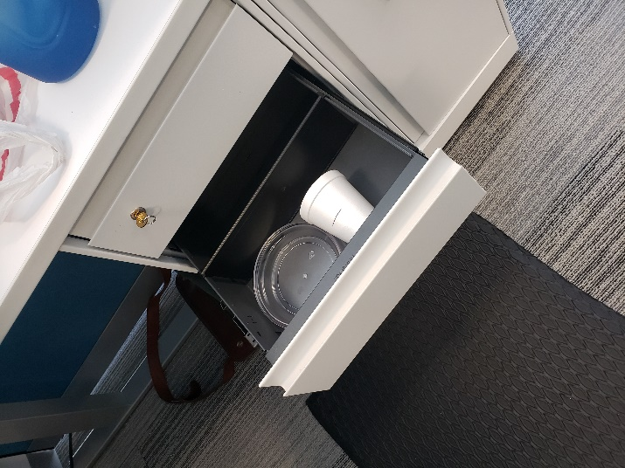

Take the water tray and place the pot inside.

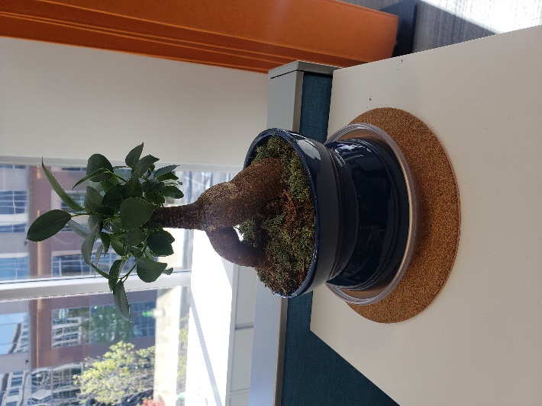

Fill the cup to the black line with water.

Pour the water evenly across the green moss and return the water cup to the drawer.

Wait a couple hours before removing the water tray. Pour the water out of the tray and return it to the drawer.

When you place the pot back onto the cork mat, rotate it 180 degrees. You want to face the opposing side towards the window (common sense here).

Whisper to the tree that it is doing GREAT…. Just kidding. Do not do that. That is crazy. It is just a plant.