**A smart jump rope that counts calories burned**

**Table of Contents**

Ⅰ.Introduction 3

Ⅱ.Aims and Objectives 3

Ⅲ.Background 4

Ⅳ.Materials and Methods 4

Ⅴ.Results 7

Ⅵ.Discussion 8

**Ⅶ.Conclusion** 9

Ⅷ.Reference List 9

Ⅸ.Appendices 10

# Ⅰ. Introduction

As the pace of modern life accelerates and health awareness increases, there is a growing demand for precise monitoring of exercise effectiveness and fitness outcomes. To meet the needs for convenient and personalized fitness, smart fitness applications have emerged. The realization of smart fitness primarily relies on big data and artificial intelligence technologies. With the development of computer technology and deep learning methods, the application of AI in fields such as sports training and healthcare has become increasingly mature.

Jump rope, as a fitness activity suitable for people of all ages, can help improve cardiovascular function, enhance muscle strength and endurance, and improve metabolic rate and exercise efficiency. Additionally, this activity requires minimal equipment and space, and has low participation costs, making it one of the most popular fitness activities[1]. Therefore, the development of smart jump ropes is of significant importance.

Smart jump ropes, through built-in sensors and algorithms, can record key data such as the user's jump count, speed, and calories burned in real time. This data not only helps users understand their exercise volume and energy expenditure but also allows for the creation of personalized fitness plans tailored to their needs[4]. Through continuous data collection and analysis, smart jump ropes not only enhance users' understanding and control of their fitness progress but also promote scientific and personalized health management, providing strong support and guidance for a healthy lifestyle.

# Ⅱ. Aims and Objectives

Accurately recording calorie consumption is crucial for health management. According to one study, jump rope offers significant benefits for enhancing cardiovascular, respiratory, and nervous system functions[5]. Therefore, we aim to use our designed smart jump rope, equipped with algorithms to record jump counts and accurately calculate calorie consumption based on users' physical conditions. This will help fitness enthusiasts develop personalized fitness plans and exercise more scientifically.

We allow users to upload data and share their workout results with friends, participate in jump rope competitions, and increase social interaction and enjoyment. Our smart jump rope can also aid patients in the rehabilitation phase by improving cardiopulmonary function, increasing physical strength, and enhancing coordination. Through our algorithms, we record jump counts and calories burned, enabling patients to understand their health status at any time and share data with their doctors for more scientific health management.

Thus, our smart jump rope is not just a fitness tool but an intelligent technology that can tailor exercise programs to individual characteristics. Continuous recording of calorie consumption and data analysis enables users to better understand their exercise effectiveness, thereby adjusting and optimizing their training plans to achieve more efficient fitness and rehabilitation outcomes.

# Ⅲ. Background

The development history of smart jump ropes can be traced back to the rapid advancement and popularization of fitness technology over the past decade. Initially, jump rope, as a traditional aerobic exercise, was widely used in fitness and training but was limited to simple counting and time measurement[2].

With the improvement of sensor technology, embedded systems, and data analysis capabilities, smart jump ropes gradually emerged. The first generation of smart jump ropes began to incorporate accelerometers and other sensors, capable of accurately measuring users' jump counts and frequencies. This data could be displayed in real-time through connected mobile applications or built-in screens, allowing users to instantly understand their exercise performance and calories burned.

As market demand and technology progressed, the functionalities of smart jump ropes continued to expand. Modern smart jump ropes not only record basic jump rope data but also perform data analysis, providing personalized fitness advice and training plans. Some advanced smart jump ropes can even synchronize data with health monitoring devices or smartwatches, enabling comprehensive health management and exercise tracking[3].

The development of smart jump ropes has not only innovated in technology but also propelled the fitness market towards greater intelligence and personalization. They provide users with more accurate and enjoyable fitness experiences while helping them manage and improve their health more scientifically[7]. With the continuous advancement of fitness technology, smart jump ropes are expected to further evolve and develop in the future, contributing significantly to the promotion of a healthy lifestyle and overall well-being.

# Ⅳ. Materials and Methods

The essential parameters are gathered during jumping rope using an MPU 6050, processed and calculated by an Arduino UNO platform, and finally displayed on an LCD screen, showing the core values such as the number of jumping ropes and the number of calories burned. The specific method is as follows: the gyroscope is used to detect the Euler angle, the raw data of three angles is obtained through the gyroscope, and then the data is converted into the Euler angle using the appropriate formula. The resulting Euler angle data is then entered into a rotation matrix for processing and analysis. This process allows for the accurate measurement of the trajectory and attitude of the jump rope, thus enhancing the functionality and user experience of the smart jump rope.

The Euler's angle correlation formulae through the angle of the gyroscope during rope skipping are: $$\text{roll}=\arctan\left(\frac{\text{GyY}}{\text{GyZ}}\right)⋅\frac{180}{π}$$

$$\text{pitch}=\arctan\left(\frac{-\text{GyX}}{\sqrt{{\text{GyY}}^{2}+{\text{GyZ}}^{2}}}\right)⋅\frac{180}{π}$$

$$\text{yaw}=\arctan\left(\frac{\text{GyY}}{\text{GyX}}\right)⋅\frac{180}{π}$$

$$\text{transformedAccZ}=\text{transformedAccZ}⋅\frac{\text{GRAVITY}}{16384.0}$$

In the smart rope skipping application, the initial step involved the acquisition of three rotation angles (roll, pitch and yaw) provided by the gyroscope. Subsequently, the aforementioned angles are employed to construct a rotation matrix, through which a coordinate transformation is performed in order to transform the acceleration data measured by the acceleration sensor (acceleration sensor) during rope skipping into the geodetic coordinate system. This methodology allows for a more precise analysis of the dynamic behaviours and force effects associated with jumping rope, thereby facilitating further optimisation of the gaming experience and data accuracy.

The pertinent formula for the establishment of the geodetic coordinate system is as follows:

$$R=\left(\begin{matrix}\cos{ψ}\cos{θ} & \cos{ψ}\sin{θ}\sin{ϕ}-\sin{ψ}\cos{ϕ} & \cos{ψ}\sin{θ}\cos{ϕ}+\sin{ψ}\sin{ϕ} \\ \sin{ψ}\cos{θ} & \sin{ψ}\sin{θ}\sin{ϕ}+\cos{ψ}\cos{ϕ} & \sin{ψ}\sin{θ}\cos{ϕ}-\cos{ψ}\sin{ϕ} \\ -\sin{θ} & \cos{θ}\sin{ϕ} & \cos{θ}\cos{ϕ}\end{matrix}\right)$$

Since the initialised angle of rotation in the XY plane is uncertain, we need to process the data further to ensure accuracy. In order to extract the rotation angle of the unit circle, we need to analyse in detail the components in the XY direction, which contain certain X and Y components respectively.

However, due to the uncertainty of the initial rotation angle in the XY plane, it is difficult to ensure the accuracy of the angle by conventional processing methods. To address this problem, the principal component analysis (PCA) method was introduced in this study. PCA is a widely used dimensionality reduction technique in statistics that is capable of extracting the main variables from a multidimensional dataset[8]. In this study, PCA was applied to analyze data in the XY plane to extract the main directional components. Specifically, PCA is able to identify the principal components in the x- and y-directions, and the projection corresponding to the xoy-plane after PCA

Through the analysis of PCA, we are able to extract the major rotational directions from the raw data and calculate the plane angle of hand rotation accordingly. This process not only improves the accuracy of the angle measurement, but also enhances the system's ability to parse the motion data. Ultimately, this PCA-based analysis method can significantly improve the accuracy and stability of the smart jump rope system. By accurately measuring and correcting the rotation angle of the hand, this system is able to provide more precise movement data, thus optimising the user's exercise experience and training effect.

The formula for principal component analysis is as follows：

$$X^{'}=X-μ$$

$$C=\frac{1}{n-1}(X^{'})^{T}X^{'}$$

$$C=VΛV^{T}$$

$$W=\left(\begin{matrix}| & | & & | \\ v_{1} & v_{2} & ... & v_{k} \\ | & | & & |\end{matrix}\right)$$

$$Z=X^{'}W$$

These formulas describe the process of Principal Component Analysis (PCA) for downscaling high-dimensional data.

In the field of signal processing, the sliding window technique represents an effective method for time series analysis, employed widely for the purposes of data smoothing and feature extraction. In this study, the sliding window method is employed for the analysis of accelerometer data, with the objective of enhancing signal stability and identifying key motion events. The specific method entails the establishment of 10 samples. A sliding window is a data collection method that accumulates the most recent accelerometer readings while replacing the oldest data points with new data as it is received. The moving subset of data is employed to calculate the mean and variance, thereby reducing noise and facilitating the detection of significant events, such as jumping manoeuvres.

For calculating calories, we propose a calorie calculation method based on mechanical parameters. Firstly, we define a basic calories per jump consumption (baseCaloriesPerJump) based on the body weight type of the individual. This value varies depending on the body weight type (bodyType). $$baseCaloriesPerJump=\{\begin{matrix}0.05 & if bodyType = 0 \\ 0.07 & if bodyType = 1 \\ 0.10 & if bodyType = 2 \\ 0.0 & otherwise\end{matrix}$$

Further, we analyse the accelerometer data to calculate the averageForce, the maxForce and the minForce.

$$averageForce=\frac{AcX.getAverage+AcY.getAverage+AcZ.getAverage}{3}$$

$$maxForce=\frac{AcX.getMax+AcY.getMax+AcZ.getMax}{3}$$

$$minForce=\frac{AcX.getMin+AcY.getMin+AcZ.getMin}{3}$$

From this, the final mechanical index is calculated

$$forceFactor=\frac{averageForce+maxForce-minForce}{10000}$$

Finally, the total calorie burn was calculated by combining the number of jumps, the basic per-jump calorie burn value, the force factor, and the duration of the exercise. $$Calories=jumpCount×baseCaloriesPerJump×(\frac{averageForce+maxForce-minForce}{10000})×(\frac{elapsedTime}{60000})$$

# Ⅴ. Results

Picture 1

We processed the motion monitoring data by performing Gaussian regression based on the measured results. Gaussian regression is an effective statistical method for fitting data and identifying key feature points[9]. The location of the peak of the Gaussian Regression curve is determined by the location of the peak, and the location where the peak is located is the optimal result of the signal processing. The figure below shows the results of applying a sliding window to analyse irregular sine data (e.g. Figure 2) and the neutral curve after Gaussian regression (e.g. Figure 3):

Picture 2

Picture 3

Among the important parameters are:

**mean = 12.7475**

**variance = 13.798**

**Acc = 97.67%**

The combination of these values and graphs serves to illustrate the efficacy of our signal processing approach, as well as its precision in identifying and analysing motion events within accelerometer data through the utilisation of a sliding window and Gaussian regression.

# Ⅵ. Discussion

We discussed the content related to Implications, from the perspectives of Feedback and Monitoring. The provision of real-time feedback on calorie consumption has the potential to encourage consistent exercise, as users are able to make adjustments to their exercise plan based on the real-time data. The precise and real-time tracking of calorie consumption is of significant importance for the safe and effective performance of exercise, particularly for individuals with specific health conditions who require the guidance of rehabilitation exercises.

Additionally, we discussed the strengths of our project. The advanced sensors and algorithms incorporated into the design of the Smart Jump Rope enable precise calorie estimation, ensuring the reliability of the data provided to the user. Furthermore, integrating calorie counting into a compact and straightforward exercise device makes it convenient for users to carry the device throughout their daily routines, eliminating the need for additional assistive devices.

Finally, we discussed the shortcomings of our project. It is acknowledged that the physiology of individual users may vary, which could potentially result in inaccuracies in calorie estimation. It is therefore essential to ensure that the jump rope is used correctly in order to obtain accurate data. This is because improper technique or inconsistent jumping can lead to erroneous results. Furthermore, external factors, such as environmental conditions, including temperature and surface type, can influence exercise intensity and, consequently, calorie consumption.

Ⅶ. Conclusion

This study proposes a novel calorie calculation method based on Gaussian regression, which is developed through a comprehensive analysis of exercise monitoring data. Additionally, potential avenues for future research are presented. Firstly, future research will adopt more advanced sensor technologies, including more accurate accelerometers, gyroscopes and heart rate sensors, in order to provide more detailed and comprehensive exercise data. This will facilitate improvements in the accuracy and reliability of data collection. Secondly, the utilisation of virtual reality and augmented reality technologies will be employed to enhance the user experience of the smart jump rope. The provision of an immersive exercise environment and personalised training scenarios will serve to enhance user engagement and motivation. Furthermore, future research will concentrate on the development of intelligent movement analysis and feedback systems. The further development of intelligent algorithms and machine learning technologies will enable the smart jump rope to provide personalised real-time feedback and exercise suggestions based on the user's exercise habits, physiological characteristics and health goals. It should be noted, however, that this study is not without limitations. It should be noted that the number of calories burned when performing the same exercise will vary depending on the individual's body mass and physiological state. Such variation is predominantly attributable to factors including an individual's weight, height, age, gender, muscle mass and metabolic rate. To address these limitations, future research could provide more personalised and accurate exercise monitoring and health management services by improving the algorithms used to reflect individual differences with greater precision.

# Ⅷ. Reference List

[1] P. Moore, "Jumping rope has physical and mental benefits. Here's how to do it safely and effectively," *The Washington Post*, pp. NA-NA, 2021.

[2] C. C. Chen and S. Y. Lin, "The impact of rope jumping exercise on physical fitness of visually impaired students," Research in Developmental Disabilities, vol. 32, no. 1, pp. 25-29, 2011.

[3] X. Hou and C. Liu, "Rope Jumping Strength Monitoring on Smart Devices via Passive Acoustic Sensing," Sensors, vol. 22, no. 24, pp. 9739, 2022.

[8] A. Maćkiewicz and W. Ratajczak, "Principal components analysis (PCA)," Computers & Geosciences, vol. 19, no. 3, pp. 303-342, 1993.

[9] F. Bunea, A. B. Tsybakov, and M. H. Wegkamp, "Aggregation for Gaussian regression," 2007.

# Ⅸ. Appendices

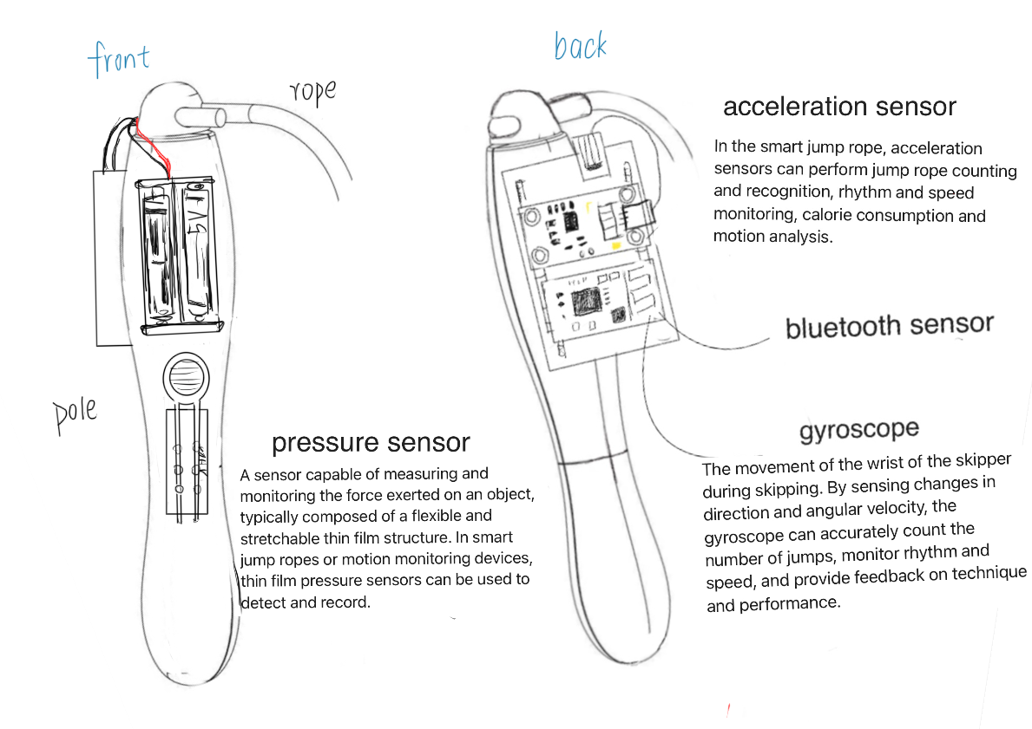

Appendices 1 Design Sketches

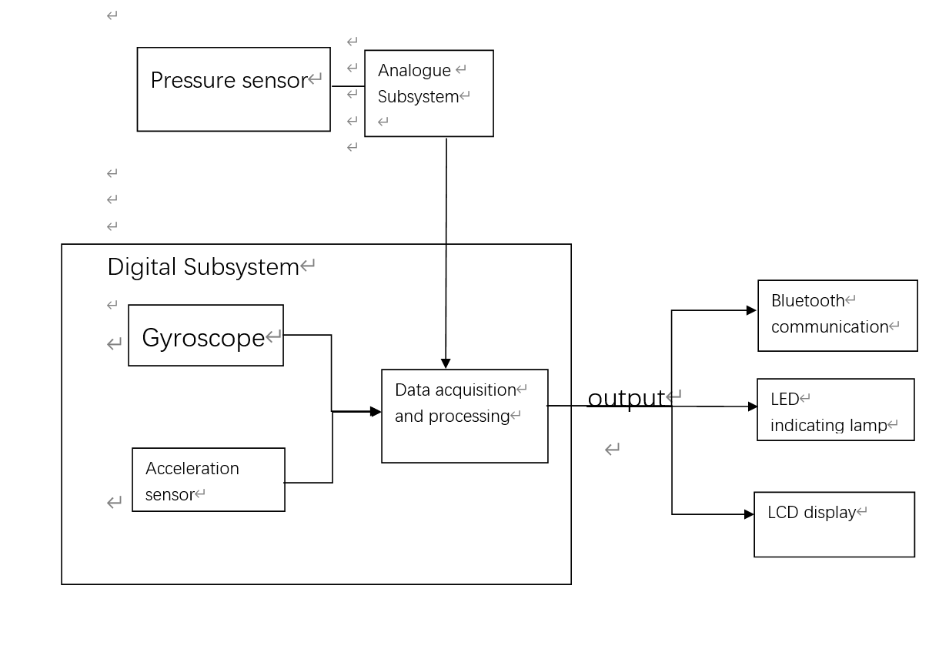

Appendices 2 Component Functions and Flowcharts

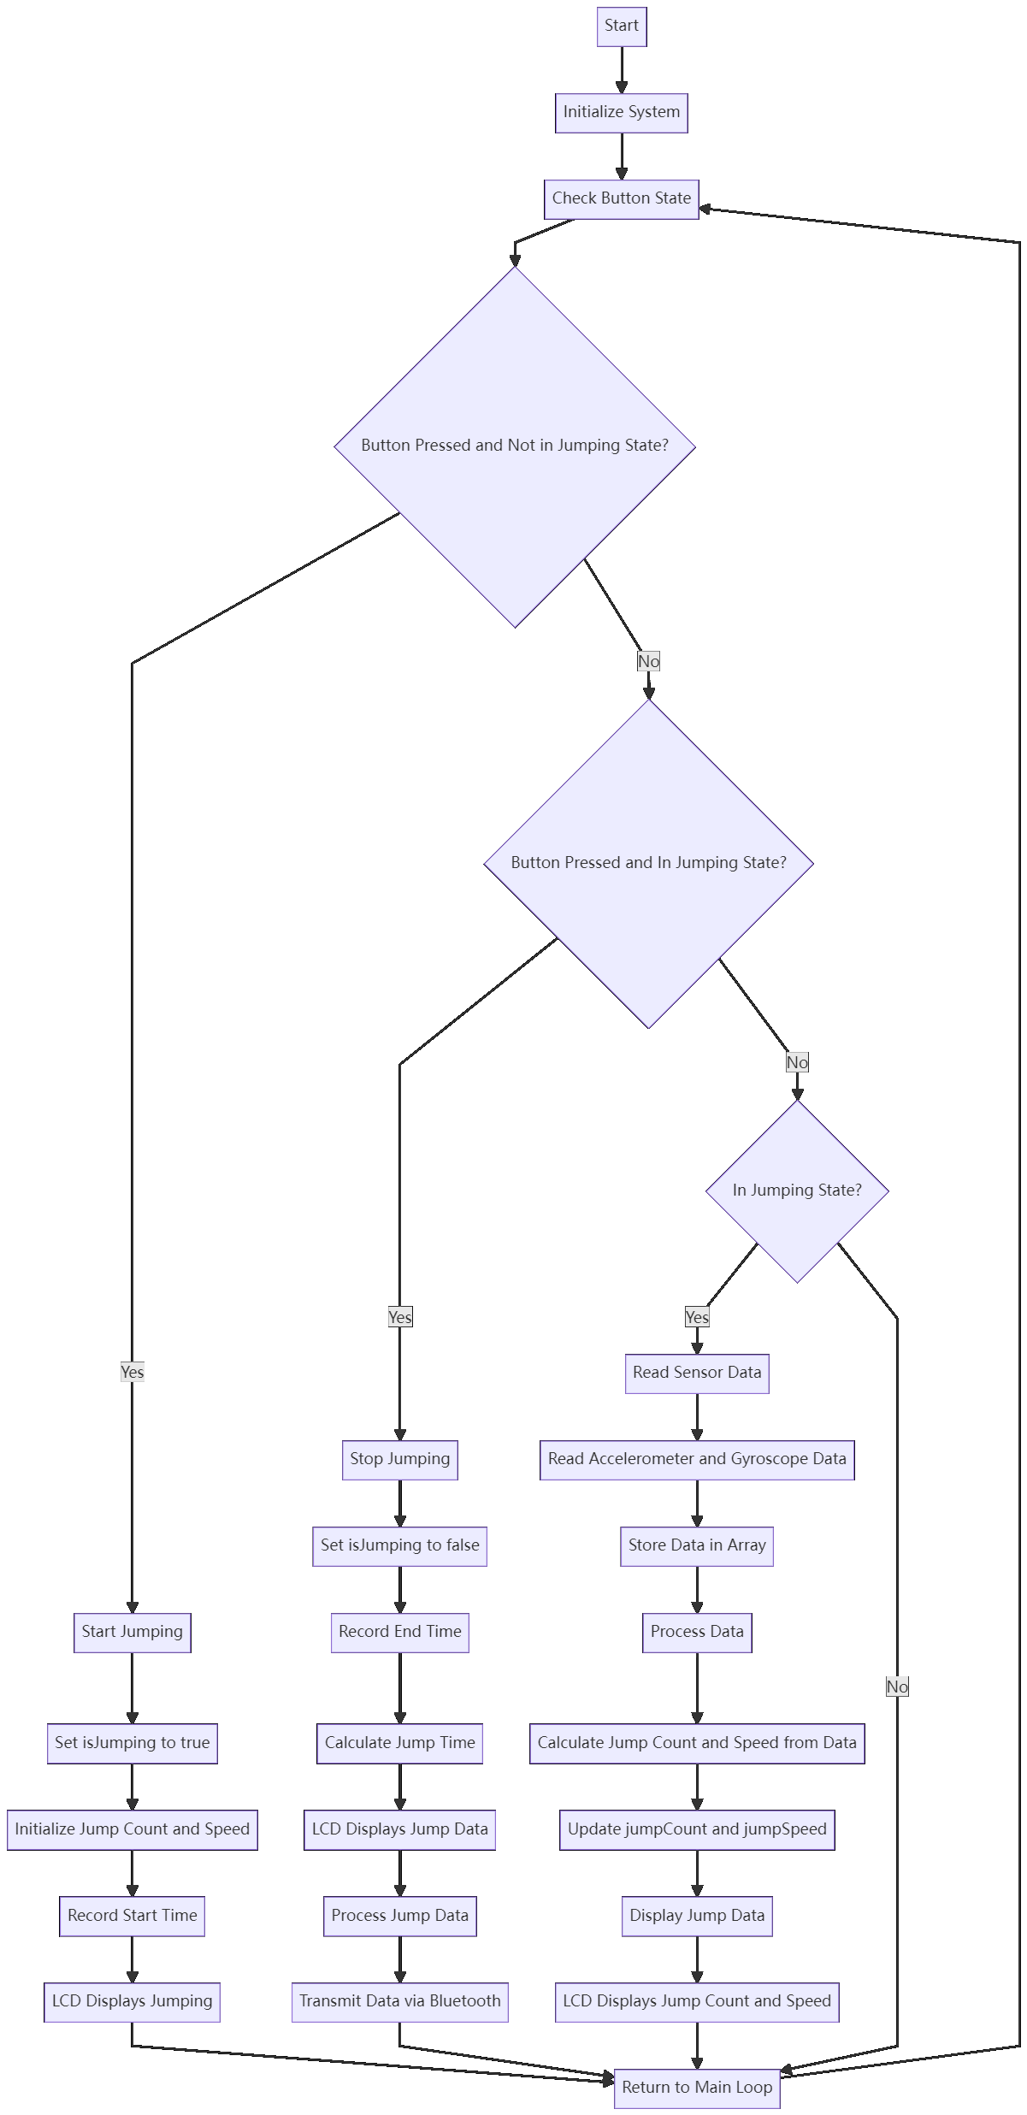

Appendices 3 algorithm flow chart

Appendices 4 Restrictions and Requirements Form