Anatomy of a Death Spiral: Newspapers and Their Credibility

Philip Meyer and Yuan Zhang

Editors have long believed in their hearts that the economic success of newspapers depends on their credibility. We find evidence to support this belief by examining 21 counties where newspaper credibility has been measured. The more people believe what they read in the papers, the greater the robustness of circulation penetration over a recent 5-year period. Unfortunately, both credibility and readership are falling in what appears to be a classic reinforcing process.

Philip Meyer is Knight Professor of Journalism, University of North Carolina at Chapel Hill.

Yuan Zhang is a second-year PhD student at the University of North Carolina at Chapel Hill.

Delivered to the Media Management and Economics Division, Association for Education in Journalism and Mass Communication, Miami Beach, Fla., August 10, 2002
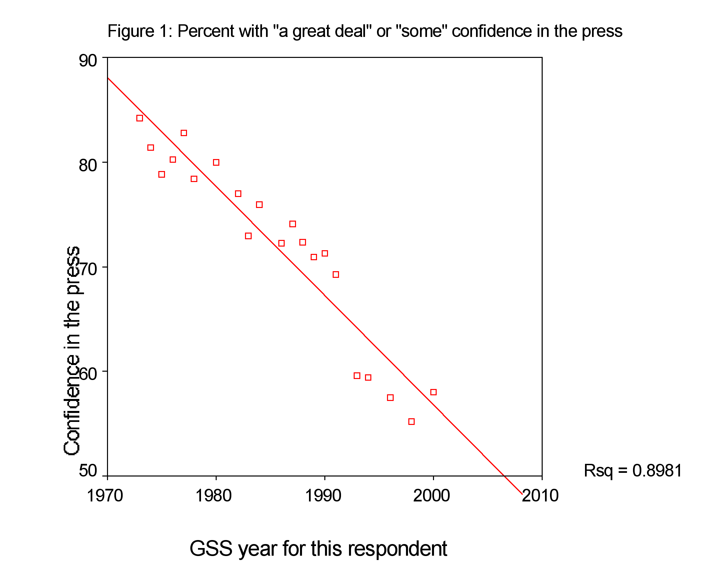

Inquiries to
Philip Meyer
CB 3365 Carroll Hall
University of North Carolina
Chapel Hill, NC
27599

Philip_meyer@unc.edu

919 962-4085
Introduction
While newspaper editors have fretted about their credibility for decades, they have been unable to do much about it. Given limited resources by their publishers and owners, they remain mostly frozen at the wheel while both readership and confidence in the press decline steeply and consistently.
The surface evidence suggests a classic death spiral or reinforcing process. Waning confidence in the press causes lower readership which reduces profits which limits the availability of resources for the editorial product, causing confidence to fall still more. The trend lines in Figure 1 and Figure 2 provide the evidence. According to the General Social Survey, expressions of “a great deal” or “some” confidence in the press have declined at 0.8 points per year. The proportion who read a newspaper every day has fallen a percentage point per year since the first measurement by the National Opinion Research Center in 1967.

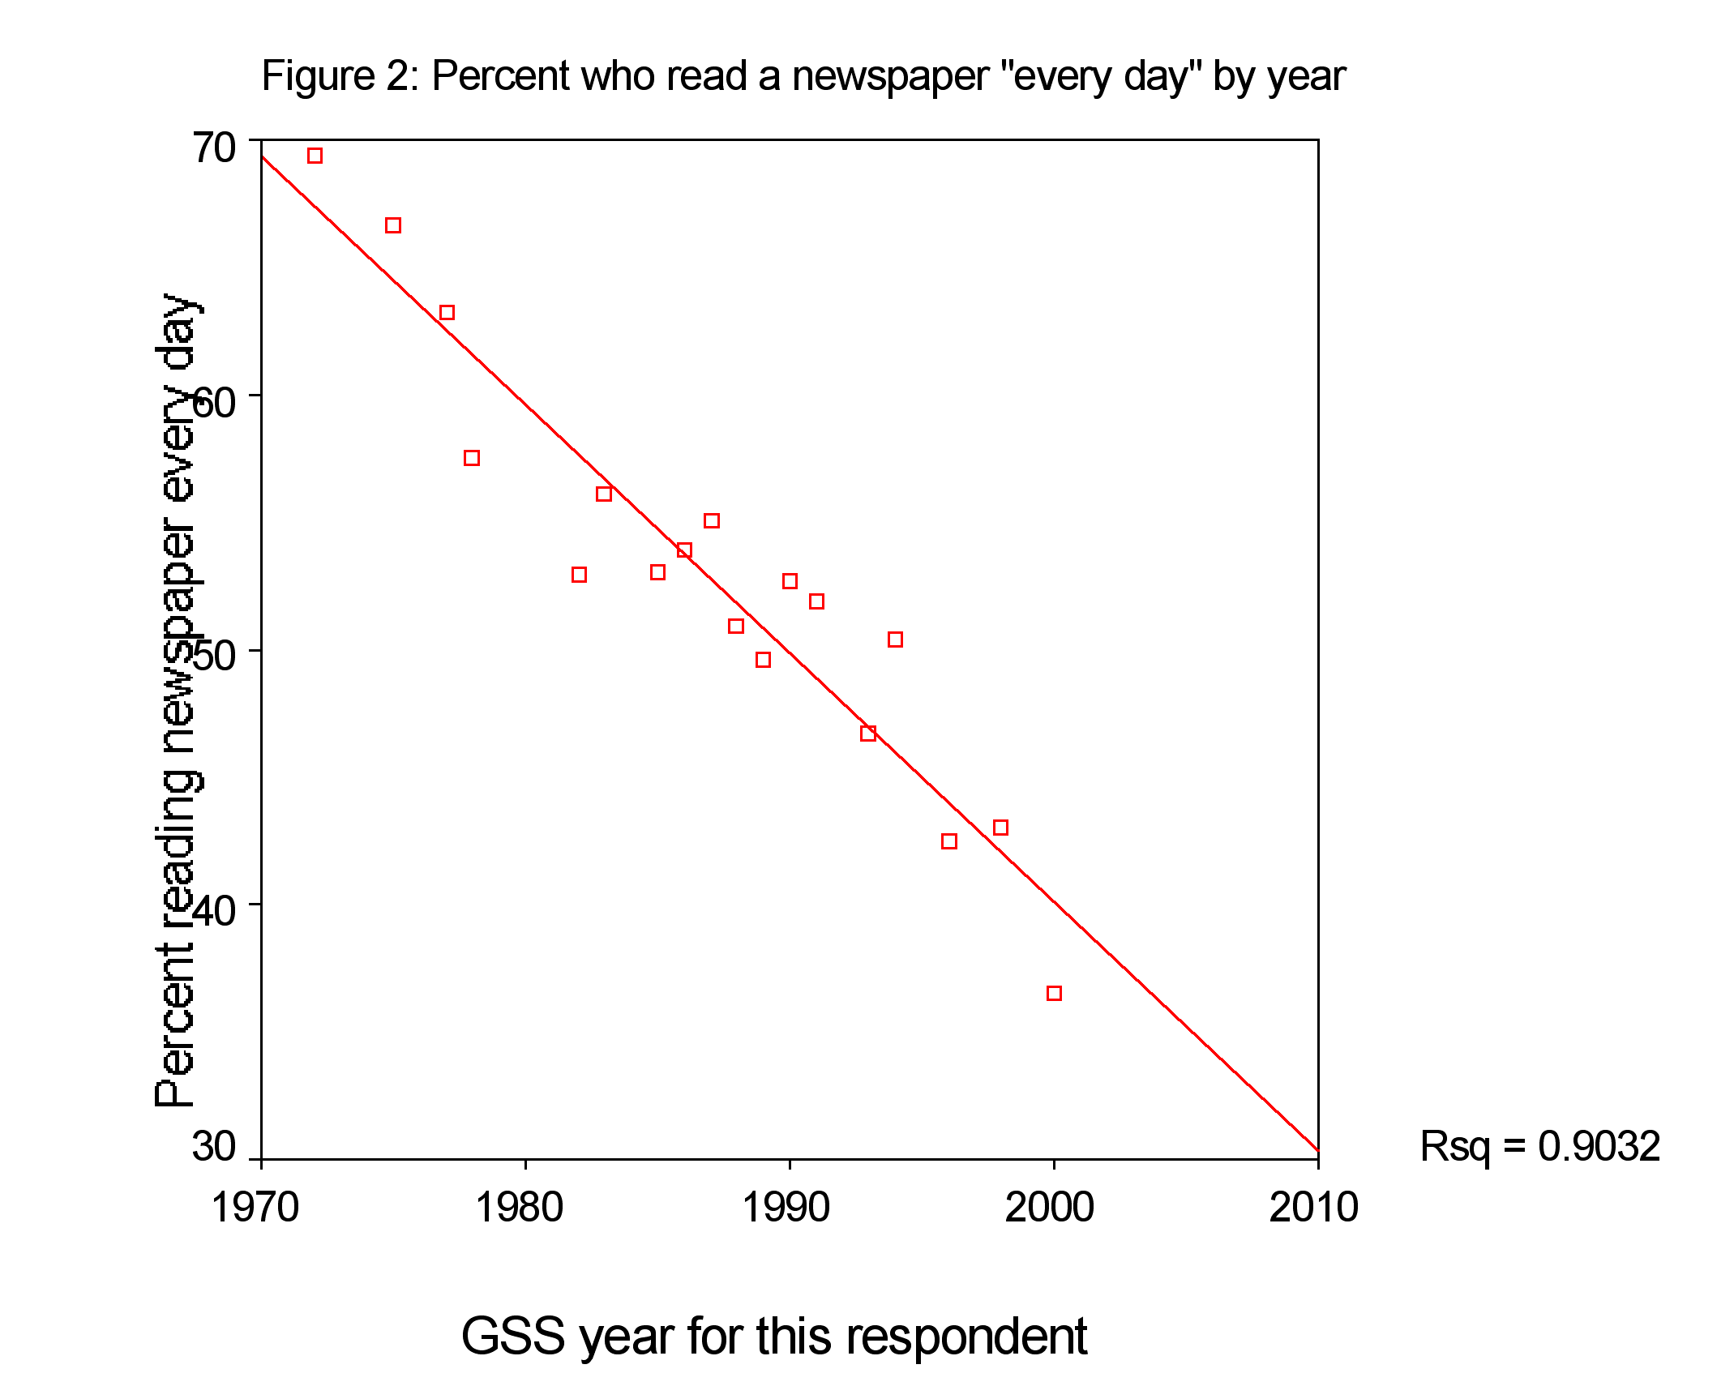
However, it is imprudent to draw causal inferences from parallel changes across time. Both readership and confidence could be the result of some secular trend that affects everything in society. Textbooks abound with illustrations of spurious correlation over time, e.g., between liquor consumption and church attendance. (Both increase due to the growing population.)
To see if there is really a causal link between low confidence and low readership, we need an experimental design that holds time constant. Because the problem is too large for the laboratory, we need a natural experiment that can tell us whether confidence and readership covary within a limited time frame. This report describes such a natural experiment. It builds on work that others began as far back as 1985 when two major studies produced contrasting interpretations of the problem.

Previous credibility research
The most alarming report came from Kristin McGrath of MORI Research, hired by the American Society of Newspaper Editors to do a national survey. “Three-fourths of all adults have some problem with the credibility of the media,” she wrote, “and they question newspapers just as much as they question television.”
A contrasting report was issued early the following year by the Times Mirror newspaper after it hired The Gallup Organization to cover the same territory.
“If credibility means believability, there is no credibility crisis,” said this report, written by Andrew Kohut and Michael Robinson. “The vast majority of the citizenry thinks the major news organizations are believable.”
Oddly, the data collected by the two organizations were not very different. Their varying question forms obscured close comparison, but 84% in the Times Mirror study gave a positive rating to their local daily newspaper on a scale where “4 means you can believe all or almost all of what they say, and 1 means you can believe almost nothing of what they say.” The ASNE study used a 5-point scale, and 85% gave either a positive or neutral rating on accuracy of the newspaper with which they were the most familiar.
Another contribution to the conversation came in 1998 when Christine Urban, also working for ASNE, produced another report. Hers made no reference to the earlier work, but it did propose six major sources of low trust. Number one on the list: “The public sees too many factual errors and spelling or grammatical mistakes in newspapers.”
Two purely descriptive studies were published in 2001. News credibility was one of a very broad array of social indicators asked about in 1999 by the Knight Foundation which found that 67 percent believe “almost all or most” of what their local daily newspaper tells them. A similar result was published at the same time by American Journalism Review, based on fieldwork in 2000 funded by the Ford Foundation. This study reported that 65 percent believe all or most of what they read in the local paper.
Designers of none of these studies made any effort to attain compatibility with previous work so that comparisons could be made over time. Still, American Journalism Review’s author declared, “newspapers seem to be rising in readers’ esteem.”
Nor were any of the studies informed by any kind of theory that might help us understand how much credibility a newspaper needs, how much it costs to get it, and whether the cost is worth it. As careful and detailed as they were, they generated little but description “waiting for a theory or a fire.”

A proposed model
Much of the variation in historical concern with the credibility problem may be based more on emotion than reality. The purpose of this inquiry is to find a more solid theoretical basis for assessing the problem. One untested theoretical assumption is that credibility has something to do with business success. It was expressed eloquently by a Knight Ridder executive a quarter century ago:

A newspaper's product is neither news nor information. We are in the influence business. We create two kinds of influence: societal influence (not for sale) and influence on the decision to buy (for sale). But they are related, because the former enhances the value of the latter.
The appeal of the influence model is that it provides a business rationale for social responsibility. The way to achieve societal influence is to obtain public trust by becoming a reliable and high-quality information provider, which frequently involves investments of resources in news production and editorial output. The resulting higher quality justifies more public trust attributed to the newspaper and, not only larger readership and circulation, but influence with which advertisers will want their names associated.
Because trust is a scarce good, it could be a natural monopoly, as argued by Meyer. Once a consumer finds a trusted supplier, there is an incentive to stay with that supplier rather than pay the cost in time and effort of evaluating a substitute.
It follows then that societal influence of a newspaper achieved from practicing quality journalism could be a prerequisite for financial success. Social responsibility in the democratic system supports, rather than impedes, the fulfillment of a newspaper’s business objectives, through the channels of obtaining public trust and achieving societal influence, which then feeds back into further fulfillment of the public mission, thereby creating a virtuous cycle (see Figure 3).
Figure 3. Societal Influence Model for the Newspaper Industry
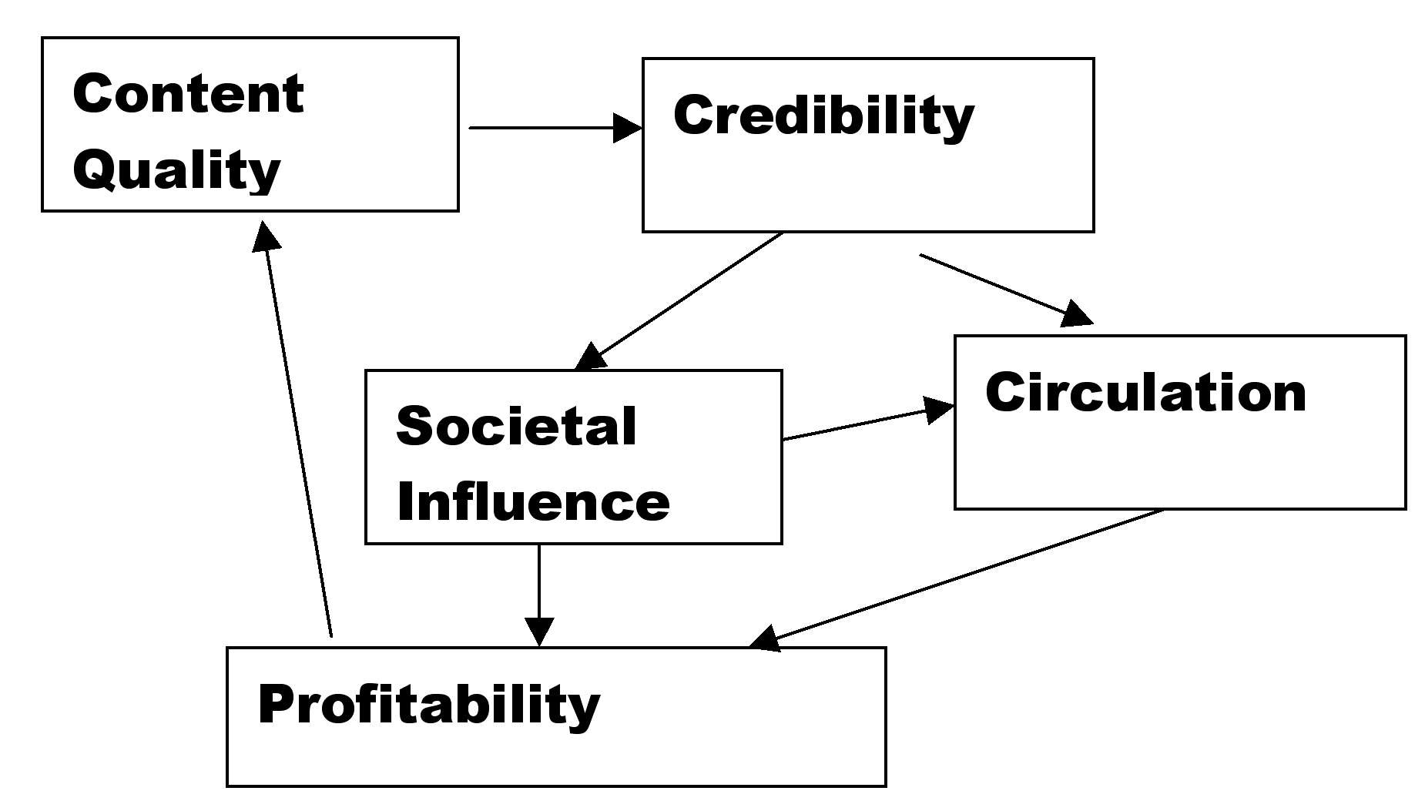

Reversing the argument, cutbacks in content quality will erode public trust, weaken societal influence, and eventually lead to losses in circulation and advertising dollars. But managers, under pressure from owners and investors, will do this anyway because reducing quality has a quick effect on revenue that is instantly visible while the costs of lost quality are distant and uncertain.
If those distant costs could be made more concrete and predictable, managers and investors might make different decisions. The purpose of this study is to reduce the uncertainty about the long-term cost of low credibility using individual communities as the level of analysis. Previous studies using communities have focused on editorial quality in general rather than specifically targeting credibility.

Community based studies
The Washington Post’s coverage of the Pentagon Papers and the Watergate affair provided anecdotal evidence that good journalism could be profitable. The success of USA Today proved that innovations in format and content could pay off in the form of circulation and advertising success. Becker et al. studied 109 New England newspapers and found that circulation penetration (circulation divided by households) was related to news quality. Stone et al. also reported positive correlation between newspaper quality and circulation in a sample of 124 papers. Using content analysis to judge quality, Lacey and Fico found that the level of newspaper quality in 1984 was positively related to circulation (with market size controlled) in 1985 for 106 daily newspapers. Blankenburg examined quality-related variables such as staff size, number of news pages, and news-editorial budget in 149 newspapers, and found that these variables were highly correlated with circulation. More recently, Lacey and Martin’s case study of the Thompson papers found that they lost revenue and circulation during the 1980s when high profits goals were set. Overall, most studies have found a positive relationship between quality and circulation. However, they are mostly dated and have not used direct measures of credibility as an indicator of quality. Today's pressing media environment calls for new empirical evidence, particularly in regard to the priorities the newspaper industry has to take.
Our test of the model will be a very basic one: a search for a correlation between credibility and profitability. We need to be able to measure these two variables at the level of individual newspapers. Fortunately, a convenience sample is available.

The natural experiment
The Knight Foundation keeps track of the 26 communities where John S. and James L. Knight operated newspapers in their lifetimes. They range from large (Philadelphia and Detroit) to very small (Milledgeville, Ga., and Boca Raton, Fla.). This common history will make our findings less generalizable to the universe of all daily newspapers, but it carries an offsetting advantage. By removing some of the differences in corporate culture and history from the causal model, the choice of these communities reduces some possible sources of spuriousness. Like a laboratory experiment conducted at constant temperature, this inquiry holds aspects of corporate history and culture constant.
Our independent variable is credibility as measured in a social indicators study fielded in 1999 by the Knight Foundation. The dependent variable is a little more complicated. We call it circulation robustness, and we measure it by comparing changes in newspaper household penetration as measured by the 1995 and 2000 county penetration reports of the Audit Bureau of Circulations (ABC). Penetration declined almost everywhere. We define penetration as robust when the 2000 figure is a high proportion of the penetration in the 1995 report. We eliminated two Knight communities where the survey geography was not defined by counties.
This made it possible to match data from other sources, including the Audit Bureau of Circulations, in a clear and minimally ambiguous way.
We are left with a sample of 24 markets. In two of them, Columbia, S.C., and south Florida, the Knight Foundation’s historic relationship with the communities led it to define them by two counties rather than single counties. We have combined the data from other sources to match that design in the case of Richland and Lexington counties in South Carolina. In more heavily populated south Florida, we separated Dade and Broward counties and treated them as separate communities. Now we have 25.
Most of them have newspapers that are now, or have been, owned by Knight Ridder. Several have more than one strong newspaper. No attempt was made to isolate the effects of individual newspapers. These effects are self-weighting because circulation robustness is measured by the circulation of all ABC newspapers in each county, while the credibility question measures the paper with which respondent is “most familiar.”
The percent who say they believe all or almost all of what they read in the paper ranges from 13 in Tallahassee to 30 in Grand Forks (mean = 21, S.D. = 3.9). Previous research has suggested that credibility, defined straightforwardly as believability, is a stable attribute.
The same cannot be said for our dependent variable. It is based on circulation which can be subject to intense short-term fluctuations depending on local conditions.
Robustness, expressed by taking 2000 penetration as a proportion of 1995 penetration, ranged from .59 (Baldwin Co., Georgia) to 1.02 (Miami). The range was so vast in fact that a probe of the outliers was called for. Tukey’s box plot makes the outliers visible. The box represents the interquartile range or middle 50%, and the outliers are cases more than 1.5 box lengths from the edge of the box (Figure 4).
Figure 4. Tukey box plot showing outliers.

Investigating each of the outliers in turn, we found:
Dade County, Fla. – The Miami Herald’s explosive circulation boom was the result of an artifact, the unbundling of El Nuevo Herald from its mother ship. After the separation, ABC counted circulation of the Spanish language edition separately for the first time. We could think of no way to correct for this for a before-after comparison, and Dade County was dropped from the sample.
Boulder County, Colo. – In the months before the creation of the joint agency by the owners of the Denver Post and the Rocky Mountain News in 2000, the two Denver newspapers were engaged in a bitter circulation war that saw the price of a newspaper drop to a penny per copy. This battle extended into neighboring Boulder County. While it cost the local paper circulation, total newspaper circulation in the county – the variable we are using to define penetration robustness – soared. Because of this extraneous cause, we dropped Boulder County.
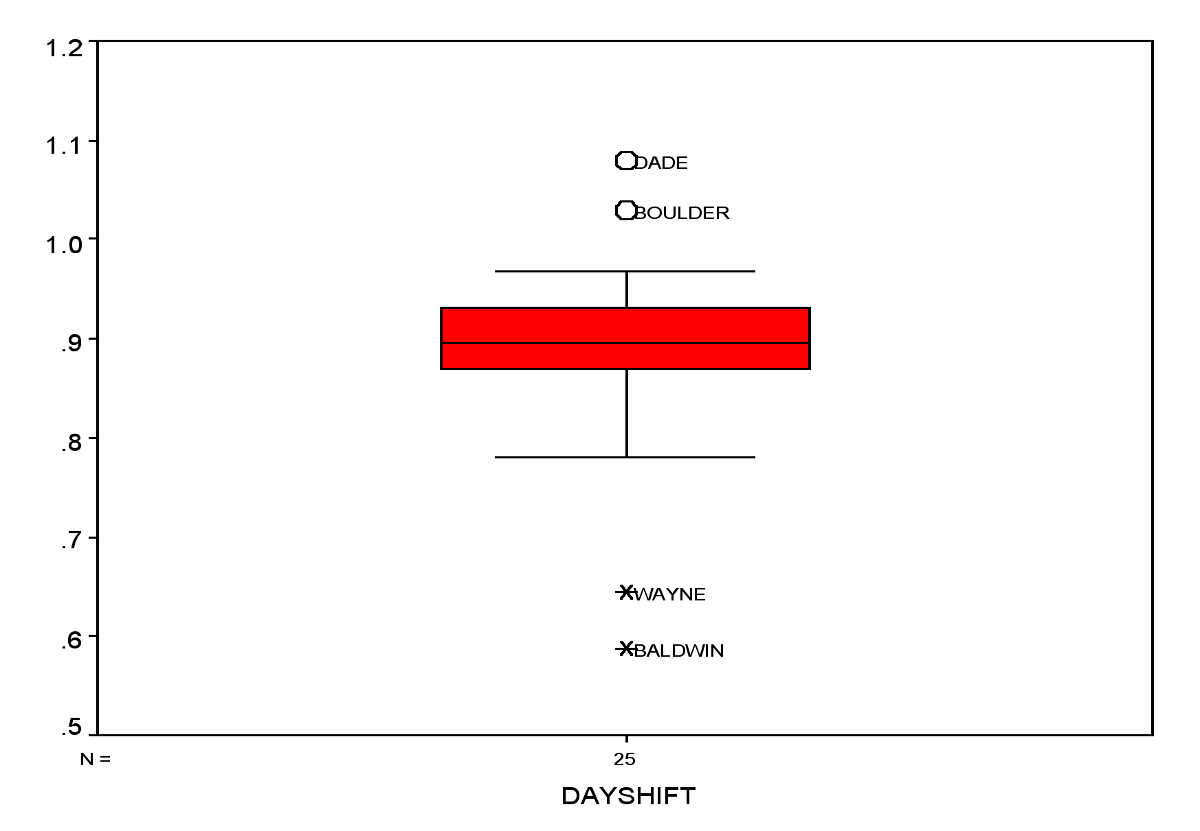
Wayne County, Mich.– Detroit, always a strong labor town, underwent a bitter newspaper strike that began in 1995 and led to many union members losing their jobs. In a display of sympathy and solidarity, enough working people in the home county stopped buying the paper to cause a catastrophic circulation decline. We took Wayne County out of the sample.
Baldwin County, Ga. – The leading newspaper, the Milledgeville Union-Recorder, is not an ABC member. The precipitous loss of ABC circulation can be ascribed to the decision of the Macon Telegraph to close its Baldwin County bureau. Since our sample is defined by audited circulation, Baldwin County was removed from the sample.
That leaves 21 communities without obvious exogenous variables to mask the effect of credibility on circulation. Here’s how we operationalized credibility.
The question in the Knight Foundation surveys was, “Please rate how much you think you can believe each of the following news organizations I describe. First, the local daily newspaper you are most familiar with. Would you say you believe almost all of what it says, most of what it says, only some, or almost nothing of what it says?”
We know from the previous reports of McGrath, Urban, and Stepp that two demographics, age and race, have a substantial impact on newspaper credibility. Blacks and older citizens are more suspicious of what they read in newspapers.
This difference is also found in the 1999 Knight data. In the total the sample, (N = 15,481), belief in the newspaper was negatively correlated with age (r = -.129, p < .01) and positively, although less importantly, with race treated as a binary variable where black = 1
(r=-.065, p < .01).
Because our counties differ in the proportions of blacks and older citizens, we chose to account for those effects before looking for the effect of credibility on penetration retention.
We leveled the playing field by running multiple regression with trust as the dependent variable and percent black and mean age – both from the survey data – as the independent variables. The unstandardized regression residuals represent each county’s trust score with the effects of race and age filtered out (observed minus expected). For example, Grand Forks County’s score of 7.8 means that the newspaper’s credibility score was 7.8 percentage points above what the age and racial makeup of its citizens would have led us to predict.
Here are the counties with their credibility scores and 1995-2000 penetration robustness listed in order of their credibility.

County Credibility Robustness
(Adj.)
Grand Forks ND 7.89 .96
Muscogee GA 4.83 .97
Broward FL 4.64 .87
Harrison MS 3.65 .90
Brown SD 2.17 .96
Lexington SC* 0.91 .84
St. Louis MN 0.58 .87
Centre PA 0.54 .84
Mecklenburg NC 0.44 .89
Manatee FL 0.23 .90
Philadelphia PA 0.06 .93
Bibb GA -0.10 .91
Fayette KY -0.68 .94
Allen IN -1.04 .90
Horry SC -1.13 .92
Ramsey MN -1.72 .88
Palm Beach FL -1.73 .88
Santa Clara CA -1.84 .87
Summit OH -4.71 .91
Sedgwick KS -4.89 .84
Leon FL -8.09 .78
*Includes Richland County
The correlation coefficient is .609, meaning that the credibility of a county’s newspapers explains 37 percent of the robustness in their combined daily penetration.
The probability that this relationship is due to chance is less than one half of 1 percent
(p = .003).
When the robustness of Sunday circulation is used as the dependent variable, 38 percent of the variance is explained (r = .613, p = .003). The first link in the model in Figure 3 is established. Credibility is related to circulation. The relationship is clearer if we look at the scatter plot (Figure 5).
Figure 5. Circulation robustness by credibility
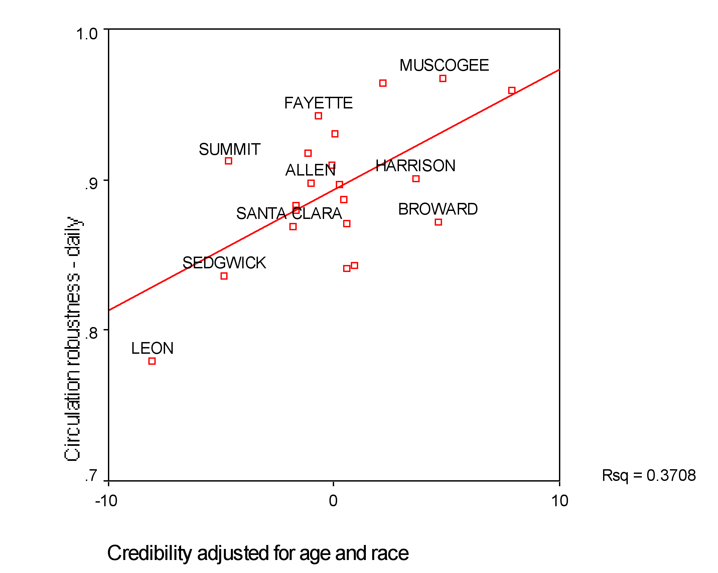
We now have the first quantitative measure of the benefit of credibility. The slope of the regression line is .008, meaning that circulation robustness -- the ability of a county’s newspapers to hold their collective circulation in the face of all of the pressures degrading it -- increases by .8 of a percentage point for each 1 percent increase in credibility. And the finding is robust. When credibility is left unadjusted for age and race, the correlation is diminished only slightly and remains statistically significant.
Correlation, of course, neither proves causation, nor establishes its direction. While it can be taken as evidence in support of the model in Figure 3, it does not tell us whether it is a picture of a virtuous cycle or a vicious cycle.
Stepp, who has the advantage of holding the most recent credibility data, argues that the news is good, that the public’s faith in newspapers is improving. He bases this on weak evidence: one question in one survey in which respondents are asked to compare their present attitude with their remembered attitudes from the past. He is supported by an uptick in the NORC 2000 data – from 58 percent who have a great deal or some confidence in the press, compared to 55 percent two years earlier. But the difference is within the range of measurement error. More data points are needed to overcome the gloomier picture painted by NORC’s 30-year trend line on readership and confidence in the press.

Further research
We need more thorough testing of the model. While the link between credibility and robustness of circulation may deserve the priority we gave it, there is also a strong need to test the link between content and credibility. The demonstrated value of credibility should motivate us to find how credibility can be created through content – or whether content makes a difference at all.
An obvious variable to investigate is accuracy in reporting. Urban’s 1999 study provided cross-section evidence at the level of the individual reader. But it is almost a tautology that people who perceive errors in the paper are less likely to believe it. To make Urban’s finding convincing, we need evidence at the community level. Is a newspaper that is objectively more accurate also more believed? A replication of Mitchell Charnley’s path-breaking accuracy study in each of the markets where trust is also measured could give us stronger evidence.
Beyond content, the history of a newspaper’s relationship with its community should be considered. David Loomis, looking at the same data we are using, noticed a striking difference in credibility between two similar southern newspaper markets, Columbus, Ga., and Tallahassee, Fla., and did some first-hand investigating in both communities.
He found that the leading papers in the two towns had quite different histories from the civil rights movement. The paper in Tallahassee, before its acquisition by the Knights in 1965 was a die-hard supporter of segregation. The paper in Columbus took a mediating role in the community, and today Columbus is one of the few places where newspaper credibility is as high among blacks as whites. Perhaps no ordinary amount of content manipulation can overcome history.
Efforts are also needed to measure a newspaper’s societal influence and its effect on both credibility and profitability. McGrath’s study for ASNE led to some secondary analysis that suggested that credibility has a community affiliation dimension that interacts with simple believability. Despite the intriguing opportunity this information offered for a theoretical basis for civic journalism, we know of no attempts to replicate or build upon that finding. However, an opportunity exists in both the Knight Foundation data and another recent set of community benchmark surveys organized by Robert Putnam for his Saguaro Seminar. Both measure community involvement as well as trust in media. However, the Putnam survey asked about trust in media generally, rather than newspapers specifically as the Knight Foundation did.
Because our model attempts to describe a string of causal relationships, time series studies are needed to clarify and validate it. Fortunately, the Knight Foundation has designed its community surveys for periodic measurement, and the second in the series entered the field in 2002.

We regret not starting this work years ago. The decline of newspapers is not likely to be halted or reversed until investors can see a measurable benefit from a newspaper’s community influence, its social responsibility. Without such measurements, owners and managers will continue to regard quality as mere cost, and the self-reinforcing loop of the death spiral will continue.

References

Reinforcing processes are examined from a systems theory perspective by Peter M. Senge in The Fifth Discipline: the Art & Practice of the Learning Organization, Currency Doubleday, 1990. p. 81.
NORC first asked the newspaper readership question in 1967 as part of Sidney Verba and Norman Nie’s Participation in America study. It became part of the General Social Survey in 1972.
Newspaper Credibility: Building Reader Trust, a National Study Commissioned by the American Society of Newspaper Editors. MORI Research, Inc., Minneapolis, April 1985.
The People & the Press: A Times Mirror Investigation of Public Attitudes Toward the News Media Conducted by The Gallup Organization. Times Mirror, January 1986.
The People & the Press, p. 20
Listening and Learning: Community Indicator Profiles of the Knight Foundation Communities and the Nation, Miami: Knight Foundation, 2001.
Carl Sessions Stepp, “Positive Reviews,” American Journalism Review, March 2001, p. 58.
This phenomenon is not confined to media businesses. Ronald Coase, in a critique of early institutional studies in business administration, said, “Without a theory they had nothing to pass on except a mass of descriptive material waiting for a theory or a fire.” Quoted by Oliver E. Williamson in Giovanni Dosi, Davide J. Teece and Josef Chytryl, Eds., Technology, Organization and Competitiveness: Perspectives on Industrial and Corporate Change, Oxford University Press, 1998.
Hal Jurgensmeyer (1931-1995) in a conversation with the first author, Miami, Fla., 1978.
Philip Meyer, “Learning to Love Lower Profits,” American Journalism Review, December, 1995.
Nancy H. Maynard, "Can Media Economics Match Its Aspirations?" Nieman Reports, 49 (2), 1995. p35-37.
John Morton, "Short Term Losses, Long Term Profits," American Journalism Review, 19 (7) 1997.
Lee B. Becker, Randy Beam, and John Russial, "Correlates of Daily Newspaper Performance in New England," Journalism Quarterly, Spring 1978, p100-108.
Gerald C. Stone, Donna B.Stone, and Edgar P. Trotter, "Newspaper Quality's Relation to Circulation,” Newspaper Research Journal, Spring 1981, 16-24.
Stephen Lacey and Frederick Fico (1991), "The Link Between Newspaper Content Quality and Circulation," Newspaper Research Journal, Spring, p46-57.
William B. Blankenburg (1989), "Newspaper Scale and Newspaper Expenditures," Newspaper Research Journal, Winter, p97-103.
Stephen Lacey and Hugh J. Martin (1998), "Profits Up, Circulation Down for Thompson Papers in 80s," Newspaper Research Journal, Summer, p 70-76.
The John S. and James L. Knight Foundation promotes excellence in journalism worldwide and invests in the vitality of 26 U.S. communities where the communications company founded by the Knight brothers published newspapers. The Foundation is wholly separate from and independent of those newspapers.
Listening and Learning
Periods covered by these reports varied, but the audits generally fell in the year preceding the report.
Long Beach, California, and Gary, Indiana.
Philip Meyer, “Defining and Measuring Credibility of Newspapers: Developing an Index,” Journalism Quarterly, 65:3 (Fall 1988) 567-575.
We appreciate the help of Armando Boniche, research manager of The Miami Herald, in sharing this history.
Barrie Hartman, former executive editor of the Boulder Daily Camera provided this background.
When credibility without the controls for age and race is the dependent variable, the variance explained is 35% and 30%, respectively, for daily and Sunday circulation robustness.
Mitchell Charnley, “Preliminary Notes on a Study of Newspaper Accuracy,” Journalism Quarterly, 13:4 (December 1936), pp. 394-401.
David O. Loomis, Tale of Two Cities: Connections Between Community, Corporate Culture, and Civic Journalism, PhD dissertation, University of North Carolina at Chapel Hill, 2002.
Meyer, “Defining and Measuring Credibility of Newspapers.” See also Mark Douglas West, "Validating a Scale for the Measurement of Credibility: A Covariance Structure Modeling Approach." Journalism Quarterly 71:1, Spring1994, pp159-168.
Putnam’s codebook was available in February 2002 at www.cfsv.org/communitysurvey/docs/survey_instrument.pdf
We checked credibility as measured by Putnam against penetration robustness and found no correlation. When respondents are asked about “media,” we suspect that they tend to answer in terms of television rather than newspapers.

