How Many News People Does a Newspaper Need?

Philip Meyer and Minjeong Kim

Newspaper editors and newspaper investors see the news-editorial staff in different ways. To an editor, the staff creates the influence that makes the newspaper a viable commercial product. To an investor, the staff is mostly cost that shrinks the bottom line. We looked at more than 400 newspapers and found that those with above-average staff size (adjusted for circulation size) in 1995 were more successful at retaining circulation in the next five years. The explained variance was small but significant.

Philip Meyer is Knight Professor of Journalism, University of North Carolina at Chapel Hill.

Minjeong Kim is a first-year PhD student at the University of North Carolina at Chapel Hill

Delivered to the Newspaper Division, Association for Education in Journalism and Mass Communication, Miami Beach, Fla., August 7, 2002

Inquiries to
Philip Meyer
CB 3365 Carroll Hall
University of North Carolina
Chapel Hill, NC
27599-3365

philip_meyer@unc.edu

919 962-4085
fax 919 962-1549
Introduction

How many news-editorial staff members does it take to produce a viable newspaper? In recent years, there has been enough variability in newspaper staffing to produce the opportunity for a natural experiment. In the late 1990s, earnings of newspaper companies soared, and staff sizes grew. Then a mild recession led to cutbacks that some feared would permanently damage their companies. Jay Harris, publisher of the San Jose Mercury, resigned over that issue. In March 2002, Editor & Publisher reported that the end of the recession would not lead newspapers to return their staffing to previous levels. “Permanent fixed-cost reductions” would be the top priority as investor-pressured newspaper companies continued to try to improve their profit margins.
While publishers recognize that news-editorial and sales jobs have something to do with a newspaper’s ability to grow – or, if growth is impossible, to at least retard its decline – these categories were not immune from the recession cuts. Such decisions are difficult for managers because the value of the news-ed staff, while intuitively appreciated, is difficult to measure with any precision. Most attempts have been indirect.

Literature Review
Williamson argued that declining circulation could be remedied by improving the quality of the news product. Some newspapers have demonstrated that the quality of their newspapers have enhanced their business success. Examples include the Guardian in the United Kingdom and Times Mirror, in addition to the Washington Post’s coverage of the Pentagon Papers and the Watergate affair. Recently, Lacey and Martin found that the Thompson papers lost revenue and circulation during the 1980s when high profit goals were set. These cases and anecdotes show that good quality produces profit. Others have explored more specific indicators of newspaper quality for predicting the relationship between quality and circulation. Becker et al. found that staff size, starting salary, number of women on staff and type of ownership were related to newspaper performance by studying 109 daily newspapers in New England in 1973. Also, Stone et al. studied 124 newspapers using an interval scale for newspaper quality. The interval scale was created by the categorical distinction between superior and inferior papers and the numerical rating established by judges’ agreement. They found a positive correlation between newspaper quality and circulation. In addition, Lacey and Fico found that the quality of newspapers at time one (in 1984) was positively correlated to circulation at time two (in 1985) for 106 daily newspapers. They used a content-based quality measure. The quality index included high ratio of staff-written copy to wire service and feature service copy. Also, Blankenburg examined the 1986 Inland Daily Newspaper Association Cost and Revenue Study data. He found quantifiable quality-related variables—expenditures on news-editorial departments, staffing levels and number of news pages—in the data: He found that these variables were somewhat correlated with circulation in 149 newspapers.
In short, several studies have found a positive correlation between quality and circulation, and a few have related staff size to quality. But the studies are old, and their samples are small. We looked for a larger data set and a direct way to detect the possible link between staff size and circulation success.
Method
To start, we need a benchmark. According to newspaper folklore, a good newspaper should employ one news-editorial staff member for each 1,000 circulation.
For a test of that belief against the observable world, we used the annual census of staff members made by the American Society of Newspaper Editors. These data have been collected every year since 1978 as part of the organization’s goal to have minority staff reach the same proportion as minorities in the population served. The original target for reaching that goal was the year 2000, but it was later extended to 2025.
While ASNE publishes the minority percentage figures for each participating newspaper on its web site, it does not release the raw numbers from which those percentages are derived. However, it did provide raw data for the years 1995 and 2000 to the senior author on condition that values for individual newspapers be kept confidential.
Our first step was to merge the ASNE data files with circulation numbers from the Audit Bureau of Circulations. Like the U.S. Census, ASNE has some coverage problems and not every member newspaper responds every year. Also, many smaller newspapers do not belong to ABC and were excluded from our study for that reason.

We made one other exclusion. The national newspapers, New York Times, USA Today, and the Wall Street Journal have economies of scale that make them potentially different from local newspapers. Dropping them left us with a convenience sample of 477 ABC newspapers that responded to ASNE in 1995 and 616 responding in 2000. We checked the 1995 sample to see if the conventional-wisdom prediction of one staff member per 1,000 circulation was accurate.
3
It was. The mean news-ed staff rate for 1995 was 1.04.
But there was variation around that mean. And the average grew during the ebullient prosperity of the last half of the decade. For the year 2000, the ASNE survey showed the staffing rate had ballooned by nearly a fifth: to 1.18 per thousand circulation.
And there was some variation by circulation size, suggesting modest economies of scale. We divided our sample into four circulation categories and compared news-ed people per thousand circulation in each:
3

 | Staff per thousand circulation
Circulation | 1995 | 2000
0-15,000 | 1.15 (N=114) | 1.35 (N-182)
15,001 – 150,000 | 1.05 (N=302) | 1.15 (N=369)
150,001 – 300,000 | .86 (N=38) | .98 (N=41)
>300,000 | .72 (N=23) | .81 (N=24)
While newspaper companies prospered in this time period, the most obvious cause was their ability to raise prices in good times while newsprint prices were declining. But since these trends affected everyone in the business, we wondered if there were some small increment of business success that could be attributable to editorial staff size.
Looking at the 473 ABC newspapers that reported to ASNE in both 1995 and 2000, we grouped them into three categories depending on whether they reduced or held constant news-editorial staff size in that period, increased staff by up to 10 percent, or increased staff by more than 10 percent. The distribution:

Reduced staff 35%
Small gain 23
Large gain 41

Those that reduced staff lost significantly more circulation than the others. In the 2000 ABC county penetration report, they had an unweighted mean circulation that was 93.5% of the circulation reported in 1995. Those with small staff growth and large growth alike retained 97% of their five-year earlier circulation. The between-groups difference is statistically significant (F = 3.683, p = .026).
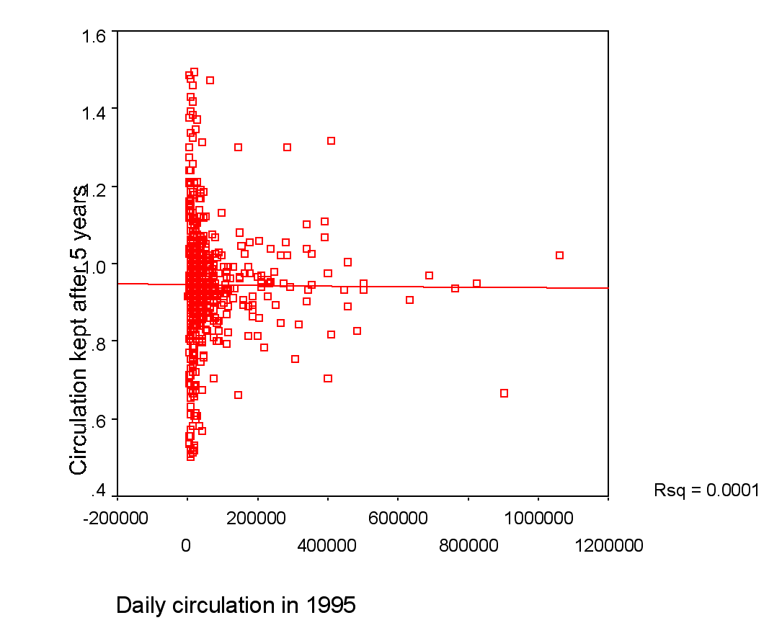
Of course, we have no way of knowing which came first: the staff loss or the circulation decline. We can make a theoretical case for one or the other as the primary cause or for a reinforcing loop where lost circulation creates financial pressure to cut staff which degrades quality and leads to further circulation loss.
Figure 1: Five-year circulation change by circulation in 1995

But because we have measures at two points in time, it is possible to look for evidence of a primary cause.
For our second look, we choose the same dependent variable, percent of 1995 circulation retained in 2000.
The dependent variable was the news-ed staff per 1,000 circulation in 1995 regardless of whether or how that figure changed in the ensuing half decade. All we need to know is whether newspapers that started the 5-year period with a more robust staff-to-circulation ratio had better results over the course of those years than those starting with less staff. Because time is one-directional, a positive result would allow us to infer that staff size is more cause than effect of healthy circulation.
A possible spurious effect is immediately suggested. Smaller papers, lacking economies of scale, will have more staff per thousand. They might also be more intimately involved with their communities and less at risk for circulation loss. If so, we should introduce a control to compensate for their lesser economies of scale.
But a look at the relevant scatter plot allays this particular fear. With extreme circulation winners and losers (> .50 in either direction) taken out for clarity, we see the scatterplot in Figure 1.

We find no correlation, just the textbook case of heteroscedasticity, a funnel pattern where the smaller the paper the more susceptible it is to circulation moves in either direction. Dividing the newspapers into quadrants by circulation size gives the same revelation. Smaller newspapers, despite their greater variance, are neither more nor less likely to suffer circulation loss than their larger brethren.
With that established, we can test for the effect of staff size with a simple regression: news-ed staff per thousand in 1995 as a predictor of circulation success over the ensuing five years.
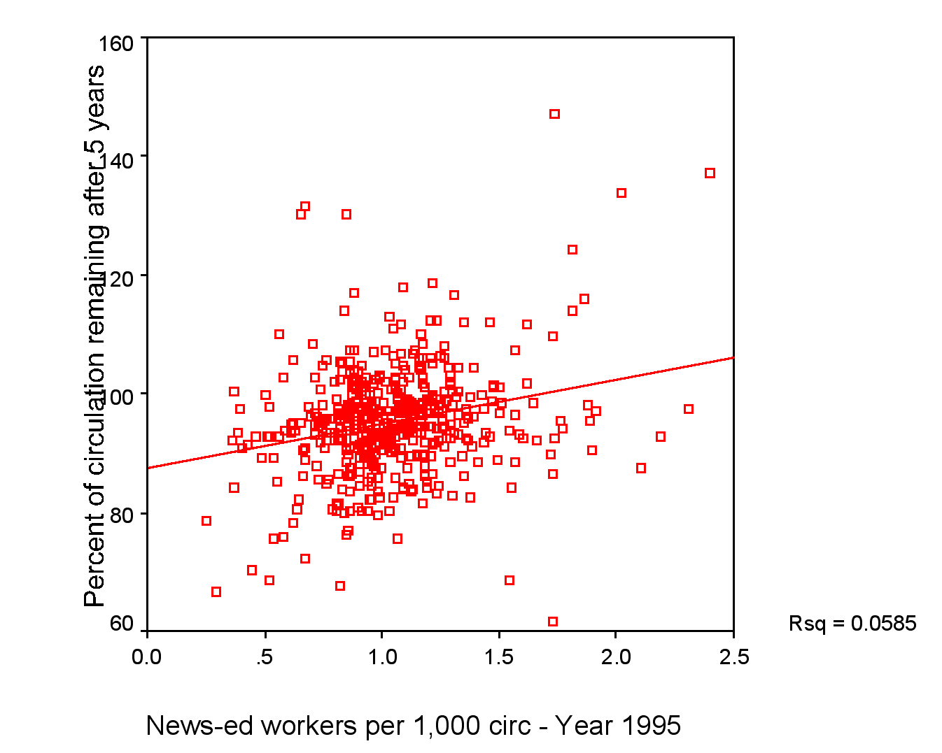
The amount of variance explained is small, 5.8%. But it is no chance phenomenon
(p < .0005). Indeed, with so many variables working to drive down newspaper circulation in the information age, we should be surprised that the effect of staff size is a visible effect at all.
AEJMC, August 7, 2002
But it is. The slope of the line is 7.427, starting from a Y intercept of 87.4. In other words, a typical newspaper with a staff/circulation ratio of 1 in 1995 would expect to have held on to 94.8% of its circulation five years later (87.4 + 7.427). But if its ratio were 1.5 per thousand, it could expect 98.5% of its original circulation.
5
This is not unmitigated good news for newspapers. To have kept its circulation constant, our hypothetical typical newspaper would have had to increase the staff ratio by (100-87.4)/7.427.
That works out to 1.7 news-ed staff members per thousand circulation – not totally out of range, but, looking at year 2000 levels, in the top nine percent of all ASNE newspapers that belong to ABC.
Still it might be worth it if only the effect were certain. But it is only one cause in a world where many other causes are trying to crowd it out. To see what explaining only 5.8% of the variance means, it helps to look at the scatter plot.

5
Figure 2: Circulation held after 5 years by staff/circulation ratio

The least-squares line moves in the expected direction. Newspapers with high staff ratios in 1995 had, on the whole, better circulation success by 2000 than those that started with low staff ratios. But, as the wide scatter around the trend line reveals, other factors were pulling circulation both up and down, and a management that banked everything on news-ed staff size alone would be offering itself as a hostage to fate.
A more important message is this: the relationship between news product and business success is not zero. An enlarged news-ed staff creates benefit as well as cost. The investment analysts who see a newspaper as a platform for delivering eyeballs to advertisers in the cheapest manner possible should think about what attracts those eyeballs to the platform.
All of this makes the need for further research fairly obvious.
First, this 5-year time comparison should be carried out with more measures at more points across a wider span of time. The effects of content on circulation are sometimes immediate, as when a major story breaks, but long-term reader loyalty takes a long term to develop.
Second, this study should be replicated with controls for other influences on circulation with particular attention to the distinction between those that cannot be controlled by management, such as market demographics, and those that can, such as promotion, presentation, delivery, price, and content. Adding more controllable variables to the equation will increase management’s ability to affect the outcome.
Third, if staff size makes a difference, it is important to know how deployment of that staff can enhance or retard the effect.
What we have done here is take data collected by other people for different purposes to build a natural quasi-experiment. Better answers can be attained with more data and larger scale quasi-experimentation, but the best answers must await a newspaper organization with the patience and resources to build a true experiment.

Jay Harris, luncheon address to the American Society of Newspaper Editors, April 6, 2001. Posted by ASNE at http://www.asne.org
Lucia Moses, The Jobs Aren’t Coming Back, Editor & Publisher, March 4, 2002.
Lenora Williamson, Circulation Drop Linked To Dull Newspapers, Editor & Publisher, New York, Oct. 2, 1976.
Howard Sharman, Britain’s Guardian Proves Quality Will Selluropes ‘Heavies’ Battle to Stay Healthy, Advertising Age, Chicago, Jan 17, 1983.
Newspapers: Times Mirror Banks on Newspaper Quality, Advertising Age, Chicago, Jan 26, 1987.
Nancy H. Maynard, Can Media Economics Match Its Aspirations? Nieman Reports, 49(2), 1995.
Stephen Lacey and Hugh J. Martin, Profits up, Circulation Down for Thompson Papers in 80s, Newspaper Research Journal, Summer, 1998.
Lee B. Becker, Randy Beam and John Russial, Correlates of Daily Newspaper Performance in New England, Journalism Quarterly, Spring 1978.
Gerald C. Stone, Donna B. Stone, and Edgar P. Trotter, Newspaper Quality’s Relation to Circulation, Newspaper Research Journal, April, 2(3) 1981.
Stephen Lacey and Frederick Fico, The Link Between Newspaper Content Quality and Circulation, Newspaper Research Journal, Spring, 12(2) 1991.
William B. Blankenburg, Newspaper Scale and Newspaper Expenditures, Newspaper Research Journal, Winter, 10(2) 1989.
http://www.asne.org
Newspaper Association of America, Facts About Newspapers – 2001.
These reports cover varying audit dates, mostly in the second half of 1999.

