3rd party services used by Focus server

These suppliers mostly offer the capability to regionalise their services.

So far as possible, for any one server, configure services to regions in the same jurisdiction for every supplier.

NB: there is some configuration information for SIP calls out of a Twilio conference call into the video meeting still to be provided.

The 3rd party suppliers are:

|  |  |  |
| --- | --- | --- |
| **Supplier** | **Service(s)** | **Web site** |
| Vonage | Video API |  |
| Amazon Web Services | Storage for recordings |  |
| Twilio | Telephony |  |
| Google | Transcription and translation |  |
| Temi | Offline transcription |  |

# Twilio

* Set up a Twilio account (twilio.com)
* With the console, you will need to configure the Voice, Chat and Sync products

## Voice

* Configure the web hook in your Voice configuration for the /sayhello endpoint on your domain
* You will need the Account SID and Auth Token for your settings_local.py
* For each phone number you want to associate with your server:
* Adapt the TWILIO_PHONE_NUMBERS JSON with your phone number and a suitable display name for it. If you specify a non-UK phone number or wish to use a different voice for the IVR announcements you should refer to the Twilio documentation for suitable values for ‘voice’ and ‘language’

## Chat configuration

* Configure a chat service with its webhooks for your domain
* You will need the service sid and chosen friendly name for your local_settings.py

Click + to add your new domain with your own chosen friendly name and domain name component:

This is an example for the present nvision server. You will need a credential list so the screenshot shows the fields you have to provide when you click to add a credential list.

Use your own server domain in the web hook URL

Secure Media must be enabled:

Use the information entered and displayed on these screens to populate these variables in the settings_local.py:

* TWILIO_SIP_DOMAIN
* TWILIO_SIP_USERNAME
* TWILIO_SIP_PASSWORD
* TWILIO_SIP_SECURE = True

## Sync service

You will need to create a Sync service with your chosen friendly name and identify it in settings_local.py:

# Vonage

* Create a Vonage Video API account
* Within the account create a project to associate with the server
* You will need the project name, API key and secret for your settings_local.py
* Configure the two webhooks for your custom domain
* Configure your archiving storage provider. Presently this must be AWS or at least S3 compatible because the use of S3 protocols to retrieve recordings is hardcoded in the application.

NB: Video codec choice may need to be reconsidered.

Editing cloud storage settings:

# AWS

AWS buckets are used for archival storage and for static web assets.

You require two buckets, one for static assets and another for recordings.

The recordings bucket should be managed by one AWS IAM user used to configure the Vonage API, and the assets buckets should be managed by another AWS IAM user identified in the settings_local.py.

You will require the following information from AWS for your settings_local.py:

* AWS_API_KEY
* AWS_SECRET
* AWS_REGION_CODE
* AWS_REGION_NAME

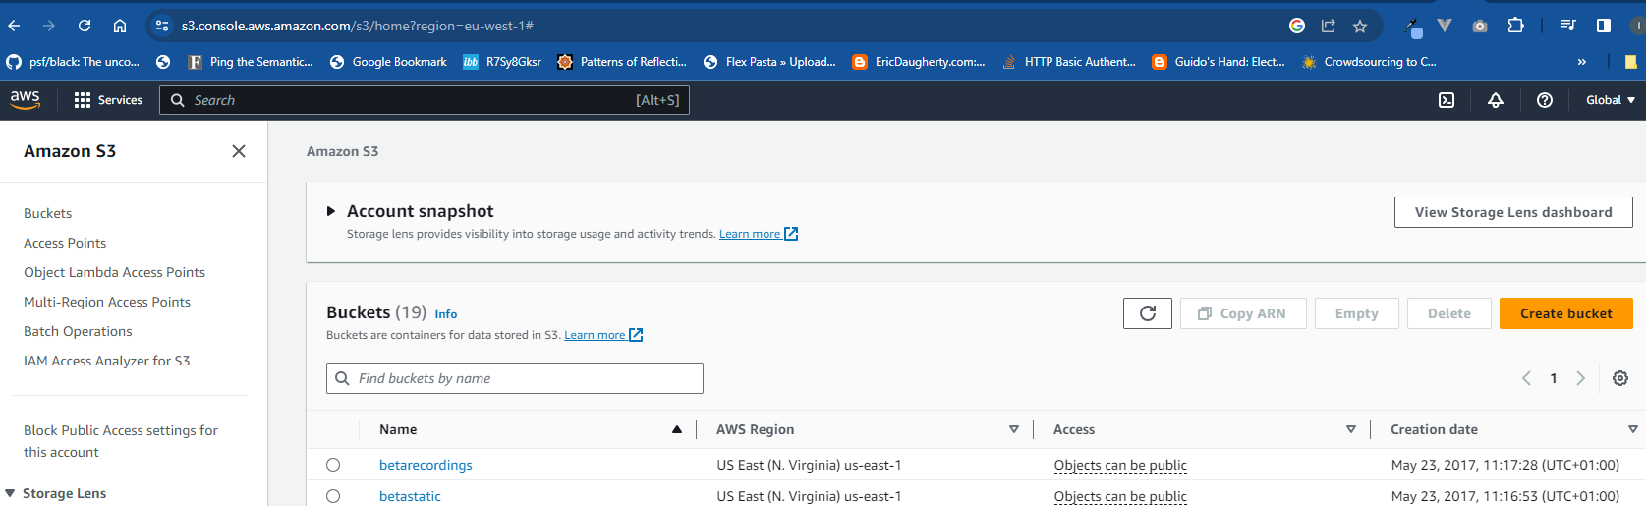

This explains the process of creating the account and the necessary users: https://chat.openai.com/share/4c45f7f6-0fad-4a18-ba23-65348cfb6fc9

# Google

You require a Google project and a JSON file containing the necessary Google API credentials for the project.

The project is identified in your settings with the symbol GOOGLE_PROJECT_ID.

The region for the project should be in REGION_ID.

Set up the Google account (if necessary) and project following this guidance https://chat.openai.com/share/ac3f30fe-5dcb-4f3d-abc8-43397b591060

The JSON file created by Google should be stored as the file /var/app/focus-distrib/gcs_speech_api.json

# Temi

Temi is an offline speech transcription API. Set up an account at temi.com and create an API key on their developer page at https://www.temi.com/account/developer

Use the key as your value for TEMI_API_KEY in settings_local.py