Generate Schedule Workflow
Simple explanation of how WICARS creates a class schedule recommendation
Purpose: This document explains what happens when a user clicks Generate Schedule. It now clearly includes time checking, conflict checking, scheduling rules, and the updated online behavior where online classes do not need a room assignment.

Flowchart
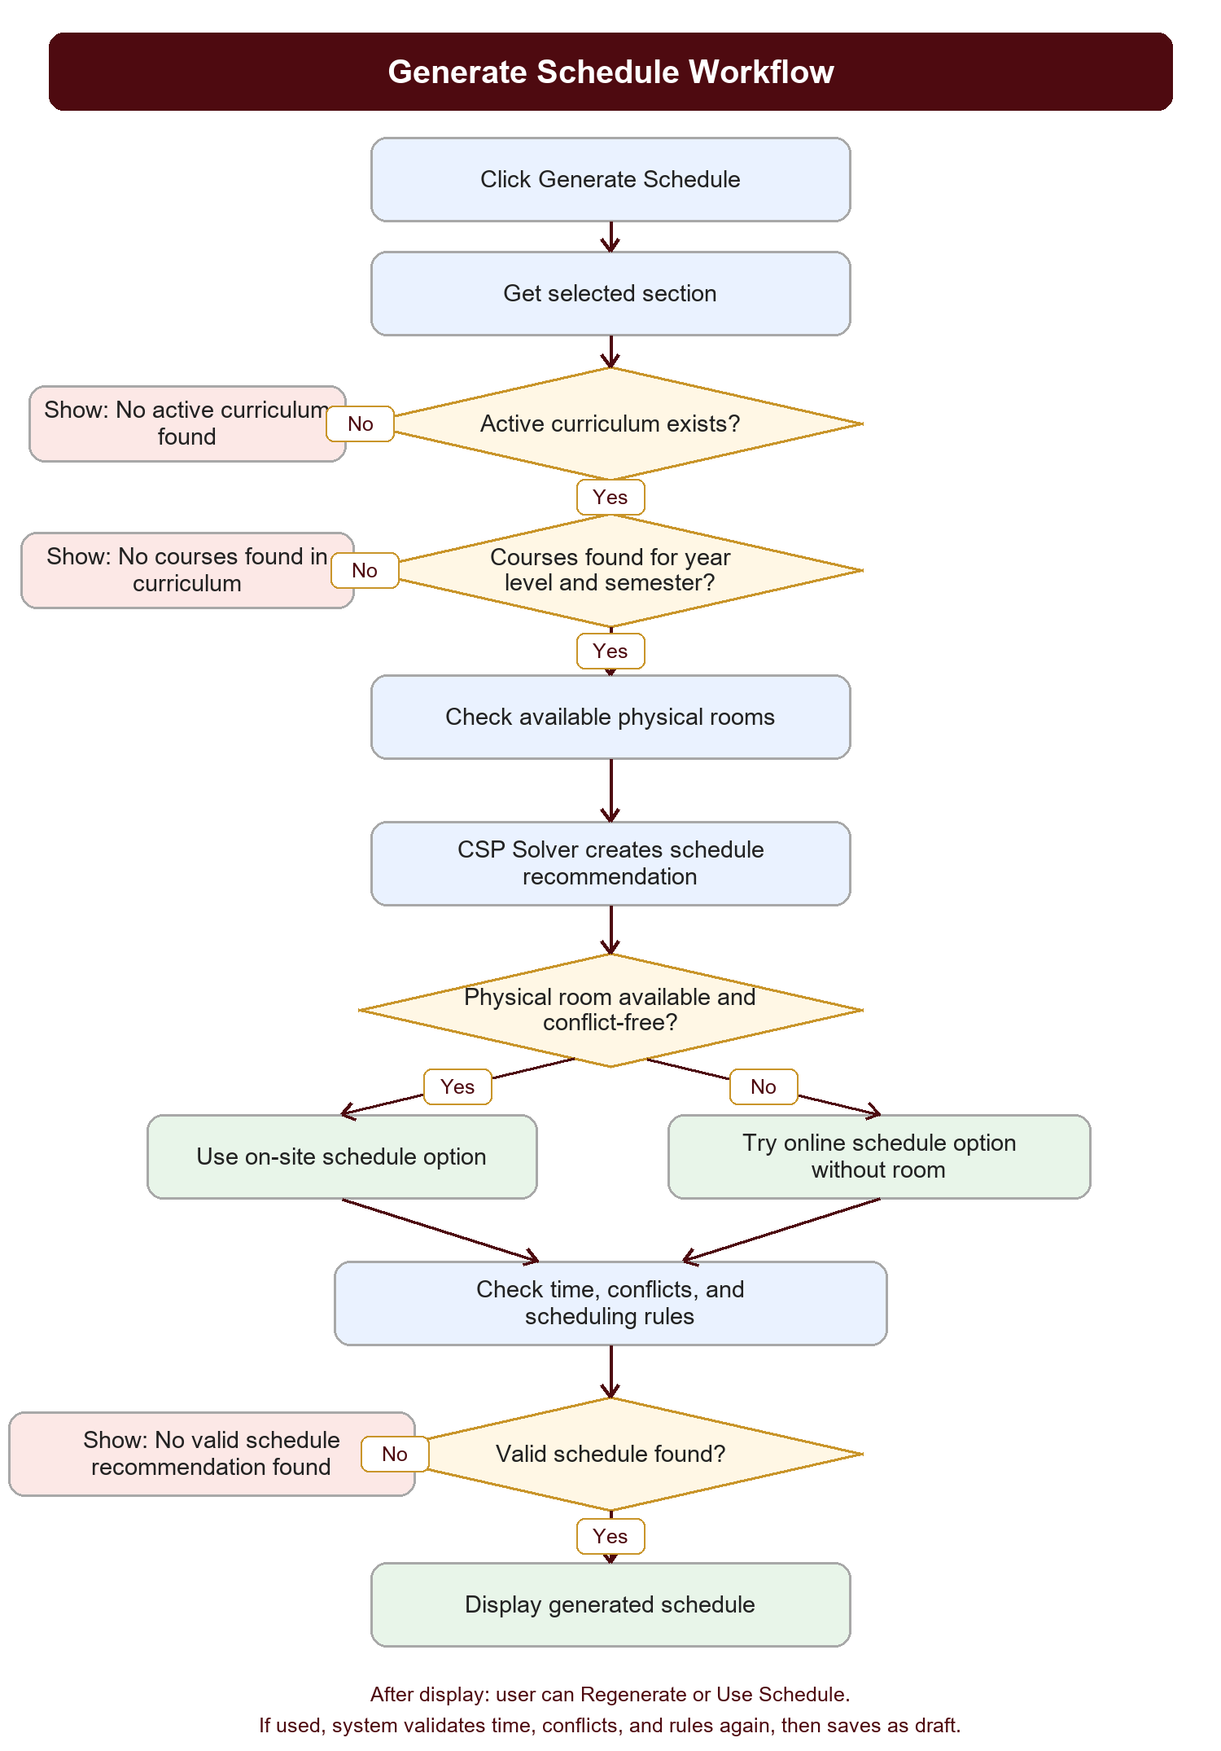

How It Works
1. User starts generation
The user clicks Generate Schedule for a selected section.
2. System checks the section
The system reads the section, year level, department, semester, and assigned academic term.
3. System checks the active curriculum
The department must have one active curriculum. If none exists, the system stops and shows No active curriculum found.
4. System gets the courses
The system reads curriculum_course and gets only the courses for that section year level and semester. If none exist, it shows No courses found in curriculum.
5. System checks rooms and possible delivery modes
The solver first tries normal on-site schedules using available lecture or laboratory rooms.
6. Online fallback is allowed
If a physical room is unavailable or causes conflicts, the solver may try online mode. Online mode does not need room_id, an online room, or a virtual room.
7. Time, conflicts, and rules are checked
The system checks time overlaps, section conflicts, faculty conflicts, room conflicts for on-site classes, allowed days, operating hours, valid time slots, and the online class limit.
8. Recommendation is displayed
If a valid combination is found, the generated schedule is shown to the user.
9. User decides what to do next
The user can regenerate if they want another attempt, or use the schedule.
10. Final validation and save
Before saving, the system validates time, conflicts, and rules again. If everything still passes, the schedule is saved as draft.
Important online rule: Online schedules can happen anywhere, so they do not need a room. However, they still cannot overlap with the same section, assigned faculty, or break the online class limit.

When Generation Stops
No active curriculum found: The department has no active curriculum to use as the source of subjects.
No courses found in curriculum: The active curriculum has no courses for the selected year level and semester.
No valid schedule recommendation found: The solver tried on-site and online possibilities, but every option still failed time checks, conflicts, or scheduling rules.

Department Room/Laboratory Workflow
This workflow explains how Generate Schedule chooses between a laboratory, a regular room, or online mode for major courses. It is useful because not all departments have their own laboratory.

Flowchart
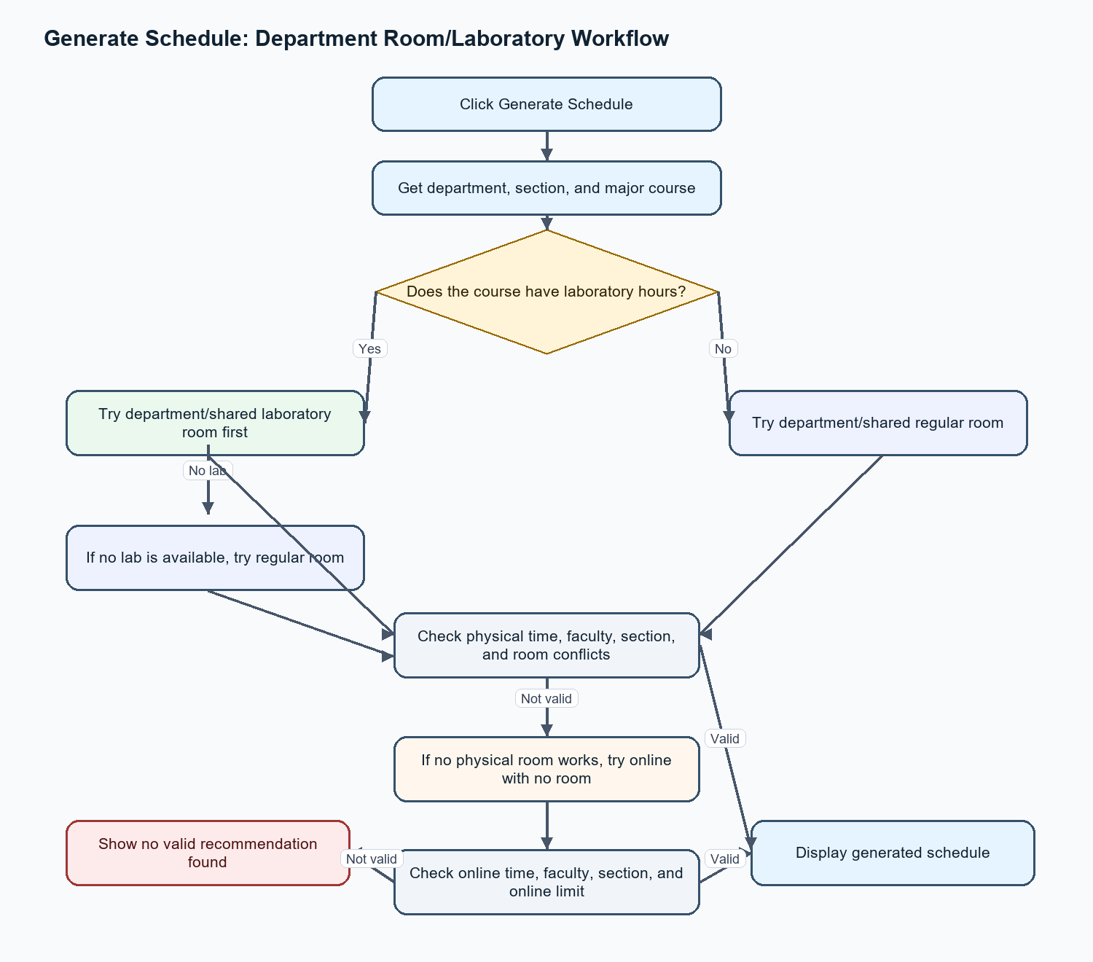

Simple Explanation
- If the major course has laboratory hours, the system tries a laboratory room first.
- If no laboratory is available, the system tries a regular room.
- If the major course has no laboratory hours, the system tries a regular room first.
- If no physical room works, the system tries online mode.
- Online mode does not need a room, but it still checks time, faculty, section, and online class limit.
- If every option fails, the system shows: No valid schedule recommendation found.

Short Rule
Use laboratory for lab courses, use regular rooms for non-lab major courses, and use online only when no valid physical schedule works.

