RADIWEB 3D
High-Performance Client-Side Medical Image Visualization Engine
User Guide

Developed by Dr. Ing. Michele Bufano
University Medical Center Freiburg
Version 1.0 | 2026
Web-Native Open Source • Research Sandbox • Freiburg System Framework

1. Introduction
RADIWEB 3D is a web-native, high-performance medical image visualization platform designed for clinical research and radiotherapy workflows. It delivers desktop-grade 3D volumetric rendering, multiplanar reconstruction (MPR), and automated multi-source co-registration — all directly within a standard web browser, with no plugins or software installation required.

Key Value Proposition
RADIWEB 3D runs entirely client-side. Your imaging data never leaves your machine — there is no backend server, no cloud upload, and no external data processing. This makes it ideal for strict institutional data protection protocols and internal research environments.

1.1 Intended Users
This guide is intended for:
- Medical physicists working with volumetric CT, MR, or PET imaging data
- Radiotherapy teams requiring dose, structure, and planning visualization
- Researchers working with NIfTI brain atlases and segmentation data
- Clinical engineers evaluating brachytherapy and RTPLAN geometries

⚠ WARNING: RADIWEB 3D is intended for research use only. It is NOT approved for clinical diagnostic decision-making.

2. Getting Started

2.1 System Requirements
RADIWEB 3D runs in any modern web browser. No installation is needed. The following are recommended for optimal performance:

Requirement | Recommended | Notes
Browser | Chrome 110+ / Edge 110+ | WebGL 2.0 required
GPU | Dedicated GPU preferred | Hardware acceleration must be enabled
RAM | 8 GB or more | For large DICOM volumes
OS | Windows, macOS, Linux | Mobile tablets also supported
Connection | No internet required | Fully client-side after initial load

2.2 Launching the Application
- Open your web browser (Chrome or Edge recommended).
- Navigate to: https://radiweb-3d.web.app — or click the "Launch RADIWEB-3D" button on the landing page.
- The application loads directly in your browser tab — no installation or login is required.
- The application is ready to use once the main interface appears.

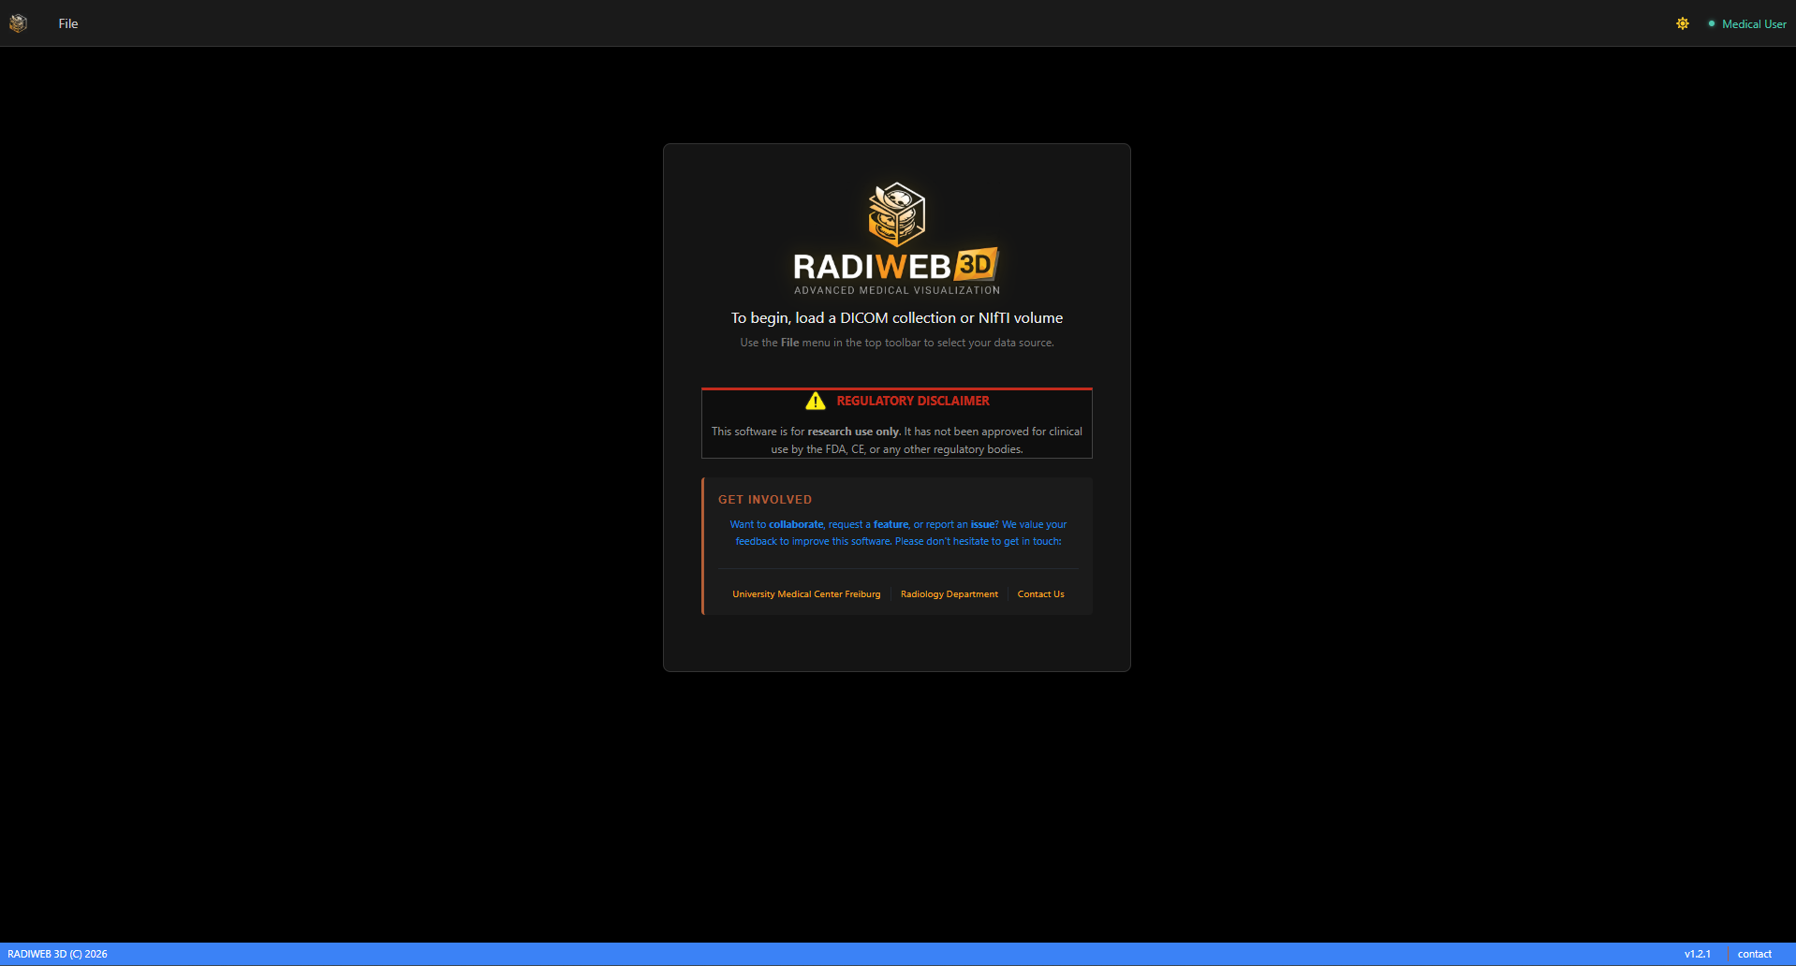
Figure: The RADIWEB 3D main interface after launching in the browser.
Live Application URL
https://radiweb-3d.web.app

2.3 The Menu Bar
The application provides two top-level menus: File and View. The View menu only appears after data has been loaded.

File Menu
The File menu is always available and provides the following options:

Menu Item | Description
Open DICOM Folder | Opens a folder picker to load a local DICOM series directory into the viewer.
Open NIfTI File | Opens a file picker to load a local .nii or .nii.gz NIfTI file.
Demo DICOM | Loads a pre-hosted DICOM dataset bundled with the application — no local files needed.
Demo NIfTI | Loads a pre-hosted NIfTI dataset bundled with the application — no local files needed.

Quick Start with Demo Data
Use Demo DICOM or Demo NIfTI to explore the application immediately without needing your own imaging data. These datasets are hosted directly by the app and load instantly.

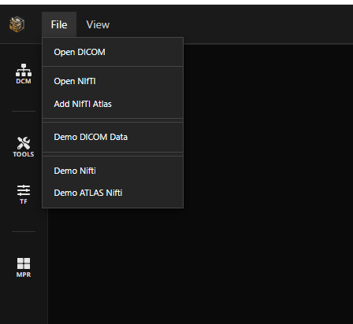
Figure: The File menu with all available data loading options.

File Menu — Additional Items After Loading a NIfTI
Once a NIfTI file has been loaded, two additional items appear in the File menu:

Menu Item | Description
Load Atlas | Opens a file picker to load a local NIfTI atlas file (.nii / .nii.gz) and overlay it on the currently loaded NIfTI volume.
NIfTI Demo Atlas | Loads a pre-hosted demo atlas bundled with the application, automatically co-registered to the active NIfTI dataset.

View Menu
The View menu appears in the menu bar once a dataset has been loaded. It allows you to switch between three layout modes:

View Mode | Description
3D (default) | Displays only the 3D volumetric render viewport. This is the default layout when data is first loaded.
MPR + 3D | Splits the interface to show the three orthogonal MPR planes (Axial, Coronal, Sagittal) alongside the 3D viewport.
Axial + 3D | Displays the Axial slice view alongside the 3D viewport — a focused two-panel layout.
Full Axial Slice | Displays only the axial slice.

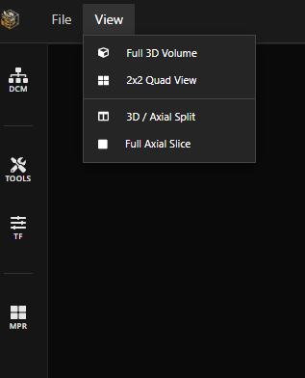
Figure: The View menu for switching between layout modes.

2.4 Loading Data
In addition to the File menu, RADIWEB 3D supports direct drag-and-drop loading from your local file system:
- Locate your DICOM folder or NIfTI files on your computer.
- Drag the entire folder (or individual files) directly into the browser viewport.
- The application will automatically detect the file type and begin in-browser parsing.
- A progress indicator will show while data is being loaded and rendered.

Supported Input Methods
You can use either the File menu or drag-and-drop to load data. Drag and drop accepts entire DICOM series folders or individual NIfTI (.nii / .nii.gz) files.

3. Supported File Formats
RADIWEB 3D natively parses standard clinical and research imaging formats on the fly, with no conversion step required.

Format | Extension | Description
DICOM | .dcm | CT, MR, and PET image volumes
NIfTI | .nii / .nii.gz | Structural atlases and label maps
RTSTRUCT | DICOM RT | Radiotherapy structure sets (contours)
RTDOSE | DICOM RT | Continuous dose distribution matrices
RTPLAN | DICOM RT | Treatment geometry and linac arc definitions
DICOM SEG | DICOM | Binary and fractional class segmentation maps
RT Brachytherapy | DICOM RT | Catheter channels, dwell positions, seed matrices

4. The Sidebar
Once a volumetric dataset has been loaded, a sidebar appears on the left side of the interface. It contains a set of panel buttons that provide access to all major controls. The buttons displayed depend on the type of data loaded — some appear only when specific file types (RT data, SEG, NIfTI atlas) are present in the loaded dataset.

Context-Sensitive Sidebar
The sidebar adapts dynamically to the loaded data. Loading a DICOM volume shows the base buttons (DCM, Tools, TF, MPR). Loading a folder that also contains radiotherapy files adds the RTDATA button. Loading a DICOM SEG file adds the SEG button. Loading a NIfTI atlas adds the ATLAS button.

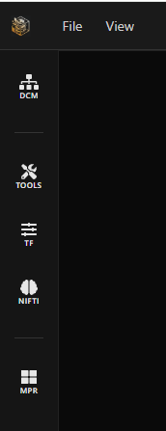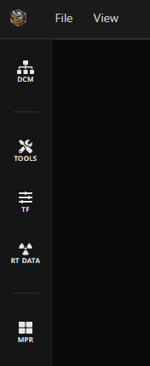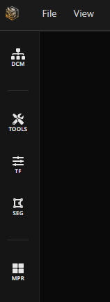

Figure: The complete sidebar as it appears when all data types are loaded.,Nift + Atlas; DICOM+RTDATA; DICOM+SEG

4.1 DCM — Series Selection & Volume Information
When a DICOM folder is loaded via File > Open DICOM Folder, the folder may contain data from more than one patient or imaging series. In this case, no volume is loaded automatically — the DCM panel opens first to let the user choose which series to visualise.

The panel displays a list of cards, one per detected series. Each card shows key information about that series, including:
- Series description
- Number of slices
- Slice dimensions (matrix size)
- Number of associated RT data files (RTDOSE, RTPLAN, RTSTRUCT, etc.) found in the same folder

The user can browse the cards and click on the desired series to load it into the viewer. Once selected, the volume is rendered and all other sidebar controls become active.

Single-Series Folders
If the loaded folder contains only one patient/volume, that series is loaded directly without requiring a selection step. The DCM panel in this case simply shows the information card for the loaded volume.

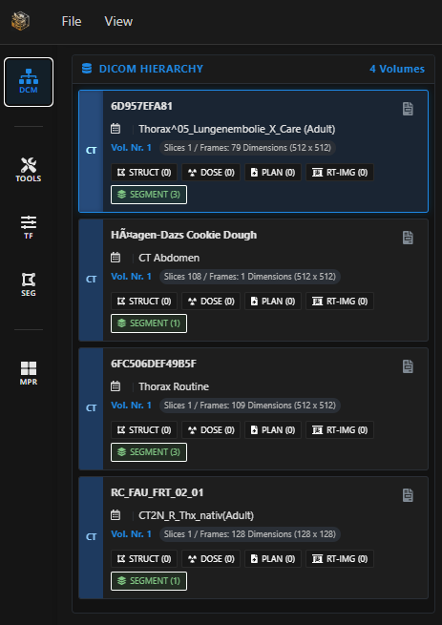
Figure: DCM panel displaying multiple series cards for a folder containing more than one volume.

4.2 Tools — Scene & Visual Controls
The Tools button opens a panel with two tabs: Scene and Visual. These controls manage the 3D rendering environment, camera behaviour, and lighting appearance.

Tab 1 — Scene
The Scene tab contains display toggles, clipping plane controls, and camera settings.

Display Toggles — the following elements can be individually shown or hidden using checkboxes:
- Orientation Cube — a 3D reference cube showing the current camera orientation.
- DICOM Coordinate System — displays the X, Y, Z patient axes in the 3D viewport.
- IEC Coordinate System — displays the IEC (International Electrotechnical Commission) gantry/couch reference axes. This option is only available when RT data has been loaded.

Clipping Plane — a checkbox activates the clipping plane. Once enabled, three sliders appear to define its position and orientation:
Slider | Description
Distance | Controls how far the clipping plane is positioned along its normal direction, cutting deeper or shallower into the volume.
Azimuth | Rotates the clipping plane horizontally around the volume.
Elevation | Tilts the clipping plane vertically, changing its angle relative to the volume.

Three shortcut buttons allow instant alignment of the clipping plane to standard anatomical orientations:
- Axial — aligns the clipping plane to the transverse (axial) plane.
- Coronal — aligns the clipping plane to the coronal plane.
- Sagittal — aligns the clipping plane to the sagittal plane.

Camera Settings — six buttons set the camera to standard anatomical views:
Button | View
A | Anterior — front view
P | Posterior — back view
I | Inferior — bottom view
S | Superior — top view
L | Left lateral view
R | Right lateral view

Two buttons control the camera projection mode:
- Perspective — standard perspective projection with depth foreshortening. Best for anatomical spatial understanding.
- Ortho — orthographic projection with no perspective distortion. Best for precise dimensional assessment.

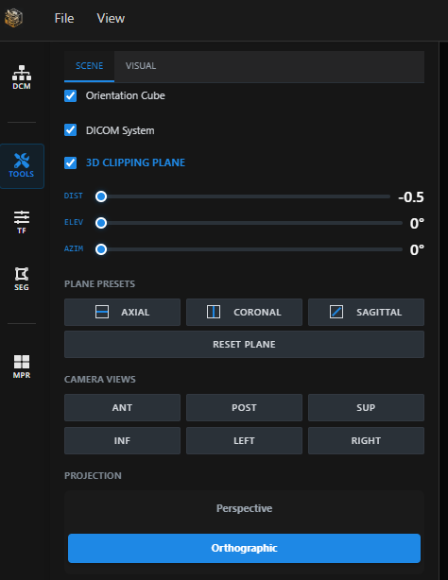
Figure: Tools panel: Scene tab with clipping plane controls and camera settings.

Tab 2 — Visual
The Visual tab provides fine-grained control over the lighting model applied to the 3D volume render.

Illumination Parameters — four lighting properties are each adjustable via a dedicated slider:
Parameter | Description
Ambient | Controls the base level of light applied uniformly across the entire volume, independent of light direction.
Diffuse | Controls the intensity of directional light scattered across surfaces, defining the main shading contrast.
Specular | Controls the intensity of the specular highlight — the bright reflective spot on surfaces facing the light source.
Shininess | Controls the sharpness of the specular highlight. Higher values produce a tighter, glossier reflection.

Light Direction — two sliders define the position of the light source in 3D space:
- Azimuth — rotates the light source horizontally around the volume.
- Elevation — raises or lowers the light source vertically.

Material Presets — three shortcut buttons apply pre-configured lighting combinations optimised for common tissue types:
- Bone — high specular and shininess, optimised for hard tissue and skeletal structures.
- Soft — low specular with higher diffuse, optimised for soft tissue and organ visualisation.
- Metal — high specular and shininess with a sharp highlight, suited for metallic implants or applicators.

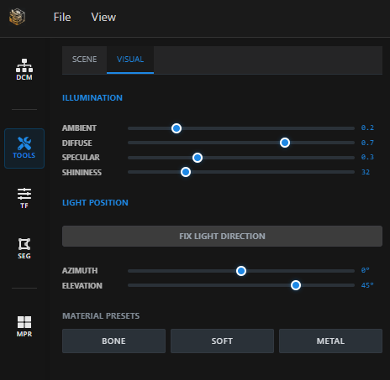
Figure: Tools panel: Visual tab with lighting and material preset controls.

4.3 TF — Transfer Functions & Rendering Modes
The TF button opens the transfer function panel. It is divided into two areas: a left sidebar for selecting the rendering mode and visibility options, and a main area with two tabs (1D and 2D) for configuring the transfer function itself.

Left Sidebar — Rendering Mode & Visibility
The left sidebar contains a set of flat buttons for selecting the active volume rendering algorithm, plus controls for surface rendering and illumination:

Rendering Mode — one of the following can be active at a time:
Button | Mode | Description
DVR | Direct Volume Rendering | Classic transfer-function-based volume rendering. Maps HU values to colour and opacity using the active TF. The primary mode for anatomical visualisation.
ISO | Iso-Surface Rendering | Renders a single iso-surface at a defined HU threshold, displayed as an opaque surface.
MIP | Maximum Intensity Projection | Projects the maximum voxel intensity along each viewing ray. Useful for highlighting bright structures such as contrast-enhanced vessels or bones.
AIP | Average Intensity Projection | Projects the average voxel intensity along each ray, providing an overview of density distribution.
MIN | Minimum Intensity Projection | Projects the minimum voxel intensity along each ray. Useful for visualising low-density structures such as airways.
X-R | X-Ray Projection | Simulates a planar X-ray projection through the volume, producing a DRR-like (Digitally Reconstructed Radiograph) result.

Visibility & Illumination Toggles:
- Show / Hide VR — toggles the visibility of the volume rendering in the 3D scene.
- Show / Hide SR — toggles the visibility of the surface rendering generated by the Marching Cubes algorithm. When both VR and SR are active simultaneously, both are displayed together in the same scene.
- Illumination On / Off — activates or deactivates the lighting model on the volume render. When off, the volume is displayed with flat, unlit colours based purely on the transfer function.

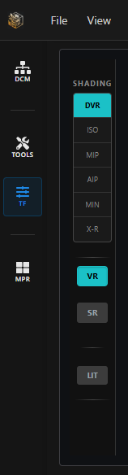
Figure: TF panel: left sidebar with rendering mode selector and visibility controls.

Tab 1 — 1D Transfer Function
The 1D tab provides an interactive chart for mapping Hounsfield Unit (HU) values to opacity, combined with a colour gradient bar for defining the colour mapping across the HU range.

Opacity Chart
The main chart displays HU values on the horizontal axis and opacity on the vertical axis. The current transfer function is represented as a series of control points connected by straight lines. The user can interact with the chart directly:
- Left-click anywhere on the chart to add a new opacity control point at that HU/opacity position.
- Right-click on an existing control point to delete it.
- Click and drag a control point to reposition it, reshaping the opacity curve.

Colour Bar
Below the opacity chart, a colour bar displays the full HU range of the dataset. The colour at each position is the result of a gradient blended across all defined colour control points. The HU values of each colour point are shown directly on the bar, giving a visual reference of which colours map to which tissue densities.

Presets
Opacity and colour control points are defined together as named presets. A list box displays all available presets, for example:
- Bone — optimised for skeletal visualisation, emphasising high-HU structures.
- Lung — optimised for low-density pulmonary tissue.
- Soft — optimised for soft tissue contrast.
- Additional presets may be available depending on the application version.

Selecting a preset from the list immediately updates both the opacity chart and the colour bar, and the 3D volume rendering in the viewport refreshes accordingly.

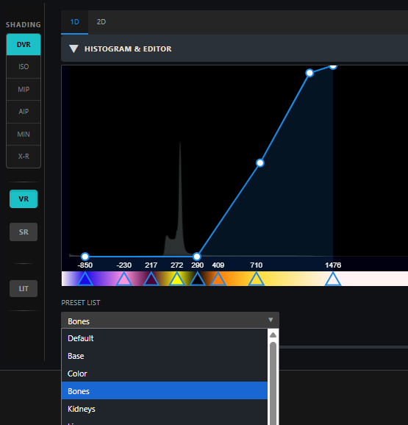
Figure: TF panel: 1D tab with opacity curve, colour bar and preset selector.

Tab 2 — 2D Transfer Function
The 2D tab provides an advanced transfer function editor that maps two properties simultaneously: Hounsfield Unit (HU) value on the horizontal axis and Gradient Magnitude on the vertical axis. This allows precise isolation of structures based on both their density and their boundary sharpness — for example, separating bone from soft tissue at their interface.

The 2D Chart
The main chart displays the HU / Gradient Magnitude space. The user populates this space by placing geometric forms — Boxes or Triangles — each of which defines a region of the HU/gradient space to be rendered with a specific colour and opacity. Multiple forms can coexist on the chart simultaneously.

Adding Forms
Two dedicated buttons allow the user to add new forms to the chart:
- Add Box — places a new rectangular form on the chart. Boxes are well suited to selecting broad density ranges with soft boundaries.
- Add Triangle — places a new triangular form on the chart. Triangles allow more focused, pointed selections ideal for targeting sharp tissue boundaries.

Interacting with Forms
Forms can be manipulated directly on the chart using the mouse. Clicking on a form selects it — the selected form is visually highlighted on the chart. Once selected, the following interactions are available:
Interaction | Description
Move | Click and drag the selected form to reposition it anywhere on the HU/gradient chart.
Resize | Drag the edges or corners of the selected form to change its size, expanding or narrowing the HU/gradient region it covers.
Rotate (Triangles only) | Triangles can be rotated by dragging with the mouse, or precisely by using the Rotation slider that appears in the properties panel when a triangle is selected.
Delete | Remove the selected form from the chart. The corresponding region is removed from the transfer function.

Form Properties Panel
When a form is selected, a properties panel appears alongside the chart with the following controls:
- Colour picker — sets the colour assigned to voxels that fall within this form's HU/gradient region. The colour is reflected in the colour bar below the chart.
- Opacity slider — controls the overall opacity of the voxels mapped by this form, from fully transparent to fully opaque.
- Falloff slider — controls how sharply the form's influence fades at its edges. A low falloff produces a hard boundary; a high falloff produces a smooth, gradual fade into surrounding regions.
- Rotation slider (triangles only) — sets the rotation angle of the triangle in degrees, as an alternative to mouse-based rotation.

Colour Bar
Below the 2D chart, a colour bar displays the colours of all currently active forms. Each form contributes its assigned colour to the bar, providing a visual summary of the full transfer function composition at a glance.

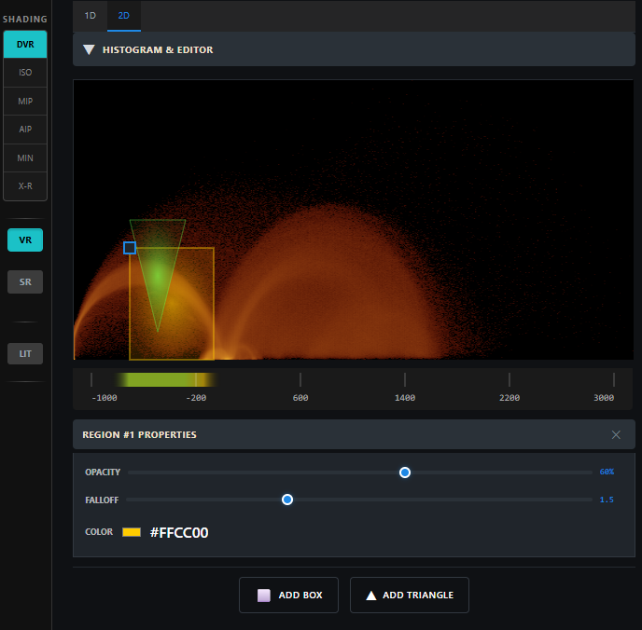
Figure: TF panel: 2D tab with geometric forms on the HU/gradient chart and the form properties panel.

4.4 MPR — Section Planes in 3D
The MPR button toggles the visibility of the three orthogonal section planes (Axial, Coronal, Sagittal) directly inside the 3D viewport. When active, the planes are rendered as textured slices within the scene and can be displayed alongside the volume rendering (VR), the surface rendering (SR), or both simultaneously.

Note
Slice scrolling and the full 2D/3D quad layout are controlled via the View menu (MPR+3D or Axial+3D modes). The MPR sidebar button is currently a visibility toggle for the section planes in the 3D scene only. This behaviour may be extended in a future version.

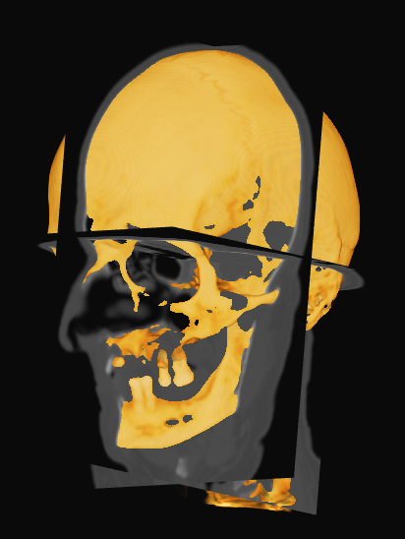
Figure: The three section planes displayed inside the 3D scene with the MPR toggle active.

4.5 RTDATA — Radiotherapy Data Panel
The RTDATA button appears automatically in the sidebar when the loaded DICOM folder contains radiotherapy files. Only the tabs corresponding to the file types actually found in the folder are shown — so a folder containing only RTSTRUCT and RTDOSE will show two tabs, not three.

Tab | Shown when
TAB-PLAN | An RTPLAN file is present in the loaded folder.
TAB-STRUCT | An RTSTRUCT file is present in the loaded folder.
TAB-DOSE | An RTDOSE file is present in the loaded folder.

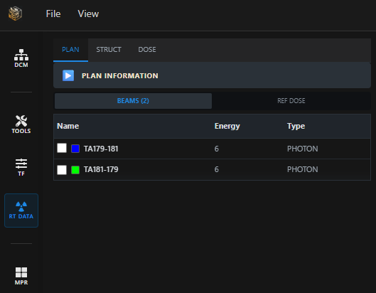
Figure: The RTDATA panel with all three tabs visible when a complete RT dataset is loaded.

TAB-PLAN
The TAB-PLAN tab displays all information and visualisation controls related to the loaded RTPLAN file. It is organised into an expandable information panel at the top, followed by two sub-tabs for beams and reference doses.

Plan Information Panel
An expandable panel at the top of the tab shows the key metadata extracted from the RTPLAN file:
- Machine — the treatment machine name.
- Plan Name — the name of the treatment plan.
- Date — the plan creation date.
- Status — the approval or clinical status of the plan.
- Fractions — the number of treatment fractions prescribed.

Sub-Tab: Beams
The Beams sub-tab lists all beam entries defined in the RTPLAN in a checkbox list. Each entry displays the beam name, energy, and beam type (e.g. Photon). A colour indicator is associated with each beam.

Only one beam can be selected at a time. When a beam is selected via its checkbox, it becomes active in the 3D scene and a control point selector appears below the list:
- A combobox lists all control points for the selected beam, each shown as P(i) [angle], where i is the control point index and angle is the gantry angle.
- Selecting a control point updates the 3D scene to display the beam geometry at that gantry position.

The 3D scene for a selected control point displays:
- A large circle around the patient representing the gantry rotation arc, composed of cylindrical segments whose length is proportional to the energy/intensity at that control point.
- The jaw aperture geometry for the selected control point.
- The MLC leaf positions for the selected control point.
- A beam projection passing through the jaw and MLC leaves and reaching the patient isocenter.

An Auto button steps automatically through all control points in sequence, animating the beam rotation around the patient so the full arc trajectory can be visualised dynamically.

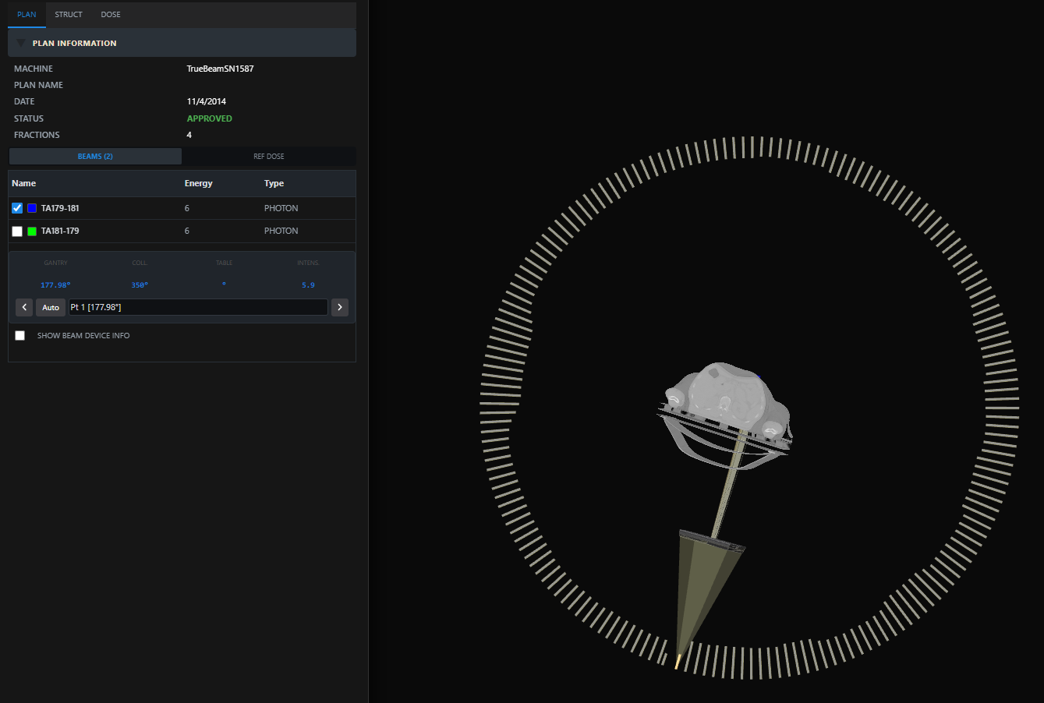
Figure: TAB-PLAN: beam selected with control point active, showing the full beam geometry in the 3D scene.

Beam Device Panel
A dedicated Beam Device panel displays the collimation geometry for the active beam. The device components typically include:
- ASYMX — asymmetric jaw in the X direction.
- ASYMY — asymmetric jaw in the Y direction.
- MLC — multi-leaf collimator leaf positions.

Each device component has an independent checkbox, allowing the user to show or hide any combination of components in the 3D scene. For example, the MLC leaves can be displayed alone, or together with both jaw components, depending on what the user wishes to inspect.

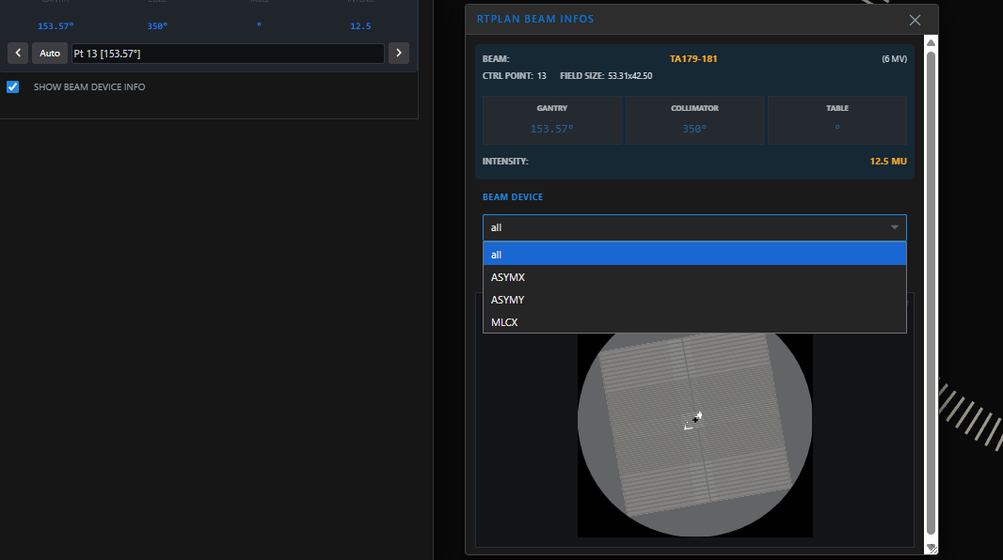
Figure: TAB-PLAN: Beam Device Panel.

Sub-Tab: Ref. Dose
The Ref. Dose sub-tab lists all reference dose entries defined in the RTPLAN in a checkbox list. Each entry displays:
- A colour indicator and checkbox to toggle display in the scene.
- Type — the dose reference type (e.g. Target, Organ at Risk).
- Description — a label identifying the dose reference point or geometry.
- Prescription Dose — the prescribed dose value associated with this reference.

When a reference dose entry is enabled via its checkbox, the corresponding reference point or geometric element is displayed in the 3D scene at its spatial position relative to the patient anatomy.

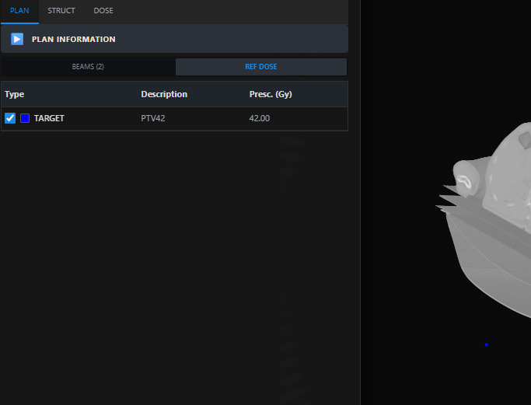
Figure: TAB-PLAN: Ref. Dose sub-tab with reference dose entries and their 3D scene representation.

4.6 SEG — Segmentation Masks
The SEG button appears when a DICOM SEG file is present in the loaded dataset. It opens a panel listing all available segmentation segments. Each segment is shown with:
- Its name and assigned color
- A checkbox to toggle its visibility independently
Multiple segments can be displayed simultaneously as translucent overlays on the anatomy.

4.7 ATLAS — NIfTI Atlas Regions
The ATLAS button appears when a NIfTI atlas has been loaded (via File > Load Atlas or File > NIfTI Demo Atlas). It opens a panel listing all anatomical regions defined in the atlas. Each region is shown with:
- Its anatomical label name
- Its assigned color (each region has a distinct color)
- A checkbox to toggle its display independently
This panel works similarly to the RTSTRUCT and RTDOSE panels — you can select and deselect any combination of atlas regions to overlay them on the active dataset. All regions are spatially co-registered and rendered in alignment with the underlying volume.

5. Core Visualization Features

5.1 Multiplanar Reconstruction (MPR)
The MPR module provides synchronized Axial, Coronal, and Sagittal slice views of any loaded volumetric dataset.

How to use MPR:
- Load a DICOM CT, MR, or PET volume.
- The interface will automatically display three orthogonal slice planes.
- Click and drag the crosshair lines in any view to navigate through the volume.
- All three views update simultaneously, maintaining sub-millimeter precision.

Technical Detail
MPR crosshairs are implemented using hybrid Canvas/SVG overlays, enabling fluid sub-millimeter line dragging with minimal rendering overhead.

5.2 Transfer Functions
Transfer functions control how voxel intensities (Hounsfield Units for CT) are mapped to visible colors and opacity in the 3D render.

1D Transfer Function
- Maps Hounsfield Unit (HU) values directly to opacity and color.
- Use to isolate specific tissue types — e.g., bone, soft tissue, or lung.
- Adjust the TF curve control points in the widget to refine visualization.

2D Transfer Function
- Advanced mode that maps both HU value AND gradient magnitude to opacity/color.
- Enables improved separation of adjacent structures with similar density.
- Ideal for detailed boundary visualization between soft tissue and bone.

5.3 Marching Cubes Surface Extraction
RADIWEB 3D executes the Marching Cubes algorithm entirely client-side to generate iso-surface meshes from volumetric data.

How to use:
- Load a volumetric dataset.
- Set a target iso-value (HU threshold for CT data).
- The surface mesh is generated in real time in your browser.
- Ideal for reconstructing bony anatomy, skin contours, or other sharply defined structures.

5.4 NIfTI Atlas Overlay
RADIWEB 3D can load and overlay complex NIfTI-format structural brain atlases directly over patient CT scans.
- Load a base DICOM CT volume.
- Drag and drop a NIfTI atlas file (.nii or .nii.gz) into the viewer.
- The atlas is automatically co-registered to the CT coordinate space.
- Individual atlas labels are color-coded and displayed as overlays on all MPR planes.

5.5 Mobile Tablet Support
RADIWEB 3D includes a memory-efficient voxel-traversal pipeline optimized for touch interactions and mobile GPU hardware acceleration.
- All core features are accessible on mobile tablet devices.
- Touch gestures are supported for panning, zooming, and slice navigation.
- The layout automatically adapts to tablet screen dimensions.

6. Multimodal Co-Registration
RADIWEB 3D features zero-click automatic spatial co-registration. When multiple datasets are loaded, the system automatically aligns them to a common coordinate space — no manual registration steps are required.

6.1 How Co-Registration Works
Step | Description
Header Matrix Mapping | Automatically parses NIfTI affine transformations (sform/qform) to synchronize coordinates with DICOM physical space.
LPS / RAS Conversion | Detects and re-orients between DICOM-native LPS (Left-Posterior-Superior) and NIfTI RAS (Right-Anterior-Superior) coordinate grids without directional inversion errors.
Resolution Agnostic Mapping | Handles mismatched grid dimensions seamlessly (e.g., a 256x256 NIfTI atlas mapped onto a 512x512 CT volume).
Multimodal Overlay | Simultaneously displays structural CT, anatomical labels, and dose distributions in perfect alignment.

No Manual Registration Required
Simply load your datasets — RADIWEB 3D automatically detects coordinate spaces and aligns all loaded sources on the fly.

7. Radiotherapy Analytics
RADIWEB 3D provides a comprehensive suite of radiotherapy-specific visualization and analysis tools.

7.1 RTSTRUCT Contour Visualization
Render DICOM RTSTRUCT files to visualize structure contours overlaid on anatomical images.
- Load a DICOM CT series.
- Drag and drop the RTSTRUCT DICOM file.
- Structure contours are automatically rendered on all MPR planes with per-structure color coding.
- Overlapping structures are handled using high-performance polygon sorting.

7.2 DICOM SEG Segmentation Masks
Load DICOM SEG files to visualize binary or fractional segmentation masks.
- Both binary and fractional class segments are supported.
- Segmentation masks are rendered as translucent overlays on the anatomy.
- Multiple segments can be displayed simultaneously.

7.3 RT Dose Visualization
Overlay continuous dose distributions directly onto anatomical images.
- Load a DICOM CT series and an RTDOSE file.
- Dose is automatically co-registered and rendered as a color wash overlay.
- Adjust the dose threshold and color lookup table (LUT) to customize the display.
- Alpha-blending controls allow fine-tuning of overlay transparency.

7.4 Dose-Volume Histogram (DVH) Engine
RADIWEB 3D computes Dose-Volume Histograms asynchronously to maintain full interface responsiveness during computation.
- DVH is calculated entirely in the browser using Web Worker threads.
- Requires a loaded RTDOSE and at least one structure (RTSTRUCT or SEG) to be active.
- Results are displayed as an interactive chart panel.
- DVH data can be inspected per structure.

7.5 RTPLAN 3D Beam Geometry
Visualize complex radiotherapy beam arrangements in true 3D space.
- Load a DICOM CT series with an RTPLAN file.
- Beam trajectories are projected from linac source to isocenter in 3D.
- Jaw aperture and MLC positioning are represented geometrically.
- Rotate and inspect the full beam arrangement relative to patient anatomy.

7.6 Brachytherapy Geometry
RADIWEB 3D natively reconstructs brachytherapy applicator geometries from DICOM RT Brachytherapy files.
- Renders catheter paths and interstitial/intracavitary channel structures in 3D.
- Active dwell point positions are visualized superimposed over patient anatomy.
- Both interstitial and intracavitary applicator configurations are supported.

8. Data Privacy & Security
RADIWEB 3D is built with a 100% client-side processing pipeline. Understanding how your data is handled is important:

Aspect | Details
Data Storage | No data is stored. Files are read into browser memory only during the session.
Network Transmission | No imaging data is sent to any server. Zero network activity occurs during analysis.
Backend | There is no backend server. The application is a self-contained browser application.
Session Persistence | Data is lost when the browser tab is closed. No caching of imaging data occurs.
Compliance | Suitable for use within strict institutional firewalls and internal research sandboxes.

Zero Server Footprint
RADIWEB 3D is fully compliant with localized data protection workflows. It is ideal for environments where patient data must not leave institutional systems.

⚠ WARNING: Despite the client-side architecture, RADIWEB 3D is intended for RESEARCH USE ONLY and must not be used for clinical diagnostic decisions.

9. Contributing & Community

9.1 Reporting Issues
If you encounter any bugs, incorrect orientations, or parsing errors:
- Open an issue on the GitHub repository: https://github.com/rtdicomexplorer
- Include the file format, browser version, and a description of the unexpected behaviour.

9.2 Contributing Code
RADIWEB 3D is built by and for the medical physics community. Contributions are welcome:
- Submit a Pull Request on GitHub to optimize shaders, add format parsers, or improve performance.
- See the repository CONTRIBUTING.md for code style and submission guidelines.

9.3 Citing RADIWEB 3D
If RADIWEB 3D assists your research, clinical trials, or academic work, please cite the project:

@article{radiweb3d2026,
author = {Your Name and Contributors},
title = {RADIWEB 3D: High-Performance Client-Side Medical Image Visualization Engine},
journal = {Journal of Digital Imaging},
year = {2026},
volume = {39},
pages = {112--120}
}

10. Technical Architecture
RADIWEB 3D is built on a fully web-native technology stack designed for high-performance client-side rendering:

Layer | Technology | Purpose
Application Framework | Angular & TypeScript | Component architecture and type-safe application logic
3D Graphics Engine | Three.js (WebGL) | GPU-accelerated volume rendering via WebGL fragment shaders
UI / Overlay Layer | HTML5 Canvas & SVG | Sub-pixel precision crosshairs and anatomical overlays
Parallel Processing | Web Workers | Asynchronous DVH computation without blocking the UI thread
Data Parsing | JS/TS Binary Array Streaming | Asynchronous in-memory DICOM and NIfTI file parsing

Pixel matrices are offloaded directly onto WebGL fragment shaders via Three.js, while structural crosshairs are projected onto high-precision SVG vector overlays. This hybrid approach retains crisp sub-pixel precision across all supported platforms.

11. Contact & Support
Contact | Details
Author | Dr. Ing. Michele Bufano
Institution | University Medical Center Freiburg
Email | michele.bufano@uniklinik-freiburg.de
GitHub | https://github.com/rtdicomexplorer
ORCID | https://orcid.org/0009-0000-5067-9814
LinkedIn | https://www.linkedin.com/in/michele-bufano-76a631158/

RADIWEB 3D — Open-Access Web Innovations in Medical Physics
Research Use Only — Not for Clinical Diagnostic Decisions

