TD R/ANTARES

Jalal-Edine ZAWAM

13 décembre 2017

## readAntares

Most data from a simulation can be imported in the R session with function readAntares().

myPath<-"E:\\ANTARES\\Exemple_antares\\2_exemple_etudes_importantes\\TYNDP\\ST2030\\ST2030"  
opts<-setSimulationPath(myPath, "20170830-1049eco-reference")  
  
myData<-readAntares(  
 areas = "all",   
 links="all",   
 clusters = "all",   
 linkCapacity = TRUE,  
 mustRun = TRUE,  
 showProgress = FALSE  
)

## Remove your virtual areas

You can remove your virtual areas and correct your initial data.

myConData<-removeVirtualAreas(  
 x=myData,  
 storageFlexibility = getAreas(select = c("pum", "tur", "z_dsr", "y_mul")),   
 newCols = FALSE  
 )

## getAreas ans getLinks

Compute the number of areas without virtual areas.

virtuarAreas<-getAreas(select = c("z_dsr", "y_mul", "pum", "tur"))  
realAreas<-getAreas(exclude = virtuarAreas)  
  
length(getAreas(exclude = virtuarAreas))

## [1] 54

Compute the number of links without virtual areas

length(getLinks(areas = realAreas, exclude = virtuarAreas))

## [1] 105

## antaresDataList : List of date.tables

Compute the number of areas with unsupplied energy

length(unique(myConData$areas[`UNSP. ENRG`>0]$area))

## [1] 19

Compute the number of areas with spilled energy

length(unique(myConData$areas[`SPIL. ENRG`>0]$area))

## [1] 24

Compute the number of links with congestion

length(unique(myConData$links[`CONG. PROB +`>0]$link))

## [1] 96

length(unique(myConData$links[`CONG. PROB -`>0]$link))

## [1] 98

length(unique(myConData$links[`CONG. PROB +`>0 | `CONG. PROB -`>0]$link))

## [1] 102

length(unique(myConData$links[`CONG. PROB +`>0 & `CONG. PROB -`>0]$link))

## [1] 89

Compute the sum of the spilled energy by area and order the result by the spilled energy

## PRINT ONLY RESULT   
kable(resCompute[, .SD[1:7], ])

|  |  |
| --- | --- |
| area | sumSpilled |
| es | 2020833 |
| gb | 1664705 |
| de | 1555247 |
| ie | 951593 |
| nl | 497123 |
| ni | 206839 |
| pt | 175267 |

Compute the sum of the unsupplied energy by area and order the result by the unsupplied energy

## PRINT ONLY RESULT   
kable(resComputeUnsEne[, .SD[1:7], ])

|  |  |
| --- | --- |
| area | sumUnspilled |
| fr | 38421 |
| gb | 5587 |
| fi | 3863 |
| luf | 1333 |
| be | 456 |
| ee | 419 |
| pl | 419 |

## Explain the result for unsupplied energy in France: with rpart or others statical packages FactoMineR, kmeans

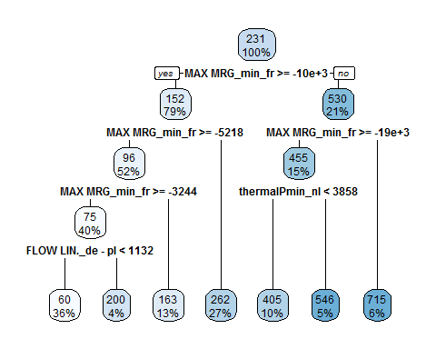

## Explain the result for unsupplied energy in France without some variables

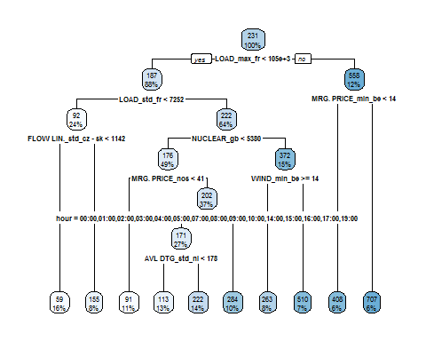

## antaresViz : prodStack, exchangesStack and plot

Get the first year and the first date where there is more than 700MW of unsupplied energy in France and use prodStack to visualize the production stack for this week.

## [1] "mcYear :4"  
## [1] "time :2018-01-05 18:00:00"  
## [1] "day :5"  
## [1] "mcYear :5"  
## [1] "time :2018-02-08 18:00:00"  
## [1] "day :8"

# prodStack, exchangesStack

myDataFr<-suppressWarnings(readAntares(areas = "fr", mcYears = mcYears[1], showProgress = FALSE, links = "all", linkCapacity = TRUE))  
  
#prodStack(myDataFr, dateRange=c("2018-01-01 00:00:00", "2018-01-07 23:00:00"), interactive = FALSE, area="fr")  
  
#exchangesStack(myDataFr, dateRange=c("2018-01-01 00:00:00", "2018-01-07 23:00:00"), interactive = FALSE, area="fr")  
  
#plot(myDataFr$areas, dateRange=c("2018-01-01 00:00:00", "2018-01-07 23:00:00"), interactive = FALSE, elements="fr", variable="MRG. PRICE", mcYear=4, type="ts", stepPlot=TRUE)  
  
plot_ly(economics, x = ~date, y = ~unemploy / pop)

## No trace type specified:  
## Based on info supplied, a 'scatter' trace seems appropriate.  
## Read more about this trace type -> https://plot.ly/r/reference/#scatter

## No scatter mode specifed:  
## Setting the mode to markers  
## Read more about this attribute -> https://plot.ly/r/reference/#scatter-mode

## Warning: l'exécution de la commande '"D:\Users\jalazawa\AppData\Roaming/  
## PhantomJS/phantomjs.exe" "D:/Users/jalazawa/Documents/R/win-library/  
## 3.4/webshot/webshot.js" "[{\"url\":\"widget5345ac52c8a.html\",\"file\":  
## \".\\webshot534108a44bc.png\",\"vwidth\":480,\"vheight\":384,\"delay\":  
## 0.2,\"zoom\":1}]"' renvoie un statut 5

## Error in (function (url = NULL, file = "webshot.png", vwidth = 992, vheight = 744, : webshot.js returned failure value: 5

# use consolidated data

myDataFr<-suppressWarnings(readAntares(links = getLinks(areas = c("z_dsr450", "y_mul", "pum", "tur", "fr")), areas = getAreas(select = c("z_dsr450", "y_mul", "pum", "tur", "fr")), mcYears = 4, linkCapacity = TRUE, showProgress = FALSE))  
  
myConDataFr<-removeVirtualAreas(  
 x=myDataFr,  
 storageFlexibility = getAreas(select = c("pum", "tur", "z_dsr", "y_mul")),  
 newCols = FALSE,   
 reassignCosts = TRUE  
)  
  
#prodStack(myConDataFr, dateRange=c("2018-01-01 00:00:00", "2018-01-07 23:00:00"), interactive = FALSE, area="fr")  
  
#exchangesStack(myConDataFr, dateRange=c("2018-01-01 00:00:00", "2018-01-07 23:00:00"), interactive = FALSE, area="fr")

# antaresViz : plotMap

configure a layout or import one

#mlTyndp<-mapLayout(readLayout())  
#plotMapLayout(mlTyndp)  
#saveRDS(mlTyndp, file = "E:\\ANTARES\\Exemple_antares\\2_exemple_etudes_importantes\\TYNDP\\ST2030\\ST2030\\user\\mlTyndp2017_V2.rds")  
  
mlTyndp<-readRDS(file = "E:\\ANTARES\\Exemple_antares\\2_exemple_etudes_importantes\\TYNDP\\ST2030\\ST2030\\user\\layout\\mapLayoutTyndp.rds")

# Data for Europe

myDataEurope<-suppressWarnings(readAntares(links = "all", areas = "all", linkCapacity = TRUE, showProgress = FALSE, mcYears = mcYears[1]))  
  
myConDataEurope<-removeVirtualAreas(  
 x=myDataEurope,  
 storageFlexibility = getAreas(select = c("pum", "tur", "z_dsr", "y_mul")),  
 newCols = FALSE  
)  
  
addLoadFactorLink(myConDataEurope)

# Use plotMap

The flow value of Great Britain/France is equal to zero, these two countries have unsupplied energy.

The flow between Belgium/France is 1295 but the link is not congested because Belgium has no marge.

All others flows to France are congested.

plotMap(  
 myConDataEurope,   
 mlTyndp,   
 sizeAreaVars=varPlotMap,   
 areaChartType="pie",   
 interactive = FALSE,  
 sizeMiniPlot = TRUE,   
 colAreaVar="LOAD",   
 colLinkVar="congestion",  
 sizeLinkVar="FLOW LIN.",  
 popupAreaVars = c(varPlotMap, vecAde, "PSP", "LOAD", "SPIL. ENRG"),   
 timeId = 115,   
 type = "detail"  
)

## Warning: l'exécution de la commande '"D:\Users\jalazawa\AppData\Roaming/  
## PhantomJS/phantomjs.exe" "D:/Users/jalazawa/Documents/R/win-library/  
## 3.4/webshot/webshot.js" "[{\"url\":\"widget534148345e8.html\",\"file\":  
## \".\\webshot53437d32f0b.png\",\"vwidth\":480,\"vheight\":384,\"delay\":  
## 0.2,\"zoom\":1}]"' renvoie un statut 5

## Error in (function (url = NULL, file = "webshot.png", vwidth = 992, vheight = 744, : webshot.js returned failure value: 5

# With interaction

plotMap(  
 myConDataEurope,   
 mlTyndp,   
 .updateBtn = TRUE,   
 .updateBtnInit=TRUE  
)

# You can change color option with plotMapOption

linkColorScaleOpts<-colorScaleOptions(  
 breaks = 1,   
 negCol = "#00FF00",   
 zeroCol = "#FFFFFF",   
 posCol = "#FF0000",   
 naCol = "#EEEEEE",  
 levels = c(0,1)  
)  
  
resOptions<-plotMapOptions(  
 linkColorScaleOpts = linkColorScaleOpts  
)  
  
plotMap(  
 myConDataEurope,   
 mlTyndp,   
 sizeAreaVars=varPlotMap,   
 areaChartType="pie",   
 interactive = FALSE,  
 sizeMiniPlot = TRUE,   
 colAreaVar="LOAD",   
 colLinkVar="congestion",  
 sizeLinkVar="FLOW LIN.",  
 popupAreaVars = c(varPlotMap, vecAde, "PSP", "LOAD", "SPIL. ENRG"),   
 timeId = 115,   
 type = "detail",   
 options = resOptions  
)

## Warning: l'exécution de la commande '"D:\Users\jalazawa\AppData\Roaming/  
## PhantomJS/phantomjs.exe" "D:/Users/jalazawa/Documents/R/win-library/  
## 3.4/webshot/webshot.js" "[{\"url\":\"widget53410de5f6c.html\",\"file\":  
## \".\\webshot5343c29673a.png\",\"vwidth\":480,\"vheight\":384,\"delay\":  
## 0.2,\"zoom\":1}]"' renvoie un statut 5

## Error in (function (url = NULL, file = "webshot.png", vwidth = 992, vheight = 744, : webshot.js returned failure value: 5

# Save memory and time with h5

Write your simulation in h5.

writeAntaresH5(  
 path="E:\\ANTARES\\Exemple_antares\\2_exemple_etudes_importantes\\TYNDP\\ST2030\\ST2030\\writeH5",  
 allData = FALSE, #thermalAvailabilites and hydroStorage were not exported  
 misc = TRUE,   
 thermalAvailabilities = FALSE,  
 hydroStorageMaxPower = TRUE,   
 reserve = TRUE,  
 linkCapacity = TRUE,  
 mustRun = TRUE,   
 writeAllSimulations = TRUE,  
 writeMcAll = TRUE,  
 nbCores=3,  
 removeVirtualAreas=TRUE,  
 storageFlexibility=getAreas(select = c("pum", "tur", "z_dsr", "y_mul")),  
 newCols = FALSE,  
 overwrite = TRUE,   
 timeSteps = "hourly"  
)