CS579 Fall 2009

Class #2 Homework

Submitter: Charlie Kim, John Natale

2. [30%] Application Design

Please look through the solution document for HW#1 and use the ER design and list of named relationships shown there for the Online Auction Application. You are now going to continue the design starting from the solution for HW#1.
There are two parts to this, (a), (b), as well as two extra credit parts (c) and (d)

➔ a) Determine the User Roles and draw a User Role Diagram. Only include roles needed for the requirements. Remember two important characteristics of these diagrams:
- Subroles represent "a kind of". If B is a subrole of A, it means that
  - a B is a kind of A -- e.g. a Known User is a kind of User
  - Any operation that can be done by a B can be done by an A
- Organize your User Role Diagram so that an operation is explicitly associated with only one role. If an operation seems to apply to multiple roles, assign it instead to a common super-role. (Note: You can define an operation so that its behavior depends upon who the user is as well as its parameters.)
- Remember that the same user can possibly take on more than one role. Even if two roles are disjoint, it just means that a user can't play both roles at the same time.

➔ b) List the names of your User Operations, organized by role, and within each role, by queries and actions.
- Include input parameters and descriptions for each operation.
  - Each input parameter should be preceded by a colon. Note that parameters represent information passed into the operation, and explicitly provided by the user. In a web-based application, these typically hold the values of filled-in text fields, or identify radio buttons or check boxes chosen on a page before the user clicks a button to submit the request to the web server.
  - For a query operation (assuming a web-based application), very briefly describe what data is displayed to the user. Make sure the input parameters only represent information passed into the operation (they do NOT name the fields to be displayed)
  - For an action operation, very briefly describe what the operation does, in terms of how it affects the data managed by the database or the application, but do NOT describe the contents of the page that an action operation returns.
  - Once a user has logged in, the middle-tier keeps track of the identity of the current user, so there's no need to pass a user id as a parameter to another operation unless it is meant to represent some other user.
  - If a user operation creates a new instance (e.g. a new bid), think carefully about whether you want the user to supply its primary key (in which case it will need to be passed as a parameter) or whether you want the operation to assign it automatically (in which case it should NOT be passed in as a parameter).
- You must include ALL actions (including Register, Login & Logout) and ALL queries needed to fulfill the requirements.
- Remember that the conceptual model exactly reflects information that the database maintains. If you have operations whose parameters correspond to data that would need to be stored in the DB, make sure that the conceptual model has attributes where they can be stored. For example, the Item class has an itemid, not an itemname, so providing an item name as a parameter would be useless, since it would be impossible to store it, or to look up an item based on its name.

- Do NOT include any operations not required or strongly implied by the requirements, except:
  - Include ONLY ONE additional query that would specifically be useful for a user who has previously posted an item for auction. In addition to naming this operation, ➔ you must MARK IT with a (P) to get credit for it.
  - Include ONLY ONE additional query that would specifically be useful for a user who has previously made a bid on an item currently being auctioned off. In addition to naming this operation, ➔ MARK IT with a (B) to get credit for it.
Role | Query | Action
Unknown User | listCategories()  listActiveItems(:catnam)
Logged-In User | listCategories()  listActiveItems(:catnam)  listHighestBid(:itemid) | postItem(:itemid,:descry,:closetime)  bidItem(:bidid,:amt)
Posted User | listCategories()  listActiveItems(:catnam)  listHighestBid(:itemid)  listAllBids(:itemid)

➔ c) [EXTRA CREDIT] Identify two actions which have pre-conditions (implied by the requirements). List the operation, along with its parameters. Associated with each operation, list all of its pre-conditions.
- You may NOT choose the Login or Logout operations
- You must choose the operation used to place a bid
- Mark a pre-condition as [ROLE] if it is corresponds to the fact that the operation is assigned to a role in the User Role Diagram

➔ d) [EXTRA CREDIT] See if you can identify any operations which might reasonably have interesting state-related post-conditions (i.e. ones that describe the result of changing the database state.

➔ At the end of this homework, you can find an example (with requirements and ER diagram) for an Online Job Board Application. Please use EXACTLY the same format for your application design.

I STRONGLY RECOMMEND that you draw ER and User Role diagrams by hand. At least, PLEASE DO NOT SPEND EXCESS TIME producing them on-line

If you absolutely feel compelled to use a tool to draw ER and User Role diagrams, I recommend that you use PowerPoint [so you can cut and paste symbols from my lecture slides], then cut and paste the PowerPoint into IrfanView [available free from download.com], then cut and paste from IrfanView into Word.

3. [25%] State Constraints:
In this problem, you will be given a list of business rules about the Online Auction Application and asked to determine whether or not each CAN BE a conceptual state constraint

A Conceptual State Constraint specifies an invariant property of the database state (something that you would like to always be true). It must be possible to check a state constraint by looking at the database at an arbitrary time, ➔ so there must be attributes or relationships in the conceptual model which can be tested at any time to determine if the state constraint is true or not.

A state constraint must constrain. That is, it must limit the allowable states of the system. A statement which does not constrain anything can't be a constraint.

Below, you will find a list of business rules, some of which are conceptual state constraints for the application. Precede each statement with one of the following symbols:

S – could be a state constraint
X – is NOT a state constraint

In addition, some of the state constraints are redundant – i.e. they are already specified by the ER diagram for the Auction Application. In addition to indicating the appropriate symbol, also mark these with an asterisk – e.g. use *S for a redundant state constraint.

➔ Following the rules, you will see some extra credit instructions as well

Business Rules
- X Users can post any number of items
- X Itemscan only be posted for auction from 8am to midnight GMT.
- *S Bids cannot be placed on items whose auctions have closed
- S All bidid's are unique
- *S Every item is in at most one category
- S Every bid is placed by a single user
- X When an item is posted for auction, its closing time must be at least 24 hours after the time it was posted.
- *S Every item must have a title, a description and a closing time.
- X The amount of a new bid must be larger than all existing bids for the same item.
- S Every user must have a user name.
- S A bid can never be changed or withdrawn.
- S Users cannot place bids on items they have posted
- X A user can bid on the same item multiple times.
- X A user who views the bids on an item is only allowed to see the last 3 of them unless the user is logged in
- S Only the user who posted an item can withdraw it.
- X A user can only withdraw a posted item up to 4 hours prior to the close of the item' auction.
- S Only registered users can post bids or items.
- X Anyone can browse the list of categories, and then browse the list of posted items in a specific category which are still being auctioned off.
- *S Every category must have a category name.
- S When an item has been withdrawn, all bids for the item are removed from the system

[EXTRA CREDIT]

There are four kinds of conceptual state constraints:
- Entity Instance Constraints (I)
Constrains the values of a single entity
- Entity Class Constraints (C)
Constrains the values of entities of a single entity class independent of any relationships, but requires consideration of more than one entity at a time
- Relationship Constraints (R)
Specifies how entities in one entity class can/must be related (via a single relationship) to entities of the related class, without considering any other relationships or entity classes.
- General Conceptual State Constraints (G)
Constrains values based on multiple relationships or unrelated entity classes

Instead for marking S for a state constraint, mark either

I – entity instance constraint
C – entity class constraint
R – relationship constraint
G – general conceptual state constraint

As described above, use an asterisk to mark constraints which are redundant (i.e. already implied by the conceptual diagram). So, for example, use *I to represent a redundant entity instance constraint.

[EXTRA CREDIT]

Statements which are not state constraint may be pre-conditions or post-conditions.
Instead of just marking X for something that it not a state constraint, mark these statements as

B - pre-condition (something that should be checked before an operation executes)
A - post-condition (something that can be checked after an operation executes)
X – neither a state constraint, a pre-condition, or a post-condition

A condition (just like a state constraint) must constrain. It must constrain the behavior or the output of the system in some way. A statement which does not constrain anything can't be a constraint or a condition.

Here's how to distinguish between state constraints and conditions in more detail:

- pre-conditions: something that you can check before executing an operation
WARNING: There are some statements which sound like pre-conditions, but which can be checked at an arbitrary time (not just before the operation) by looking at the database state, so they should be marked as state constraints
WARNING: There are some statements which sound like state constraints, but the database doesn't contain the information needed to check them at an arbitrary time, so they can only be checked before executing an operation. These should be marked only as pre-conditions.
WARNING: A pre-condition either allows an operation to proceed, or prevents it from executing. A pre-condition cannot be used to control the details of an operation's results. That can only be done using a post-condition, which describe the results of an operation (including the resulting database state, or characteristics of the output), which can vary based on the initial state.
- post-conditions: something which describes how the state has changed after performing an operation

WARNING: A post-condition is any statement which describes the state after performing a specific operation, but if this statement can be checked at an arbitrary time (not just after the operation) by looking at the database state, it should be marked as a state constraint.
NOTE: A post-condition can sometimes be enforced by doing checking before the operation begins. But it's still a post condition if it describes what the expected state is after the operation. For example, suppose the operation AddOneToX adds one to a variable x. The statement, "AddOneToX must finish with x having the value 12" is a post-condition, since it describes what the state must be at the end of the operation. You could enforce this constraint by checking whether or not x is 11 at the beginning of the operation. But it’s still stated as a post-condition. If you instead stated it as "only allow AddOneToX to execute if x is initially 11", then it would be a pre-condition.
There is an advantage to using post-conditions (where appropriate), because post-conditions can also be enforced by undoing the operation or fixing up the state. For example, if we ran AddOneToX, and x wasn't 12 afterwards, the system (using a trigger to monitor the result) could just set it to 12. That degree of flexibility is not available for pre-conditions, which can only be enforced by allowing the operation to proceed or not.

Remember that there are statements which sound like pre-conditions or post-conditions, but which can be checked at any arbitrary time, just by looking at the database state. You should treat these as state constraints. Pre-conditions and post-conditions can only be enforced when an operation executes. However, state constraints provide additional flexibility. Although you CAN check them whenever an operation is executed which might violate the constraint, you can instead (for performance) or in addition (for reliability), check the constraint at arbitrary or regular intervals (e.g. once a day at 2am).

4. [25%] Conceptual Design

You are given the following requirements for a Hospital Meal Application.

A Hospital Meal Application maintains upcoming menus which are specific to a day and mealtime (e.g. the Thursday Lunch Menu), and are made up by the hospital dietician. A menu is comprised of the menu items which are available on that particular menu (e.g. Lasagna [a menu item] might be on the Thursday Lunch Menu, but not on the Thursday Dinner Menu).

From the computer in each of their rooms, a patient can order a personalized meal (e.g. that patient's Thursday lunch meal) from the corresponding menu up to 3 days in advance. For each meal, the patient can select the menu items they will be having at that meal from the items actually available on the corresponding menu.

The application also keeps track of the ingredients (e.g. mustard, salt) used in each menu item. As part of patient registration, the registration clerk obtains from the patient, a list of ingredients to which they are allergic, and this information is made available to the Hospital Meal Application. In particular, when a user is shown a particular menu, they are not shown the menu items that contain ingredients to which they are allergic.
You must generate

a) the User Role Diagram. Do NOT generate the list of operations.
b) The Easy Crow Magnum or UML ER Diagram.

- Include and properly denote the primary key attribute for each entity class
- Show all other important attributes for each entity class
- Show all relationship characterizations
- Indicate all mandatory participation constraints and any more complex cardinality constraints
- Do NOT indicate optional participation
This is not a simple ER diagram; it has at least 5 entity classes, but

- Be careful NOT to include singleton classes – that is, classes that have only a single instance.
- Remember that an entity class or a relationship only should be included in an ER diagram if it represents information that is later needed to perform a query or an action. In particular, DON'T include relationships that simply represent what a user can change or view unless the requirements specifically indicate that such information should be retained persistently in the database.
- Specifically, not every user role needs to be represented as an entity class.
Additionally

- Pay very close attention to 1:M vs M:N relationships. Every time you draw a 1:M relationship, carefully check whether it should be M:N instead. I strongly recommend you study the Bikeshop example we discussed in class before doing this problem. It is very applicable to this problem
- Avoid 1-1 relationships.
- ➔ Make sure your attributes all have simple types; an attribute which holds a complex set of data generally means that you need to rethink your design, adding more entity classes.
- Also, please look at the notes on entity attributes in the solution to HW#1 and remember that it would be both incorrect and redundant to include entity attributes -- attributes (or groups of attributes) which identify other entities; they should be represented using relationships.

I STRONGLY RECOMMEND that you draw your ER and User Role diagrams by hand. PLEASE DO NOT SPEND EXCESS TIME producing them on-line (although if you are compelled to do so, I recommend that you use PowerPoint [so you can cut and paste symbols from my lecture slides], then cut and paste the PowerPoint into IrfanView [available free from download.com], then cut and paste from IrfanView into Word).

Online Job Board Application

Requirements

An Online Job Board Application allows job candidates to provide
- personal information
- information about the job they are seeking, including the industry and title they are looking for, and the location they would prefer to work (let's assume just one to keep things simple)
- a job history, each entry of which describes a job they had, including the company they worked for, and the dates they worked for them.

Company representatives can post information about their company (including the industry they are in) and can post open jobs (and remove them when they are filled).
- Each open job posting includes the location and title of the job, as well as other information.

Easy Crow Magnum Diagram
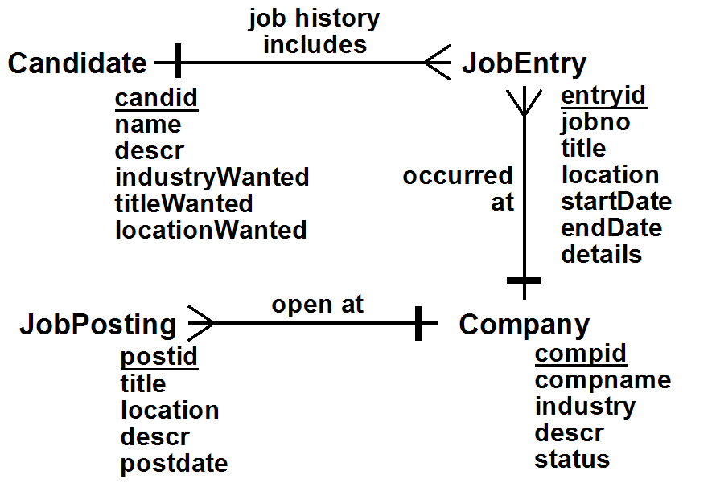

Relationships

JobHistory: (1) Candidate job history includes (*) JobEntry
-- JobHistory is the name of the job history includes relationship
-- between a Candidate and any number (i.e. *) of JobEntries

OccurredAt: (*) JobEntry occurred at (1) Company
-- Note that the relationship description combines the relationship characterization
-- and the names of the related entity classes,
-- putting (*) in front of the entity class associated with a crow's foot.

OpenPostings: (*) JobPosting open at (1) Company

User Role Diagram

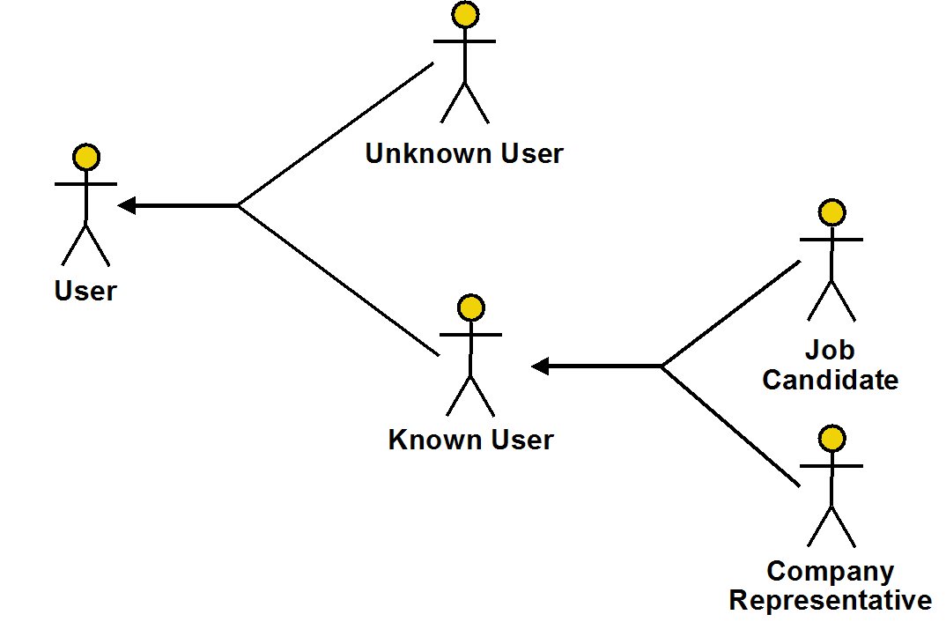

User Operations (Online Job Board Application)

UnknownUser
Actions [Note: Passwords are not kept in the database]
Login( :userid, :pwd ): Logs in user with specified :userid and :pwd
RegisterCandidate( :userid, :pwd, :name, :descr ):
Registers a candidate
RegisterCompany( :compname, :pwd, :industry, :descr, :status ): Registers a new company (automatically creates a new compid for the company). Status is INFO, ACTIVE, or PREMIUM
ActivateCompany( :compid, :pwd, :status ): Activates an INFO-only company at the specified status (ACTIVE or PREMIUM)

Known User
Queries
ShowCompanyInfo( :compid ): Shows information about the indicated company
ShowCompaniesWithPostings( :industry, :title, :location ): Shows companies that have jobs posted with the specified industry, title & location. A NULL value for an attribute means ANY.
ShowPostings( :compid, :title, :location ): Shows jobs posted with the specified title & location. A NULL value for an attribute means ANY.
GetPosting( :postid ): Shows details of the specified posting
Actions
Logout: Logs out the current user
SetPwd( :oldpwd, :newpwd, :repeatnewpwd ):
Changes the current user's password

Job Candidate
Queries
GetPersonalInfo: Gets personal info for the current candidate user
GetJobDesired: Gets information about the job wanted by the current candidate user
GetJobHistory: Gets a summary of the list of previous jobs of the current candidate user
GetJobEntry( :jobno ): Gets the details of the specified job history entry for the current user
ShowMatchingCompanies: Shows companies that have jobs posted that match what the current candidate user wants
ShowMatchingPostings( :compid ): Show postings by a specific company that match what the current candidate user wants, or by any company if :compid is NULL.
Actions
RemoveMeAsCandidate: Unregisters the current candidate user
UpdatePersonalInfo( :name, :descr ):
Provides new personal information for the current candidate user
UpdateJobDesired( :industryWanted, :titleWanted, :locationWanted ):
Provides new details of the job wanted by the current candidate user
AddJobEntry( :compid, :title, :location, :startDate, :endDate, :details ):
Adds a new job entry for the current candidate user
UpdateJobEntry(
:jobno, :compid, :title, :location, :startDate, :endDate, :details ):
Updates the jobno'th entry of the current candidate user
DeleteJobEntry( :jobno ): Deletes the jobno'th entry of the current user
AddCompany( :compname, :industry, :descr ):
Adds info about a company not currently in the database, automatically creating a new id for the company

Company Representative
Queries
GetCompanyInfo:
Gets information, including status, about the current representative user's company
GetPostings: Gets the list of postings made by the current representative user's company
ShowCandidates( :titleWanted, :locationWanted ): Shows a list of candidates who want to work in the industry of the current representative user's company, with the specified title and location. NULL means any
ShowJobCandidates( :postid ): Shows a list of candidates who match the specified job posted (which must be a job posted for the current representative user's company)
ShowMatchingCandidates: Shows a list of candidates who want to work in the industry of the current representative user's company, with a title and location that match any job my company has posted.
ShowCandidateInfo( :candid ): Shows information about the specified candidate
ShowJobHistory( :candid ): Gets a summary of the list of previous jobs of the specified candidate
ShowJobEntry( :entryid ): Shows the details of a particular job history entry
Actions
UpdateCompanyInfo( :industry, :descr, :status ):
Changes information about the current representative user's company
AddJobPosting( :title, :location, :descr ): Adds a new job posting for the current representative user's company. Automatically sets postid and postdate.
UpdateJobPosting( :postid, :title, :location, :descr ): Updates the specified posting and resets postdate
DeleteJobPosting( :postid ): Deletes the specified posting

(Note: Get is used to mean that the information shown will be updatable by the user;
Show is used to mean that it will not be)

Operations with Pre-Conditions (incomplete)

Note: Some pre-conditions are marked as [ROLE]. These are implied by the assignment of the operation to a role.

Login( :userid, :pwd )
- [ROLE] There must not be a user currently logged in
- There must be a user registered with the specified :userid and :passwd

Logout
- [ROLE] There must be a user logged in

RemoveMeAsCandidate
- [ROLE] The current user must be a JobCandidate

AddJobEntry( :compid, :title, :location, :startDate, :endDate, :details )
- [ROLE] The current user must be a JobCandidate
- :enddate must be after :startdate
- :compid must be the id of a company in the database

UpdateJobEntry( :jobno, :compid, :title, :location, :startDate, :endDate, :details )
- [ROLE] The current user must be a JobCandidate
- The current user must have a jobno'th job entry
- :enddate must be after :startdate
- :compid must be the id of a company in the database

UpdateJobPosting( :postid, :title, :location, :descr )
- [ROLE] The current user must be a CompanyRepresentative
- :postid must identify a posting by the current company

GetPostings
- [ROLE] The current user role must be CompanyRepresentative

GetJobPosting( :postid )
- [ROLE] There must be a user logged in

ShowJobCandidates( :postid
- [ROLE] The current user role must be CompanyRepresentative
- :postid must be a job posted by the current company

Actions with Interesting State-Related Post-Conditions (incomplete)

RemoveMeAsCandidate
- All Job Entries for the current user are removed

AddJobEntry( :compid, :title, :location, :startDate, :endDate, :details)
- The entyid of the newly created job entry is one larger than the previous created JobEntry
- The jobno's of all the JobEntrys for the associated candidate or (re)set to go in sequence starting at one, so they are ordered by startdate

UpdateJobEntry( :jobno, :compid, :title, :location, :startDate, :endDate, :details )
- The jobno's of all the JobEntrys for the associated candidate or (re)set to go in sequence starting at one, so they are ordered by startdate

UpdateJobPosting( :postid, :title, :location, :descr )
- Resets the postdate of the posting to be the current date

Queries with Interesting Output-Related Post-Conditions (incomplete)

ShowJobCandidates( :postid ):
- If the current company's status is not PREMIUM, only shows 10 candidates

