CS579 Fall 2009

Class #3 Homework Solution

Hardcopy only (no e-mail) due at start of Class #4

Homework must be typed UNLESS your handwriting is extremely readable!
Late homework (received in e-mail by 7am the following morning) will be penalized one partial grade (e.g. from A- to B+). Late homework received within 48 hrs after class ends will be penalized two partial grades (e.g. from A- to B). Homework received up to 5 days late will be penalized one full grade (e.g. from A- to B-). Homework will not be accepted more than 5 days late, or if a solution to the homework has already been posted.

Recommended Reading

Bowman (The Practical SQL, 4th Ed)
- Chapter 3 (Creating and Modifying Tables), pages 72-83
- Chapter 6 (Grouping Data & Reporting from It)
- Chapter 7 (Joins) pages 206-211 (Natural Joins)

Models and Languages for Database Design & Theory

Relational Modeling

Connolly & Begg
- Chapter 3 (The Relational Model)
- Section 5.3.4 SQL (Grouping)
- Section 6.1-6.3.4 SQL Data Definition (Tables/Constraints)

Oracle Database 10g
- Chapter 4, Planning Oracle Applications
- Chapter 12, Grouping

Lab Exercise Set #3 (complete before class #4)

Available online at courseinfo.

Do NOT hand in the output.

Project Initiation

The project begins this week. You will design the requirements for a realistic database application, and, by the end of the term, you will implement a good portion of it.

I strongly recommend that you work in a group. This generally enhances learning, spreads the work, and produces better designs and implementations. A single person can do the project if you already have strong database and programming experience, but you must check with me first. Pairs generally seem to work best, but groups of three can sometimes work effectively (especially if you've worked together successfully before) although be prepared for the additional overhead of collaborating and arranging to share work equally.

Every group larger than two people MUST have a team leader. It is the team leader's responsibility to make sure that (a) the team succeeds, and (b) each person on the team has the opportunity to fully participate in and/or review each aspect of the project. If you have any concerns about your team's success, or the success of any member of your team, it is your responsibility to let me know as soon as possible. Either the team or I can change the team leader if necessary.

Each individual's grade for the project will be a combination of (a) the grade for the project as a whole, and (b) the contribution that you made to the project (in terms of quality, quantity, and leadership). Individual project grades will be determined at the end of the term.

It is your individual responsibility to ensure that you have an opportunity to participate in and review each aspect of the project, since that will both affect your project grade, as well as your ability to do well on exams. If there are any problems or issues, let me know as soon as possible.

Project Deliverable

This week, your group begins design of the project. ➔ Do not aim for a perfect design and do not spend excessive amounts of time tying to resolve specific issues. Make decisions as quickly as you can, and move on. You will have a chance to make changes later, after we discuss your preliminary design.

This is NOT a project management course, so you do NOT need to hand in any material related to project planning, management, scheduling, or risk analysis unless I explicitly ask for it.

➔ Your team name and/or project name must appear on all project documents.

➔ Look at my Example Project Deliverable for Week #3, and please use the same format.

Your group must bring 3 copies of the project deliverable to class (stapled together separately from any homework problems) – one will be for me; you'll use the other copies for peer review – you will be reviewing each other's deliverables during class.

1) Your team name and your project name. At least one of them (usually your team name) must be humorous (without being excessively tasteless, please, although I'm pretty tolerant). You can change your team or project name later if you need to.

2) (if your team has > 1 person) A team participation report, with your team name and project name, the name of the team leader, and for each member of the team
- the percentage of the overall work that each member did this week
- a very brief description of the main things that each member focused on this week
- what work was done together, and who did (or did not) review work done by other members

This report is to be written by the team leader, who is responsible for its accuracy.

3) A very preliminary draft of the project requirements, in clear non-technical English, in paragraph format. ➔ Make sure your system maintains some data that is specific to at least some individual users of the system, and which is used in some significant way in user operations. For example, the employee database system maintains the salary of each employee.

4) A simple conceptual ER diagram for your project (in Crow Magnum, Easy Crow Magnum, or UML). You do NOT need to show any attributes at all. Aim for 5-9 entity classes. Include at least as many 1:M and M:N relationships as there are entity classes (count carefully!). It’s fine if the diagram is hand-drawn.

5) A list of the entity classes, with a very brief description of each.

6) A draft user role diagram (which can also be hand-drawn). There should be at least two roles other than the generic User, Unknown User, and Known User roles. You will not need to specify the user operations until next week, but make sure that the application is designed so that at least two of the roles (and preferably more) have associated actions.

Self Quiz

Do not hand these in. Make sure you know the answers, though!

➔ Answer the following questions about Grouping related to Lab Exercise Set #3.

a) Explain the difference, if any, between the following two statements

select job, sal from Emps group by job, sal order by job, sal;
select distinct job, sal from Emps order by job, sal;

They're identical

b) Which of the tuples resulting from the following SQL query has a value of 1 for knt, which have a different value, and why.

select job, sal, count(*) as knt from Emps group by job, sal order by job, sal;

This indicates how many tuples have the same values for a particular job and salary. There are two analysts with a salary of 3000, so the knt for ANALYST 3000 is 2. Similarly, there are also two salesmen with the salary 1250, so the knt for SALESMAN 1250 is 2 as well. Every other job/salary pair has a single instance, so their knt is 1

c) What’s the result of the following statement and why

select distinct job, sal, count(*) from Emps order by job, sal;

This is a bit tricky. There's no GROUP BY clause, so count(*) signifies an aggregation that will produce a single value by counting up the total number of tuples. That's at odds with job and sal, which implies generating a separate value of job and sal for every tuple. Most databases (including Oracle) will give an error as a result.

The distinct is actually irrelevant (in most databases). In most databases, the statements
SELECT count(*) FROM Emps
SELECT DISTINCT count(*) FROM Emps
are both legal and produce the same result. SELECT count(*) FROM Emps produces a single tuple. Adding distinct gets rid of duplicates, which simply has no effect, since there is just one tuple.

d) Explain why the results of the following two statements are the same or different

select job, sal from Emps where sal <> 3000 group by job, sal;
select job, sal from Emps group by job, sal having sal <> 3000;

They have the same effect because the restriction is based on sal, and it doesn’t matter whether we remove tuples based on sal, and then group by sal, or whether we group by sal and then remove groups based on sal.

e) Explain why the results of the following two statements are the same or different

select job, sal from Emps where deptno <> 20 group by job, sal;
select job, sal from Emps group by job, sal having deptno <> 20;

The first removes the tuples where deptno <> 20 before grouping; the other tries to do it afterwards, but can’t, since deptno is not available after grouping.
f) Explain why the results of the following two statements are the same or different

select job, sal from Emps where avg(comm) > 100 group by job, sal;
select job, sal from Emps group by job, sal having avg(comm) > 100;

The second removes the groups whose average comm is larger tham 100. The first one is illegal, since aggregates can’t be used in where clauses.

g) Explain why the results of the following two statements are the same or different

select deptno from Emps having count(job) < 4;
select deptno from Emps having count(distinct job) < 4;

They are both illegal, because HAVING requires GROUP BY!

So, suppose, they actually were written as

select deptno from Emps group by deptno having count(job) < 4;

versus
select deptno from Emps group by deptno having count(distinct job) < 4;

The first counts the number of employees in each department whose jobs are not null. That is, it simply counts the number of employee in each department and only keeps those where the number is less than 4, and only department 10 has less than 4 employees.
The second counts the number of different job titles represented in each department. Departments 10, 20 and 30 have three different job titles each, so they are all listed.

➔ Answer the following questions about Natural Joins related to Lab Exercise Set #3.

a) Explain why there is or is not any difference in the number of tuples produced by

select * from (Emps NATURAL JOIN Depts);

select * from Emps, Depts
where Emps.deptno = Depts.deptno;

They have the same number of tuples because they both join the tuples in Emps and Depts where the deptno values match. Note that the fact that Emps.deptno is a foreign key for Depts.deptno is irrelevant! What matters for a natural join is that the attributes both have the same name – in this case, deptno.

b) Explain why there is or is not any difference in the attributes generated by the above two SQL queries

The NATURAL JOIN just keeps one of the matching deptno column.
The second one keeps both of the deptno columns.

The order of the attributes listed is different, though this is database-specific.
In Oracle, the NATURAL JOIN first lists the attributes whose names are the same (the ones used to join) – in this case deptno, followed by the remaining attributes of the first table (Emps) and then of the second table (Depts). The second query lists all the attributes of Emps and then all the attributes of Depts.

c) The first query below does not use a join, while the second one does. Is the join needed? Why or why not?

select empno, ename, deptno from Emps where ename = 'SCOTT'
select empno, ename, dname
from (Emps NATURAL JOIN Depts) where ename = 'SCOTT'

It is needed because dname is in the Depts table, which needs to be joined with the Emps table to get the dname corresponding to an employee's deptno.

d) Explain the differences, if any, between the queries below, and any reasons for them.

select deptno from Depts order by deptno;
select distinct deptno from (Emps NATURAL JOIN Depts);

The first lists the dept numbers of all the departments; it includes dept 40, which does not have any employees.

Because dept 40 does not have any employees, it is not included in the join, so it does not show up in calculating the distinct department numbers!

e) Explain the similarities and differences, if any, between the contents of the Depts table and of the MDepts table (in the exercises) and the reasons for them.

MDepts contains a dmgr attribute which hold the employee number of each department' department manager.

MDepts does not have a tuple for dept 40; There are no employees in dept 40 and so it is not included in the join! (In other words dept 40 doesn’t appear because of the join, not just because there is no department manager for dept 40).
Otherwise, Depts and MDepts have tuples for the remaining departments because every department which does have employees has a department manager.

f) Explain the differences, if any, between the queries below, and any reasons for them.

select dmgr from MDepts order by dmgr;
select empno from Emps where job = 'DEPTMGR' order by empno;

No difference; they both list the employee number of department managers.

Problems

IMPORTANT: You may do problems 1 and 2 on your own (preferable) or with a partner.
I recommend that you do problem 3 together with a partner.

About working with a partner or team:

- If you do a problem together with a partner or team, then only hand in ONE COPY of that problem with all of your names on it.
- Please staple together (no paper clips please, they detach way too easily) the problems you did alone. Separately staple together the problems you did together.

- Working with a partner or a team means working together on the entire problem. If you just start working together, but then actually work out the details on your own, hand in your own solution. If you personally did very little work on a problem, but your name is on it when it is handed in, then you are involved in plagiarism -- taking credit for work that is not yours. All forms of plagiarism are a serious university offense, and I'm required to report them to the Student Academic Conduct Review Board, so please let’s not go there.
- If you are working with partners, and there's a significant imbalance in the quantity or quality of a partner's work, it’s essential you talk to me. Otherwise, it will almost certainly be the case that the underperforming partner will end up doing badly in the exams, and will either be forced to drop the course or will end up with a low grade. If you let me know there's a problem, I can make sure that students get additional help if they need it, or work with a different partner or team.

If you have ANY questions, post them on the newsgroup. Answering questions posted to the newsgroup can positively impact your grade.

1. [35%] SQL Grouping

Using the Emps and Depts table you created in exercise #1, write and test SQL that will solve the problems below.

➔ IMPORTANT: Make sure that the actual code that you write is independent of the actual data in the table. That, your code should do the right thing even if there were a different set of employees in the table
➔ For full credit, write any required joins using NATURAL JOIN expressions

➔ Note that you must use the Emps and Depts table, which you created as a result of
lab exercise #1, not the emp and dept table.

I strongly recommend that you test these, but that is not required. You do not need to hand in a spool file (unless, due to problems installing Oracle, you have not yet done so)

a) Display the count of the number of employees at each location loc

SELECT loc, count(*) As knt FROM (Emps NATURAL JOIN Depts)
GROUP BY loc

You could use count(empno) but using count(*) has the same effect, is clearer, and on some systems, may have better performance. Using count(ename) wouldn't count employees whose name wasn't entered; that's probably unlikely, but isn’t what the problems asks for -- it asks to count all employees, even those who are nameless.

b) Display the count of the number of distinct salary values that occur in each department

SELECT deptno, count(distinct sal) AS levels FROM Emps
GROUP BY deptno

Note that you could also write

SELECT deptno, count(distinct sal) AS levels
FROM (Depts NATURAL JOIN Emps)
GROUP BY deptno

However, the join is unnecessary. You would need to do the join if you want to list the departments by name. Then (assuming department names are unique), you would need to write

SELECT dname, count(distinct sal) AS levels
FROM (Depts NATURAL JOIN Emps)
GROUP BY dname

You also might like to get a result tuple for every department, including those which have no employees. In that case, you'd like to see a value of ZERO for levels. To do that, you need an outer join (which we'll discuss later) which can be written as

SELECT deptno, count(distinct sal) AS levels
FROM (Depts NATURAL LEFT JOIN Emps)
GROUP BY deptno

c) For each unique combination of location and jobs, list the minimum and total salary of those who have that job at that location.

SELECT loc, job, min(sal) AS minsal, sum(sal) AS sumsal
FROM (Emps NATURAL JOIN Depts)
GROUP BY loc, job

d) List the jobs in each department where only one person in the department has the job. (You can assume that every employee has a job)

SELECT deptno, job FROM Emps
GROUP BY deptno, job
HAVING count(*) = 1
ORDER BY deptno, job

Note: You could write having count(job) = 1 or even having count(deptno) = 1. Both would give the correct answer, but it is always better to use count(*) when you can. There's also no need to join with the Depts table, unless the intent was to list the departments by name. In that case (assuming department names are unique), the code would look like

SELECT dname, job FROM (Emps NAURAL JOIN Depts)
GROUP BY deptno, job
HAVING count(*) = 1
ORDER BY dname, job

e) For each location loc where there is only a single department located, display the count of the number of different jobs at that location

SELECT loc, count(DISTINCT job) AS jknt
FROM (Emps NATURAL JOIN Depts)
GROUP BY loc
HAVING count(DISTINCT deptno) = 1

2. [30%] Relational Implementation & Reverse Engineering

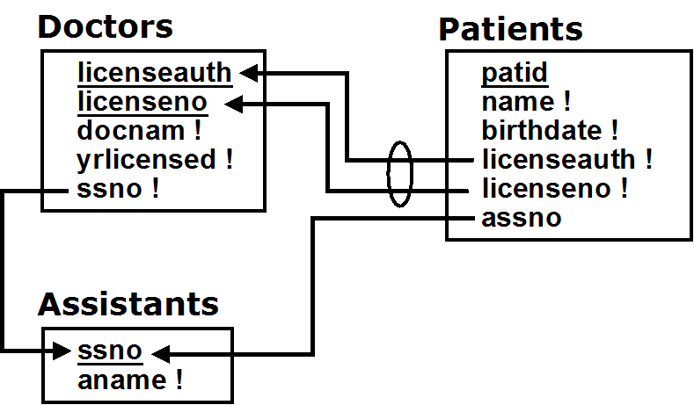
Look at the following relational schema diagram, which describes a situation in which doctors treat patients and are assisted by assistants who medicate patients, and do parts (a), (b) and (c).

a) Write and test the SQL to create the three tables which correspond to this relational schema. Make sure that it includes all the appropriate
- primary key constraints
(NOTE: There are primary key constraints, but no explicit UNIQUE constraints)
- not null constraints
- and foreign key constraints (using references)
which are shown in the relational schema above.

➔ To get full credit, you must include the output from the spool file, showing successful creation of the tables.
➔ You must create a table before you refer to it or else you will get errors!

create table Assistants (
ssno char(9) primary key,
aname varchar(30) not null);

-- Assistants must be created first, since Doctors references it

create table Doctors (
licenseauth varchar(20),
licensno number(8),
docname varchar(30) not null,
yrlicensed number(4) not null,
ssno char(9) not null references Assistants,
primary key( licenseauth, licenseno ) );

-- Patients must be created last, since it references both Assistants and Doctors

Create table Patients (
patid number(8) primary key,
name varchar(30) not null,
birthdate date not null,
licenseauth varchar(20) not null,
licenseno number(8) not null,
assno char(9) references Assistants,
foreign key( license, licenseauth ) references Doctors;

For extra credit, provide names for the constraints.
It is very useful to provide names for constraints, especially foreign key and check constraints. If there's an error, this name is reported in error messages. (Primary key and null constraints can be named as well, but they're less likely to be violated).

With named foreign key constraints, Doctors and Patients would look like

create table Doctors (
licenseauth varchar(20),
licensno number(8),
docname varchar(30) not null,
yrlicensed number(4) not null,
ssno char(9) not null constraint Doctors_FK_ssno references Assistants,
primary key( licenseauth, licenseno ) );

Create table Patients (
patid number(8) primary key,
name varchar(30) not null,
birthdate date not null,
licenseauth varchar(20) not null,
licenseno number(8) not null,
assno char(9) constraint Patients_FK_assno references Assistants( ssno ),
constraint Patients_FK_Doctors
foreign key( license, licenseauth ) references Doctors;

It is possible to create the tables without any foreign key constraints, and then add that later. For example, if you created Doctors without a foreign key constraint, you could add it later by executing

ALTER TABLE Doctors
add constraint Doctors_FK_ssno
foreign key( ssno ) references Assistants;

b) Write and test the SQL to insert three tuples
(and include the spool file for that as well)
- a patient who sees a doctor and is medicated by an assistant
- that doctor
- the assistant to that doctor who medicates the patient

NOTE: Because of the foreign key constraints you (should have) specified when you defined the tables, you must be careful to write the inserts in an order that will actually allow them to all be done without raising an error! Also, do NOT use a SELECT as part of any INSERT.

INSERT INTO Assistant
VALUES ( 30472, 'Sylverter Bluetooth' );

/* Because of the foreign key constraint, the assistant must be inserted before the doctor, since the doctor references the assistant */
INSERT INTO Doctors
VALUES( 'The Authority', 2345678, 'Letitia Monmouth', 1344, 30472 );

/* Similarly, the patient must be inserted last, since she references both the doctor and the assistant */
INSERT INTO Patients
VALUES( 11111, 'Saringa Hamedi, '11-OCT-1383',
'The Authority', 2345678, 30472 );

c) Draw a (Easy) Crow Magnum or UML ER Diagram corresponding to the relational schema above, based on carefully reverse engineering it. You must
- Show all attributes, making sure you indicate primary keys, and attributes which are required to have values.
- Be careful NOT to include entity attributes!
- Show all relationship characterizations (make sure the names are appropriate)
- Show mandatory [but NOT optional] participation constraints.

In the solution, shown below, foreign key constraints correspond to 1:M relationships. The arrow in the foreign key constraint points in the same direction as the arrow in the crow's foot.
There's a mandatory child participation constraint on the assisted by relationship (a doctor is assisted by exactly one assistant) because the corresponding foreign key attribute (i.e. ssno in Doctors) has a not null constraint.

The same is true of the treats relationship (a patient is treated by exactly one doctor) because the corresponding foreign key attributes (i.e. licenseauth and licensno in Patient) both have a not null constraint.

Other non-null constraints in the relational schema diagram are represented as required constraints (also using exclamation marks) in the ER diagram, though you'd probably want to only draw them when essential or for diagrams meant for documentation.

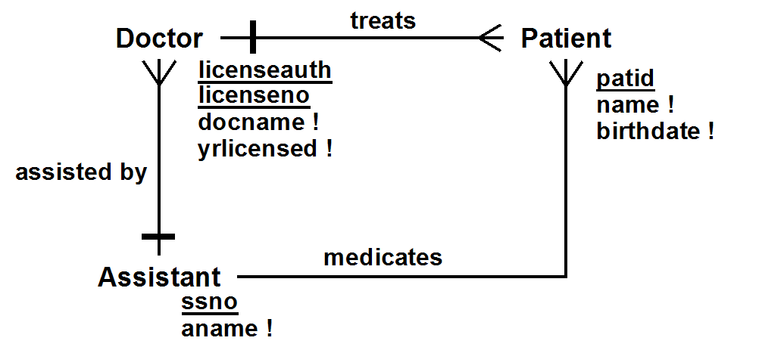

3. [35%] Requirements & Conceptual State Constraints
Below, you will find requirements for an Employee Database Application, and the ER model designed to implement those requirements. ➔ I strongly recommend that you read through the solution to the conditions and constraints problem in HW #2 before doing this problem!

This problem asks you to extract all the conceptual state constraints from the requirements except those already visually represented by the ER diagram. You must separate out entity instance constraints, entity class constraints, relationship constraints, and general conceptual constraints.

Only include those conceptual constraints which appear in, or are implied by the requirements. Remember that
- conceptual constraints are written in plain non-technical English
- conceptual constraints involve the conceptual model (as show above). They refer to entity classes & relationships, not to tables!
- a state constraint specifies an invariant property of the database state (something that you would like to always be true). It must be possible to check a state constraint by looking at the database at an arbitrary time, so there must be attributes or relationships in the conceptual model which can be tested at any time to determine if the state constraint is true or not.
- a state constraint constrains. That is, it limits the states of the database which are allowable. A statement which does not constrain anything can't be a constraint.

Do NOT include

- pre-conditions: Business rules which can ONLY be checked prior to specific operations, determining whether or not the operation is allowed
- post-conditions: Business rules which ONLY describe how the state has changed after doing an operation, but which are not always true at an arbitrary point in time
- state constraints which are already visually represented by the ER diagram (e.g. mandatory participation constraints)

NOTE: To provide additional help, following this problem you will find the filled-in solutions for an Online Job Board Application

Employee Database Application Requirements

An Employee Database Application keeps track of all employees of a small company, including their name, job and salary. The company is divided into departments (with a name and location), and every employee works for a single department.

Only employees can successfully login to the system, however, even without logging in, a user can get the names and locations of all the company departments.

An employee can optionally provide and change their own address, and can see the address of any other employee who has provided an address and made it public, given that employee's name. An employee can see a list of the names and jobs of all the employees in their own department, and can find out the department and location of another employee given their name.

Every employee (except for the President – the employee whose job is 'PRESIDENT') has a manager, who directly manages them. An employee does not need to be in the same department as their direct manager. However, every employee works at the same location as their direct manager, unless they are directly managed by the President. When a manager is terminated, all employees who directly reported to them instead will instead report to their old manager’s manager. Managers can get a list of all the employees that they directly manage, or all employees beneath them in the management hierarchy, along with the job, salary and manager of each.

Every department has at most one department manager (the employee in a department whose job is 'DEPTMGR'), and must have a department manager if it has a clerk. Any employee can find out the managers of the various departments. Every department manager may also directly manage employees, and all department managers are directly managed by the president. A department manager can see the job, salary and manager of all other employees in their department, and can change the jobs and salaries of all the other employees in their department, and terminate employees in their department. A department manager can hire a new employee for their department, only if their initial direct manager is also in the same department. A department manager can change the direct manager of an employee in their department only if both the old and the new manager are in the same department. When a department loses its manager, the employee in the department with the highest salary (or one of them if there is more than one) becomes the manager, if one is needed.
The president can see and change the jobs, salaries, managers, and departments of all other employees, and can hire and terminate any other employee. The President can also create and destroy departments and move them to a new location. When destroying a department, the President can choose to either terminate all the employees in the department, or move them all together to a different department. However, no operation can affect the president.

ER Model:
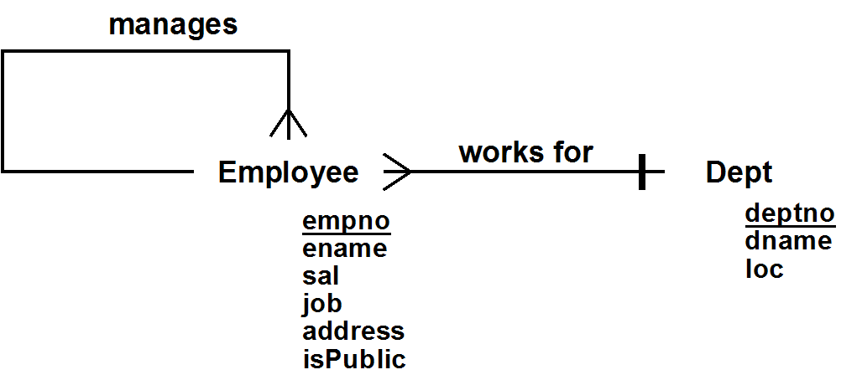

Relationships:

Manages: Employee manages (*) Employee
WorksFor: (*) Employee works for (1) Dept

➔ HERE ARE THE QUESTIONS FOR THIS HOMEWORK PROBLEM:

a) Entity Instance Constraints

a1) List all entity instance constraints on Employee. These are conceptual state constraints which constrain the value of a single Employee at a time, independent of any relationship

- Every employee has a name, job & salary
- isPublic is either T or F
- sal is greater than 0
a2) List all entity instance constraints on Dept. These are conceptual state constraints which constrain the value of a single Dept at a time, independent of any relationship

- Every department has a name and location

b) Entity Class Constraints

b1) List all entity class constraints on Employee. These are conceptual state constraints which only involve the Employee class, independent of any relationship, but which require consideration of more than one Employee at a time

➔ OnePrez
Only one employee has the job of PRESIDENT

b2) List all entity class constraints on Dept. These are conceptual state constraints which only involve the Dept class, independent of any relationship, but which require consideration of more than one Dept at a time

➔ UniqueDeptNames
Department names are unique

c) Relationship Constraints

c1) List (and name) all relationship constraints on the Manages relationship:

Note: These are conceptual state constraints which involve the Manages relationship (see the list of named relationships above) and possibly the class(es) it relates (in this case only the Employee class; no other classes or relationships).

➔ NoPrezMgr
The President does not have a manager

➔ EmpMgr
Every employee other than the President has a manager
➔ ManageCirc
No one manages themselves, their manager, their manager's manager, etc.
➔ ManageDeptMgr
All department managers are directly managed by the President (if there is one, or by no one if there isn't)
c2) List (and name) all relationship constraints on the WorksFor relationship:

Note: These are conceptual state constraints which involve the WorksFor relationship (see the list of named relationships above) and possibly the class(es) it relates (the Employee & Dept classes, but no other relationships).

➔ OneManager
Every department has at most one department manager

➔ DeptMgrClerks
Every department that has a clerk has a department manager
d) General Conceptual State Constraints. List all general conceptual state constraints. These are conceptual state constraints which involve two or more relationships (or two or more unrelated classes)

➔ ManageLoc
Every employee works for a department at the same location as their direct manager, if they have one, unless their direct manager is the president
Online Job Board Application Requirements

An Online Job Board Application allows job candidates and company representatives to post information and find possible matches.

After a company representative registers their company, they can provide and later update information about it, including the industry it is in (chosen from a standard list) and a description. They can also post, update and remove job openings, each one describing the title and location of the job and an optional description. Two job openings for the same company must not have the same title and location.

A company representative can deactivate their company (and later, after arranging payment, reactivate it or make it’s status premium). When a company is deactivated, all of that company’s job postings are removed. The only company-representative-specific operations that can be done by a company representative for an inactivate company are to update the company information and reactivate the company. Excluding inactive companies, only 30% of the companies within an industry can have PREMIUM status. Only companies with PREMIUM status can have more than 3 jobs posted.

After a job candidate registers, they can provide and later update their name and other personal information, as well as the industry, title and location of the job they are seeking. They can also provide information about each of the jobs they have had, including the start and end dates (unless they are still at that job), the company, and optionally their job title, location, and other details. If the company they worked is not already in the database, they can provide information about it. A candidate may have more than one job entry for the same company, but if so, their dates of employment must not overlap. If a candidates removes themselves from the system, their job history is removed as well.

A company representative for an active company can browse and search through employees and see their information. A job candidate can find job openings that match their desires. Either can both browse and search through companies and lists of open jobs.

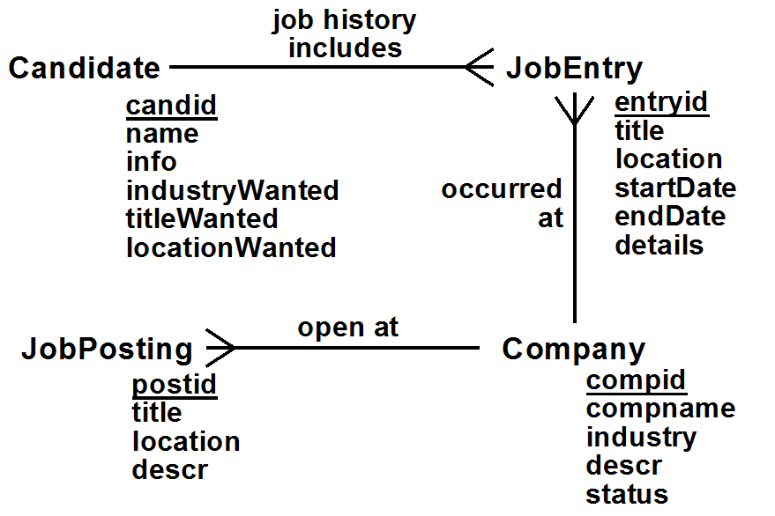
ER Diagram

Relationships

JobHistory: Candidate job history includes (*) JobEntry
OccurredAt: (*) JobEntry occurred at Company
OpenPostings: (*) JobPosting open at Company

a) Entity Instance Constraints

a1) Candidate
- Every candidate must have a name
- IndustryWanted must be one of the approved industry values

a2) Company
- Industry must be one of the approved industry values
- Status is either PREMIUIM, ACTIVE or INACTIVE

a3) JobEntry
- Either no endDate is provided, or it must be greater than the startDate
- StartDate must be provided

a4) JobPosting
- Both the title and the location must be provided

b) Entity Class Constraints

b1) Candidate: None

b2) Company:

➔ PremiumLimits
Excluding inactive companies, only 30% of the companies within an industry can have PREMIUM status

b3) JobEntry: None

b4) JobPosting: None

c) Relationship Constraints

c1) JobHistory Constraints: None

c2) OccurredAt Constraints: None
c3) OpenPostings Constraints:
➔ UniqueOpenings
Two job openings for the same company must not have the same title and location

➔ PremiumPostings
Only companies with premium status can have more than 3 jobs posted

d) General Conceptual Constraints

➔ NoOverlappingDates
If a candidate has two job entries for the same company, the dates must not overlap (involves both the JobHistory & OccuredAt relationship)

