CS579 Fall 2009

Class #8 Homework Solution

Hardcopy only (no e-mail) due at start of Class #9

➔ E-mail a zip file of your project folder
by 11pm on the night before the start of Class #9

Bring the requested hardcopy to class
(see PROJECT DELIVERABLES details below)
Homework must be typed UNLESS your handwriting is extremely readable!
Late homework (received in e-mail by 7am the following morning) will be penalized one partial grade (e.g. from A- to B+). Late homework received within 48 hrs after class ends will be penalized two partial grades (e.g. from A- to B). Homework received up to 5 days late will be penalized one full grade (e.g. from A- to B-). Homework will not be accepted more than 5 days late, or if a solution to the homework has already been posted.

Recommended Reading

Bowman (The Practical SQL, 4th Ed)
- Chapter 11, Solving Business Problems

Models and Languages for Database Design & Theory

Visual & Textual Languages for ER Modeling
- Sections 7 Subclasses
- Section 8 Comparative Analysis of UML, Chen & Crow Magnum

Connolly & Begg
- Section 12.1 Enhanced ER Modeling
- [OPTIONAL] Chapter 4 Relational Algebra & Calculus

Oracle Database 10g
- Chapter 14 Complex Possibilities

Project Continuation

This week, you will be adding superclasses/subclasses to your conceptual model, modifying your relational schema accordingly, and planning how you will initially populate your database

PROJECT DELIVERABLES

➔ Your team name and/or project name must appear at the beginning of all .sql files which you created, and on each team document.

E-mail a zip file of your project folder by 11pm on the night before the start of class, with the subject HW #8 from teamname. Note: Make sure that the paths of all files in the zip file are relative to the project folder root
➔ READ CAREFULLY: Also, at the start of class, hand in HARDCOPY of
- Your Project Status Document (including your team report)
- Your latest specifications (which should not include your team report)
- ➔ DefineAppSystem.sql
- ➔ Your population plan

ALL PROJECT HOMEWORK MUST BE TYPED. HANDWRITTEN MATERIAL WILL NOT BE ACCEPTED (unless you check with me first) ➔ PLEASE provide everything you hand in for your project in a single packet, either stapled, or put in a pocket folder

➔ Please hand in project deliverables separately from other homework

PROJECT GRADING

Grading for this week's assignment will be based on the following:
- Project Status Document
- Revisions to Conceptual Model
- Revisions to Conceptual Schema
- Revised Table Creation Code
- Populate Plan

Each individual's grade for the project will be a combination of (a) the grade for the project as a whole, and (b) the contribution that you made to the project (in terms of quality, quantity, and leadership). Individual project grades will be determined at the end of the term.

It is your individual responsibility to ensure that you have an opportunity to participate in and review each aspect of the project, since that will both affect your project grade, as well as your ability to do well on exams. If there are any problems or issues, let me know as soon as possible.

It is the team leader's responsibility to make sure that (a) the team succeeds, and (b) you do your best to see that each person on the team has the opportunity to participate in and/or review each aspect of the project. If you have any concerns about your team's success, or the success of any member of your team, it is your responsibility to let me know as soon as possible. Either the team or I can change the team leader if necessary.

PROJECT TASKS

1) (if your team has > 1 person) A team participation report (written by the team leader), listing the team name for your group, the name of your project (if different from the team name), the name of the team leader, and for each member of the team
- a very brief description of the main things that member focused on this week
- the percentage of the overall work that member did this week

2) Revise the specifications for your application as necessary. Highlight any changes.

Your specifications must include the following revisions:
- Your ER model must be revised to ➔ include at least one subclass. You will get more credit if both the superclass and the subclass have relationships with other entity classes. Include design notes for any interesting or complex design decisions, including why you did or didn't use subclass discriminators.

- Your relational schema must be revised to represent the changes in your ER model. ➔ NOTE: You may NOT use a superclass-only representation for all of your superclass/subclass relationships. At least one of them must use a superclass/subclass or a subclass-only representation.

- Revise your list of User Operations so that at least one of your operations accesses information in a table corresponding to a superclass, and at least one (possibly the same one) will accesses information in a table corresponding to a subclass. Remember that you need to discuss with me any operation which you believe will require user interaction beyond filling in the initial parameters.

3) Update the code to create the tables and views for your application (i.e. using CREATE TABLE and CREATE OR REPLACE VIEW) to correspond to the changes in your specifications.

4) Test that your code to create your tables still works. Do the following

- Using SQL*Plus, connect to the database as the new user you created for your application (e.g. ZooDB), with password OK (or just connect as SCOTT or your user if you were unable to create a new database user).
- Run the application setup script you created (e.g. @/zooset)

- Run (in SQL*Plus)
@&ac

This runs create.sql (which you can look at), which builds the core subsystem code, and then runs the code in AppSubsystems\DefineAppSystem.sql, which should create your tables.

Running @&ac automatically creates the spool file Spool\create.LST. Please do not change or fake its content. ➔ It must be included in your zipped deliverable.

Very carefully look through the script file to see if Oracle reported any errors. If there are errors, fix them, then keep executing @&ac until there are no errors. Read Hints for Debugging with SQL*Plus and PL/SQL (in courseinfo) for help and advice.

5) In the next assignment, you will populate your database with actual data -- enough to do a decent job of testing your application without going overboard.
➔ In preparation, this week you will write ➔ and place in Doc\PopPlan.doc, a thoughtful plan (about a page) that specifies how you will populate the database, including
  - how much data there will be for the various tables
  - the kind of data you will use
  - any interesting relationships among the data
  - the order in which you will insert the data

You will have some choices about how to generate the data that you need to insert:

- You can insert each tuple explicitly (e.g. via INSERT statements). That's how the Employee Database Application works, as you can see in _EmpApp\Populate\populate.sql.
- You can read the data from a file, which will require uses of a PL/SQL package.
- You can automatically generate some of the data using PL/SQL code. For example, you might populate a table using a FOR loop. This could lead to boring names such as Employee1, Employee2, etc., but can be a fast way to get a large number of tuples created
Have fun. Don't go overboard. It's often possible to do a reasonable job of checking that your operations work with very little data (but not too little). Remember it's up to you to make sure that populating the database does not become a time sink!
Begin working out the details of the actual data you will use to populate the database. That will save time next week, when you will have more to do.

6) Write a Project Status Document (➔ in Doc/status-8.doc), including the elements below (please follow the format of the sample report provided in courseinfo)

Problems

IMPORTANT: You MAY do these problems on your own or with a partner.
If you do any problems with a partner,
hand in one copy with your names on it.

If you have ANY questions, post them on the newsgroup. Answering questions posted to the newsgroup can positively impact your grade.

1. [100%] Subclasses

Suppose you are given the following conceptual model:

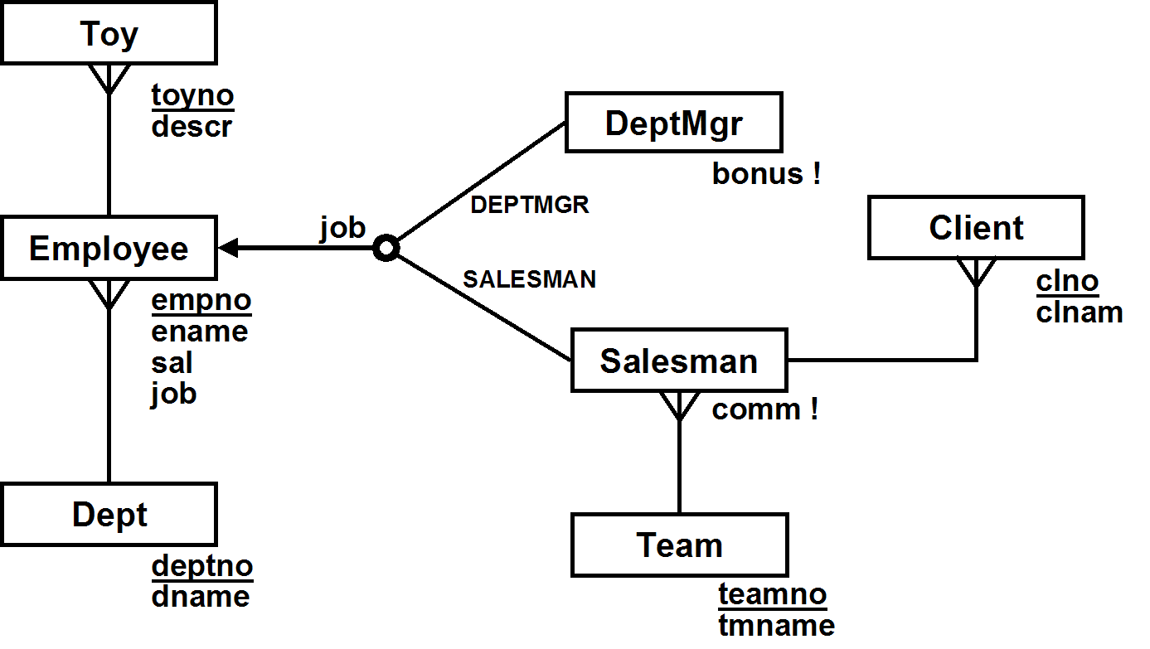

a) Separately draw the Relational Schema resulting from [1] superclass/subclass, [2] superclass-only, and [3] subclass-only mappings of the model. Make sure you
- underline primary keys
- make certain that your foreign keys are pointing in the right direction
- indicate cascading deletes when they are required by the conceptual model, but not otherwise
Note: In the subclass-only mapping, it would be INCORRECT to have a table which represents all employees. However, you will need to add some other table to keep track of employees who are neither salesmen nor dept mgrs.

Superclass/Subclass

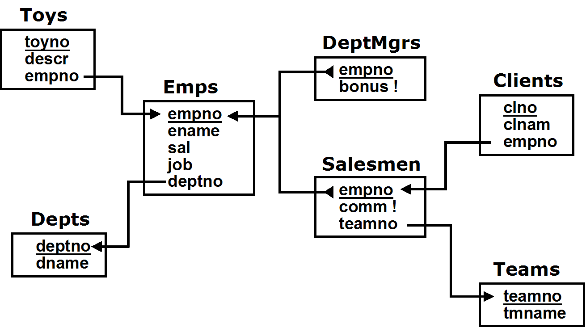

Superclass-only

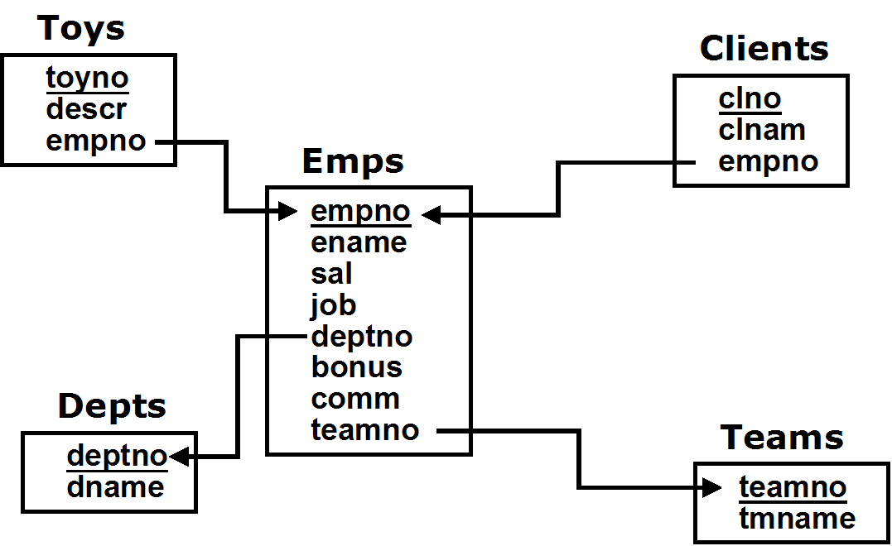

Note that we cannot require that bonus and comm. be non-nuill here, since there are entries in this tables for all employees

Subclass-only

First of all, here is an incorrect solution
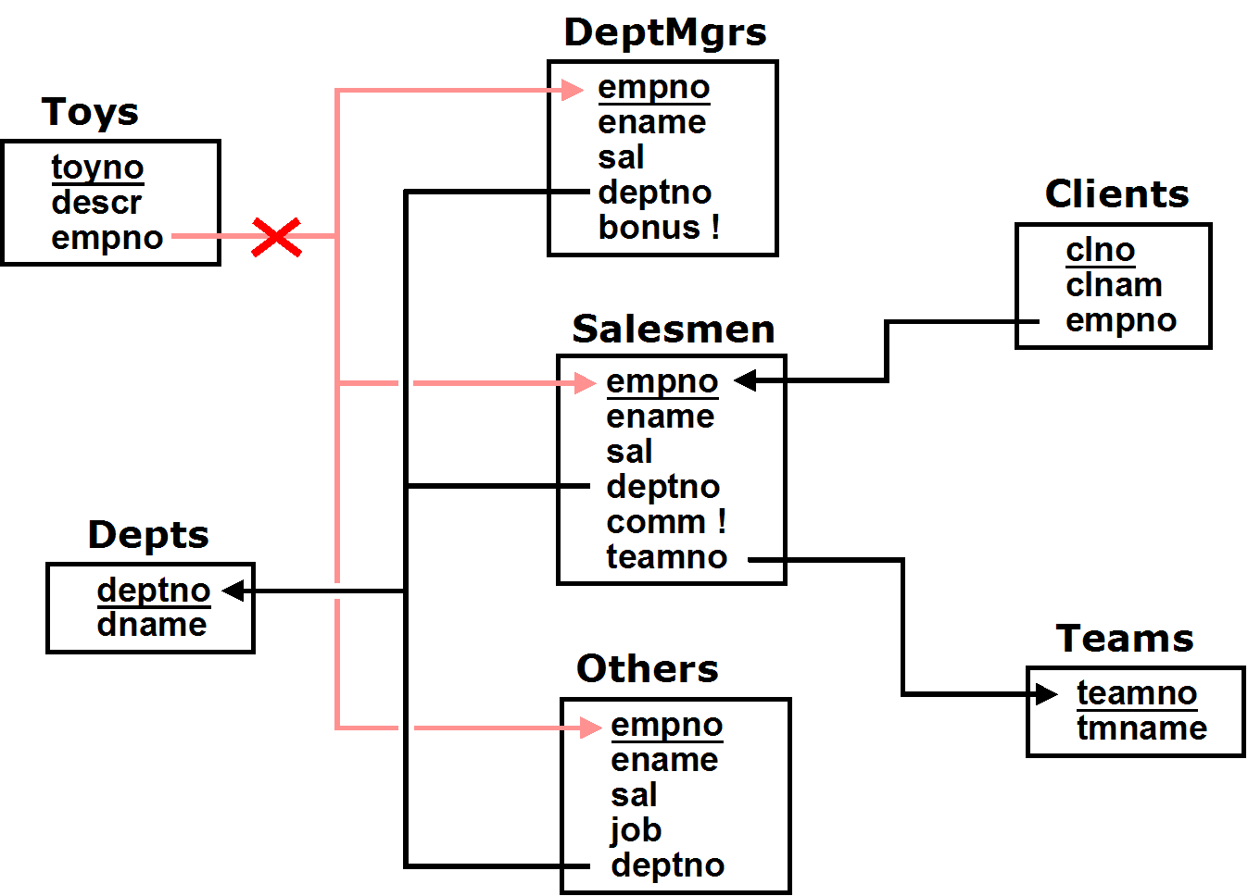

The reference from Toys.empno to DeptMgrs, Salesmen and Others is incorrect, since it would imply that a Toy must be owned by an employee who is a Salesman, as well as a DeptMgr as well as some other type of employee, which can never be possible, since those classes are all disjoint.

A correct solution is below

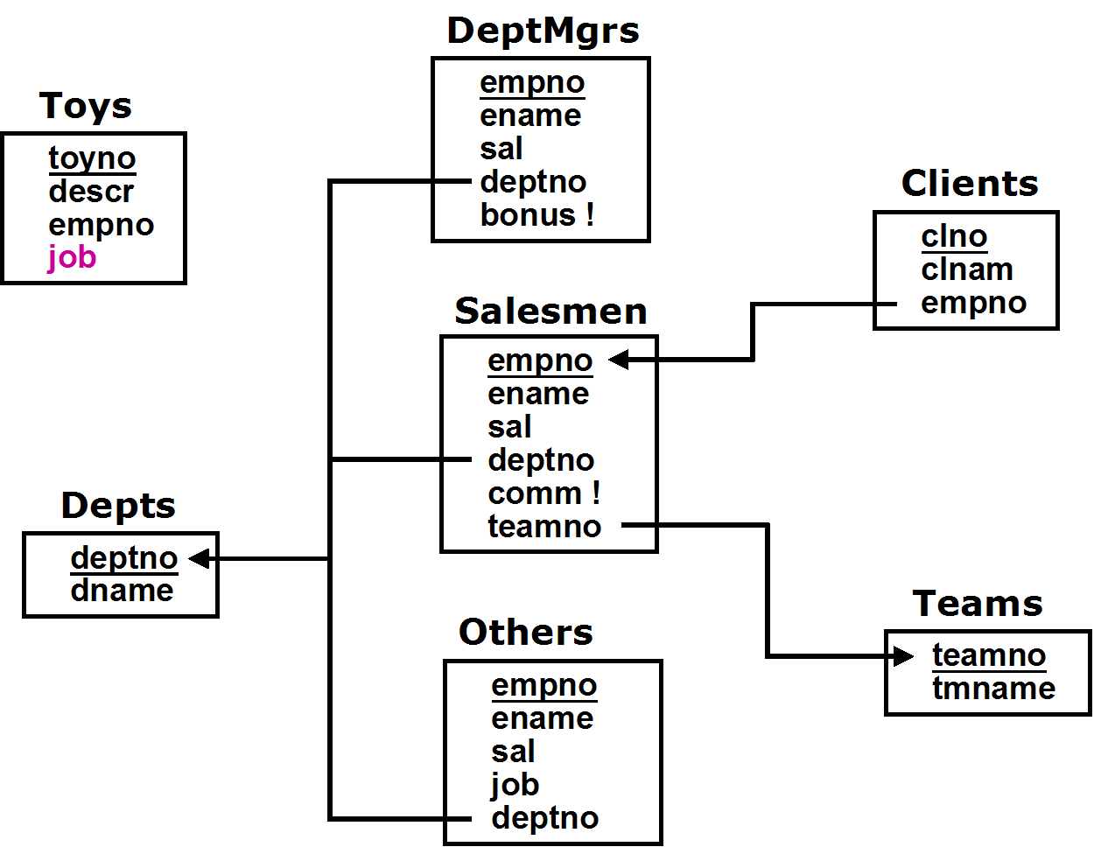

Notes:

1) The job attribute in Toys is not required, but could potentially be used to speed up the code that determines the name of an employee who owns a specific toy, since it indicates which table holds info for that employee.

2) Neither Salesmen nor DeptMgrs need a job attribute, since the job value would always be the same for all tuples in the table.

3) An Others table is needed to hold tuples of employees who are neither salsmen nor dept mgrs
Another reasonable solution, which provides referential integrity in exchange for the space of additional attributes, provides a separate attribute in Toys for each kind of possible owner:
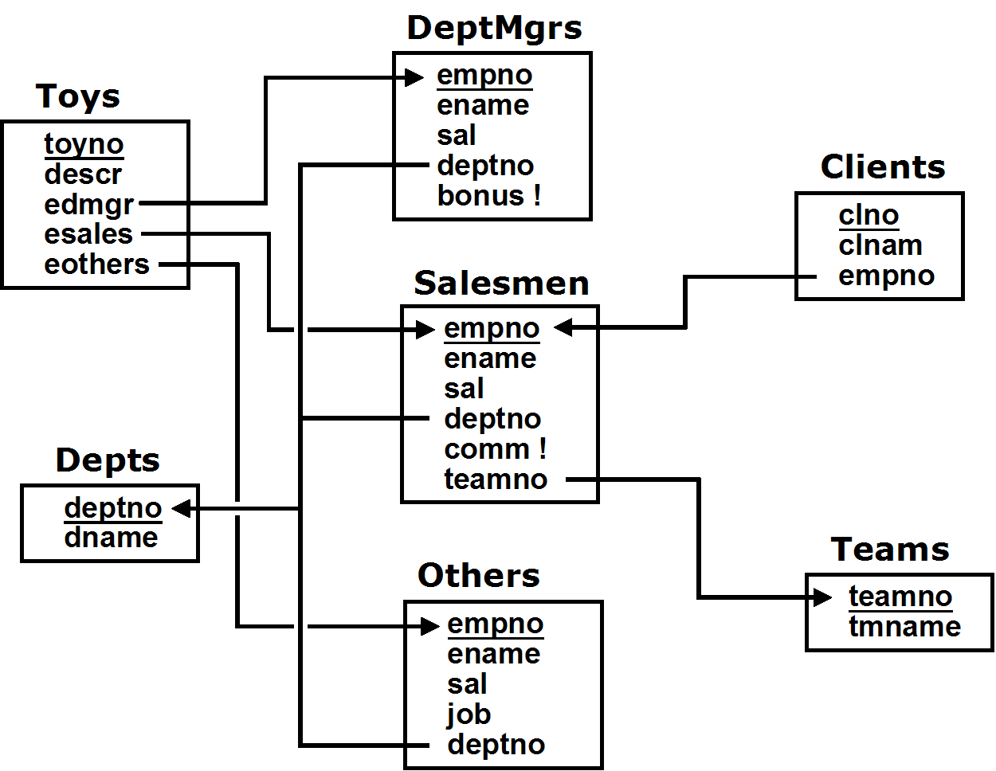

b) For each of the 3 mappings (superclass-subclass, superclass-only, and subclass-only), write the (one or possibly more) INSERT statement(s) needed to add a new dept mgr for dept 20 to the database, with empno 5162, ename 'BOAZ', sal 2200, and bonus 200.

Superclass/Subclass
INSERT INTO Emps( empno, ename, sal, job, deptno )
VALUES( 5162, 'BOAZ', 2200, 'DEPTMGR', 20 )
INSERT INTO DeptMgrs( empno, bonus )
VALUES( 5162, 200 )

Superclass-only
INSERT INTO Emps( empno, ename, sal, job, deptno, bonus )
VALUES( 5162, 'BOAZ', 2200, 'DEPTMGR', 20, 200 )

Subclass-only
INSERT INTO DeptMgrs( empno, ename, sal, deptno, bonus )
VALUES(5162, 'BOAZ', 2200, 20, 200 )

c) Suppose that we define the compensation of an employee in the following way:
- if they're a dept manager, it is their salary plus their bonus
- if they're a salesman , it is their salary plus their commission
- For all other employees, it is just their salary

For each of the 3 mappings, write a single SQL query that lists the name and compensation of each employee, ordered by name (you may assume that all employee have unique names). I recommend that you do them in the order:
[1] subclass-only, [2] superclass-only, [3] superclass-subclass.

Subclass-only

-- The simplest technique uses UNIONs. UNION ALL is more efficient
-- than UNION, but only works because we know that all
-- employee names are unique

SELECT ename, sal + comm AS compense FROM Salesmen
UNION ALL
SELECT ename, sal + bonus AS compense FROM DeptMgrs
UNION ALL
SELECT ename, sal AS compense FROM Others
ORDER BY ename

-- This version is a bit esoteric, but shows how
-- full joins can be used to recreate the superclass-only table

SELECT ename, sal + nvl(comm,0) + nvl(bonus,0) as compense
FROM ((Salesmen NATURAL FULL JOIN DeptMgrs)
NATURAL FULL JOIN Others)
ORDER BY ename

Superclass-only

Since we know that comm is always NULL for non-salesmen, and that bonus is always NULL for non-deptmgrs, we can use

SELECT ename, sal + nvl(comm,0) + nvl(bonus,0) as compense
FROM Emps
ORDER BY ename

We can also write

SELECT ename, sal + comm as compense FROM Emps
WHERE job = 'SALESMAN'
UNION ALL
SELECT ename, sal + bonus AS compense FROM Emps
WHERE job = 'DEPTMGR'
UNION ALL
SELECT ename, sal AS compense FROM Emps
WHERE job NOT IN ('SALESMAN','DEPTMGR')
ORDER BY ename

SELECT ename,
(CASE job WHEN 'SALESMAN' THEN sal + comm
WHEN 'DEPTMGR' THEN sal + bonus
ELSE sal END) AS compense
FROM Emps
ORDER BY ename

Superclass/Subclass

SELECT ename, sal + comm AS compense
FROM Emps NATURAL JOIN Salesmen
UNION ALL
SELECT ename, sal + bonus AS compense
FROM Emps NATURAL JOIN DeptMgrs
UNION ALL
SELECT ename, sal AS compense
FROM Emps
WHERE job NOT IN ('SALESMAN','DEPTMGR')
ORDER BY ename

-- Here we do UNION ALL's to collect the payments for each employee
-- then group by ename and sum then up. This is inefficient, though

WITH Payments AS (
SELECT ename, comm AS pay FROM Salesmen
UNION ALL
SELECT ename, bonus AS pay FROM DeptMgrs
UNION ALL
SELECT ename, sal AS pay FROM Emps)
SELECT ename, sum(pay) AS compense FROM Payments
GROUP BY ename
ORDER BY ename

-- Here we use Subqueries
SELECT ename, sal +
nvl( (SELECT comm FROM Salesmen s WHERE e.empno = s.empno), 0 ) +
nvl( (SELECT bonus FROM DeptMgrs d WHERE e.empno = d.empno), 0 )
AS compense
FROM Emps e
ORDER BY ename

SELECT ename, (CASE job
WHEN 'SALESMAN' THEN
(SELECT sal + comm FROM Salesmen s WHERE e.empno = s.empno)
WHEN 'DEPTMGR' THEN
(SELECT sal + bonus FROM DeptMgrs d WHERE e.empno = d.empno)
ELSE sal END) AS compense
FROM Emps e
ORDER BY ename

-- Here, we use left joins
-- to recreate the superclass-only table
SELECT ename, sal + nvl(comm,0) + nvl(bonus,0) as compense
FROM ((Emps NATURAL LEFT JOIN Salesmen)
NATURAL LEFT JOIN DeptMgrs)
ORDER BY ename

2. [Extra Credit] Conceptual Design:
A tennis club wants to design a database that keeps track of members, with their personal information (name, address, phone number), when they joined, and their member id, and of instructors, with their personal information (name, address, phone number), skill level, and their instructor id.

Courts at the tennis club can be reserved for hourly slots from 8am to 8pm every day, and must be reserved before they can be used, either for games or for lessons. The database keeps track of all reservations, including the one person who reserved each court slot. The database also keeps track of who plays or takes lessons during each court slot.

A court can either be reserved for a singles or doubles game (but only by a member who will play in the game), or for a lesson (by that lesson's instructor). Lessons are either individual lessons (for members only) or group lessons (open to non-members).

The club requires that the identity be recorded of every person who plays on a court (including non-members who play games with members, or who take a group lesson, or instructors). If a non-member plays for the first time, they must provide their personal information (name, address, phone number), and are given a unique id, which they can subsequently use.

There are two parts to this problem (a) and (b)

a) Draw the corresponding (Easy) Crow Magnum or UML ER diagram. Show all
- relationship characterizations (not needed for subclass relationships)
- mandatory participation constraints, dependent and identifying relationships as needed.
- all relevant attributes, with primary keys and discriminators denoted appropriately

➔ You MUST use subclassing. Draw the subclasses correctly. Make sure the arrows point toward the superclass. Correctly distinguish between overlapping and disjoint subclasses. For disjoint subclasses, distinguish between those which are complete and incomplete, and use subclass discriminators where appropriate.
If you use any enumerated attributes (i.e. attributes which take on a small number of fixed values, like TRUE/FALSE, or like BIG/MEDIUM/SMALL), you MUST write a design note which describes the possible values of the attribute and what each value means.

➔ You MUST use the following entity classes: Lesson, Game, Instructor and Member. You will need additional entity classes as well. In particular, consider classes which are superclasses of the ones above.

b) List any relationship and general conceptual state constraints (i.e. NO entity constraints, no pre or post conditions) which are based directly on the requirements, and which are not already redundant with your ER diagram.

THE APPROACH I PREFER incorporates more constraints in the ER diagrams (especially by using relationships between subclasses!). In general, this means that fewer or simpler constraints will need to be specified explicitly!

The solutions we will describe below all use the entity class:

- Person, a superclass for Instructor and Member. We could have added a separate NonMember class, but it is not necessary, since when ever we want to refer to non-members, we can just use Person. In particular, we assign a personid to every person, which acts as the unique id assigned to non-members.
- Activity, a superclass for Lesson and Game

Below, we will show two solutions. The first uses a much simpler ER diagram, with relationships only between the superclasses, but requires explicit specification of a number of state constraints. The second solution uses relationships among the subclasses, as well as relationships subclasses. It has a more complex ER diagram, but captures all of the state constraints in the diagram itself.

Before we start looking at complete solutions, note that the requirements certainly suggest that we should have a Court class, and a Reservation class, where a reservation is the use of a court for a particular timeslot on a particular date. That is
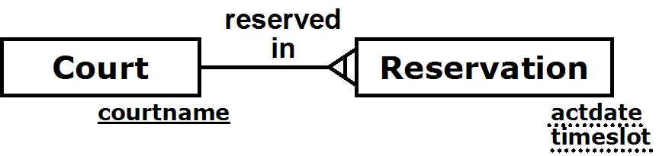

Now
- A reservation must be made by a Person (who can make multiple reservations)
- Every reservation is for a single activity, and every activity requires a reservation

So, ignoring who participates in an activity, this leads to

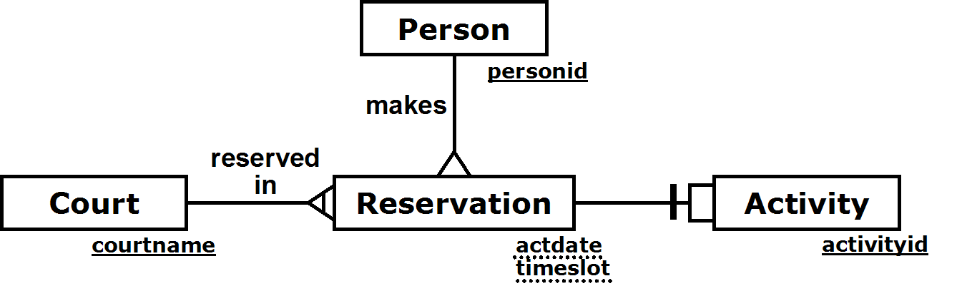

This is a fine and completely reasonable starting point. However, because a Reservation and an Activity are so closely tied together (in a 1:1 relationship), we will keep our solutions simpler by simply folding Reservation into Activity which leads to the diagram below (although note that we now need an explicit state constraint)

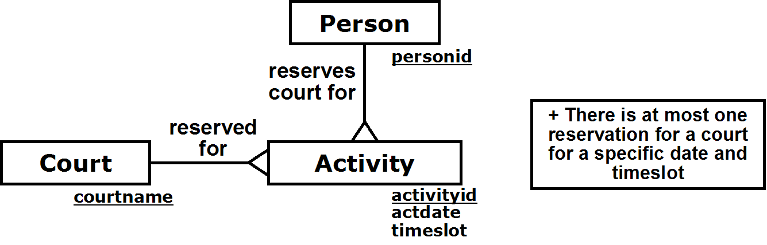

We can make our diagram even simpler still by downgrading Court from an entity class to an attribute, leaving us with the diagram
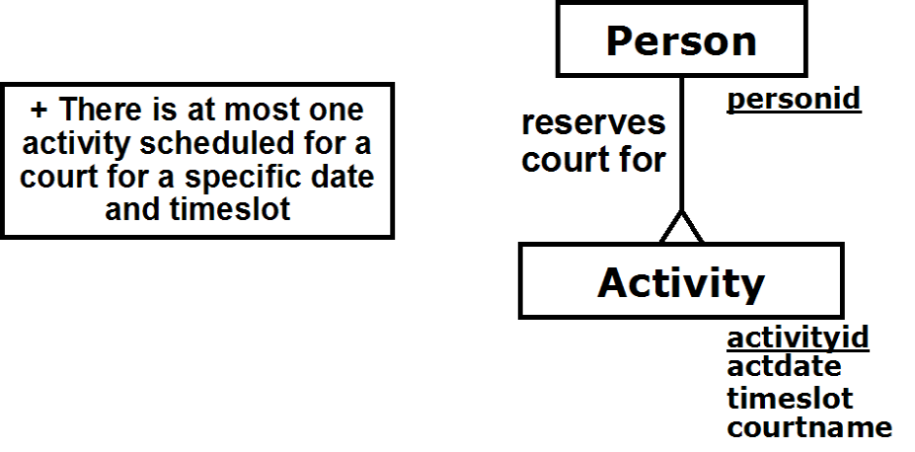

So now we move to our first solution, in which the only relationship shown is between Person and Activity. It is the M:N participates relationship, represented as a bridge class, so a partRole attribute can be added which distinguishes between a participant and a reserver:
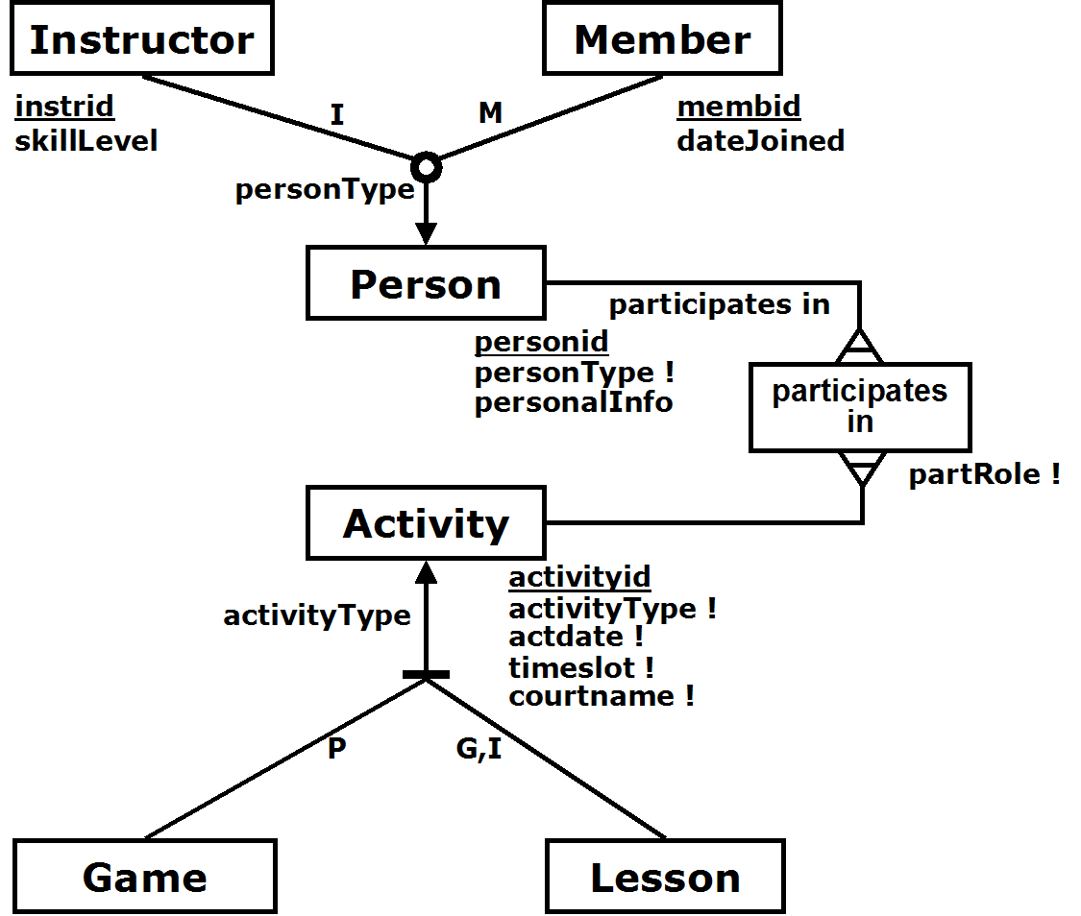

Enumerated attributes:
personType: I (instructor), M (member), N (non-member)
acivityType: P (play game), G (group lesson), I (individual lesson)
partRole: P (participant), R (reserver)

The state constraints are

- There is at most one activity scheduled for a court for a specific date and timeslot
- Each activity must have a single reserver
- A reservation for a lesson must be made by the instructor for that lesson
- An individual lesson has one participant in addition to the instructor, and that participant must be a member
- Singles game must have 2 participants and doubles game must have 4 participants

The Relational Schema diagram for the ER diagram above is shown below

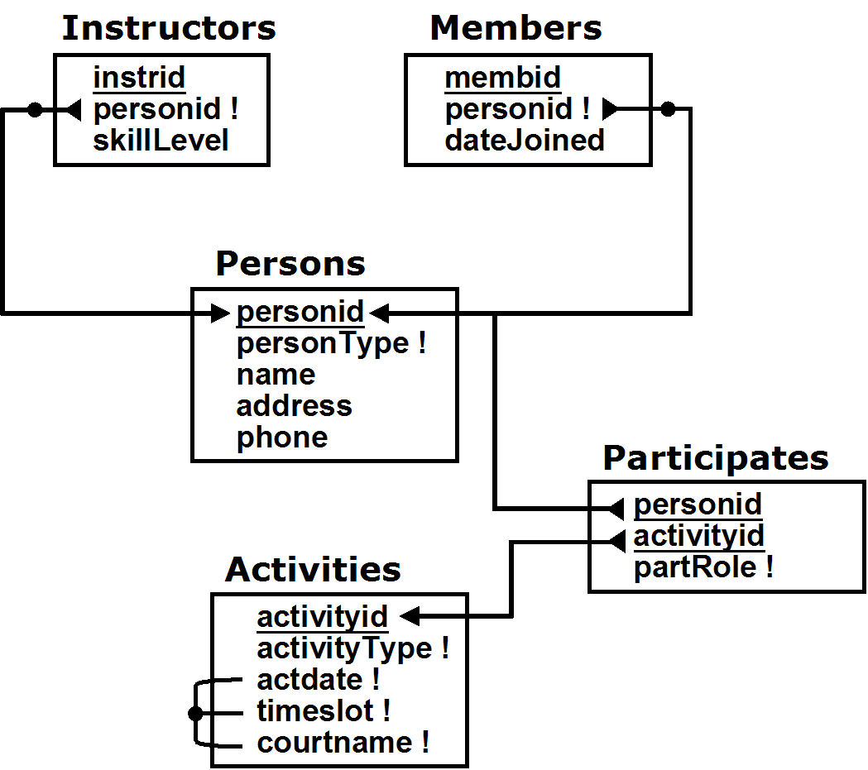

Note that we could have replaced the participates in relationship by two parallel relationships between Person and Activity: "make reservation" (a 1:M relationship), and "participates in" (an M:N relationship). Then we could eliminate the constraint
- Each activity must have a single reserver
by
- A reservation for a game must be made by a member who participates in the game (which could be shown directly on the ER diagram using a relationship subclass)

The second solution not only does that, but adds more subclasses and uses relationships between the subclasses to replace many of the state constraints
(but adds Court back)

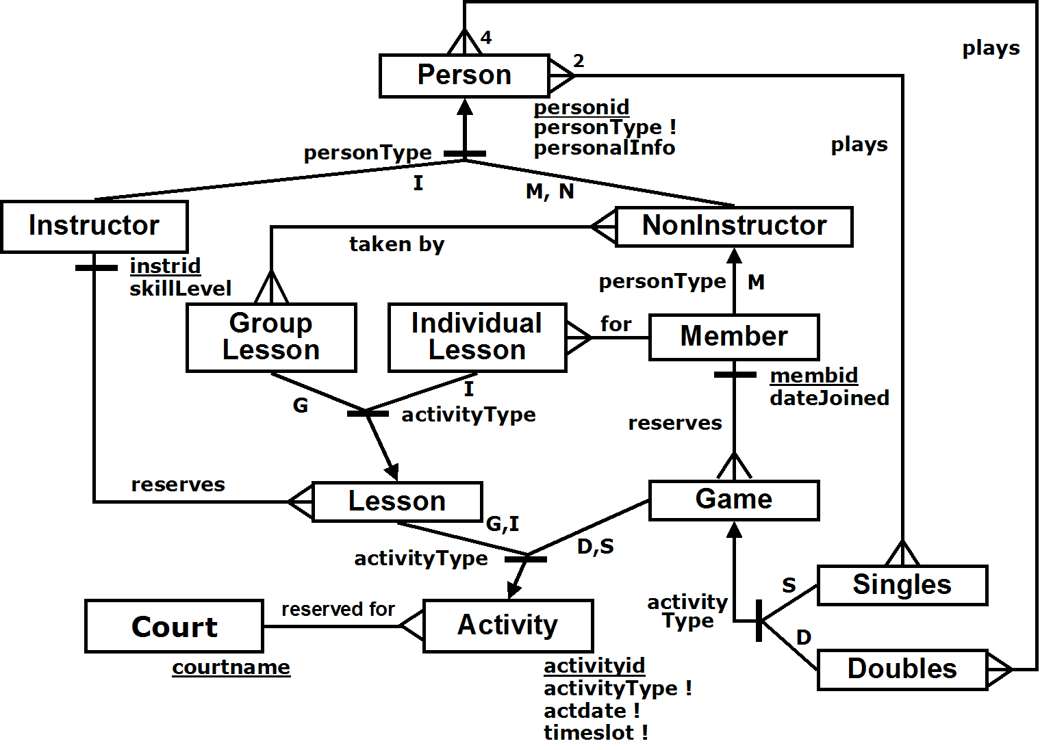

Enumerated attributes:
personType: I (instructor), M (member), N (non-member)
acivityType: D (doubles), S (singles), G (group lesson), I (individual lesson)

State Constraints
- There is at most one reservation for a court scheduled for a specific date and timeslot
- The reserver of a game must also be one of the participants

In this approach, we further subdivide Lesson into Group Lesson and Individual Lesson. Only members can take individual lessons, but both members and guests can take group lessons.

We also divide Person into Instructor and NonInstructor. A NonInstructor consists of both members and guests, so Member is a subclass of NonInstructor. NonInstructors represent the subclass of Person who can take group lessons.

In the initial requirements, we did not clarify whether Instructors could play in games or not. We assume they can; if not, then we would have a Plays relationship between NonInstructor and Game instead of Person and Game. So we can see already that placing relationships between subclasses forces us to understand the requirements at a deeper level than the previous approaches.

Now, let's see how we can represent the explicit state constraint
- The reserver of a game must also be one of the participants
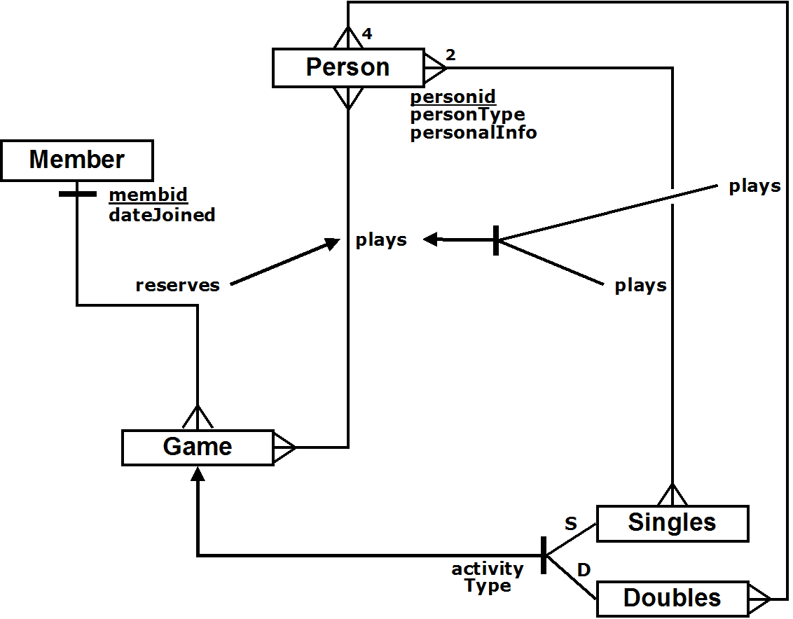
in the ER diagram directly. We need to define a plays relationship between Game and Person that is a complete superclass of the two specific plays relationships, and then we can make that a superclass of the reserves relationship. That part of the diagram would then look like:

The relational model could then be (see explanation below)

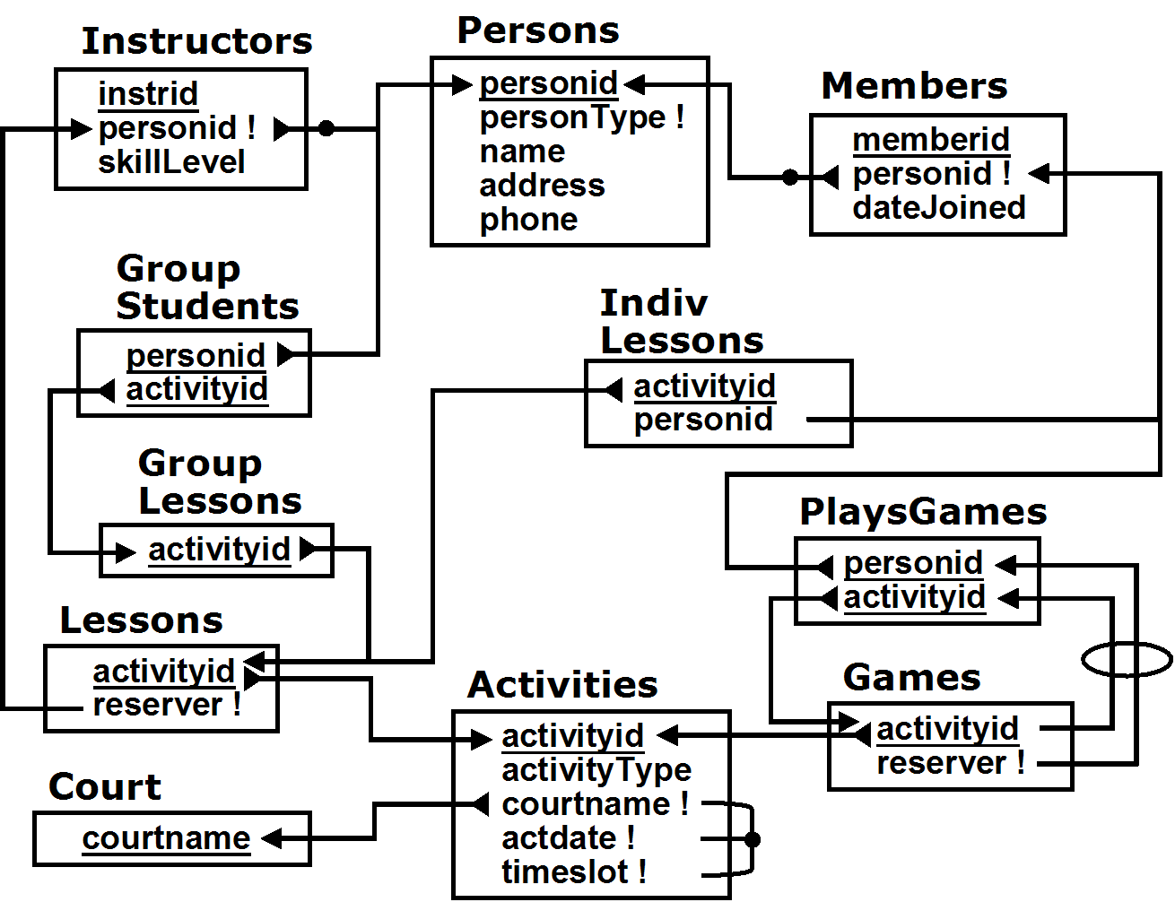

We chose to use a superclass-only mapping for Singles, Doubles and NonInstructor.

Note that because of the NonInstructor superclass-only mapping, the students in a group lesson could now potentially be instructors. In other words, we have lost the more specific referential integrity checking that would have been possible if we had a separate NonInstructors table. To retain that checking, we would have to enforce the assertion:

EACH GroupStudents s SATISFIES
EACH Person p WHERE s.studentid = p.studentid SATISFIES
p.personType IN ['M', 'N']

There is also something unexpected in the relational schema. We chose to have Lessons.reserver reference Instructor.personid, not Instructor's primary key, instrid. The same is true of the references to Members.personid.

That is not illegal. In many RDB's (including Oracle) a foreign key can reference any unique attribute(s), and both Instructor.personid and Members.personid are unique. Of course it must be noted explicitly as part of relational mapping. Of course, a better alternative for the conceptual model would have added instrid and memberid to Instructor and Member respectively, but without making them primary keys. Then personid would have been the primary key of Instructors, and would naturally have been used as the referent for Lessons.reserver.

We have chosen to use more superclass-only mappings instead of subclass-only ones. In fact, if we only used superclass-only mappings, the relational model for solution 2 would have ended up looking very similar to the relational model for solution 1.

3. [Hard: EXTRA CREDIT] Overlapping Subclasses

Suppose you are given the conceptual model described below, which shows three overlapping subclasses of Employee.

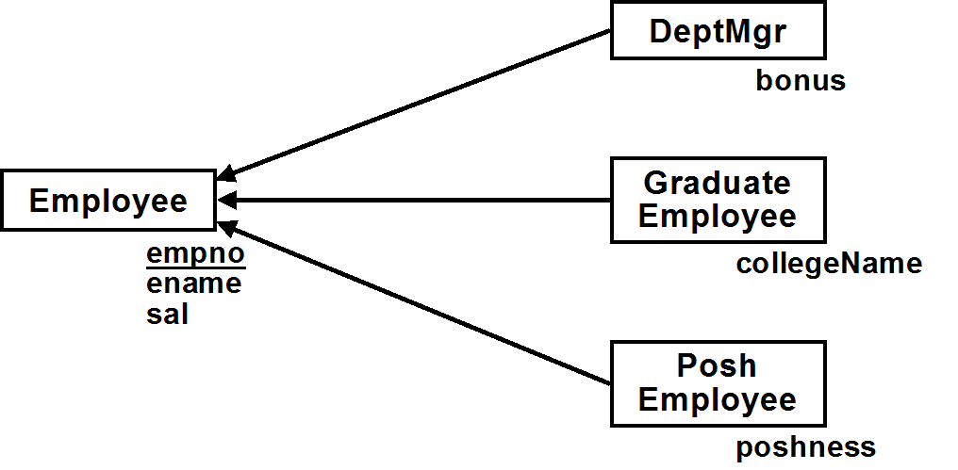

a) Draw the Relational Schema or write a brief relational model resulting from a subclass-only mapping of the conceptual model. Remember that subclass-only means that there is no table (e.g. Emps) which represents all employees. You can only have tables which represent subclasses of employees.

b) Based on that relational model, write one or more UPDATE statements to add 100 to the salary of all posh dept managers (i.e. who are both PoshEmployees & DeptMgrs). Note: this is more complex than it might first appear.

IMPORTANT NOTE: An UPDATE statement that uses a view is only legal if it can only update a single base table on which the view is based.
ANOTHER IMPORTANT NOTE: This REALLY is more complicated than you might think… (Even if you think you already figured out why it's complicated, it’s probably even trickier than that!)

The important thing to notice is that the subclasses may overlap! There are two ways to do subclass-only mappings of overlapping subclasses. Neither is very good. In fact, this problem illustrates why subclass-only mappings of overlapping subclasses are problematic.

The first approach creates a single table for each subclass, plus a separate table for the employees who are not in ANY of the subclasses.

PlainEmps( empno, ename, sal )
DeptMgrs( empno, ename, sal, bonus )
GradEmps( empno, ename, sal, collegeName )
PoshEmps( empno, ename, sal, poshness )

To update the salary of posh dept mgrs, we have to update three (yes three!) tables. A posh dept mgr will be both in the PoshEmps table as well as in the DeptMgrs table. But in addition, a posh dept mgr might also be a graduate employee, and if so, they will also be in the GradEmps table.

-- update dept mgrs who are also posh employees
UPDATE DeptMgrs SET sal = sal + 100
WHERE empno IN (SELECT empno FROM PoshEmps)

-- update posh employees who are also dept mgrs
UPDATE PoshEmps SET sal = sal + 100
WHERE empno IN (SELECT empno FROM DeptMgrs)

-- update grad employees who are posh dept mgrs
UPDATE GradEmps SET sal = sal + 100
WHERE empno IN (SELECT empno FROM PoshEmps)
AND empno IN (SELECT empno FROM DeptMgrs)

The last UPDATE can also be written as

UPDATE GradEmps SET sal = sal + 100
WHERE empno IN (
SELECT empno FROM PoshEmps
INTERSECT
SELECT empno FROM DeptMgrs)

or

UPDATE GradEmps SET sal = sal + 100
WHERE empno IN (
SELECT empno FROM (PoshEmps NATURAL JOIN DeptMgrs))

The following answer is incorrect:

CREATE VIEW PoshDeptMgrs AS
(SELECT * FROM PoshEmps NATURAL JOIN DeptMgrs)

UPDATE PoshDeptMgrs SET sal = sal + 100;

The noted database consultant C. J. Date argues that this should be legal; that updating the tuples in the view should correspond to updating the tuples in both of the underlying base tables. However, this is a minority view, and is not part of standard SQL, or supported by Oracle. Both of these require that a view update must correspond to an update of only a single base table, not more than one.

Besides, even if this were allowed, it would only update PoshEmps and DeptMgrs, but not GradEmps.

In any case, the problem with using a subclass-only approach with a separate table for each subclass is that there is redundant information (though spread across multiple tables). An employee who belongs to multiple subclasses is in each of the subclass tables. This means that the salary must be updated in each of those tables.

An alternate approach, described below, eliminates the redundancy by creating a separate table for every distinct combination of subclasses (of course, an assertion to enforce complete disjointedness would still be needed). Of course, this is cumbersome in a different way, especially if there are many combinations.
PlainEmps( empno, ename, sal )
JustMgrs( empno, ename, sal, bonus )
JustGrads( empno, ename, sal, collegeName )
JustPosh( empno, ename, sal, poshness )
GradMgrs( empno, ename, sal, collegeName, bonus )
PoshMgrs( empno, ename, sal, poshness, bonus )
PoshGrads( empno, ename, sal, poshness, collegeName )
PoshGradMgrs( empno, ename, sal, poshness, collegeName, poshness )

Now, updating the posh grad managers is relatively straightforward. We just update PoshMgrs (only posh and managers) and PoshGradMgrs (those who are graduate employees as well)

UPDATE PoshMgrs SET sal = sal + 100
UPDATE PoshGradMgrs SET sal = sal + 100

c) Suppose that you use a superclass/subclass mapping, with the tables Emps, Managers, GradEmps and PoshEmps. Add a single attribute to Employee (something like a subclass discriminator), so that queries that are based on checking an employee's subclasses can be done by only accessing the Emps table.

(1) First, describe the required attribute and how the values it can take on should be interpreted

(2) Second, write the SQL for the example queries below, showing how they only need to access the Emps table
(a) List the names of all employees who are dept managers
(b) List the names of all employees who are graduates
(c) List the names of all employees who are posh dept managers
(d) List the names of employees who are neither graduates, posh, nor dept managers
HINT: Look at the last section of lab exercise #1.

The trick is to add empmask, which uses a 3 bit mask, one bit each for indicating whether the employee is a dept manager, a graduate, or posh

define DEPTMGRS = 4;
define GRADUATES = 2;
define POSH = 1;

List the dept managers:
SELECT ename FROM Emps
WHERE bitand( empmask, &DEPTMGRS ) > 0

List the graduates:
SELECT ename FROM Emps
WHERE bitand( empmask, &GRADUATES ) > 0

List the posh dept managers
SELECT ename FROM Emps
WHERE bitand( empmask, &POSH + &DEPTMGRS ) > 0

List employees who are neither posh, grads, nor dept mgrs
SELECT ename FROM Emps
WHERE empmask = 0

