Abbreviated Crow Magnum Summary
Ellis S Cohen
2009

A.1 Entity Classes

Entity class (1) without attributes, (2) with primary keys only, (3) with all attributes.

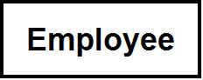
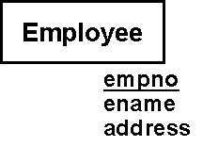

Entity class with (1) domains and (2) attribute constraints (could also be combined)

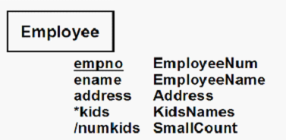
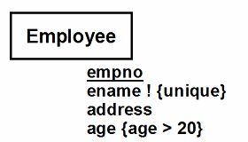
Entity classes with entity constraint
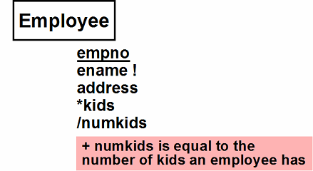

A.2 Relationships

1:M, 1:1 and M:M Relationships

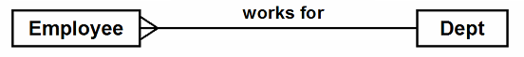
Indicating Relationship Direction

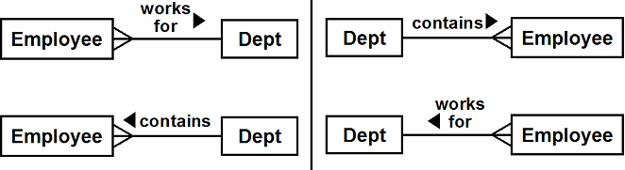
Mandatory Participation

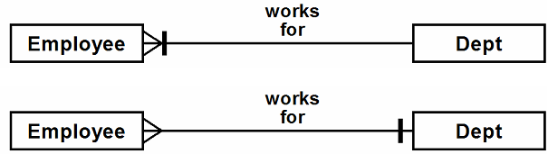

Indicating General Cardinality

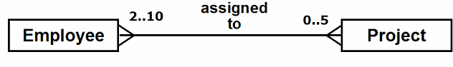

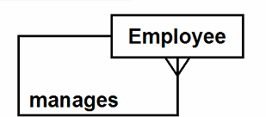
Reflexive 1:M Relationship

Relationship or General State Constraint

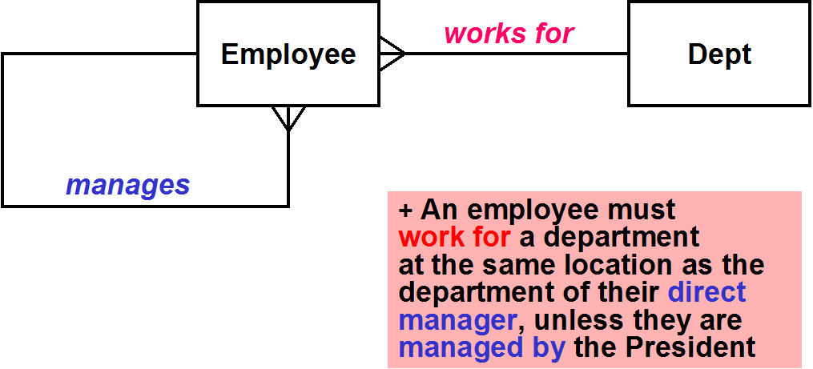

A.3 Dependent and Identifying Relationships

Dependent Entity Class with 1:M Dependent Relationship
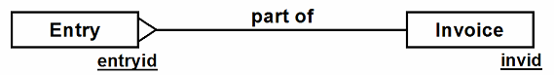

Weak Entity Class with Discriminator and 1:M Identifying Relationship

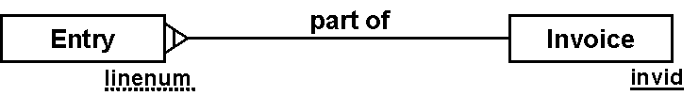

Dependent Entity Class with 1:1 Dependent Relationship

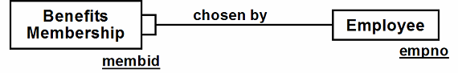
Weak Entity Class with 1:1 Identifying Relationship
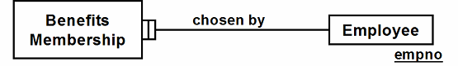

A.4 Bridge Entity Classes

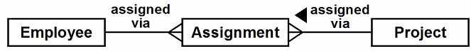
Bridge Entity Class

Bridge Entity Class with Mandatory Participation

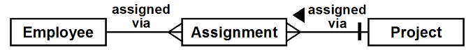
Bridge Entity Class with Attributes
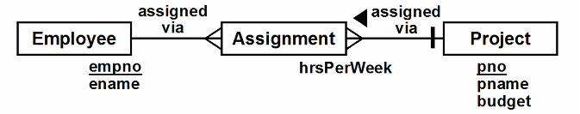
Bridge Entity Class with Dependent Relationship
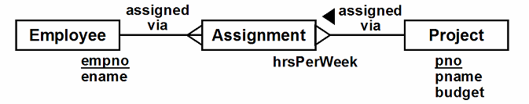
Bridge Entity Class with Primary Key
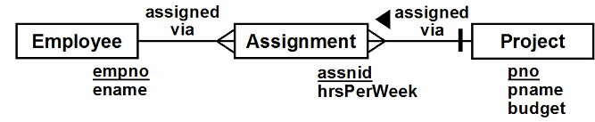
Bridge Entity Class with Identifying Relationship

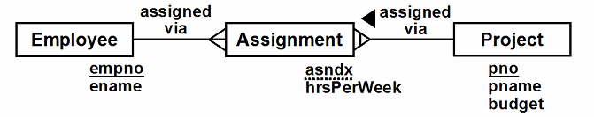
Weak Bridge Class
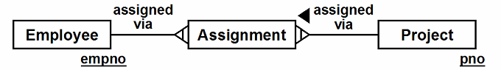
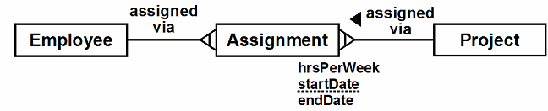
Weak Bridge Class with Instance Discriminator
Weak Bridge Class in a 1:M Relationship

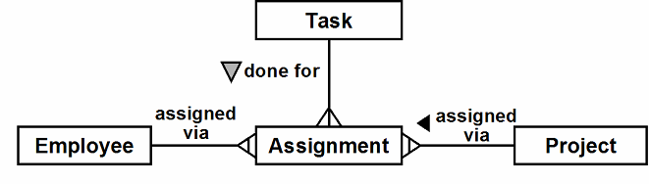

A.5 Subclasses

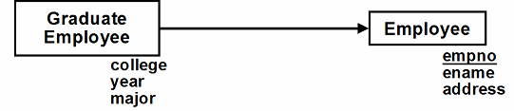
Identified Subclass

Identified Subclass with Unique Attribute
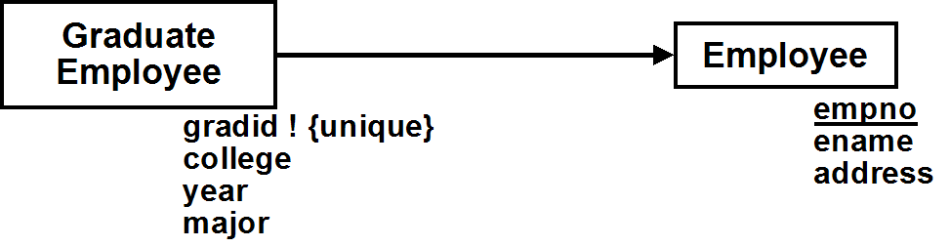

Dependent Subclass

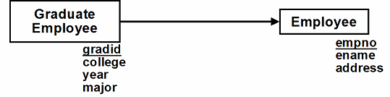

Weak Subclass

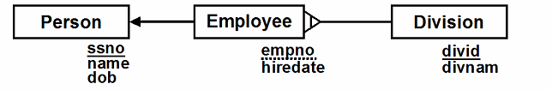

Overlapping Group of Subclasses

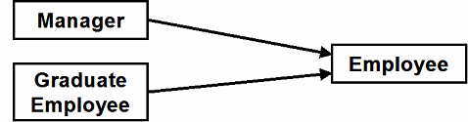

Disjoint Group of Subclasses

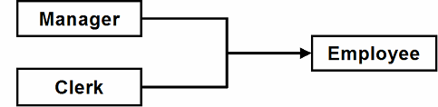

Disjoint Group of Subclasses with Subclass Discrimination

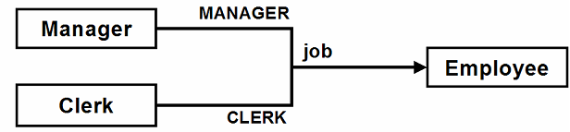

Complete and Incomplete Disjoint Groups of Subclasses

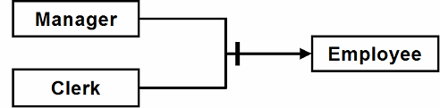

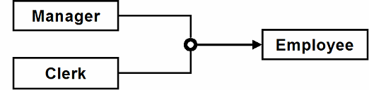

Multiple Inheritance
