CS579 Fall 2009

Class #4 Homework Solution

Hardcopy only (no e-mail) due at start of Class #5
Homework must be typed UNLESS your handwriting is extremely readable!
Late homework (received in e-mail by 7am the following morning) will be penalized one partial grade (e.g. from A- to B+). Late homework received within 48 hrs after class ends will be penalized two partial grades (e.g. from A- to B). Homework received up to 5 days late will be penalized one full grade (e.g. from A- to B-). Homework will not be accepted more than 5 days late, or if a solution to the homework has already been posted.

Reading

Bowman (The Practical SQL, 4th Ed)
- Chapter 7 (Joins), pages 205-233

Models and Languages for Database Design & Theory

Visual & Textual Languages for ER Modeling

1.6-1.8 Attribute Domains & Constraints

1.11 Derived Attributes

3.1-3.3 Dependent & Identifying Relationships

Connolly & Begg
- Section 11.4 ER Modeling (Strong & Weak Entity Types)
- Section 5.3.7 SQL (Multi-Table Queries)
- Section 12.2-12.3 Enhanced ER Modeling (Aggregation & Composition)

Oracle Database 10g
- Chapter 13 Query Dependence, pp 249-253 (Joins)

Lab Exercise #4 (complete before class #5)

Available online at courseinfo.

Do NOT hand in the output.

Project Continuation

➔ Note: Your team name and/or project name must appear on all project documents. You can change your team or project name if you need to (but let me know)

➔ Look at my Example Project Deliverable for Week #4, and please use the same format.

This week, your team must hand in (stapled together separately from any homework problems):

1) (if your team has > 1 person) A team participation report (written by the team leader), listing the team name for your group, the name of your project (if different from the team name), the name of the team leader, and for each member of the team
- a very brief description of the main things that member focused on this week
- the percentage of the overall work that member did this week

2) A revised set of project requirements. Highlight any changes.

3) A revised ER diagram, using either (Easy) Crow Magnum or UML, for the entity classes needed by your project. The ER diagram must
- Include 5-9 entity classes
- Include at least as many 1:M and M:N relationships as there are entity classes (count carefully!)
- ➔ Include at least one weak entity class, which has at most one identifying relationship
- Show ALL attributes (with primary keys and discriminators properly denoted) and all mandatory participation constraints (do NOT show optional participation)

4) A list of the entity classes, with a very brief description of each.

5) A revised user role diagram. Highlight any changes.
6) A list of User Operations for your application.
- Organize them by role.
- Within each role, separate the queries from the actions.
- For each operation, include the parameters and a very brief description. Use a format similar to the ones used in previous assignments.
- Do not include more than 25 operations, so if you can think of more, pick the 25 most important and useful ones. You will probably only be implementing 10-15 of them, but you don't need to choose those yet.

For each entity class, consider

- Do you need an action to create an instance (or multiple instances) of the class? In many cases, you can assume that the database comes pre-populated with all the needed instances of a class, but in other cases, you will need actions to dynamically create an instance.
- Do you need actions to modify attributes of an instance of the class, or groups of related instances? These are usually interesting and important operations.

- Do you need an action to delete an instance (or multiple instances) of the class? Sometimes this is useful and necessary. But it can lose important historical information. Sometimes it's just better to add a status attribute, so you can mark an instance as ACTIVE or INACTIVE (maybe you only delete or archive an instance after it has been inactive for some period of time).
- Do you need operations to query certain instances of a class? Do you want this information grouped by some attribute? Do you want your queries to pull in information from related classes (which will require joins). Ask what a user of the system will actually want to know.

For each relationship, consider

- Do you need an action to add or remove a link between existing instances? Often, links between instances are created when one of the instances is created, but other times, you will want to have actions that change a link (e.g. moving an employee from one department to another, reassigning a different employee to a project). These are usually the most interesting and important operations, especially when they involve adding/removing more than one link at the same time.
- Do you need operations to query relationships (i.e. which employees are working for or managing various types of projects)? Do you want this information grouped in some way? These are the most interesting queries, especially when they span multiple relationships. Again, ask what a user of the system will actually want to know.
In addition
- You should have both a Login and a Logout operation. Login should take both a userid and a password as parameters. The userid could either be numeric or a string, depending on what you think is most appropriate or convenient for your application.
- You must have at least one action operations (other than Login, Logout or SetPwd) and two query operations whose functionality depends in some way on the identity (not just the role) of the user who is currently logged in (but not just to enforce some pre-condition). For example, in the Employee Database Application ChangeAddr changes the address of the current logged in user, and ShowDeptEmps shows the names and jobs of all employees who work in the same department as the current logged in user.
- You should have at least one action operation, and at least one query operation which requires access to data in two or more entity classes.
- Your application code will keep track internally of the identity of the user who is currently logged in. The means that ➔ you should almost never provide the current user as a parameter to an operation (other than Login), since the operation's implementation can find out (on its own) who is the current user.
- Do not include operations which require interaction with the user (e.g. via a dialogue box) after the user has entered parameters and invoked the operation). If you have an operation which you believe requires such interaction, ➔ you need to discuss how to handle this situation with me.

7) List at least one interesting relationship or general conceptual state constraints (with names for each) that could be enforced by your application. Each constraint
- must be described in plain non-technical English, and refer to entities and relationships in the conceptual ER model (not to tables)
- involve at least one relationship and/or two entity classes
- must NOT be a constraint which could be represented directly in the ER diagram itself (e.g. you MAY NOT use a dept must have at least 3 employees, since that can be represented directly in the ER diagram)
- must not be able to be implemented just by using a built-in relational constraint (e.g. UNIQUE, CHECK, NOT NULL, REFERENCE).
- could potentially be violated by one of your operations, depending on the parameters to the operation, the identity of the user, the current state of the database (even if it doesn't initially violate the constraint), and/or the order in which operations are executed.
- must correspond to or be implied by some statement in your project requirements (add it if necessary)
- MUST NOT BE identical to one in the Employee Database Application
➔ For each of these constraints, list
- the user action operations which could potentially violate the constraint.

8) [EXTRA CREDIT] Identify at least two actions which have interesting state-related post-conditions. Remember that post-conditions are interesting if they have some of the following characteristics
- Don't obviously or immediately follow from a simple description of the operation
- are not invariant (i.e. always true); the operation made it true
- involve changes to entity classes or relationships other than the one that the operation obviously needs to affect
- ensure that redundant data is kept consistent

List the two actions and the post-conditions of those actions. Make sure that all of the post-conditions are implied by some statement in your project requirements (add it if necessary)
- At least one of the post-conditions should affect a class or relationship other than the one(s) primarily affected by the operation.
- ➔ Include at least one post-condition which is not simply a lifetime dependency rule (e.g. when a dept is deleted, delete all of its employees). Often, this can be done, by having the side-effect either
  - depend on a change of state, rather than on deletion -- so for example, in the Employee Database Application, we could add a status attribute to the Department entity class. A post condition for the operation that sets the status of a department to INACTIVE could require that employees of the department are deleted.
  - associate the child with another parent rather than deleting it -- so for example, in the Employee Database Application, when a department is deleted, the post condition could move its employees to another department (e.g. the PARTY dept, or the department with the smallest # of employees)
  - be based on the deletion of the last child (of some type) of a parent -- so for example, in the Employee Database Application, when the last clerk in a department is deleted, the post condition could move a clerk to that department from another dept which has two of them, or else it might change some other employee's job to clerk.

9) [EXTRA CREDIT] Identify at least one operation (preferably two, and not Login, Logout or SetPwd) which have identity-based user pre-conditions. List the actions and the pre-conditions.

A user pre-condition describes a constraint on the circumstances in which an operation is allowed to execute, based on the role or identity of the current user. User pre-conditions may either be role-based or identity-based.

- A role-based user pre-condition depends just upon the role of the user who is logged in -- for example, in the Employee Database Application, ShowDirect is associated with the Manager role. This is equivalent to the pre-condition for ShowDirect: the current user must be a Manager (or some subrole of Manager). ➔ Don't include role-based pre-conditions for this deliverable.
- An identity-based user pre-condition depends upon the identity of the user who is logged in, in some way more complicated than just their role. For example, in the Employee Database Application, TerminateEmp, which terminates an employee, can only be done by the President, or by the Dept Manager who is in the same department as the current logged in user (i.e. not just by any user with the role of DeptMgr)

PROJECT GRADING

Each individual's grade for the project will be a combination of (a) the grade for the project as a whole, and (b) the contribution that you made to the project (in terms of quality, quantity, and leadership). Individual project grades will be determined at the end of the term.

It is your individual responsibility to ensure that you have an opportunity to participate in and review each aspect of the project, since that will both affect your project grade, as well as your ability to do well on exams. If there are any problems or issues, let me know as soon as possible.

It is the team leader's responsibility to make sure that (a) the team succeeds, and (b) you do your best to see that each person on the team has the opportunity to participate in and/or review each aspect of the project. If you have any concerns about your team's success, or the success of any member of your team, it is your responsibility to let me know as soon as possible. Either the team or I can change the team leader if necessary.

Self Quiz

Do not hand these in. Make sure you know the answers, though!

a) Explain the similarities and differences among the results of the following queries

SELECT ename, pname FROM Emps, Projects
WHERE empno = pmgr;

SELECT e.ename, p.pname FROM Emps e, Projects p
WHERE e.empno = p.pmgr;

SELECT e.ename, p.pname
FROM (Emps e CROSS JOIN Projects p)
WHERE e.empno = p.pmgr;

SELECT ename, pname
FROM (Emps e CROSS JOIN Projects p)
WHERE empno = pmgr;

These are all cross joins (using both the original and SQL-92 syntax), and they all produce the same result. For each project, it lists the name of the project and the name of the project manager.

Emps and Projects have no attribute names in common, so it doesn’t matter whether qualified names are used or not. Even when table aliases are defined, many databases (including Oracle) do not require (in most cases) that they be used.

b) Explain the similarities and differences among the results of the following queries

SELECT ename, pname
FROM (Emps CROSS JOIN Projects)
WHERE empno = pmgr
AND sal > 2500;

SELECT ename, pname
FROM (Emps JOIN Projects ON empno = pmgr)
WHERE sal > 2500;

SELECT ename, pname
FROM (Emps JOIN Projects
ON empno = pmgr
AND sal > 2500);

These queries all produce the same result. For each project, it lists the name of the project and the name of the manager, but only if the project manager's salary is more than 2500.

Using JOIN ON restricts the pairs of tuples being matched; using WHERE restricts the tuples resulting from the JOIN. The results are equivalent for inner joins, and a decent optimizer will produce the same execution plan. So in the cases above, it doesn’t matter whether JOIN ON, WHERE, or a combination of the two, are used.

Problems

IMPORTANT: You may do any of these problems on your own or with a partner.
About working with a partner or team:

- If you do a problem together with a partner or team, then only hand in ONE COPY of that problem with all of your names on it.
- Please staple together (no paper clips please, they detach way too easily) the problems you did alone. Separately staple together the problems you did together.

- Working with a partner or a team means working together on the entire problem. If you just start working together, but then actually work out the details on your own, hand in your own solution. If you personally did very little work on a problem, but your name is on it when it is handed in, then you are involved in plagiarism.
- If you are working with partners, and there's a significant imbalance in the quantity or quality of a partner's work, it’s essential you talk to me. Otherwise, it will almost certainly be the case that the underperforming partner will end up doing badly in the exams, and will either be forced to drop the course or will end up with a low grade. If you let me know there's a problem, I can make sure that students get additional help if they need it, or work with a different partner or team.

If you have ANY questions, post them on the newsgroup. Answering questions posted to the newsgroup can positively impact your grade.

1. [30%] SQL Join Problems

Solve each of the following problems that involve the Emps relation. This exercise is primarily about using joins, so for those of you who know about subqueries, DON'T USE THEM.

For each problem, you MUST
(1) draw the join diagram, and
(2) write a single SQL SELECT statement which produces the requested result (I recommend you test it, but that's not required). Full credit only if you use JOIN ON where appropriate.

a) Find the employees in each department who were hired after their department manager. IMPORTANT NOTE: An employee's department manager is the one person in the employee's department with a job of 'DEPTMGR'; this need not be their direct manager! For each such employee, list their name, department number, hiredate, and the name and hiredate of the department manager. Sort the result by department number, and within that by the employee's hiredate.

a1) Draw the join diagram

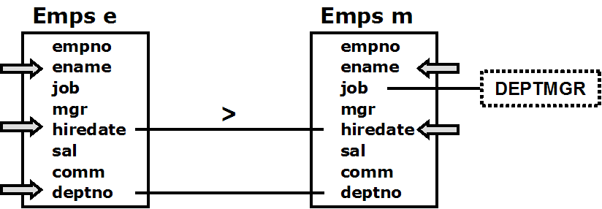

a2) Write the single SQL SELECT statement. Remember, for full credit, use JOIN … ON to identify the matching tuples (but use WHERE for conditions that are not used for matching)

SELECT e.ename, e.deptno, e.hiredate as hd1, m.ename, m.hiredate as hd2
FROM (Emps e JOIN Emps m
ON e.deptno = m.deptno AND e.hiredate > m.hiredate)
WHERE m.job = 'DEPTMGR'
ORDER BY e.deptno, e.hiredate

Because this is an inner join, it doesn't really matter which conditions go in the WHERE clause and which go in the ON clause, but to support clarity, use the ON clause for exactly those conditions that match tuples in the tables being joined -- in this case

e.deptno = m.deptno AND e.hiredate > m.hiredate

Also note that following code is incorrect; it finds employees hired after their direct manager, but only if their direct manager is a dept manager. But it misses finding employees who are directly managed by someone other than the dept manager.

SELECT e.ename, e.deptno, e.hiredate, m.ename, m.hiredate
FROM (Emps e JOIN Emps m
ON e.mgr = m.empno AND e.hiredate > m.hiredate)
WHERE m.job = 'DEPTMGR'
ORDER BY e.deptno, e.hiredate

b) List the names (but NOT employee numbers) and jobs of employees who directly manage other employees, along with the count of the employees they directly manage. Extra credit if you consider the possibility that more than one employee may have the same name and job.
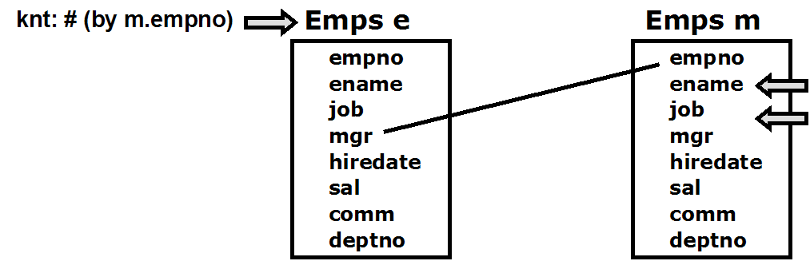

We need to do the join because we need to get the name and job of the managers.

SELECT m.ename, m.job, count(*) AS knt
FROM (Emps e JOIN Emps m ON m.empno = e.mgr)
GROUP BY m.empno, m.ename, m.job

Because this is an inner join, join conditions can go equally well in the ON or the WHERE clause, but it is better to put restrictions on matching in the ON clause.

Grouping by m.empno ensures that multiple employees with the same name & job are all listed.

c) List ONLY the employee numbers (NOT the employee names) of those who directly manage more than one other employee (think about this carefully!)

In a way, this is a trick question, because it actually doesn't require a join.

If you did do a join, then the join diagram would look something like

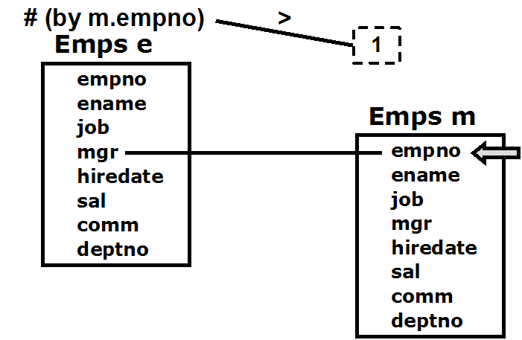

SELECT m.empno
FROM (Emps e JOIN Emps m ON m.empno = e.mgr)
GROUP BY m.empno
HAVING count(*) > 1
But you can see that instead of selecting m.empno, you could equivalently select e.mgr, since they match, in which case, there's no need to do the join at all except that we need to exclude the case where mgr is NULL.

SELECT mgr FROM Emps
WHERE mgr IS NOT NULL
GROUP BY mgr
HAVING count(*) > 1

d) [EXTRA CREDIT] List ONLY the employee numbers (NOT the employee names) of those who directly manage more than one other direct manager.

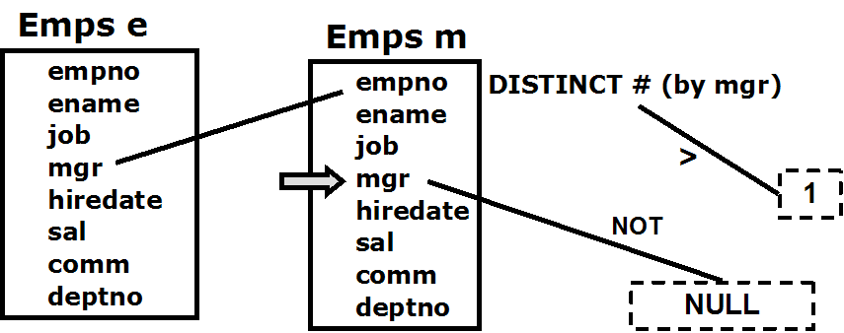

SELECT m.mgr
FROM (Emps e JOIN Emps m ON m.empno = e.mgr)
WHERE m.mgr IS NOT NULL
GROUP BY m.mgr
HAVING count( DISTINCT empno ) > 1

2. [20%] Weak Entity Class Reverse Engineering

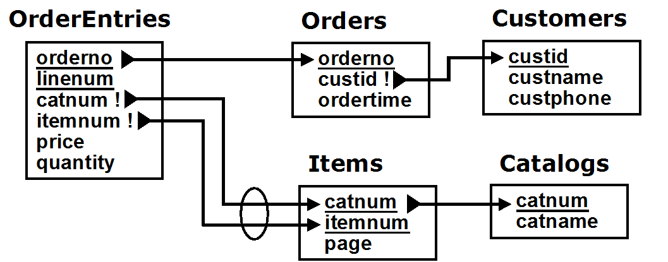

Look at the Relational Schema above for a system which maintains unprocessed customer orders.

It has the Brief TRex Model:

Customers( custid, custname, custphone )
Catalogs( catnum, catname )

Orders( orderno, custid, ordertime )
- custid not null references Customers on delete cascade
Items( catnum, itemnum, page )
- catnum references Catalogs on delete cascade
OrderEntries( orderno, linenum, catnum, itemnum, price, quantity )
- orderno references Orders on delete cascade
- catnum, itemnum not null
- foreign key( catnum, itemnum ) references Items on delete cascade

Draw an Easy Crow Magnum or a UML Diagram that would best map to it, based on the relational state constraints in the diagram above. Make sure you
- Show ALL attributes
- Use the appropriate symbol to indicate in the ER diagram which relationships should be independent, mandatory, dependent, or identifying,

The corresponding Easy Crow Magnum solution is
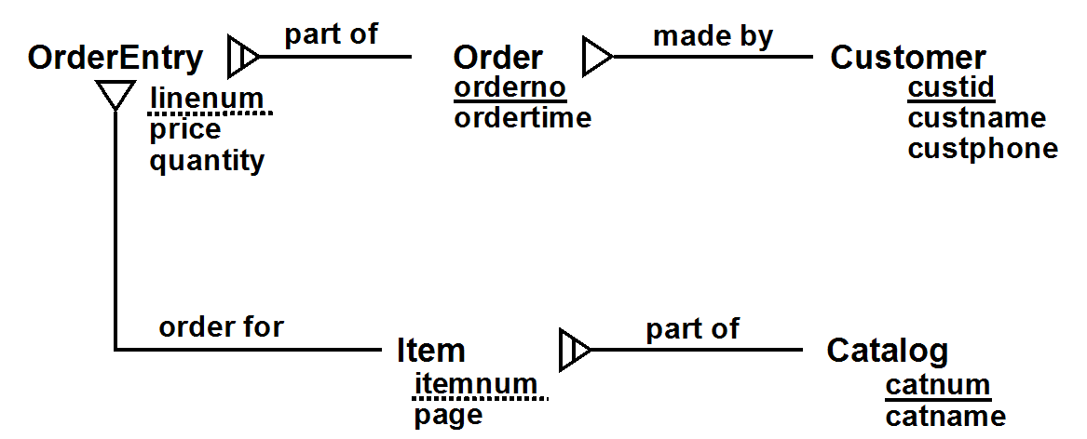

with Brief ConText

Entity Classes
Customer( custid, custname, custphone )
[Customer] Order( orderno, ordertime )
Catalog( catnum, catname )
[Catalog] Item( itemnum, page )
[Order, Item] OrderEntry( linenum, price, quantity )

Relationships
CustOrder: (*) Order made by (1) Customer
OrderParts: (*) OrderEntry part of (1) Order
OrderFor: (*) OrderEntry order for (1) Item
CatParts: (*) Item part of (1) Catalog

First, of all, Orders contains custid which references Customers's primary key custid. Since Order's custid is not a primary key or part of a primary key, this is a simple 1:M relationship. Because of the cascading delete, it is Dependent.

Next, let's turn to the reference from Items to Catalogs. We see a classic fingerprint of a weak entity class. Items' primary key is made up of the primary key of Catalogs (catnum) + itemnum. This implies that Item is a weak entity class, with identifying owner Catalog, and discriminator itemnum.

The same is true of OrderEntries. Its primary key is made up of the primary key of Orders + linenum. This implies that OrderEntry is also a weak entity class, with identifying owner Order, and discriminator linenum.

There is a composite reference from OrderEntries to Items, since Items has a composite primary key. However, neither of the reference attribute in OrderEntries (catnum + itemnum) are part of OrderEntries's primary key, so this is an ordinary 1:M relationship, made Dependent by the cascading delete.

The UML solution is a bit more problematic. The closest possible solution would seem to be

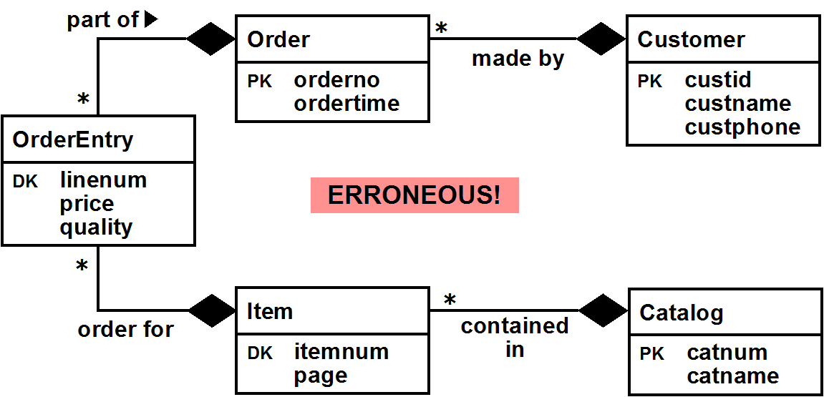

However, there are a couple of problems with this solution. First of all, there's a composition relationship between OrderEntry and both Order and Item, and this is not permitted by UML. Composition implies containment, and it's not really possible for an entity to be simultaneously contained in two parents. Even if it were allowed, there's no way of indicating what linenum acts as a discriminator for -- does it discriminate among multiple entries for the same Order or for the same Item? Without knowing this, it’s impossible to know how to build the corresponding relational model.

Since linenum discriminates among entries of the same Order, we keep the composition relationship with Order, but not with Item. That makes sense anyway, since the order for relationship is not really a containment relationship. So the correct UML model is

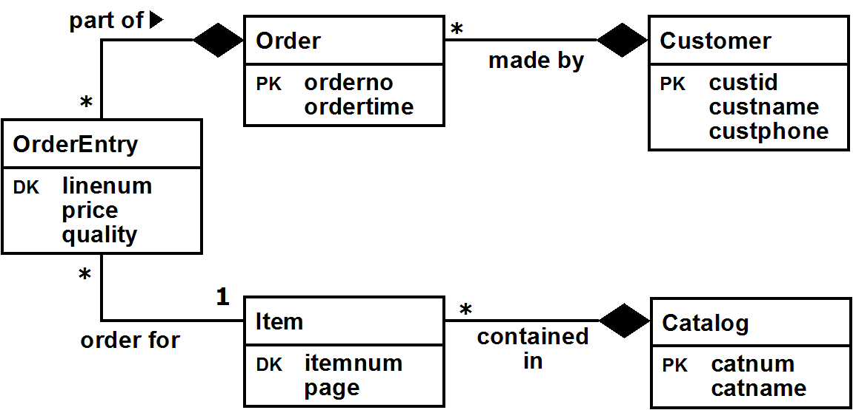

This no longer visually includes the lifetime dependency constraint between Item and OrderEntry. If we want to include it (which is probably a mistake anyway), we'd have to explicitly add the deletion integrity business rule: When an item is deleted, delete all the OrderEntries for that Item.

3. [40%] Conceptual Design Exercise

There are 3 parts to the following problem: (a), (b), and (c). Consider the requirements below, and

a) Draw an Easy Crow Magnum or UML Diagram that meets the requirements, described below, showing
- all relationship characterizations
- all attributes (but only those reasonably implied by the requirements) and
- all necessary mandatory (but not optional) participation constraints.

Some important considerations
- Make sure you use dependent and identifying relationships where appropriate. You will gain credit by doing so, but only if done correctly.
- UML & Crow Magnum indicate derived attributes by preceding them with a slash. You will gain credit by indicating derived attributes correctly, but only where appropriate.
- Review the Fan Trap and the Reverse Fan Trap. You can easily fall into one the fan traps in doing this problem. Avoid that!

➔ b) Specify all additional conceptual state constraints involving dates (but don't include constraints that just say a date attribute is required)
➔ c) Specify additional relational and general conceptual state constraints required (or clearly implied) by the requirements (i.e. don't just make stuff up!), and that can be supported by the entities, attributes and relationships in the ER diagram.
- Do NOT include entity constraints. In particular
  - Do NOT include {required} constraints (i.e. requiring that some attribute's value must be provided -- i.e. can't be null)
  - Do NOT include {unique} constraints (i.e. requiring that all the values of some attribute be unique)
- Do NOT include state constraints that are (or should be) implied by your ER diagram.
- Do NOT include relational state constraints or assertions (written using SQL)
- Do NOT include business rules which are not state constraints (e.g. pre- and post-conditions).

➔ If your conceptual model eliminated the need to explicitly specify relational or general state constraints stated in the requirements, briefly explain how and why.

---------------------------------------------------------------------

The requirements are
- A video store wants to keep track of all of its videos. When it acquires a copy of a video, it stamps a unique vidid number on it, and uses the vidid to keep track of the video.
- For each individual video it owns, the store wants to be able to track the date the video was acquired, the name of the distributor of the video, the title of the video, the year in which it was made, the id, name, address and phone number of the customer (if any) who currently has it rented along with the date and the time the video was rented, its due date, and the employee number and name of the employee who processed the rental. Keep track of current rentals only; there's no need to keep track of a video's previous rentals.
- Every customer has a membership category; the category determines the number of days that customer is allowed to rent videos.

Your design MUST use at least the following entity classes: Film (a film title), Video (a particular copy of a film title), Distributor, Employee, and Customer. By the way, note that because of remakes, two films could have the same title, but would be made in different years.

Also, your design MUST use at least the following attributes: vidid, distributor, title (of the film), yrmade (the year the film was made), custid, custaddr, custphone, category (the category of a customer), acqdate (the date a video was acquired from the distributor), rentdate (the date a video is rented, renttime (the time of day a video is rented), duedate, empno, and ename.

Note:
  - You may add other entity classes. It is not required, but do it correctly and you will discover that
- the overall design will be better
- additional conceptual constraints can be represented directly in the ER diagram, so you don't have to list them explicitly.
  - You may add other attributes, but no added attributes may be primary keys or discriminators. You will LOSE CREDIT if added attributes are primary keys or discriminators.
Finally, here are some additional requirements. Each of these requirements MUST either be represented directly in the ER diagram itself (for more credit) or by specifying a conceptual state constraint.
- All individual videos are obtained from distributors (i.e. the store doesn’t make its own copies), and all copies for a particular film are distributed by a single distributor only.
- A customer can rent a group of videos at a single time (with the same rentdate and renttime); these are all processed by the same employee.

-----------------------------

Best Solution:

First, we add a Category class, which determines the number of days a customer can rent videos.

Next, let's consider how to model the requirement that a customer rents a group of videos from an employee. The most straightforward way to deal with this is to define a Rental entity class, which represents the rental of a group of (1 or more) videos by a customer.

We can make Rental a weak entity class dependent upon customer (no customer, no rental by that customer), using rentdate and renttime to discriminate different rentals by the same customer. Because duedate can be calculated from the category of the associated customer and the rentdate, we precede it with a slash, indicating that it can be derived. Every Rental must be processed by an employee, which is represented by a mandatory participation constraint.

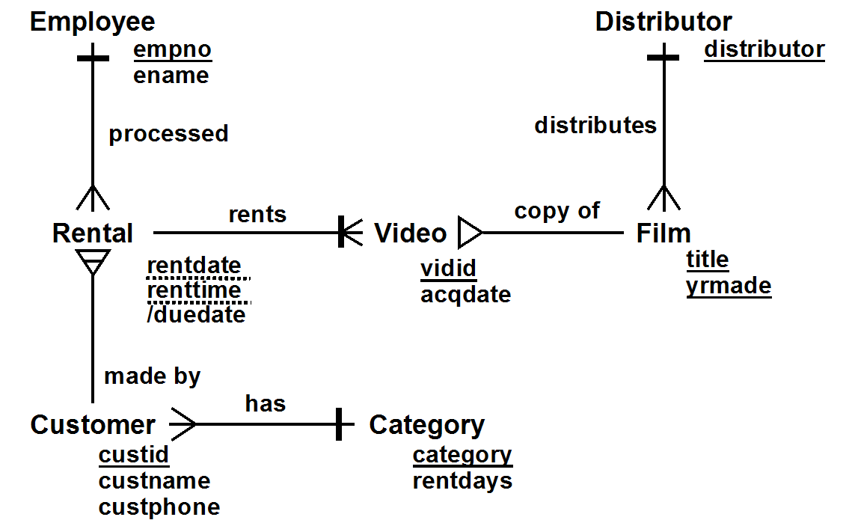

The Brief ConText for this model (without constraints) is

Entity Classes
Distributor( distributor )
Film( title, yrmade )
[Film] Video( vidid, acqdate )
Employee( empno, ename )
Category( category, rentdays )
Customer( custid, custname, custphone )
[Customer]Rental( rentdate, renttime, /duedate )

Relationships
Distributes: (1) Distributor distributes (*) Film
CopyOf: (*) Video is a copy of (1) Film
RentsVideo: Rental rents (1..*) Video
MakesRental: (1) Customer makes (*) Rental
ProcessesRental: (1) Employee processes (*) Rental
CustCategory: (*) Customer has (1) Category

The date-related constraints are:

- The date a video was acquired must NOT be
  - before the year the film was made
  - after the current date
- If a video is currently rented, the rental date must NOT be
  - before the date the video was acquired
  - after the current date
- A rental's due date is the rental's rental date plus the number of days associated with category of the customer who made the rental
(Note: this makes duedate a derived constraint, which is why it is shown preceded by a slash)

➔ This solution does NOT require any additional non-date-related state constraints!

Here are some additional notes about the solution:

- The requirements specify that each video has its own unique vidid (so it can't be a weak entity class). Every Video must be associated with a film (i.e. mandatory participation). Every film in the store's database has a distributor; this is also represented by a mandatory participation constraint.
- In addition, we made Video dependent upon Film, on the assumption that the video store would remove a film from its database when it no longer wanted to rent it anymore (i.e. so it would delete all video copies of the film from its database as well). But what if a customer has it rented out? Well, we could ignore that -- i.e. the customer got lucky and doesn’t need to return it. More likely, an access constraint would be required: a film cannot be deleted if any video copies of it are currently rented out.
- If we really wanted to get sophisticated, we could add a deleteStatus field to Film that would be used to indicate whether the store wants to delete a film. We would then add post-conditions that ensure that (a) when a film's deleteStatus is set, all videos in stock of that film are removed, (b) when a video is returned and its film's deleteStatus is set, the video is removed, and (c) when the last video copy is returned of a film whose deleteStatus is set, the film is then deleted.

Now, note the relationship among Distributor, Film & Video above. Another representation to possibly consider is:


This NOT a good representation; in fact, it is a classic Fan Trap, since it is impossible to determine which film a video has on it. Another alternative to consider is:

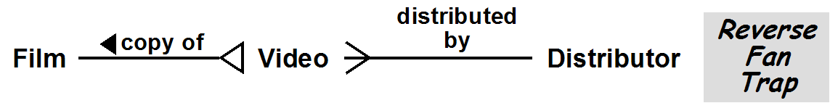

This is also not a good representation; in fact, it is a Reverse Fan Trap, since two videos for the same film could potentially have different distributors. This could be partly handled by adding the conceptual state constraint:

- All video copies of the same film are acquired from a single distributor

However, the representation also has deletion anomalies; if the last video copy of a film is deleted, it is no longer possible to determine its distributor.

-------------------------------------------------------------------

Here's an alternate solution, which is not quite as good, and which DOES require an explicit state constraint to be added (in addition to the same date-related constraints)

If we had not created a Rental class, we would need to have had Customer and Employee relate to Video directly, as shown below, with the Brief ConText (without constraints)

Entity Classes
Distributor( distributor )
Film( title, yrmade )
[Film] Video(vidid, acqdate, rentdate, renttime, /duedate )
Employee( empno, ename )
Category( category, rentdays )
Customer( custid, custname, custphone )

Relationships
Distributes: (1) Distributor distributes (*) Film
CopyOf: (*) Video is a copy of (1) Film
RentsVideo: (*) Video rented by (?) Customer
ProcessesVideo: (?) Employee processes (*) Video
CustCategory: (*) Customer has (1) Category

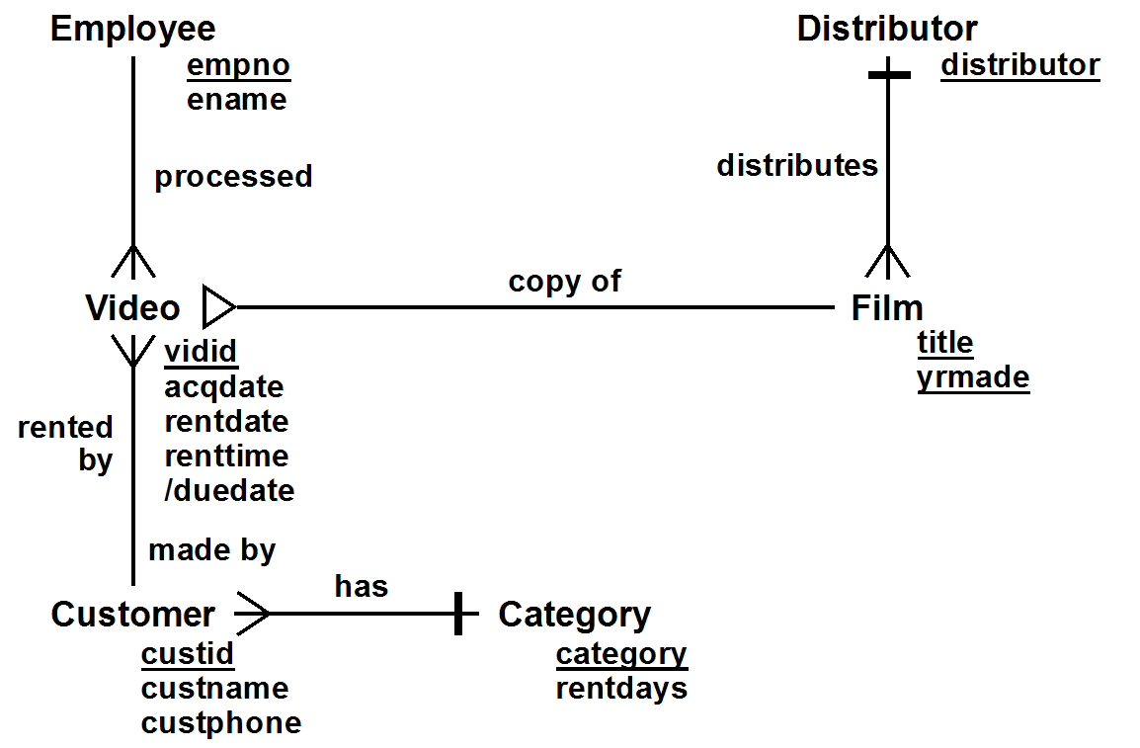

However, we now no longer have the Rental class which groups together the videos rented at the same time by a customer and associates the group with the employee renting them. Instead, we must add a general conceptual state constraint:

- All videos rented by a customer at the same date and time are processed by the same employee

4. [10%] Relational State Constraints

a) Write the table CHECK constraint corresponding to the conceptual constraint below. Note: this is the CHECK constraint that you would write as part of the definition of the Emps table, NOT an arbitrary assertion.

Every dept mgr is assigned to a department

If every employee is assumed to have a job, then the solution is

CHECK( job != 'DEPTMGR' OR deptno IS NOT NULL)

or

CHECK (NOT (job = 'DEPTMGR' AND deptno is NULL))

If job can be NULL, then the solution is

CHECK( (job != 'DEPTMGR') OR (job IS NULL) OR (deptno IS NOT NULL) )

b) [EXTRA CREDIT] Write the relational state assertion corresponding to the conceptual state constraint [Note: the answer is different from (a)]. You can assume that all employees have a job.

Every dept mgr is assigned to a department

NOT EXISTS( SELECT * FROM Emps WHERE
job = 'DEPTMGR' AND deptno IS NULL )

(SELECT count(*) FROM Emps WHERE
job = 'DEPTMGR' AND deptno IS NULL) = 0

Assuming dept numbers aren't negative, we could also write

(SELECT nvl( deptno, -1 ) FROM Emps WHERE job = 'DEPTMGR') ALL >= 0
Other more complicated solutions include

(SELECT count(*) FROM Emps WHERE job = 'DEPTMGR')
= (SELECT count(deptno) FROM Emps WHERE job = 'DEPTMGR')

(SELECT deptno FROM Emps WHERE job = 'DEPTMGR)
= (SELECT deptno FROM Emps
WHERE job = 'DEPTMGR' AND deptno IS NOT NULL)

(SELECT DISTINCT deptno FROM Emps WHERE job = 'DEPTMGR')
⊆ (SELECT deptno FROM Depts)

c) [HARD EXTRA CREDIT] Write the relational state assertion (definitely MUCH harder than you might think!) corresponding to the conceptual state constraint:

Every department has exactly one department manager
(You can assume that every dept mgr is assigned to a dept, but you CANNOT assume that every dept has at least one dept mgr)

A solution without using joins or views
-- every dept has at least one dept mgr
-- (i.e. the # of depts w dept mgrs = the # of depts)
(SELECT count(distinct deptno) FROM Emps WHERE job = 'DEPTMGR')
= (SELECT count(*) FROM Depts)

AND
-- every dept w dept mgrs has exactly one of them
(SELECT count(*) FROM Emps WHERE job = 'DEPTMGR'
GROUP by deptno) ALL = 1

The second part can instead be written using the UNIQUE function:

UNIQUE( SELECT deptno FROM Emps WHERE job = 'DEPTMGR' )

A solution using joins and views

-- Define the depts with one dept mgr
CREATE VIEW OneDeptMgr AS
SELECT deptno FROM Emps
WHERE job = 'DEPTMGR'
GROUP BY deptno
HAVING count(*) = 1

-- The # of depts w one dept mgr = the # of depts
(SELECT count(*) FROM OneDeptMgr)
= (SELECT count(*) FROM Depts)

A solution using outer joins and views

-- Determine the DeptMgrs
CREATE VIEW DeptMgrs AS
SELECT empno, deptno FROM Emps
WHERE job = 'DEPTMGR'

-- Determine the # of deptmgrs in every department
CREATE VIEW DeptMgrKnt AS
SELECT deptno, count(empno) AS knt
FROM (Depts NATURAL LEFT JOIN DeptMgrs)
GROUP BY deptno

-- The # of dept mgrs in each dept is 1
(SELECT knt FROM DepMgrKnt) ALL = 1

Some solutions using relational comparison

-- The # of dept mgrs in each dept is 1 (considering all depts)
(SELECT deptno, count(*) AS knt FROM Emps
WHERE job = 'DEPTMGR'
GROUP BY deptno) = (SELECT deptno, 1 AS knt FROM Depts)

-- The depts with one manager = the depts
(SELECT deptno FROM Emps
WHERE job = 'DEPTMGR'
GROUP BY deptno
HAVING count(*) = 1) = (SELECT deptno FROM Depts)

-- or simplest of all!
(SELECT deptno FROM Emps WHERE job = 'DEPTMGR')
= (SELECT deptno FROM Depts)

A simple solution using subqueries is

NOT EXISTS( SELECT * FROM Depts d WHERE
(SELECT count(*) FROM Emps e
WHERE e.deptno = d.deptno AND job = 'DEPTMGR') != 1)

which can also be written using relational calculus extensions as

EACH Depts d SATISFIES
ONE Emps e SATISFIES
e.deptno = d.deptno AND job = 'DEPTMGR'

