Team: Smiling Solo
Project: Patch Request Application

Project Specifications

Requirements

A Patch Request Application keeps track of all patch requests of an engineering group, including the bug number, target date, and priority. The patch request will be posted for a specific software branches, and single patch may have multiple bug fixes.

Only engineers may login to the system, however, even without logging in, a user can get the list and contents of the released patches.

The engineers can adjust the priority and target date, and can see the pending patches. Developers register themselves to fix the patch requests, and provide the estimate fix schedule.

Every patch request except locally found bugs has customer list of who are waiting for the bug fix, and the dollar number for the impact. For the internally found bugs, the customer is set to ‘local’ and the potential cost will be assigned instead of dollar number for the impact. When a project is lost, the relevant bugs of the lost customer will be re-evaluated to re-priorities the bug fix schedule.

Every employee (except for the President – the employee whose job is 'PRESIDENT') has a manager, who directly manages them. An employee does not need to be in the same department as their direct manager. However, every employee works at the same location as their direct manager, unless they are directly managed by the President. When a manager is terminated, all employees who directly reported to them instead will instead report to their old manager’s manager. Managers can get a list of all the employees that they directly manage, or all employees beneath them in the management hierarchy, along with the job, salary and manager of each.

Every department has at most one department manager (the employee in a department whose job is 'DEPTMGR'), and must have a department manager if it has a clerk. Any employee can find out the managers of the various departments. Every department manager may also directly manage employees, and all department managers are directly managed by the president.

A department manager can see the job, salary and manager of all other employees in their department, and can change the jobs and salaries of all the other employees in their department, and terminate employees in their department. A department manager can hire a new employee for their department, only if their initial direct manager is also in the same department. A department manager can change the direct manager of an employee in their department only if both the old and the new manager are in the same department.

A department without a manger has an acting manager (as long as the department has employees). When a department loses its manager or acting manager, the employee in the department with the highest salary (or one of them if there is more than one) becomes the acting dept manager.
The president can see and change the jobs, salaries, managers, and departments of all other employees, and can hire and terminate any other employee. The President can also create and destroy departments and move them to a new location. When destroying a department, the President can choose to either terminate all the employees in the department, or move them all together to a different department. However, no operation can affect the president.
Entity-Relationship Diagram

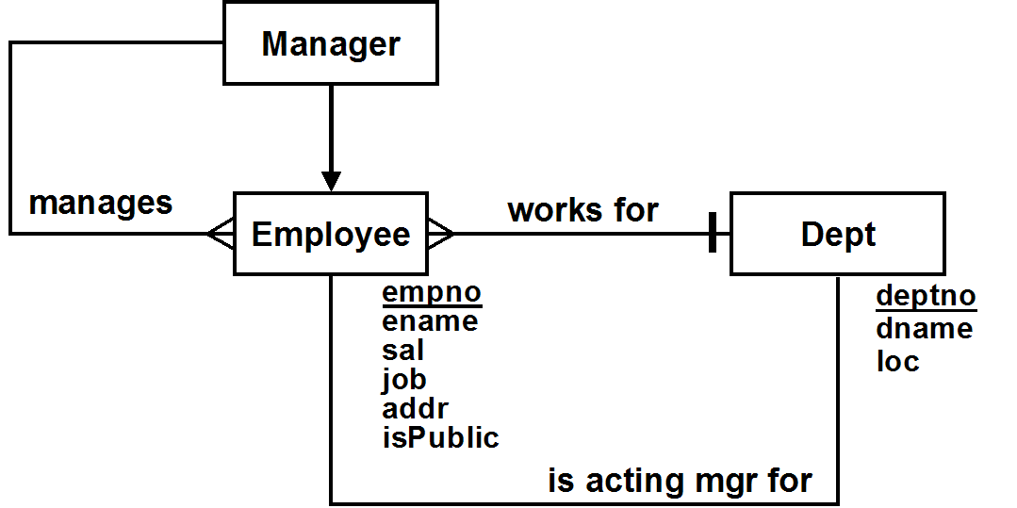

Entity Classes & Constraints

Employee
- Every employee has a name and job
- isPublic is either T or F (F is the default value)
- Only one employee has the job of PRESIDENT
- empno is larger than 1
- sal is not smaller than 100
Dept
- Every department has a name and location
- Every department name is unique
- Department numbers are all > 9
Relational Schema Diagram
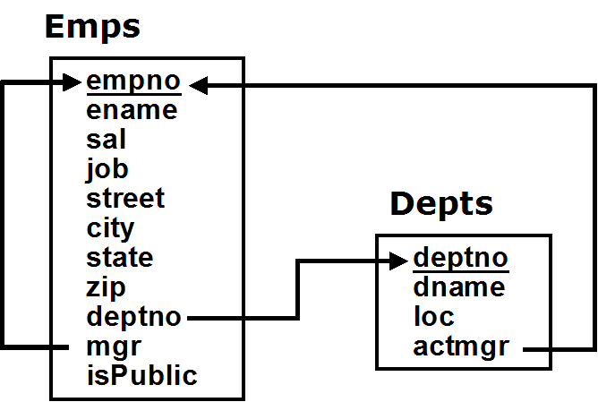

Design Notes

Superclass-only implementation of Employee/Manager ➔ Emps

User Role Diagram
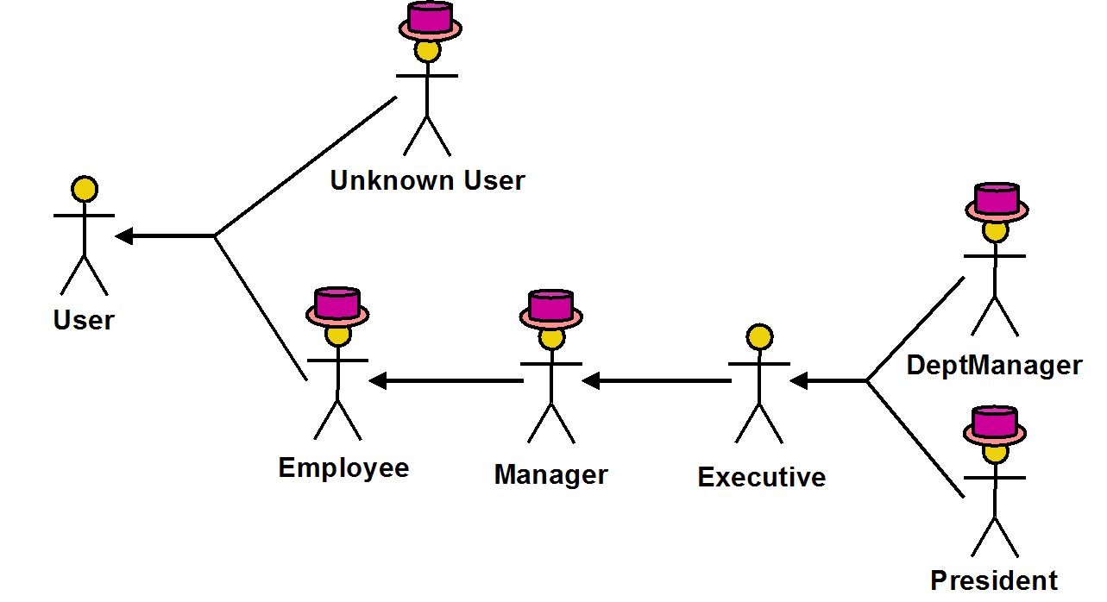

User Operations
* indicates operations to be implemented

User
Query
*ShowAllDepts: Show the names & locations of all departments

Unknown User
Actions
*Login( :empno, :pwd ): Login the specified user

Employee
Queries
*ShowAddr( :ename ): Show the address of another employee,
if public, given their name
*ShowDeptEmps: Show names & jobs of all employees who work in my department
*ShowDeptLoc( :ename ): Show the dept and location of another employee,
given their name
*GetMyInfo: Get my personal information
Actions
*ChangeAddr( :addr, :isPublic ): Set/change my address, and mark it public or not
SetPwd( :oldpwd, :newpwd, :confpwd ): Changes password
*Logout: Logout the current user

Manager
Queries
*ShowDirect: Show the name, department and job of all the employees who report directly to me
*ShowBelow: Show the name, department & job of all the employees who work underneath me

Executive
Queries
*ShowCtrlEmps: Show info about employees I control
Actions
*AddEmp( :empno, :ename, :sal, :job, :mgr, :deptno ): Hire an employee
*ChangeJob( :empno, :job ): Change the job of an employee
*ChangeSal( :empno, :sal ): Change the salary of an employee
*ChangeMgr( :empno, :mgr ): Change the manager of an employee
*ChangePosition( :empno, :deptno, :mgr, :job ): Change the department and/or possibly manager and/or job of an employee
*TerminateEmp( :empno ): Terminate an employee

President
Actions
*CreateDept( :deptno, :dname, :loc ): Create a new department
*DestroyDept( :deptno, :newdept ): Destroy an existing department, possibly moving its employees to a new department
*MoveDept( :deptno, :newloc ): Move a department to a different location

Actions with State-Related Post-Conditions

AddEmp
- If a dept mgr is hired into a dept with an acting mgr, the acting mgr loses that role

ChangeJob
- If an employee is promoted to become the dept mgr of a dept, the acting mgr loses that role
- If a dept mgr is demoted, the acting mgr becomes the highest paid employee in the dept

ChangePosition
- If an employee becomes the dept mgr of a dept, the acting mgr of that dept (if there is one) loses that role
- If a dept loses its dept mgr, the highest paid employee in the dept (if there is one) becomes the acting mgr

TermnateEmp
- If a dept loses its dept mgr, the highest paid employee in the dept (if there is one) becomes the acting mgr
- If the terminated employee managed other employees, then their direct manager is changed to the person who managed the terminated employee

DestroyDept
- When a department is destroyed, all its employees are either terminated or moved to another department

Conceptual Transition Constraints

➔ SetActMgr
Constraint: If a department loses its dept manager or acting manager, or if an empty department gains new employees (but not a department manager), the employee in the department with the highest salary (at the end of the base operation), or one such employee if there are more than one, becomes the acting manager.
Operations: AddEmp, ChangeJob, ChangePosition, TerminateEmp

➔ OnLoseDept
Constraint: When a department is deleted, all employees in the department are either terminated, or moved together to a different department
Operations: DestroyDept

➔ OnLoseMgr
Constraint: When a manager is terminated, all employees who directly reported to them end up directly reporting to their manager
Operations: TerminateEmp, DestroyDept

Operations with Identity-Based User Pre-Conditions

Login
- a user can’t login if already logged in

AddEmp
- a dept mgr can only hire an employee into their dept, and if their initial direct manager is in the same dept

ChangeJob
- an employee can't change their own job
- a dept mgr can only change the jobs of employees in their own department

ChangeSal
- an employee can't change their own sal
- a dept mgr can only change the salaries of employees in their own department

ChangePosition
- an employee can't change their own job, mgr or dept
- a dept mgr can only change the jobs of employees in their own department
- a dept mgr can only change the mgr of employees in their own department, and then only if both the old and new mgr are in their dept as well
- a dept mgr cannot change an employee's dept

TerminateEmp
- an employee can't terminate themselves
- a dept mgr can only terminate employees in their own dept

Queries with Output-Related Post-Conditions

ShowAddr
- Only shows employees who allow their address to be public

ShowCtrlEmps
- If the user is a dept mgr, only shows information about employees in their department.

Conceptual Access Constraints

Informational Status Access Constraints

➔ SeeAddr
An employee can see another employee's address only if they have made it public

Causal Status Access Constraints

None

Informational Role-Based Access Constraints

➔ EmployeeQueries
All queries except ones that just provide the numbers, names & locations of departments require that the user be logged in (i.e. their role or some ancestor role must be Employee)

Causal Role-Based Access Constraints

➔ EmployeeActions
All actions except those that login a user require that the user be logged in (i.e. their role or some ancestor role must be Employee)

➔ AffectDept
An employee's department can only be changed by the President

➔ PrezActions
A department can only be created, destroyed or moved by the President

Informational Identity-Based Access Constraints

➔ SeeSal
An employee's salary can only be seen by the President, or by their department manager

➔ SeeJobMgr
Users who are not executives can only find out the job or mgr of employees in their department, or that they directly or indirectly manage

Causal Identity-Based Access Constraints

➔ GoodLogin
A user cannot login if that user is already logged in

➔ ChangeOwnAddr
An employee's address can only be changed by themselves

➔ ChangeOwnPwd
An employee's password can only be changed by themselves

➔ AffectSelf
An employee cannot change their own salary, job, manager or dept

➔ AffectPrez
No operation may be used to hire, terminate or change the salary, direct manager, dept or job (new or old) of the president

➔ NewMgr
An employee can be hired by a dept manager only if their new direct manager is in the department manager's department.

➔ ExecutiveActions
An employee can only be hired, fired or have their job, salary or manager changed by the President, or by the manager of their department

➔ UpdateMgr
An employee's direct manager can only be changed by a department manager if both the old and new direct manager are in the department manager's department.

Complex Conceptual State Constraints Enforced by Check Constraints

➔ NoPrezMgr
The President does not have a manager

In Emps, CHECK( job <> 'PRESIDENT' OR mgr IS NULL )

➔ EmpMgr
Every employee other than the President has a manager

In Emps, CHECK( job = 'PRESIDENT' OR mgr IS NOT NULL )

Complex Conceptual State Constraints Requiring Other Enforcement

➔ OnePrez
Constraint: Only one employee has the job of president
Operations: AddEmp, ChangeJob, ChangePosition
Tables: Emps

➔ ManageCirc
Constraint: No one manages themselves, their manager, their manager's manager, etc.
Operations: AddEmp, ChangeMgr, ChangePosition
Tables: Emps

➔ ManageDeptMgr
Constraint: All department managers are directly managed by the President (if there is one, or by no one if there isn't)
Operations: AddEmp, ChangeMgr, ChangeJob, ChangePosition
Tables: Emps

➔ OneDeptMgr
Constraint: Every department with employees either has one department manager or an acting manager who works for that dept, but not both
Operations: AddEmp, ChangeJob, ChangePosition, TerminateEmp
Tables: Emps

➔ DeptMgrClerks
Constraint: Every department that has a clerk has a dept manager
Operations: AddEmp, ChangeJob, ChangePosition, TerminateEmp
Tables: Emps

➔ ManageLoc
Constraint: Every employees works at the same location as their direct manager, if they have one, unless their direct manager is the president
Operations: AddEmp, ChangeMgr, ChangePosition
Tables: Emps, Depts

Manifest Views (and Relational State Assertions)

➔ OnePrez
Only one employee has the job of president

Manifest View: NONE

State Assertion:
(SELECT count(*) FROM Emps WHERE job = 'PRESIDENT') <= 1

➔ ManageCirc
No one manages themselves, their manager, their manager's manager, etc.

Manifest View:
-- provide a view with pairs of each employee and the manager at every level
CREATE RECURSIVE VIEW Mgrs( empno, mgr ) AS
SELECT empno, mgr FROM Emps WHERE mgr IS NOT NULL
UNION
SELECT e.empno, m.mgr FROM Emps e, Mgrs m WHERE e.mgr = m.empno

State Assertion:
NO Mgrs SATISFIES empno = mgr

➔ ManageDeptMgr
All department managers are directly managed by the President,
or by no one if there is no President

Manifest View: None

State Assertion:
WITH VALUE thePrez AS (SELECT empno FROM Emps WHERE job = 'PRESIDENT')
CASE (thePrez IS NULL) THEN
EACH Emps WHERE job = 'DEPTMGR' SATISFIES mgr IS NULL
ELSE
EACH Emps WHERE job = 'DEPTMGR' SATISFIES mgr = thePrez
END CASE

➔ OneDeptMgr
Every department with employees either has one department manager or an acting manager who works for that dept, but not both

Manifest View:
-- For each department, provides count of #employees, actmgrs & deptmgrs
CREATE VIEW DeptMgrsView AS
SELECT deptno,
(SELECT count(*) FROM Emps e
WHERE e.deptno = d.deptno) AS eknt,
(SELECT count(*) FROM Emps e
WHERE e.deptno = d.deptno AND e.empno = d.actmgr) AS aknt
(SELECT count(*) FROM Emps e
WHERE e.deptno = d.deptno AND e.job = 'DEPTMGR') AS mknt
FROM Depts d
State Assertion:
EACH DeptMgrs d WHERE eknt > 0 SATISFIES aknt + mknt = 1

State Assertion without Manifest View:
EACH Depts d WHERE (SOME Emps e SATIFIES e.deptno = d.deptno)
SATISFIES
(SELECT count(*) FROM Emps e
WHERE e.deptno = d.deptno AND e.empno = d.actmgr) +
(SELECT count(*) FROM Depts d
WHERE e.deptno = d.deptno AND job = 'DEPTMGR') = 1

➔ DeptMgrClerks
Every department that has a clerk has a dept manager

Manifest View:
-- For each dept, has # of clerks (cknt) & # of deptmgrs (mknt)
CREATE VIEW DeptClerkMgrs AS
SELECT deptno,
(SELECT count(*) FROM Emps e
WHERE e.deptno = d.deptno AND e.job = 'CLERK') AS cknt
(SELECT count(*) FROM Emps e
WHERE e.deptno = d.deptno AND e.job = 'DEPTMGR') AS mknt
FROM Depts d

State Assertion:
EACH DeptClerkMgrs d WHERE d.cknt > 0 SATISFIES d.mknt > 0
State Assertion without Manifest View:
EACH Depts d
WHERE (SOME e WHERE e.deptno = d.deptno SATSIFIES e.job = 'CLERK')
SATISFIES (SOME e WHERE e.deptno = d.deptno SATISFIES e.job = 'DEPTMGR')

➔ ManageLoc
Every employees works at the same location as their direct manager, if they have one, unless their direct manager is the president

Manifest View:
-- for each employee with a mgr, indicates their job, dept and their dept location
-- their mgr, and their mgr's job, dept, and dept location
CREATE VIEW MgrLocsView AS
SELECT e.empno AS eno, e.loc AS eloc,
m.empno AS mno, m.loc AS mloc, m.job AS mjob
FROM EmpsDept e, EmpsDept m WHERE e.mgr = m.empno

State Assertion:
EACH MgrLocsView WHERE mjob <> 'PRESIDENT'
SATISFIES mloc = eloc

State Assertion without Manifest View:
WITH EmpsDept AS (
SELECT empno, mgr, loc, job FROM Emps NATURAL JOIN Depts)
VALUE thePrez AS (SELECT empno FROM Emps WHERE job = 'PRESIDENT')
EACH EmpDepts e WHERE e.mgr <> thePrez AND e.mgr IS NOT NULL
SATISFIES e.loc = (SELECT loc FROM EmpDepts m WHERE e.mgr = m.empno)

