CS579 Fall 2009

Class #5 Homework Solution

Hardcopy only (no e-mail) due at start of Class #6
Homework must be typed UNLESS your handwriting is extremely readable!
Late homework (received in e-mail by 7am the following morning) will be penalized one partial grade (e.g. from A- to B+). Late homework received within 48 hrs after class ends will be penalized two partial grades (e.g. from A- to B). Homework received up to 5 days late will be penalized one full grade (e.g. from A- to B-). Homework will not be accepted more than 5 days late, or if a solution to the homework has already been posted.

Reading

Bowman (The Practical SQL, 4th Ed)
- Chapter 7 (Joins), pages 225-229 (Outer Joins)
- Chapter 9 (Creating & Using Views)

Models and Languages for Database Design & Theory

Visual & Textual Languages for ER Modeling
- Sections 1.9-1.10 Multivalued & Derived Attributes
- Section 4 Bridge Classes

Connolly & Begg
- Section 6.4 SQL Data Definition (Views

Oracle Database 10g
- Chapter 13, pages 249-253 (Outer Joins)

Lab Exercise #5 (complete before class #6)

Available online at courseinfo.

Do NOT hand in the output.

Project Continuation

➔ Note: Your team name and/or project name must appear on all project documents. You can change your team or project name if you need to (but let me know)

➔ Look at my Example Project Deliverable for Week #5, and please use the same format.

This week, your team must hand in (stapled together separately from any homework problems):

1) (if your team has > 1 person) A team participation report (written by the team leader), listing the team name for your group, the name of your project (if different from the team name), the name of the team leader, and for each member of the team
- a very brief description of the main things that member focused on this week
- the percentage of the overall work that member did this week

2) A revised set of project requirements Highlight any changes.
➔ Your project requirement should be written at the conceptual level. They should NOT talk about tables; they should talk about entity classes and relationships.

3) A revised ER diagram (with at least one weak entity class, and at least one bridge class, showing all attributes and mandatory participation constraints). Highlight any changes.

4) List each entity class along with a brief description, and ➔ all entity constraints relevant to that class (not already shown in the ER diagram)

5) The relational schema corresponding to your ER model. Make sure that there is an obvious mapping from the ER model to the relational model -- i.e. no magic! -- there should be a clear correlation between the two models. Include design notes indicating any complex design decisions you made.

6) A revised user role diagram. Highlight any changes.

7) A revised list of User Operations for your applications. Highlight any changes. Remember that:

- You want to look through all your classes and see whether you need operations to create, update delete or query instances, and you want to look through all your relationships and see whether you need operations to add, remove or query links.
- You must have at least one action operations (other than Login, Logout or SetPwd) and two query operations whose functionality depends in some way on the identity (not just the role) of the user who is currently logged in (but not just to enforce some pre-condition).
- You must have at least one query operation and one action operation which requires access to data in two or more entity classes (or tables).
- Do not include operations which require interaction with the user (e.g. via a dialogue box) after the user has entered parameters and invoked the operation.

8) A list of any complex conceptual state constraints (with names for each) that can be implemented directly by a check constraint associated with a table. A state constraint is complex if
- it involves a relationship -- e.g. an employee can’t manage themselves -- which can be implemented (in the employee DB application) by
CHECK( empno <> mgr)
- the check constraint requires the use of AND or OR -- e.g. The president may not have a manager, which can be implemented by
CHECK (job = 'PRESIDENT' OR mgr IS NOT NULL)
Provide
- a name for the conceptual constraint
- the description of the conceptual constraint written in plain non-technical English, which refers to entities and relationships in the conceptual ER model (not to tables)
- the code of the check constraint, and the table it is associated with

9) List at least two interesting relationship or general conceptual state constraints (with names for each) that could be enforced by your application.
Each constraint
- must be described in plain non-technical English, and refer to entities and relationships in the conceptual ER model (not to tables)
- involve at least one relationship and/or two entity classes
- must NOT be a constraint which could be represented directly in the ER diagram itself (e.g. you MAY NOT use "a dept must have at least 3 employees", since that can be represented directly in the ER diagram)
- must not be able to be implemented using just a built-in relational constraint (e.g. UNIQUE, CHECK, NOT NULL, REFERENCE).
- could potentially be violated by one of your operations, depending on the parameters to the operation, the identity of the user, the current state of the database (even if it doesn't initially violate the constraint), and/or the order in which operations are executed.
- must correspond to or be implied by some statement in your project requirements (add it if necessary).
- MUST NOT BE identical to ones in the Employee Database Application, unless you check with me IN ADVANCE
➔ For each constraint, list
- the user action operations which could potentially violate the constraint.
- the tables (in the relational schema) which must be accessed to enforce the constraint

10) [EXTRA CREDIT] For your two most interesting conceptual state constraints, describe and write the definition of the manifest view that would you would use to check them. Remember that a manifest view has the following characteristics:
- Manifest: Just by looking at the contents of the manifest view, it is easy to tell whether the constraint is satisfied or not.
- Easy Checking: The constraint can be enforced simply and clearly based on the manifest view.
- Summarization: The view summarizes the underlying data, keeping as much information as possible. It should not be empty or result in just one tuple if the constraint is satisfied. ➔ A view that just does a join without using GROUP BY probably doesn’t do summarization!
- Debugging: If the manifest view indicates that the constraint is not satisfied, it also provides useful information about which tuples in the underlying data are responsible for violating the constraint.
➔ If a manifest view does not require either a JOIN or GROUP BY, then the state constraint it supports is probably not interesting enough and you should choose something more complicated. At least one of the manifest views should require a JOIN.

11) [EXTRA CREDIT] Make a list of at least three actions which have interesting state-related post-conditions, and describe the post-conditions (e.g. DeleteCandidate deletes all of the job entries associated with that candidate) for each such action.

- At least one of them should affect a class or relationship other than the one(s) primarily affected by the operation.
- Include at least one post-condition which is not simply a lifetime dependency rule (e.g. when a dept is deleted, delete all of its employees). Often, this can be done, by having the side-effect either
  - depend on a change of state, rather than on deletion -- so for example, in the Employee Database Application, we could add a status attribute to the Department entity class. A post condition for setting the status of a department to INACTIVE could require that employees of the department are deleted. You can do something similar for your application
  - associate the child with another parent rather than deleting it -- so for example, in the Employee Database Application, when a department is deleted, the post condition could move its employees to another department (e.g. the PART dept, or the department with the smallest # of employees)
  - be based on the deletion of the last child (of some type) of a parent -- so for example, in the Employee Database Application, when the last clerk in a department is deleted, the post condition could move a clerk to that department from another dept which has two of them, or else it might change some other employee's job to clerk.

12) [EXTRA CREDIT] Make a list of at least two operations (not Login, Logout or SetPwd) which have identity-based user pre-conditions. List the actions and the pre-conditions.
PROJECT GRADING

Each individual's grade for the project will be a combination of (a) the grade for the project as a whole, and (b) the contribution that you made to the project (in terms of quality, quantity, and leadership). Individual project grades will be determined at the end of the term.

It is your individual responsibility to ensure that you have an opportunity to participate in and review each aspect of the project, since that will both affect your project grade, as well as your ability to do well on exams. If there are any problems or issues, let me know as soon as possible.

It is the team leader's responsibility to make sure that (a) the team succeeds, and (b) you do your best to see that each person on the team has the opportunity to participate in and/or review each aspect of the project. If you have any concerns about your team's success, or the success of any member of your team, it is your responsibility to let me know as soon as possible. Either the team or I can change the team leader if necessary.

Self Quiz

Do not hand these in. Make sure you know the answers, though!

a) Explain the similarities and differences among the results of the following queries

SELECT e.ename, p.pname
FROM (Emps e JOIN Projects p ON empno = pmgr);
SELECT e.ename, p.pname
FROM (Emps e LEFT JOIN Projects p ON empno = pmgr);
SELECT e.ename, p.pname
FROM (Emps e LEFT JOIN Projects p ON empno = pmgr)
WHERE pname IS NOT NULL;

For each project, the first query lists the name of the project and the name of the project manager.
The second query does a LEFT join, so it also includes tuples for employees who are not project managers. These will have a NULL project name.

The third one then eliminates the tuples with NULL project names. These are just the tuples added in the second query, so the results are the same as for the first query.

b) Explain the similarities and differences among the results of the following queries

SELECT ename, pname
FROM (Emps JOIN Projects ON empno = pmgr)
WHERE sal > 2500;

SELECT ename, pname
FROM (Emps LEFT JOIN Projects ON empno = pmgr)
WHERE sal > 2500;

SELECT ename, pname
FROM (Emps LEFT JOIN Projects
ON empno = pmgr
AND sal > 2500);

For each project, the first query lists the name of the project and the name of the manager, but only if the project manager's salary is more than 2500.

In the second query, the LEFT JOIN also includes the tuples of employees who are not project managers. However, the restriction (sal > 2500) is applied to all the tuples resulting from the join, so the result only includes tuples for employees whose sal > 2500. Those who are not project managers will have NULL for pname.

In the third query, the salary restriction is used as part of determining which tuples match; matching tuples only include project managers who make more than 2500. Because it is a LEFT JOIN, we then add in all the employees who are not matched, so we do end up with at least one tuple for every employee.
This means that a tuple for an employee who doesn't have a sal > 2500 will have a NULL pname even if that employee actually manages a project.

Problems

IMPORTANT: You may do any of these problems on your own or with a partner.
About working with a partner or team:

- If you do a problem together with a partner or team, then only hand in ONE COPY of that problem with all of your names on it.
- Please staple together (no paper clips please, they detach way too easily) the problems you did alone. Separately staple together the problems you did together.

- Working with a partner or a team means working together on the entire problem. If you just start working together, but then actually work out the details on your own, hand in your own solution. If you personally did very little work on a problem, but your name is on it when it is handed in, then you are involved in plagiarism.
- If you are working with partners, and there's a significant imbalance in the quantity or quality of a partner's work, it’s essential you talk to me. Otherwise, it will almost certainly be the case that the underperforming partner will end up doing badly in the exams, and will either be forced to drop the course or will end up with a low grade. If you let me know there's a problem, I can make sure that students get additional help if they need it, or work with a different partner or team.

If you have ANY questions, post them on the newsgroup. Answering questions posted to the newsgroup can positively impact your grade.

1. [25%] M:N Relational Mapping
Consider the following requirements for part of a hospital database: This database keeps track of patients, including their prognosis, the list of medicines they are taking, the doctors that have seen them (including the id # and the title of the doctor), and the operations performed on them, with a description of each. For each operation, the database also keeps track of the doctors who attended the operation, and the room in which the operation was performed, along with a description of the room.
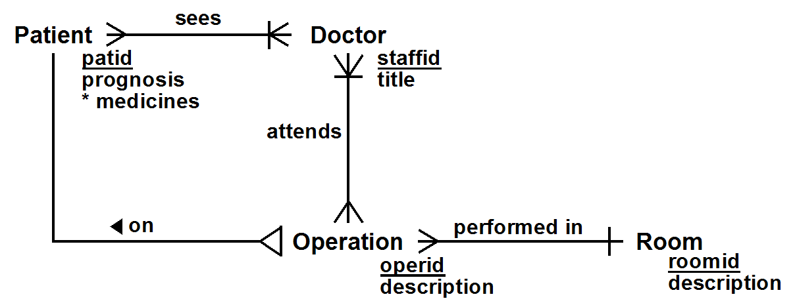

The DB designer generated the ER diagram above for these requirements, with the corresponding Brief ConText model

Entity Classes
Patient( patid, prognosis, *medicines )
Doctor( staffid, title )
Room( roomid, description )
[ Patient ] Operation( operid, description )

Relationships
SeesDoctor: (*) Patient sees (1..*) Doctor
HasOperation: (*) Operation on (1) Patient
AttendsOperation: (1..*) Doctor attends (*) Operation
OperationRoom: (*) Operation performed in (1) Room
You must generate the corresponding relational schema, keeping the following points in mind:
- Do NOT add attributes or references which are not explicitly included in the conceptual model.
- Only add surrogate primary keys to prevent composite foreign keys.
- Use Weak Entity Class mappings for any multivalued attributes.
- Assume M:N relationships use cascading deletes.
Make sure you draw all references with arrows pointing in the right direction – toward the unique attribute(s) referenced, and that you underline primary keys (NO dotted underlines; you are creating a relational schema, not a conceptual model).
[EXTRA CREDIT] Note that *medicines is a multi-valued attribute representing the set of medicines that a patient takes. For extra credit, make sure that each medicine taken by a patient corresponds to a medicine in a table of approved medicines
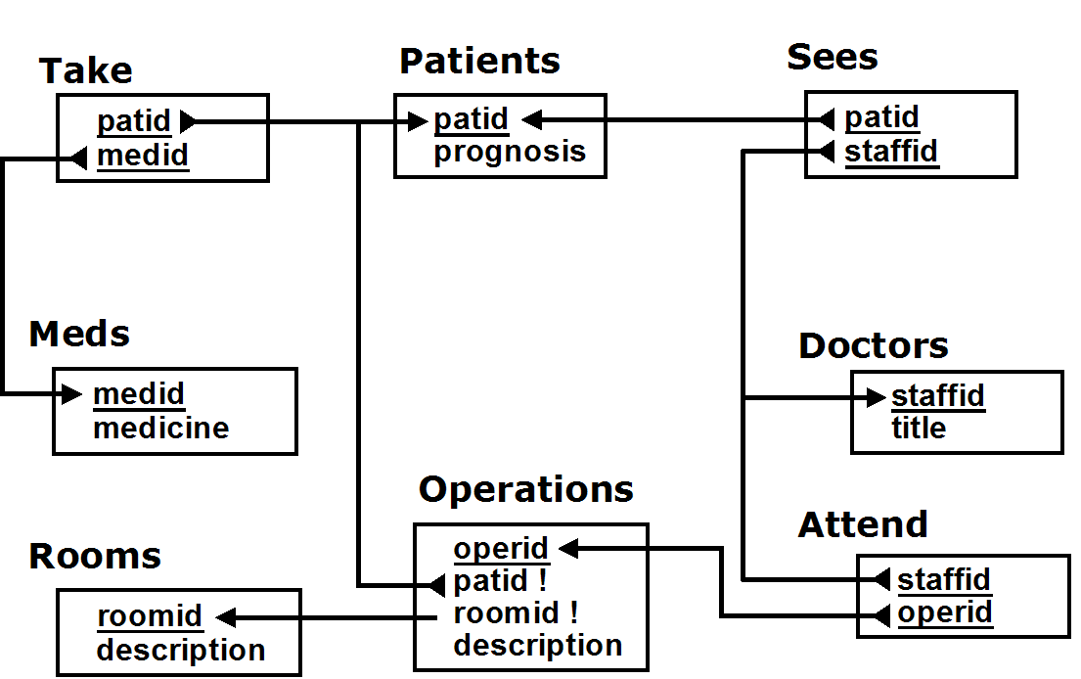
The M:N relationships between Patient & Doctor and between Doctor & Operation both require a bridge table (Sees and Attends respectively, below). The multivalued attribute *medicines is mapped (by Weak Entity Class mapping) to the Takes table. The requirement that medicines need to be checked against a master list could be implemented using a CHECK constraint. We chose to add a master Meds table of medicines with a reference from Take's medicine attribute to Meds. This actually means that a better conceptual model would have included a Medicine class with an M:N takes relationship between Patient and Medicine.

2. [25%] Conceptual Design

You are designing a database that keeps track of people, the projects to which they are assigned, and the meetings they attend. Each meeting results in a set of actions. Each action is associated with a particular project, and is assigned to one of the participants at the meeting, all of which is tracked in the database.

a) Draw an (Easy) Crow Magnum or UML diagram corresponding to these requirements. Make sure you
- Show all relationship characterizations
- Show all primary keys and discriminators
- Carefully consider whether 1:M relationships are independent, mandatory, dependent or identifying, and note them accordingly
- Carefully consider whether M:N relationships should be depicted with or without bridge classes

b) List all relationship and general state constraints, specified by the requirements, which are not already represented explicitly by your ER diagram. Note: it is possible (with some thought) to create an ER diagram that actually explicitly represents all such constraints (so the answer to this part is empty), and that solution will get the most credit. However, simpler ER models will require an explicit state constraint.

There are a variety of solutions to this problem, which are shown below. First of all, there are three things you will NOT see in these solutions.

- You will NOT see a 1:M relationship between projects and meetings. The requirements do NOT state that a meeting is held for the purpose of a single project. You won't see an M:N relationship either, because the specs don't assumes or require that the database needs to keep track of what projects were discussed at a meeting.
- You will NOT see a 1:M relationship between projects and persons. The requirements do NOT state that a person is only associated with a single project.
- You will NOT see the entity class Employee. The requirements talk about the persons who attend meetings and who are assigned to projects; they do not imply those persons are employees.

A good solution is shown below:

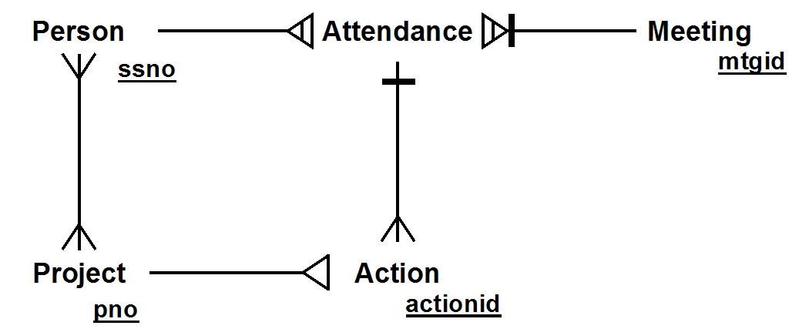

Here are the important things to note about this solution:

- In the M:N relationship between Person and Meeting, we explicitly include the bridge class Attendance (or, we could have used a relationship class instead) so that we can use Attendance in a 1:M relationship with Action, since actions are assigned to people who attend meetings. Note that we in included a mandatory participation constraint since we expect that a meeting has at least one attendee.
- We made Action dependent on Project. If a project is cancelled, the actions associated with the project would be cancelled as well.
- Why not make the relationship from Attendance to Action a dependent relationship? If a person is deleted, all their attendances must be deleted, which would then cause actions assigned to that person to be deleted. That's probably not what we intend; we'd probably like them to be reassigned instead (more on this later).
An essential decision is how we will uniquely identify Actions. In the solution above, we chose to give Action its own primary key. As an alternative, we could make Action a weak entity class with Project as its identifying owner; naction discriminates among the actions associated with a particular project.

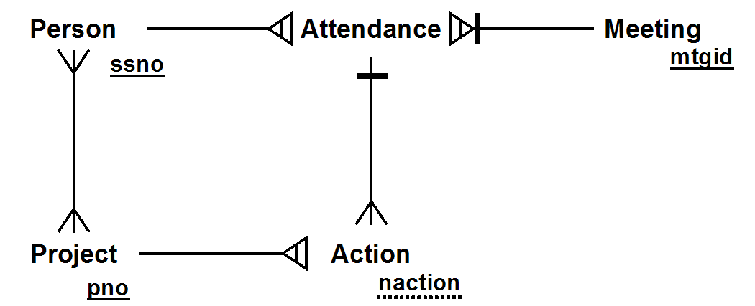

This has the following relational model
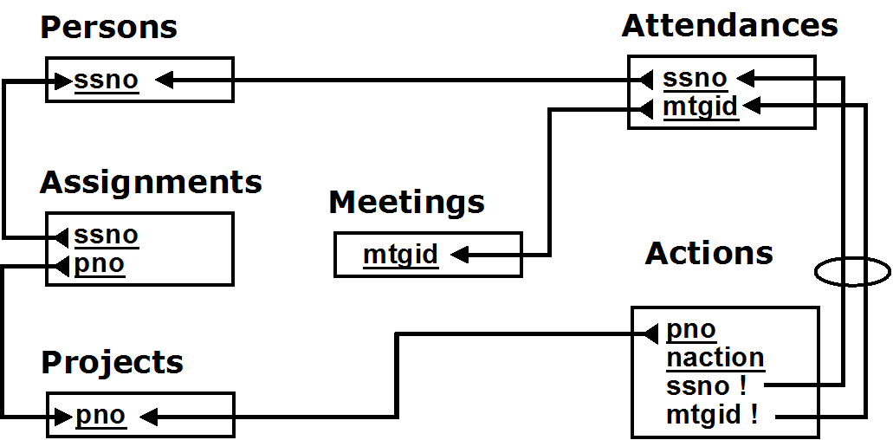

Here is an alternate solution:

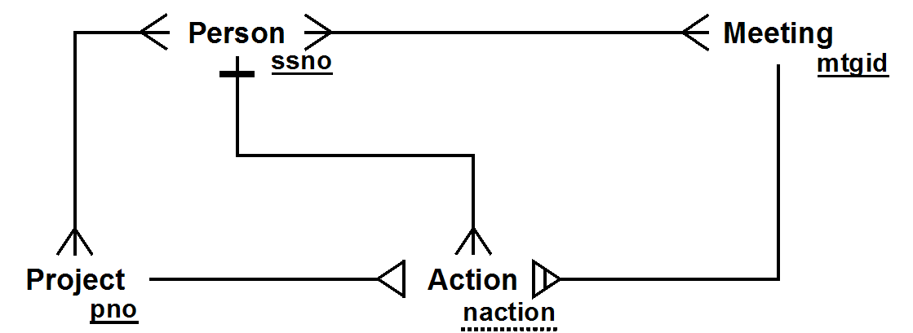

Instead of defining a bridge class for Attendance, and relating Action to it, in this model, Action is related separately to both Project and Meeting, and as a result, we decided to identify actions relative to the meeting they were assigned in, rather than (as in the solution above), relative to the project they were assigned for.

There is a downside. Even though Action still does have a relationship with Meeting, we can no longer ensure that an Action is associated with a meeting attended by the person assigned to the project. This is clear when comparing the two relational schemas. The schema for the second solution still requires an Attendances table (a bridge table resulting from the M:N relationship between Person and Meeting, but there is no longer a referential integrity constraint from Actions (ssno, mtgid) to Attendances (ssno, mtgid)

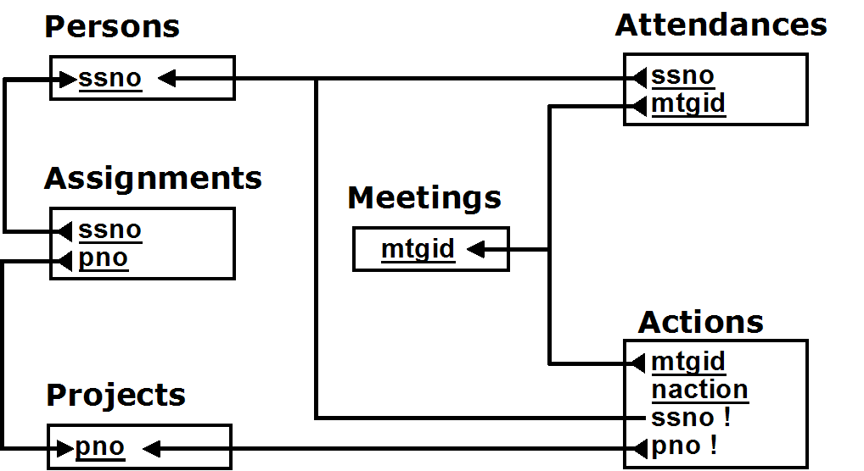

This solution would require that we add a separate conceptual state constraint:

Actions are only assigned to a person who attended the meeting at which the action was assigned.

There is an interesting advantage of this model. Suppose persons are deleted form the database when they are no longer involved with the company. We probably would want to reassign that action to a different person. The earlier solutions would require that the action be reassigned to another person who was at the same meeting. This is arguably too strong, and is not required by this solution. In fact, this consideration argues that

Actions are only assigned to a person who attended the meeting at which the action was assigned

is not a state constraint (i.e. it does not need to be invariant), but is a post-condition-like business rule it simply insists that when an action is assigned at a meeting, the action (at that time) be assigned to someone who was at the meeting. It does not insist that it remain assigned.

Another possible, but incorrect, alternative is shown below:

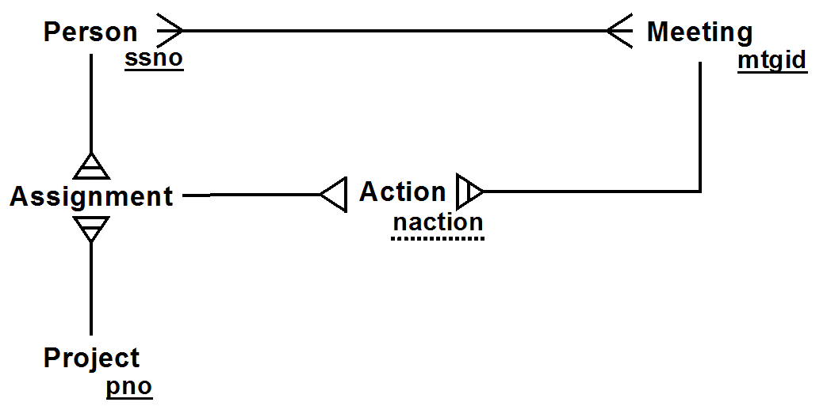

This is similar to the previous solution, but associates an action with a person assigned to a project. Now, this might be a reasonable assumption, but the requirements don't actually specify that an action for a project be assigned to a person who is currently assigned to that project.

3. [25%] Outer Joins

Solve each of the following problems (using the Emps relation) by using Outer Joins (for those of you who know about subqueries, DON'T USE THEM). For each problem, you MUST

- Draw the join diagram (by hand is fine)
- Write a single SQL SELECT statement which produces the requested result
(I recommend you test it, but that's not required). These may be easier to write if you use factored views. Extra credit if you DON’T use views, though.

a) List the names and jobs of ALL employees, along with the count of the employees they directly manage (which will be 0 if they don't manage anyone). Extra credit if you consider the possibility that more than one employee may have the same name.

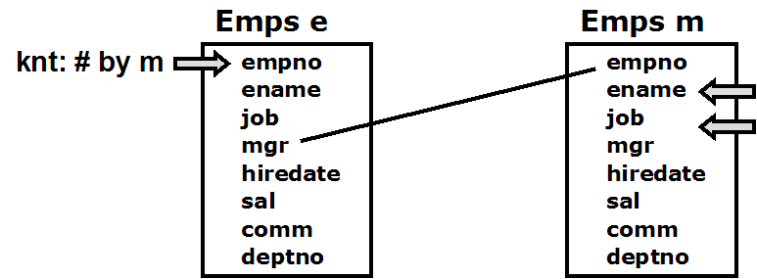

SELECT m.ename, m.job, count(e.empno) AS knt
FROM (Emps e RIGHT JOIN Emps m ON m.empno = e.mgr)
GROUP BY m.empno, m.ename, m.job

This can also be done using views:
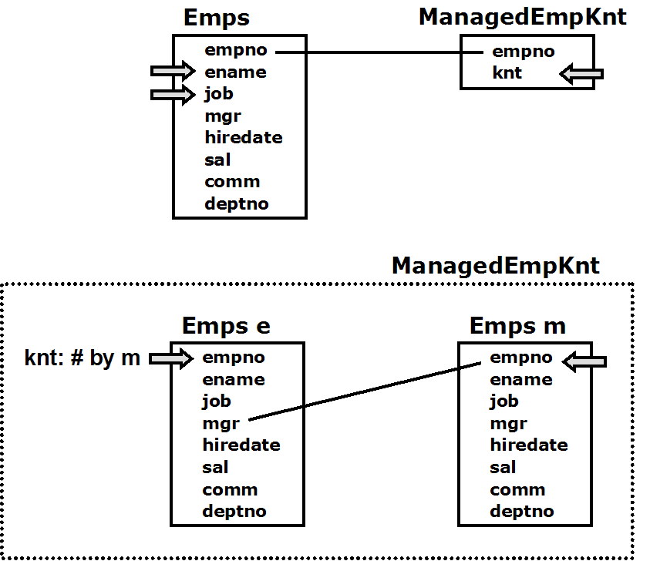

CREATE VIEW ManagedEmpKnt as
SELECT m.empno, count(e.empno) AS knt
FROM (Emps e RIGHT JOIN Emps m ON m.empno = e.mgr)
GROUP BY e.empno

SELECT ename, job, knt
FROM Emps NATURAL JOIN ManagedEmpKnt

b) Suppose your database also has the table Asns( empno, pno, hrsPerweek ) which describes which employees are assigned to which projects (and for how many hrs per week). You may assume that every employee is assigned to a department.

Write a single SELECT statement, that for every department that has employees, provides three pieces of information
- the deptno of the department
- the number of employees in that department
- the # of employees in that department that are assigned to at least one project

Note: This is harder than it may first appear. Try an example by hand, or actually test it out.

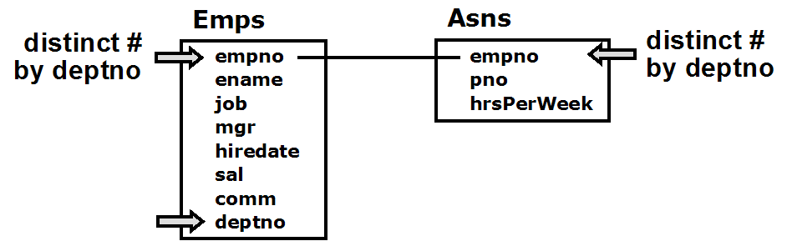

SELECT deptno, count(DISTINCT e.empno) as eknt,
count(DISTINCT a.empno) AS aeknt
FROM Emps e LEFT JOIN Asns a ON a.empno = e.empno
GROUP BY deptno;

Note that count(distinct pno) would count the # of projects that employees in the department are involved in,
count(pno) or count(a.empno) would just count the # of assignments of employees in each department
count(*) or count(e.empno) would count the # of assignments of employees in each department, plus 1 for each employee without an assignment!

Using views, this can be written as

WITH EmpKnt AS (
SELECT deptno, count(*) AS eknt FROM Emps
GROUP BY deptno),
EmpAsnKnt AS (
SELECT deptno, count(DISTINCT a.empno) AS aeknt
FROM Emps e LEFT JOIN Asns a ON a.empno = e.empno
GROUP BY deptno)
SELECT * FROM EmpKnt NATURAL JOIN EmpAsnKnt

4. [25%] Factored Views
You are given the following two tables
Owners( ssno, name, dob, address, phone )
Vehicles( vehno, make, model, year, ssno )
- ssno references Owners

Note: An example of a make is 'Honda'; an example of a model is 'Accord'.
year is the year the vehicle was built.

Each owner may own any number of vehicles, built in different years. Suppose, for
each owner we would like to know
- their name, and
- the vehicle number (i.e. vehno) of the vehicle they own that was most recently built (i.e. based on the year of the vehice)
If an owner owns more than one such vehicle, list all of them (e.g. if a person owns 4 vehicles, one built in 1963, one in 1996, and two in 2002, the result set will include tuples corresponding to the two vehicles built in 2002)

Do not include owners who do not currently own a vehicle. Note that owners with different ssno's may have the same name.

You must implement this using a SQL statement using a factored view. You may NOT use subqueries (if you know what they are). Note: Views are not just a convenience. There is no way that this can be written without using a view (unless you use subqueries).

a) In plain and clear English, describe the view that you will use and why it is useful in solving the problem

The view shows, for each user (indicated by ssno), the maximum year of the cars owned by that ssno.

By joining this view with Vehicles, you can get the required result

b) Write a single SQL statement (using factored views) that solves the problem.

WITH MaxOwnYear AS (
SELECT ssno, max(year) AS maxyr
FROM Vehicles
GROUP BY ssno )
SELECT name, vehno
FROM ((MaxOwnYear NATURAL JOIN Vehicles) NATURAL JOIN Owners)
WHERE year = maxyr
ORDER BY name, vehno

Here's an alternative solution, which includes the name in MaxOwnYear

WITH MaxOwnYear AS (
SELECT ssno, name, max(year) AS maxyr
FROM (Owners NATURAL JOIN Vehicles)
GROUP BY ssno, name )
SELECT name, vehno
FROM (MaxOwnYear NATURAL JOIN Vehicles)
WHERE year = maxyr
ORDER BY name, vehno

Note that using subqueries, this can be written as

WITH VehicleOwners AS (SELECT * FROM Owners NATURAL JOIN Vehicles)
SELECT name, vehno FROM VehicleOwners vo
WHERE year = (SELECT max(year) FROM Vehicles v
WHERE v.ssno = vo.ssno)
ORDER BY name, vehno

