CS579 Fall 2009

Class #2 Homework Solution

Hardcopy only (no e-mail) due at start of Class #3
Homework must be typed UNLESS your handwriting is extremely readable!
Late homework (received in e-mail by 7am the following morning) will be penalized one partial grade (e.g. from A- to B+). Late homework received within 48 hrs after class ends will be penalized two partial grades (e.g. from A- to B). Homework received up to 5 days late will be penalized one full grade (e.g. from A- to B-). Homework will not be accepted more than 5 days late, or if a solution to the homework has already been posted.

Recommended Reading

Bowman (The Practical SQL, 4th Ed)
- Chapter 3 (Creating and Modifying Tables), pages 68-71
- Chapter 5 (Sorting Data & other Techniques), pages 155-173

Models and Languages for Database Design & Theory

Visual & Textual ER Languages for Conceptual Modeling
- Section 1.7 (Attribute Constraints)
- Section 1.12 (Entity Constraints)
- Chapter 2 (Relationships)

Connolly & Begg
- Chapter 10 Fact-Finding Techniques
- Chapter 15 Conceptual Database Design
- Sections 11.6-11.7 Conceptual Constraints

Oracle Database 10g
- Chapter 9 Numeric Data & Functions, pp 175-184 (Aggregate Functions)

Lab Exercise Set #2 (complete before class #3)

Available online at courseinfo.

Do NOT hand in the output.

Self Quiz

Do NOT hand the answers for the self-quiz portion of the homework. Make sure you know the answers, though!

Answer the following questions about Lab Exercise Set #2. Treat this like a quiz. Keep your answers brief. Limit the time you spend on this!

a) Informally (in plain English a non-technical person could understand) characterize the actual results of the following two statements, and explain the similarities and differences.

select empno from Emps where job = 'DEPTMGR';
select distinct mgr from Emps where mgr is not null;

The first one lists the employee numbers of department managers.
The second one lists the employee numbers of employees who manage someone else.

All department managers manage someone, so the second group includes the first. However, the PRESIDENT and some ANALYSTs also manage other employees and their employee numbers also show up in the second group.

b) Explain the results of these two statements. How many rows are selected, and what are their contents? If they are the same, why? If they differ, why?

select job from Emps;
select distinct job from Emps;

The first one lists the jobs of each employee. There are 14 employees, each has a job, so the answer is 14.

The second only lists the jobs which are different. There are 5.

c) Explain the results of these two statements. How many rows are selected, and what are their contents? If they are the same, why? If they differ, why?

select job, sal from Emps order by job, sal;
select distinct job, sal from Emps order by job, sal;

The second only lists the ones which are different. Two analysts and two salesmen have the same salary, so the first gives 14 rows; the second gives twelve rows.

d) Explain the results of these two statements. How many rows are selected, and what are their contents? If they are the same, why? If they differ, why?

select count(*) from Emps;
select count(mgr) from Emps;

One manager is null, so the count of managers is 13 instead of 14.

e) Explain the results of these two statements. How many rows are selected, and what are their contents? If they are the same, why? If they differ, why?

select count(comm) from Emps;
select count(100 + comm) from Emps;

Most operators (e.g. +, –, etc.) produce a null result if either operand is null – reasonable, since SQL generally treats NULL as UNKNOWN. So, if comm is NULL, 100+comm is NULL as well, so there's no difference in the results. There are 4 rows that don't have NULL comm values, and therefore 4 rows that don't have NULL values for 100+comm

f) Explain the results of these two statements. How many rows are selected, and what are their contents? If they are the same, why? If they differ, why?

select count(mgr) from Emps;
select count('$' || mgr) from Emps;

Most operators (e.g. +, –, etc.) produce a null result if either operand is null – reasonable, since SQL generally treats NULL as UNKNOWN. Concatenation is an exception. It treats a NULL as an empty string, so concatenating '$' and NULL results in '$' (which is certainly not null!).

The first has a null value, which is ignored in counting, so we get 13.
The second does not have a null value, so we get 14

g) Explain the results of these two statements. How many rows are selected, and what are their contents? If they are the same, why? If they differ, why?

select count(mgr) from Emps;
select count(distinct mgr) from Emps;

There are 6 distinct non-null mgr values, so the result is 6 instead of 13. In the first case, we are counting the number of employees that have managers; in the second case, we are counting the number of managers!

Problems

IMPORTANT: Do problem 1 on your own.
I recommend you do problems 2-4 together with a partner or team, different than anyone you worked with last week

About working with a partner or team:

- If you do a problem together with a partner or team, then only hand in ONE COPY of that problem with all of your names on it.
- Please staple together (no paper clips please, they detach way too easily) the problems you did alone.
- Separately staple together the problems you did together.

- Working with a partner or a team means working together on the entire problem. If you just start working together, but then actually work out the details on your own, hand in your own solution. If you personally did very little work on a problem, but your name is on it when it is handed in, then you are involved in plagiarism -- taking credit for work that is not yours. All forms of plagiarism are a serious university offense, and I'm required to report them to the Student Academic Conduct Review Board, so please let’s not go there.
- If you are working with partners, and there's a significant imbalance in the quantity or quality of a partner's work, it’s essential you talk to me. Otherwise, it will almost certainly be the case that the underperforming partner will end up doing badly in the exams, and will either be forced to drop the course or will end up with a low grade. If you let me know there's a problem, I can make sure that students get additional help if they need it, or work with a different partner or team.

If you have ANY questions, post them on the newsgroup. Answering questions posted to the newsgroup can positively impact your grade.

1. [20%] SQL

Using the Emps table you created in exercise #1, write and test SQL that will solve the problems below.

➔ IMPORTANT: Make sure that the actual code that you write is independent of the actual data in the table. That, your code should do the right thing even if there were a different set of employees in the table

➔ Note that you must use the Emps table, which you created as a result of
lab exercise #1, not the emp table.

If you are having trouble installing Oracle, contact me, and we will discuss how best to do this homework.

Otherwise, you must hand in the output of a spool file that shows the queries and results (you will learn how to do this in the lab exercises). Make sure that you inspect the results to ensure that the answers are what you would expect.

Handwritten output, or output that simulates the actual spool file, is not acceptable. It is fine if the spool file contains some erroneous attempts. Simply use a pen to (a) indicate which answer is correct, and (b) cross out the SQL and output which is incorrect!

a) List all info about all employees except those listed as having a commission larger than $300. Order by deptno, and within deptno by job.

SELECT * FROM Emps
WHERE (comm <= 300) OR (comm IS NULL)
ORDER BY deptno, job

An alternate version (using nvl, which is Oracle-specific) is

SELECT * FROM Emps
WHERE nvl( comm, 0 ) <= 300
ORDER BY deptno, job

b) List all the distinct combinations of dept numbers and jobs, ignoring analysts and dept managers. (Note: you can assume everyone is assigned a job)

SELECT DISTINCT deptno, job FROM Emps
WHERE job NOT IN ('ANALYST', 'DEPTMGR')

or, less elegantly,

SELECT DISTINCT deptno, job FROM Emps
WHERE job <> 'ANALYST' AND job <> 'DEPTMGR'

If we also want to consider cases where job is NULL, then we'd want

SELECT DISTINCT deptno, job FROM Emps
WHERE job NOT IN ('ANALYST', 'DEPTMGR') OR job IS NULL

c) Display the most recent date that an analyst was hired

SELECT max(hiredate) AS mostRecentHire
FROM Emps WHERE job = 'ANALYST'

d) Display the count of the number of departments that have employees

SELECT count(DISTINCT deptno) AS numdepts FROM Emps

Note that it is not necessary to add "where deptno is not null", since the count function (when used with a specific column) already ignores NULLs. It is also not necessary to add the WHERE clause

WHERE empno IS NOT NULL

since empno can never be NULL since it is the primary key. There's also no need to add the WHERE clause

WHERE ename IS NOT NULL

First of all, it’s unlikely that an employee wouldn’t have a name. But even if a department's employees are all nameless, we still do want to count that department.

2. [30%] Application Design

Please look through the solution document for HW#1 and use the ER design and list of named relationships shown there for the Online Auction Application. You are now going to continue the design starting from the solution for HW#1.
There are two parts to this, (a), (b), as well as two extra credit parts (c) and (d)

➔ a) Determine the User Roles and draw a User Role Diagram. Only include roles needed for the requirements. Remember two important characteristics of these diagrams:
- Subroles represent "a kind of". If B is a subrole of A, it means that
  - a B is a kind of A -- e.g. a Known User is a kind of User
  - Any operation that can be done by a B can be done by an A
- Organize your User Role Diagram so that an operation is explicitly associated with only one role. If an operation seems to apply to multiple roles, assign it instead to a common super-role. (Note: You can define an operation so that its behavior depends upon who the user is as well as its parameters.)
- Remember that the same user can possibly take on more than one role. Even if two roles are disjoint, it just means that a user can't play both roles at the same time.

➔ b) List the names of your User Operations, organized by role, and within each role, by queries and actions.
- Include input parameters and descriptions for each operation.
  - Each input parameter should be preceded by a colon. Note that parameters represent information passed into the operation, and explicitly provided by the user. In a web-based application, these typically hold the values of filled-in text fields, or identify radio buttons or check boxes chosen on a page before the user clicks a button to submit the request to the web server.
  - For a query operation (assuming a web-based application), very briefly describe what data is displayed to the user. Make sure the input parameters only represent information passed into the operation (they do NOT name the fields to be displayed)
  - For an action operation, very briefly describe what the operation does, in terms of how it affects the data managed by the database or the application, but do NOT describe the contents of the page that an action operation returns.
  - Once a user has logged in, the middle-tier keeps track of the identity of the current user, so there's no need to pass a user id as a parameter to another operation unless it is meant to represent some other user.
  - If a user operation creates a new instance (e.g. a new bid), think carefully about whether you want the user to supply its primary key (in which case it will need to be passed as a parameter) or whether you want the operation to assign it automatically (in which case it should NOT be passed in as a parameter).
- You must include ALL actions (including Register, Login & Logout) and ALL queries needed to fulfill the requirements.
- Remember that the conceptual model exactly reflects information that the database maintains. If you have operations whose parameters correspond to data that would need to be stored in the DB, make sure that the conceptual model has attributes where they can be stored. For example, the Item class has an itemid, not an itemname, so providing an item name as a parameter would be useless, since it would be impossible to store it, or to look up an item based on its name.

- Do NOT include any operations not required or strongly implied by the requirements, except:
  - Include ONLY ONE additional query that would specifically be useful for a user who has previously posted an item for auction. In addition to naming this operation, ➔ you must MARK IT with a (P) to get credit for it.
  - Include ONLY ONE additional query that would specifically be useful for a user who has previously made a bid on an item currently being auctioned off. In addition to naming this operation, ➔ MARK IT with a (B) to get credit for it.
➔ c) [EXTRA CREDIT] Identify two actions which have pre-conditions (implied by the requirements). List the operation, along with its parameters. Associated with each operation, list all of its pre-conditions.
- You may NOT choose the Login or Logout operations
- You must choose the operation used to place a bid
- Mark a pre-condition as [ROLE] if it is corresponds to the fact that the operation is assigned to a role in the User Role Diagram

➔ d) [EXTRA CREDIT] See if you can identify any operations which might reasonably have interesting state-related post-conditions (i.e. ones that describe the result of changing the database state.

➔ At the end of this homework, you can find an example (with requirements and ER diagram) for an Online Job Board Application. Please use EXACTLY the same format for your application design.

I STRONGLY RECOMMEND that you draw ER and User Role diagrams by hand. At least, PLEASE DO NOT SPEND EXCESS TIME producing them on-line

If you absolutely feel compelled to use a tool to draw ER and User Role diagrams, I recommend that you use PowerPoint [so you can cut and paste symbols from my lecture slides], then cut and paste the PowerPoint into IrfanView [available free from download.com], then cut and paste from IrfanView into Word.

In this model, logged in (i.e. known) users play two different roles – that of a buyer (posting bids), and that of a seller (posting items to be bid upon). Both a Buyer and a Seller are a kind of Known User, who is, in turn, a kind of User. The other kind of User is an Unknown User, who is not logged in.

A user can be acting as a Buyer or as a Seller (or neither, if they are just browsing), and generally can play either role at any time. That leads to the diagram:

User Role Diagram
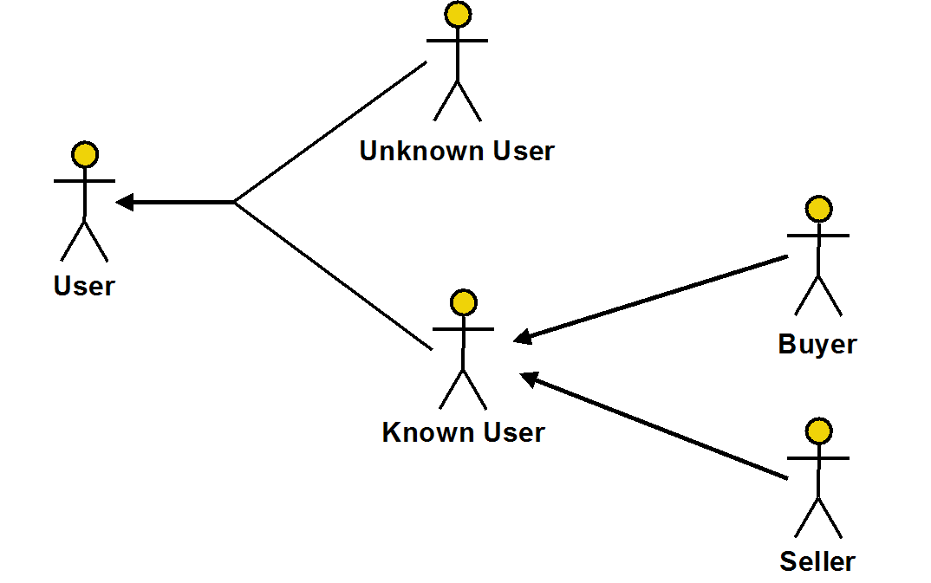

Because the lines from Buyer and Seller to Known User do not merge, the Buyer and Seller roles may overlap – a user can play both the buyer and the seller role at the same time.
That is, a user may be able to choose actions and queries that are relevant to either role from the same page.

As an alternative, the Buyer and Seller roles could be disjoint – that is, the same user cannot be a Buyer and a Seller at the same time (so the arrows from both of these roles merge as they point to their common super-role Known User). The system could require that the user log out and log back with a different user id for their other role. Or more simply, the system might require that the user simply execute some operation (not listed in the operations below) that changes the role, navigating to a new page which only supports operations for that role.

User Role Diagram
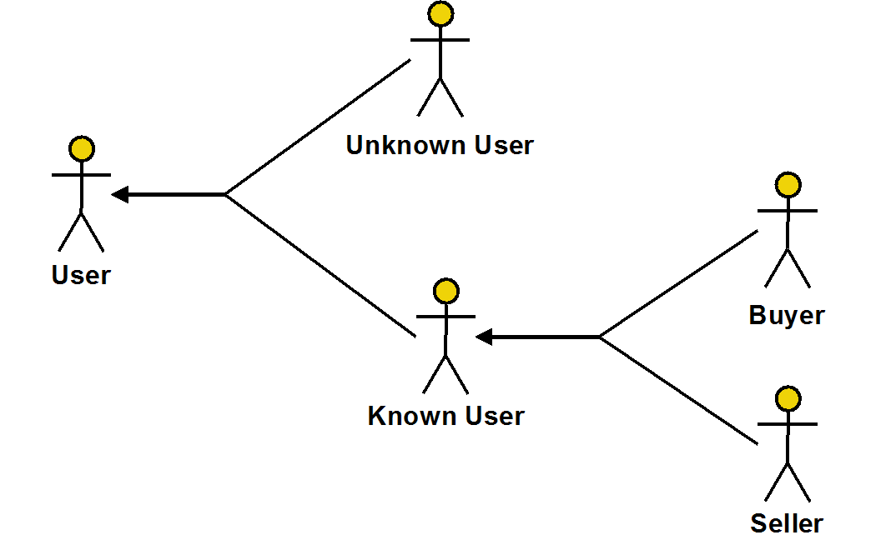

We will explore these issues in more detail during the second half of the term.

User Operations (Online Auction Application)

User
Queries
ShowCategories: Shows the categories
ShowOpenAuctionsInCategory( :catnam ): Show the auctions currently open in the specified category
ShowItem( :itemid ): Show details of specific item [Note: makes sense, but not explicitly in requirements. Might actually belong under Known User.]

Unknown User
Actions
Login( :userid, :pwd ): Logs in user with the specified userid and password
Register( :userid, :pwd, :usernam ): Registers new user

Known User
Queries
ShowHighestBid( :itemid ): Show the highest bid for the specified item
Actions
Logout: Log the current user out of the system
SetPwd( :oldpwd, :newpwd, :repeatnewpwd ): Changes the current user's password
RemoveMe: Logout & remove the current user from the system

Seller
Queries
ShowAllBidsForAuction( :itemid ): Show all bids for the auction of the specified item posted by the seller
(P) ShowMyOpenAuctions: Show a list of the user's items being auctioned where the auction has not yet closed.
(P) ShowMyClosedAuctions( :after, :before ): Show a list of the user's items whose auctions have closed after time :after (if not NULL) and before time :before (if not NULL).
Actions
PostItem( :title, :category, :descr, :closetime ): Posts a new item including the closetime of the auction

Buyer
Queries
(B) ShowMyActiveAuctions( :status ): Show the list of items whose auctions are open for which I have placed a bid. If :status is NULL, show all auction, if it is WINNING, only show auctions where my bid is the highest; if it is LOSING, only show auctions where my bid is not the highest.
(B) ShowMyCompletedAuctions( :status, :after, :before ): Show the list of items for which I have bid where the auction is closed. For :status, see ShowMyActiveAuctions. For :after and :before, see ShowMyClosedAuctions.
Actions
MakeBid( :itemid, :amt ):
Place a bid on the specified item for the specified amount.

Operations with Pre-Conditions

NOTE: A pre-condition is marked as [ROLE] if it exactly corresponds to the assignment of the operation to a role

PlaceBid( :itemid, :amt )
- [ROLE] The user must be a buyer (or a known user)
- :itemid must identify an existing item
- the item's auction closetime must be in the future
- The current user must be different from the user who posted the item
- :amt must be larger than the latest bid on the item

PostItem( :title, :category, :descr, :closetime )
- [ROLE] The user must be a seller (or a known user)
- :title must have at 5 characters
- :closetime must be at least 24 hours from now
- :category must be a valid category

Actions with Interesting State-Related Post-Conditions

PostItem
- The itemid of the newly created item is set to one larger than the previously posted item

3. [25%] State Constraints:
In this problem, you will be given a list of business rules about the Online Auction Application and asked to determine whether or not each CAN BE a conceptual state constraint

A Conceptual State Constraint specifies an invariant property of the database state (something that you would like to always be true). It must be possible to check a state constraint by looking at the database at an arbitrary time, ➔ so there must be attributes or relationships in the conceptual model which can be tested at any time to determine if the state constraint is true or not.

A state constraint must constrain. That is, it must limit the allowable states of the system. A statement which does not constrain anything can't be a constraint.

Below, you will find a list of business rules, some of which are conceptual state constraints for the application. Precede each statement with one of the following symbols:

S – could be a state constraint
X – is NOT a state constraint

In addition, some of the state constraints are redundant – i.e. they are already specified by the ER diagram for the Auction Application. In addition to indicating the appropriate symbol, also mark these with an asterisk – e.g. use *S for a redundant state constraint.

➔ Following the rules, you will see some extra credit instructions as well

Business Rules
- Users can post any number of items
- Itemscan only be posted for auction from 8am to midnight GMT.
- Bids cannot be placed on items whose auctions have closed
- All bidid's are unique
- Every item is in at most one category
- Every bid is placed by a single user
- When an item is posted for auction, its closing time must be at least 24 hours after the time it was posted.
- Every item must have a title, a description and a closing time.
- The amount of a new bid must be larger than all existing bids for the same item.
- Every user must have a user name.
- A bid can never be changed or withdrawn.
- Users cannot place bids on items they have posted
- A user can bid on the same item multiple times.
- A user who views the bids on an item is only allowed to see the last 3 of them unless the user is logged in
- Only the user who posted an item can withdraw it.
- A user can only withdraw a posted item up to 4 hours prior to the close of the item' auction.
- Only registered users can post bids or items.
- Anyone can browse the list of categories, and then browse the list of posted items in a specific category which are still being auctioned off.
- Every category must have a category name.
- When an item has been withdrawn, all bids for the item are removed from the system
=========================================
- X: Users can post any number of items (Doesn't constrain anything)
- B: Items can only be posted for auction from 8am to midnight GMT.
For this to be a state constraint, the time the item was posted would have to be an attribute so it could be checked by looking at the database state at any time. This can only be a pre-condition for the posting operation.
- R: Bids cannot be placed on items whose auctions have closed
This can be viewed as a pre-condition, but it also can be checked invariantly. Is a Relationship Constraint on the BidItem relationship, seen more clearly if it is rewritten as: Every bid's bidtime must be earlier than it's corresponding item's closetime. Why is this a Relationship Constraint: because it constrains – based on attributes of a bid and an item – whether the bid can be associated with the item or not
- *C: All bidid's are unique *(primary key constraint)
- *R: Every item is in at most one category *(key constraint)
- *R: Every bid is placed by a single user *(participation constraint)
- B: When an item is posted for auction, its closing time must be at least 24 hours after the time it was posted.
Tricky! As with #2, if an Item actually had a posttime attribute, which specified the time the item was posted, then this could actually be an Entity Constraint: An item's closing time must be at least 24 hours after its posttime. However, Item does not have a posttime constraint, so it cannot be a state constraint, since it cannot be checked at an arbitrary time. It is a pre-condition for the posting operation.
- I: Every item must have a title, a description and a closing time. (A typical non-null constraint)
- R: The amount of a new bid must be larger than all existing bids for the same item. The BidItem relationship identifies all bids for an item. This is a state constraint, which specifies something that must be true of the BidItem relationship – specifically: if the bidtime of a bid is higher than those of all other bids related by BidItems to the same item, then its amt must be higher than all their amts as well.
- I: Every user must have a user name. (A typical non-null constraint)
- X: A bid can never be changed or withdrawn.
Well, you might argue that this as a pre-condition, but it really doesn't limit the situations in which a bid change or withdraw operation can be executed. It just says that there are no such operations at all!
- G: Users cannot place bids on items they have posted
Like #3, this can be viewed as a pre-condition, but it also can be checked invariantly. The fact that it is a state constraint is clearer if it is rewritten as: There cannot be bids on items placed by the user who posted the item. It is a general conceptual state constraint involving the relationships Posts, BidItem and BidUser.
- X: A user can bid on the same item multiple times (Doesn't constrain anything)
- A: A user who views the bids on an item is only allowed to see the last 3 of them unless the user is logged in (an interesting output-related post-condition)
This must be a post-condition, since it describes the allowable output after the operation executes. It can't be a pre-condition, since it is not about allowing or disallowing the operation, but rather about what the operation's result is.
- B: Only the user who posted an item can withdraw it. (a pre-condition; nothing in the ER diagram keeps track of who withdrew a bid, so can’t be checked at an arbitrary time)
- B: A user can only withdraw a posted item up to 4 hours prior to the close of the item's auction (a pre-condition, but not an invariant property)
- *R: Only registered users can post bids or items (implied by the ER diagram).
- X: Anyone can browse the list of categories, and then browse the list of posted items in a specific category which are still being auctioned off. (Doesn't constrain anything)
- *I: Every category must have a category name. *(primary key constraint)
- A: When an item has been withdrawn, all bids for the item are removed from the system (an interesting state-related post-condition)

[EXTRA CREDIT]

There are four kinds of conceptual state constraints:
- Entity Instance Constraints (I)
Constrains the values of a single entity
- Entity Class Constraints (C)
Constrains the values of entities of a single entity class independent of any relationships, but requires consideration of more than one entity at a time
- Relationship Constraints (R)
Specifies how entities in one entity class can/must be related (via a single relationship) to entities of the related class, without considering any other relationships or entity classes.
- General Conceptual State Constraints (G)
Constrains values based on multiple relationships or unrelated entity classes

Instead of marking S for a state constraint, mark either

I – entity instance constraint
C – entity class constraint
R – relationship constraint
G – general conceptual state constraint

As described above, use an asterisk to mark constraints which are redundant (i.e. already implied by the conceptual diagram). So, for example, use *I to represent a redundant entity instance constraint.

[EXTRA CREDIT]

Statements which are not state constraint may be pre-conditions or post-conditions.
Instead of just marking X for something that it not a state constraint, mark these statements as

B - pre-condition (something that should be checked before an operation executes)
A - post-condition (something that can be checked after an operation executes)
X – neither a state constraint, a pre-condition, or a post-condition

A condition (just like a state constraint) must constrain. It must constrain the behavior or the output of the system in some way. A statement which does not constrain anything can't be a constraint or a condition.

Here's how to distinguish between state constraints and conditions in more detail:

- pre-conditions: something that you can check before executing an operation
WARNING: There are some statements which sound like pre-conditions, but which can be checked at an arbitrary time (not just before the operation) by looking at the database state, so they should be marked as state constraints
WARNING: There are some statements which sound like state constraints, but the database doesn't contain the information needed to check them at an arbitrary time, so they can only be checked before executing an operation. These should be marked only as pre-conditions.
WARNING: A pre-condition either allows an operation to proceed, or prevents it from executing. A pre-condition cannot be used to control the details of an operation's results. That can only be done using a post-condition, which describe the results of an operation (including the resulting database state, or characteristics of the output), which can vary based on the initial state.
- post-conditions: something which describes how the state has changed after performing an operation

WARNING: A post-condition is any statement which describes the state after performing a specific operation, but if this statement can be checked at an arbitrary time (not just after the operation) by looking at the database state, it should be marked as a state constraint.
NOTE: A post-condition can sometimes be enforced by doing checking before the operation begins. But it's still a post condition if it describes what the expected state is after the operation. For example, suppose the operation AddOneToX adds one to a variable x. The statement, "AddOneToX must finish with x having the value 12" is a post-condition, since it describes what the state must be at the end of the operation. You could enforce this constraint by checking whether or not x is 11 at the beginning of the operation. But it’s still stated as a post-condition. If you instead stated it as "only allow AddOneToX to execute if x is initially 11", then it would be a pre-condition.
There is an advantage to using post-conditions (where appropriate), because post-conditions can also be enforced by undoing the operation or fixing up the state. For example, if we ran AddOneToX, and x wasn't 12 afterwards, the system (using a trigger to monitor the result) could just set it to 12. That degree of flexibility is not available for pre-conditions, which can only be enforced by allowing the operation to proceed or not.

Remember that there are statements which sound like pre-conditions or post-conditions, but which can be checked at any arbitrary time, just by looking at the database state. You should treat these as state constraints. Pre-conditions and post-conditions can only be enforced when an operation executes. However, state constraints provide additional flexibility. Although you CAN check them whenever an operation is executed which might violate the constraint, you can instead (for performance) or in addition (for reliability), check the constraint at arbitrary or regular intervals (e.g. once a day at 2am).

4. [25%] Conceptual Design

You are given the following requirements for a Hospital Meal Application.

A Hospital Meal Application maintains upcoming menus which are specific to a day and mealtime (e.g. the Thursday Lunch Menu), and are made up by the hospital dietician. A menu is comprised of the menu items which are available on that particular menu (e.g. Lasagna [a menu item] might be on the Thursday Lunch Menu, but not on the Thursday Dinner Menu).

From the computer in each of their rooms, a patient can order a personalized meal (e.g. that patient's Thursday lunch meal) from the corresponding menu up to 3 days in advance. For each meal, the patient can select the menu items they will be having at that meal from the items actually available on the corresponding menu.

The application also keeps track of the ingredients (e.g. mustard, salt) used in each menu item. As part of patient registration, the registration clerk obtains from the patient, a list of ingredients to which they are allergic, and this information is made available to the Hospital Meal Application. In particular, when a user is shown a particular menu, they are not shown the menu items that contain ingredients to which they are allergic.
You must generate

a) the User Role Diagram. Do NOT generate the list of operations.
b) The Easy Crow Magnum or UML ER Diagram.

- Include and properly denote the primary key attribute for each entity class
- Show all other important attributes for each entity class
- Show all relationship characterizations
- Indicate all mandatory participation constraints and any more complex cardinality constraints
- Do NOT indicate optional participation
This is not a simple ER diagram; it has at least 5 entity classes, but

- Be careful NOT to include singleton classes – that is, classes that have only a single instance.
- Remember that an entity class or a relationship only should be included in an ER diagram if it represents information that is later needed to perform a query or an action. In particular, DON'T include relationships that simply represent what a user can change or view unless the requirements specifically indicate that such information should be retained persistently in the database.
- Specifically, not every user role needs to be represented as an entity class.
Additionally

- Pay very close attention to 1:M vs M:N relationships. Every time you draw a 1:M relationship, carefully check whether it should be M:N instead. I strongly recommend you study the Bikeshop example we discussed in class before doing this problem. It is very applicable to this problem
- Avoid 1-1 relationships.
- ➔ Make sure your attributes all have simple types; an attribute which holds a complex set of data generally means that you need to rethink your design, adding more entity classes.
- Also, please look at the notes on entity attributes in the solution to HW#1 and remember that it would be both incorrect and redundant to include entity attributes -- attributes (or groups of attributes) which identify other entities; they should be represented using relationships.

I STRONGLY RECOMMEND that you draw your ER and User Role diagrams by hand. PLEASE DO NOT SPEND EXCESS TIME producing them on-line (although if you are compelled to do so, I recommend that you use PowerPoint [so you can cut and paste symbols from my lecture slides], then cut and paste the PowerPoint into IrfanView [available free from download.com], then cut and paste from IrfanView into Word).

SOLUTION:

As we saw in the bikeshop example, there is a difference between a generic bike (e.g. a Schwinn) and a particular bike (#47925, which happens to be a Schwinn). Similarly, there's a difference here between a generic Menu, indicating what is available for a particular meal, and a Meal, identifying what a specific patient ordered from that menu for their meal. The simplest solution is below:

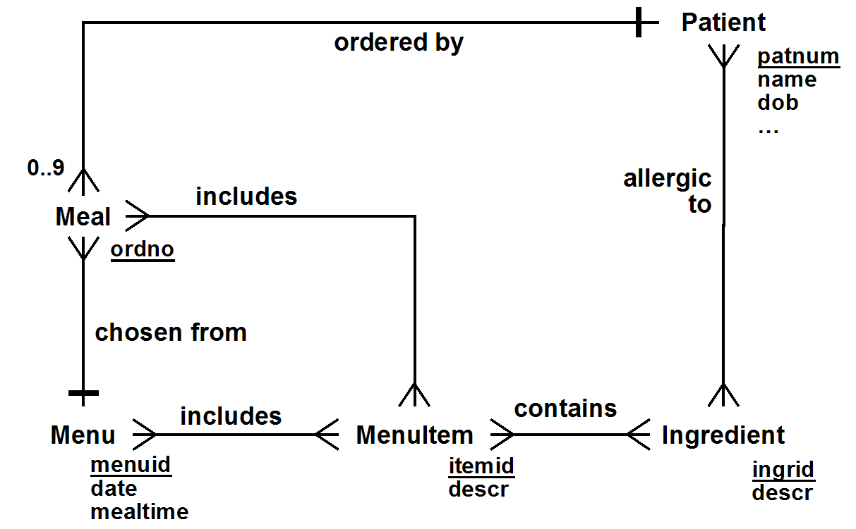

Because a patient can order meals up to 3 days in advance, there can be up to 9 pre-ordered meals per patient (3 per day). Note that this implies that meals are deleted after they are delivered. If this were not a reasonable assumption, then we'd have to remove or change this general cardinality constraint.

The individual items that appear on a menu are MenuItems. Each menu reflects the menuitems that are potentially available (e.g. Lasagna may be available on the Thursday lunch menu, but not on the Thursday dinner menu). Each individual meal is associated with MenuItems as well – not the ones which are potentially available from the corresponding menu, but the ones which are actually part of the meal.

Note that we would expect the following conceptual state constraint to be satisfied: Every menuitem which is included in a meal is included in the menu from which the meal was ordered. Of course this might not be true if there were some way that patients could order items that were not on the menu.

There are some limitations to our solution.

First, we note that there is no way to indicate the quantity of an ordered item. For example, suppose that butter were a menu item, and patients could choose the number of pats of butter they wanted. This can't be represented in the diagram above. To handle this situation, we need to return to the bikeshop analogy. Just as generic bikes are composed of generic parts, but a specific bike is composed of specific parts, so a generic menu is composed of menuitems, while a specific meal is composed of mealitems. A mealitem is an instance of the generic menuitem associated with a particular meal. Most significantly, a mealitem can include the quantity ordered. It would also be a good place to include other kinds of customizations, such as the size of the item desired (e.g. small, medium, large), or the way an item is cooked (e.g. medium rare).

Similarly, although the model above does represent a patient's allergies, there is no way to represent the severity of an individual patient's allergy to a specific ingredient. To model that, we would need to explicitly represent an IndividualAllergy (a specific reaction that an individual patient has to a specific ingredient) as an entity class in its own right, so that we can associate a severity with it (we'll discuss these more when we talk about bridge classes). Neither of these are part of the requirements, but if they were, we would want to change our ER diagram to
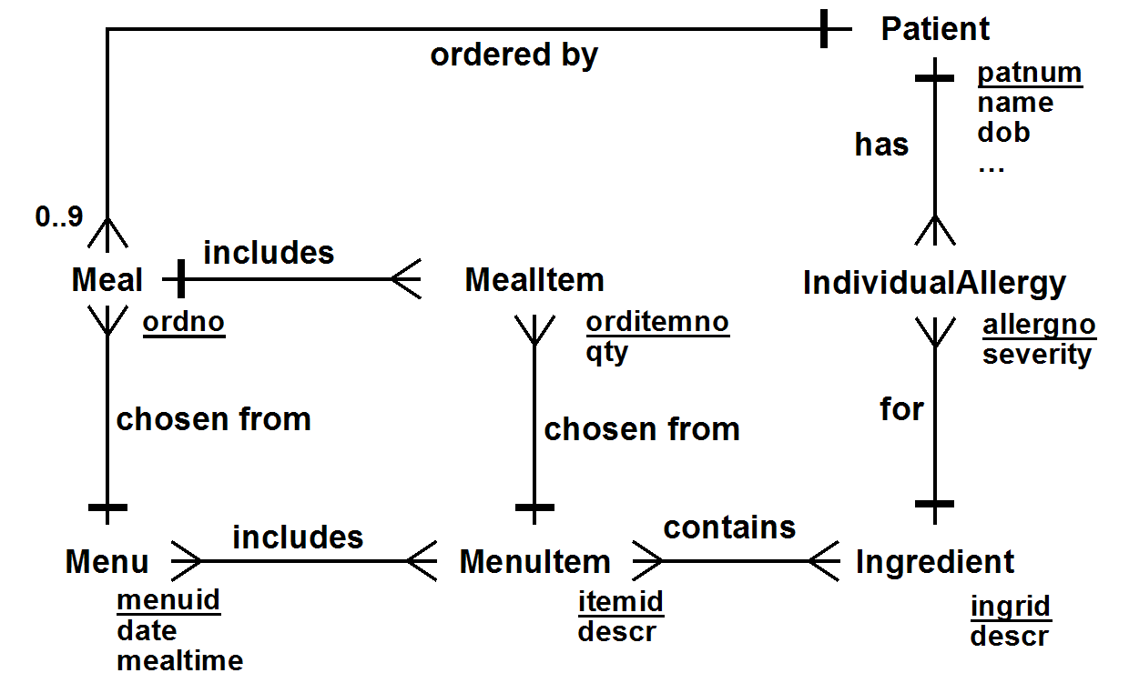

You also might have considered

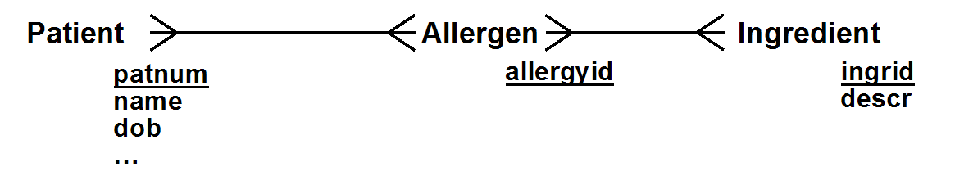

This implies that there are clearly identified allergens, that the allergens in each ingredient are well known, and that we can determine a patent's allergies to an ingredient solely based on knowing which allergens the patient is allergic to. It's not entirely unreasonable, but it is overkill, since the requirements don’t imply that such a set of allergens are named, or that there even is a clear unambiguous mapping between ingredients and allergens.

You also might have considered adding entity classes to the diagram which represented roles, along with relationships indicating how those roles interacted with other entity classes. For example:

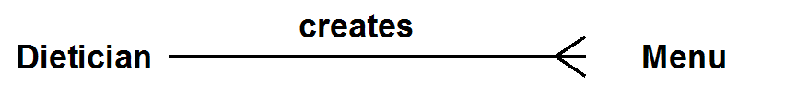

This would be unnecessary for a number of reasons. First of all, we haven't implied that there is more than one dietician, so dietician would be a singleton class. But even if there were multiple dieticians, this would not be necessary. Including this in the ER diagram implies that the database needs to persistently keep track of which dietician created which menu (so that it can be queried by a user at some point in the future). Nothing in our requirements suggests that it is needed.

Turning to the User Role Diagram: There are at least two kinds of users who clearly need access to the system – patients (who need to order meals), and dieticians (who need to enter menus).
Possibly nurses need to have access, to order meals for patients who are unable to, and doctors and nurses possibly need access, in order to check what a patient has ordered. We'll ignore this for now; hey, it's not in the requirements.

We do need to think about how the patients' allergies get entered into the database. Perhaps this is done by the registration clerk directly (though the requirements are a bit vague about this). However, it is also possible that the registration clerk enters the data into a separate Hospital Registration Database, and that somehow the two systems interact. This is an issue somewhat beyond the scope of this course; we'll just assume that there is a Registrar user, knowing that the exact way in which the allergy data is communicated to the Hospital Meal Application may end up being somewhat more complicated.

Finally, though it is not explicitly in the requirements, we also do need to think about how the user's meals actually get made. In a fully automated kitchen, the Kitchen Staff would be interactive users, and would have a user interface that would show what meals needs to be made. For a less automated kitchen, the system would probably automatically print a report listing the patients and their orders before each mealtime. In any case, we can posit a Kitchen Staff user who either interactively sees meal information, or on whose behalf the report is printed.

User Role Diagrams are really a subset of what UML calls Actor Diagrams, in which these subtler system distinctions can be represented. For this course, we will limit ourselves to the simpler User Role Diagrams.

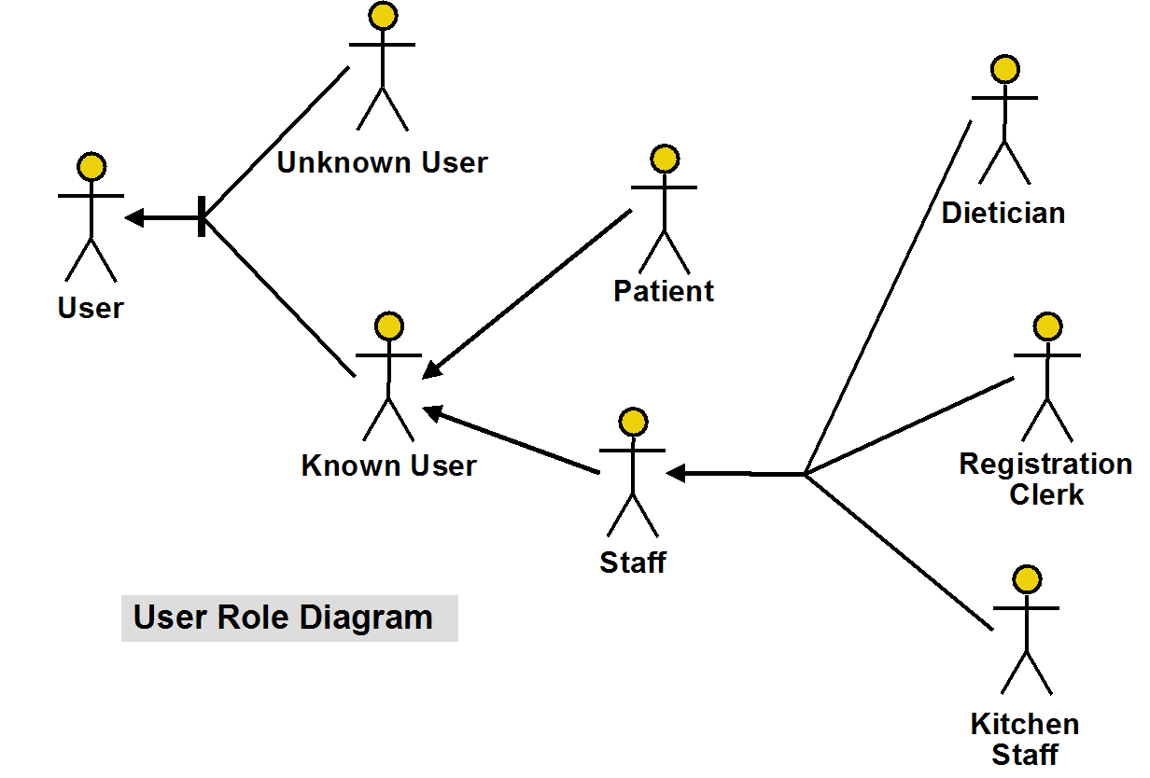

It would be reasonable to leave out the Staff Role as a super-role of Registrar, Dietician & Kitchen Staff, since nothing in the requirements requires it.

It is very useful to distinguish the Unknown User (i.e. not logged in) from the Known User. The act of logging in changes a user's role from UnkownUser to KnownUser or some role descended from it. Similarly, logging out changes their role back to UnknownUser.

Associating Login with UnknownUser essentially specifies that a Login operation cannot be performed by a logged-in user, and similarly, associating Logout with KnownUser essentially specifies that a Logout operation cannot be performed by a user who is not logged-in.

Online Job Board Application

Requirements

An Online Job Board Application allows job candidates to provide
- personal information
- information about the job they are seeking, including the industry and title they are looking for, and the location they would prefer to work (let's assume just one to keep things simple)
- a job history, each entry of which describes a job they had, including the company they worked for, and the dates they worked for them.

Company representatives can post information about their company (including the industry they are in) and can post open jobs (and remove them when they are filled).
- Each open job posting includes the location and title of the job, as well as other information.

Easy Crow Magnum Diagram
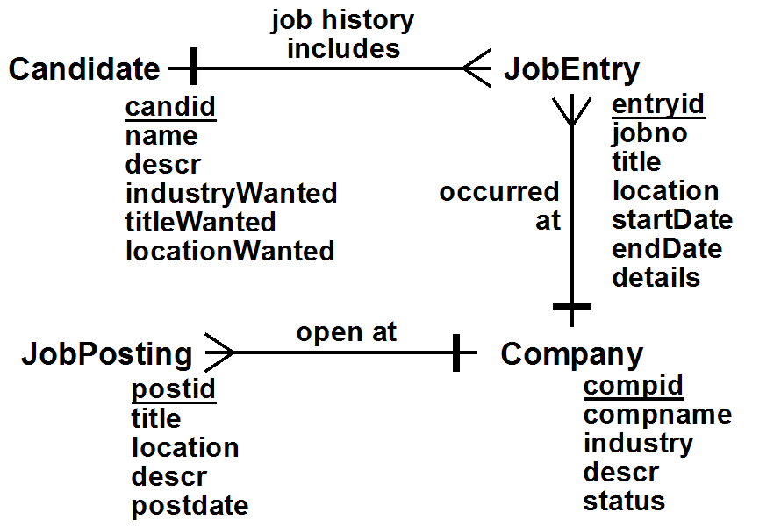

Relationships

JobHistory: (1) Candidate job history includes (*) JobEntry
-- JobHistory is the name of the job history includes relationship
-- between a Candidate and any number (i.e. *) of JobEntries

OccurredAt: (*) JobEntry occurred at (1) Company
-- Note that the relationship description combines the relationship characterization
-- and the names of the related entity classes,
-- putting (*) in front of the entity class associated with a crow's foot.

OpenPostings: (*) JobPosting open at (1) Company

User Role Diagram

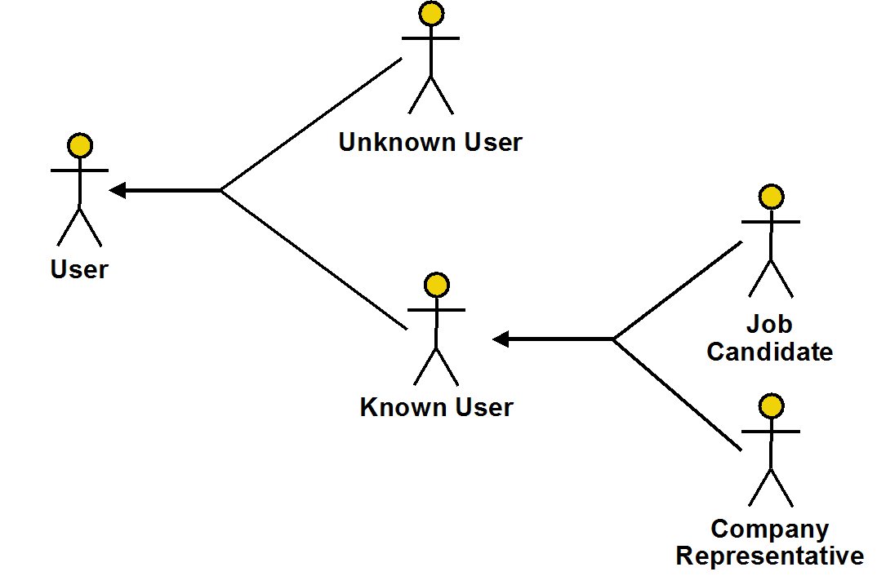

User Operations (Online Job Board Application)

UnknownUser
Actions [Note: Passwords are not kept in the database]
Login( :userid, :pwd ): Logs in user with specified :userid and :pwd
RegisterCandidate( :userid, :pwd, :name, :descr ):
Registers a candidate
RegisterCompany( :compname, :pwd, :industry, :descr, :status ): Registers a new company (automatically creates a new compid for the company). Status is INFO, ACTIVE, or PREMIUM
ActivateCompany( :compid, :pwd, :status ): Activates an INFO-only company at the specified status (ACTIVE or PREMIUM)

Known User
Queries
ShowCompanyInfo( :compid ): Shows information about the indicated company
ShowCompaniesWithPostings( :industry, :title, :location ): Shows companies that have jobs posted with the specified industry, title & location. A NULL value for an attribute means ANY.
ShowPostings( :compid, :title, :location ): Shows jobs posted with the specified title & location. A NULL value for an attribute means ANY.
GetPosting( :postid ): Shows details of the specified posting
Actions
Logout: Logs out the current user
SetPwd( :oldpwd, :newpwd, :repeatnewpwd ):
Changes the current user's password

Job Candidate
Queries
GetPersonalInfo: Gets personal info for the current candidate user
GetJobDesired: Gets information about the job wanted by the current candidate user
GetJobHistory: Gets a summary of the list of previous jobs of the current candidate user
GetJobEntry( :jobno ): Gets the details of the specified job history entry for the current user
ShowMatchingCompanies: Shows companies that have jobs posted that match what the current candidate user wants
ShowMatchingPostings( :compid ): Show postings by a specific company that match what the current candidate user wants, or by any company if :compid is NULL.
Actions
RemoveMeAsCandidate: Unregisters the current candidate user
UpdatePersonalInfo( :name, :descr ):
Provides new personal information for the current candidate user
UpdateJobDesired( :industryWanted, :titleWanted, :locationWanted ):
Provides new details of the job wanted by the current candidate user
AddJobEntry( :compid, :title, :location, :startDate, :endDate, :details ):
Adds a new job entry for the current candidate user
UpdateJobEntry(
:jobno, :compid, :title, :location, :startDate, :endDate, :details ):
Updates the jobno'th entry of the current candidate user
DeleteJobEntry( :jobno ): Deletes the jobno'th entry of the current user
AddCompany( :compname, :industry, :descr ):
Adds info about a company not currently in the database, automatically creating a new id for the company

Company Representative
Queries
GetCompanyInfo:
Gets information, including status, about the current representative user's company
GetPostings: Gets the list of postings made by the current representative user's company
ShowCandidates( :titleWanted, :locationWanted ): Shows a list of candidates who want to work in the industry of the current representative user's company, with the specified title and location. NULL means any
ShowJobCandidates( :postid ): Shows a list of candidates who match the specified job posted (which must be a job posted for the current representative user's company)
ShowMatchingCandidates: Shows a list of candidates who want to work in the industry of the current representative user's company, with a title and location that match any job my company has posted.
ShowCandidateInfo( :candid ): Shows information about the specified candidate
ShowJobHistory( :candid ): Gets a summary of the list of previous jobs of the specified candidate
ShowJobEntry( :entryid ): Shows the details of a particular job history entry
Actions
UpdateCompanyInfo( :industry, :descr, :status ):
Changes information about the current representative user's company
AddJobPosting( :title, :location, :descr ): Adds a new job posting for the current representative user's company. Automatically sets postid and postdate.
UpdateJobPosting( :postid, :title, :location, :descr ): Updates the specified posting and resets postdate
DeleteJobPosting( :postid ): Deletes the specified posting

(Note: Get is used to mean that the information shown will be updatable by the user;
Show is used to mean that it will not be)

Operations with Pre-Conditions (incomplete)

Note: Some pre-conditions are marked as [ROLE]. These are implied by the assignment of the operation to a role.

Login( :userid, :pwd )
- [ROLE] There must not be a user currently logged in
- There must be a user registered with the specified :userid and :passwd

Logout
- [ROLE] There must be a user logged in

RemoveMeAsCandidate
- [ROLE] The current user must be a JobCandidate

AddJobEntry( :compid, :title, :location, :startDate, :endDate, :details )
- [ROLE] The current user must be a JobCandidate
- :enddate must be after :startdate
- :compid must be the id of a company in the database

UpdateJobEntry( :jobno, :compid, :title, :location, :startDate, :endDate, :details )
- [ROLE] The current user must be a JobCandidate
- The current user must have a jobno'th job entry
- :enddate must be after :startdate
- :compid must be the id of a company in the database

UpdateJobPosting( :postid, :title, :location, :descr )
- [ROLE] The current user must be a CompanyRepresentative
- :postid must identify a posting by the current company

GetPostings
- [ROLE] The current user role must be CompanyRepresentative

GetJobPosting( :postid )
- [ROLE] There must be a user logged in

ShowJobCandidates( :postid
- [ROLE] The current user role must be CompanyRepresentative
- :postid must be a job posted by the current company

Actions with Interesting State-Related Post-Conditions (incomplete)

RemoveMeAsCandidate
- All Job Entries for the current user are removed

AddJobEntry( :compid, :title, :location, :startDate, :endDate, :details)
- The entyid of the newly created job entry is one larger than the previous created JobEntry
- The jobno's of all the JobEntrys for the associated candidate or (re)set to go in sequence starting at one, so they are ordered by startdate

UpdateJobEntry( :jobno, :compid, :title, :location, :startDate, :endDate, :details )
- The jobno's of all the JobEntrys for the associated candidate or (re)set to go in sequence starting at one, so they are ordered by startdate

UpdateJobPosting( :postid, :title, :location, :descr )
- Resets the postdate of the posting to be the current date

Queries with Interesting Output-Related Post-Conditions (incomplete)

ShowJobCandidates( :postid ):
- If the current company's status is not PREMIUM, only shows 10 candidates

