CS579 Fall 2009

Class #1 Homework Solution

Hardcopy only (no e-mail) due at start of Class #2
Homework must be typed UNLESS your handwriting is extremely readable!
Late homework (received in e-mail by 7am the following morning) will be penalized one partial grade (e.g. from A- to B+). Late homework received within 48 hrs after class ends will be penalized two partial grades (e.g. from A- to B). Homework received up to 5 days late will be penalized one full grade (e.g. from A- to B-). Homework will not be accepted more than 5 days late, or if a solution to the homework has already been posted.

Logistics

Join the yahoo group for this course

Get a BU computer account if you don't have one

Check out the course documents for this course at courseinfo.bu.edu

Install or gain access to Oracle

Reading

Basic Conceptual Modeling [online]

Some Oracle SQL Functions [online]

Bowman (The Practical SQL, 4th Ed)
- Chapter 1 (SQL and Relational Database Management)

DO NOT READ Chapter 2. It uses a different design methodology than the one we will be using in this course.
- Chapter 4 (Selecting Data from the Database)
- Chapter 5 (Sorting Data), pages 143-154 ONLY
- Chapter 3 (Creating and Filling a Database), pages 51-67 & 83-94 ONLY

Connolly & Begg
- Chapter 1 Introduction to Databases
- Chapter 2 Database Environment
- Section 5.1 - 5.3.2 SQL (Intro)
- Section 5.3.10 SQL (Insert/Update/Delete)
- Section 11.1-11.3 ER Modeling (Intro)
- Section 13.1 - 13.3 Normalization (Normalization & Anomalies)

Oracle Database 10g
- [As Needed] Chapter 2 Installing Oracle 10g
- [As Needed] Chapter 3 Upgrading to Oracle 10g
- Section 5 Basic SQL, pp 74-91 (Intro)
- [Optional] Chapter 7 Textual Data & Functions
- [Optional] Chapter 9 Numeric Data & Functions, pp 164-175
- [Optional] Chapter 10, Dates & Date Functions
- [Optional] Chapter 11 Conversion & Transformation Functions
- Chapter 16 Decode and Case

Online material is available from courseinfo. The material needed for this week is also available from the yahoo group for the class.

Lab Exercise Set #1 (complete before class #2)

Available online. Execute the SQL operations in the exercises (use cut & paste).

Do NOT hand in the output.

It is essential you do this lab exercise!

It tells you how to install and setup Oracle and SQL*Plus.

It also creates tables (Depts, Emps & Projects) and inserts tuples into them which are needed in future homeworks and lab exercises.

Problems

IMPORTANT: You may do problems 1-3 on your own (preferable) or with a partner.
I expect you to do problem 4 together with a partner.

About working with a partner or team:

- Please staple together (no paper clips please, they detach way too easily) the problems you did alone.
- If you do a problem together with a partner or team, then separately staple together the problems you did together. Only hand in ONE COPY of that problem with all of your names on it.

- Working with a partner or a team means working together on the entire problem. If you just start working together, but then actually work out the details on your own, hand in your own solution. If you personally did very little work on a problem, but your name is on it when it is handed in, then you are involved in plagiarism -- taking credit for work that is not yours. All forms of plagiarism are a serious university offense, and I'm required to report them to the Student Academic Conduct Review Board, so please let’s not go there.
- If you are working with partners, and there's a significant imbalance in the quantity or quality of a partner's work, it’s essential you talk to me. Otherwise, it will almost certainly be the case that the underperforming partner will end up doing badly in the exams, and will either be forced to drop the course or will end up with a low grade. If you let me know there's a problem, I can make sure that students get additional help if they need it, or work with a different partner or team.

If you have ANY questions, post them on the newsgroup. Answering questions posted to the newsgroup can positively impact your grade.

1. EXERCISE QUIZ [15%]

Answer the following questions about Lab Exercise Set #1. Treat this like a quiz. Keep your answers brief. The answer to (a) is already provided. Limit the time you spend on this! HAND THIS IN.

a) Executing the statement below gives an error. Explain why.

select sal, 2*sal as twosal, 2*twosal as foursal from Emps;

Because the select clause can only use attributes defined in the table(s) named in the FROM clause, not expressions previously named in the select clause itself.
Other databases loosen this restriction; for example, this query would be perfectly fine in SQL Server.

Something clever that will work in Oracle is

define twosal = 2*sal
select sal, &twosal as twosal, 2*&twosal as foursal from emps;

b) Separately explain (in plain English) what each of the following statements do. Please DO NOT just rephrase the query in English, but explain its intent in a way that it would be understood by someone who doesn't know anything about databases! The answer to the first one is provided and gives you an idea of the kind of answer desired.

(1) select ename, deptno, sal from Emps
where (sal > 2500) and (deptno <> 10);

It lists the name, dept# and sal of employees who make more than 2500 and who are not in department #10

(2) select ename, length(ename) as len from Emps
order by len;

It lists employee names ordered by their lengths, in ascending order (and shows the lengths as well)

(3) select ename, hiredate from Emps
where hiredate between '02-apr-83' and '01-jan-86';

It lists the name and hiredate of employees hired between 02-apr-83 and
01-jan-86

(4) select ename from Emps where ename like '%A%';

It lists the names of all employees who have a capital 'A' in their name. Note that case matters inside strings in SQL statements and within the database. In particular, employees whose names only have a lower case 'a' will not be selected.

(5) select ename, deptno from Emps where deptno not in (20, 30);

Its lists the name and department number of employees who are neither in dept 20 or 30.

c) Below are four different queries. Characterize (in plain English) the kinds of tuples returned by each of the four queries. There's also a fifth part, which asks for additional explanation.

(1) select ename, comm from Emps where comm is not null;

Lists the names and commissions of all employees who have a commission

(2) select ename, comm from Emps where comm != 0;
(3) select ename, comm from Emps where not (comm = 0);

Lists the names and commissions of all employees who have a commission, but the commission is not zero,

(4) select ename, comm from Emps where (comm != 0) or (comm is null);

Lists the names and commissions of all employees who do not have a commission of zero.

(5) Explain WHY the queries above work as they do. In particular, generalize beyond these particular queries, and explain how SQL queries treat NULL values, using these particular queries as examples

WHY: Logical expressions select tuples which are DEFINITELY satisfied by the expression. NULL is effectively treated as an "unknown" value, and most expressions which contain a NULL value have a result which is therefore unknown and also NULL. Some exceptions are (comm IS NULL), which returns TRUE if comm is NULL, or an expression which uses the function (e.g. nvl) which explicitly converts NULL to an explicit value.

In particular, in the expression (comm != 0), if the value of comm is NULL, which is treated as unknown, the result must be NULL (unknown) as well -- after all, if comm were actually 0, the result would be FALSE, and if comm were not NULL, the result would be TRUE, so a WHERE clause of (comm != 0) will never select NULL values.

In addition, NOT does not automatically select all complementary tuples. For example, NOT (comm = 0) does not select all tuples which are not selected by
comm = 0. Instead, we it is simply algebraically equivalent to comm != 0 and results in a NULL result for a NULL value of comm.
Here's another way to think about NOT (comm = 0). If comm is NULL (i.e. unknown), then comm = 0 must be NULL, or unknown. But then NOT(comm = 0) applies NOT to an unknown value, which is also unknown, so a row with a comm value of NULL will not be selected.

d) Explain what the following statement does, and why to_char(sal) must be used in the else clause, instead of just sal

select ename, sal,
case when sal < 1500 then 'UNDERPAID'
when sal >= 3000 then 'OVERPAID'
else to_char(sal)
end as salary
from Emps;

Lists the name and salary of each employee along with another column which shows UNDERPAID if the salary is less than 1500, OVERPAID if the salary is 3000 or greater, and otherwise shows the salary itself.

If to_char is not used, then that last column would have to hold both characters (e.g. OVERPAID) and numbers, and these types of data are inconsistent. The to_char function converts the numbers to a character datatype, so that all values in the column have a consistent datatype.

e) Describe (in plain English) how the tables created as a result of the following two statements are similar, and how they differ

create table Depts1 as select deptno, dname from Depts
where deptno != 10;
create table Depts2(foo, baz) as select deptno, dname from Depts
where deptno != 10;

They both contain the same data -- the dept number and name of departments in the Depts table, other than dept 10. However Depts1 has columns named deptno and dname (just as Depts does), while in Depts2 the columns are respectively renamed foo and baz.

f) Consider the following two statements

select * from Emps where sal > 3000;
select * from Emps where sal > &someSal;

Write the SQL*Plus command you would have to initially execute to ensure that the two SELECT statements would produce the same result

define someSal = 3000

2. SQL [25%]

Using the Emps and Projects table you created in exercise #1, write and test SQL that will solve the problems below.

➔ Note that you must use the Emps table, which you created as a result of the lab exercise, not the emp table.

➔ IMPORTANT: Make sure that the actual code that you write is independent of the actual data in the table. That, your code should do the right thing even if there were a different set of employees in the table

➔ REALLY IMPORTANT: Actually spend time looking at the results, comparing then to what’s in the Emps table, and seeing if the results actually do what is asked.

➔ If you are having trouble installing Oracle, contact me, and we will discuss how best to do this homework.

Otherwise, you must hand in the output of a spool file that shows the queries and results (you will learn how to do this in the lab exercises). Make sure that you inspect the results to ensure that the answers are what you would expect.

Handwritten output, or output that simulates the actual spool file, is not acceptable. It's fine if the spool file contains some erroneous attempts. Simply use a pen to (a) indicate which answer is correct, and (b) cross out the SQL and output which is incorrect!

a) List the names and employee numbers of all employees in dept #10 who are directly managed by someone. (Note: Carefully look at the Emps table to understand how the table represents the notion that an employee is managed by another employee)

select ename, empno from Emps
where deptno = 10 and mgr is not null

Note that the following answer is OK, but does assume that employee numbers will never be negative; it’s best to use "mgr is NOT NULL"

select ename, empno from Emps
where deptno = 10 and mgr > 0

Note that the following answer would be incorrect because it is too dependent upon the actual data in the table and relies on unstated assumptions -- it assumes that the only employee in dept 10 that would never be managed by anyone is the President.

select ename, empno from Emps
where deptno = 10 AND job != 'PRESIDENT'

b) List the name, dept number and job of all employees, sorted first by job, and then within job, by salary (highest to lowest).

select ename, deptno, job from Emps
order by job, sal desc

c) List the name, status, and salary (in that order) of every employee, sorted by status, and within status, by name. The status of an employee is OLDTIMER, if the employee was hired before 15-MAR-81, PLUGGER, if hired from 15-MAR-81 through (and including)
15-MAR-87, otherwise NEWBIE. (Hint: Use CASE)

select ename,
case when hiredate < '15-MAR-81' then 'OLDTIMER'
when hiredate <= '15- MAR-87' then 'PLUGGER'
else 'NEWBIE'
end as status,
sal
from Emps
order by status, ename

You could write
WHEN hiredate BETWEEN '15-MAR-81' AND '15-mar-87'
or less elegantly
WHEN hiredate > '15-MAR-81' AND hiredate <= '15-mar-87'
however, a CASE expression only evaluates one arm of the CASE -- the first one where the WHEN clause is true. The fact that we're even evaluating the second clause in the CASE statement means that we've already eliminated those tuples where
hiredate < '15-MAR-81'

This can also be written using unions, which we'll discuss later in the term. However, UNION will be less efficient except in databases with exceptionally good optimizers.

select ename ,'OLDTIMER' AS status, sal FROM Emps
WHERE hiredate < '15- MAR–81'
UNION
select ename, 'PLUGGER' AS status, sal FROM Emps
WHERE hiredate BETWEEN '15-MAR-81' AND '15-mar-87'
UNION
select ename, 'NEWBIE' AS status, sal FROM Emps
WHERE hiredate > '15-MAR-87'
order by status, ename

d) List the name, salary, commission and compensation of all employees who are not analysts. The compensation of an employee is the sum of their salary and commission (if they have a commission), or is just their salary if they don't have a commission. (Hint: Use CASE or the nvl2 or nvl function).

select ename, sal, comm,
CASE WHEN comm IS NULL THEN sal ELSE sal + comm END AS compensation
FROM Emps
where job <> 'ANALYST'

select ename, sal, comm, nvl2( comm, sal + comm, sal ) as compensation
from Emps
where job <> 'ANALYST'

select ename, sal, comm, sal + nvl(comm,0) as compensation from Emps
where job <> 'ANALYST'

select ename, sal, comm, nvl( sal + comm, sal ) as compensation from Emps
where job <> 'ANALYST'

e) Write a single INSERT statement which adds a new project tuple to the Projects table for each analyst in Emps. The project number is 60006 plus the analyst's employee number, the name of the project is 'Analysis by ' followed by the analyst's name, and the project is managed by the analyst. [Remember that your code should be independent of the actual data in the Emps table!]

insert into Projects( pno, pname, pmgr )
select 60006 + empno, 'Analysis by ' || ename, empno
from Emps
where job = 'ANALYST'

Note that in the exercise set, the Projects table is defined so that the persons attribute defaults to 1. If that were not the case, you'd want to instead write.

insert into Projects( pno, pname, pmgr, persons )
select 60006 + empno, 'Analysis by ' || ename, empno, 1
from Emps
where job = 'ANALYST'

f) Write a single UPDATE statement which updates all projects numbered between 60000 and 60999 so they are managed by employee #7788.

UPDATE Projects
SET pmgr = 7788
WHERE pno BETWEEN 60000 AND 60999

If you don't use BETWEEN, the corresponding SQL is

UPDATE Projects
SET pmgr = 7788
WHERE pno >= 60000 AND pno <= 60999

3. ER Design [30%]
Create a preliminary design for an Online Auction Application (see directions below). The requirements for this system are as follows:

Requirements

An Online Auction Application keeps track of items being auctioned off (one item per auction) and the bids on them. Any logged-in user of the system can post items to be auctioned off, specifying the time that the auction closes. Items are organized by category (each item must be placed in a single category). Anyone (logged-in or not) can browse the list of categories, and then browse the list of posted items in a specific category which are still being auctioned off. Once an item has been posted, any logged-in user can bid on it, until the auction is closed. Any logged-in user can get information about the highest bid on an item; the person who posted an item to be auctioned can get a list of all the bids on a posted item, including the identity of the user who made each bid along with the amount and time of the bid.

Directions

Design a Conceptual Model of the database to support this application, and provide the corresponding ER diagram (using Crow Magnum, Easy Crow Magnum, or UML)

- Your ER diagram MUST use Crow Magnum (or Easy Crow Magnum) or UML. The use of other ER modeling languages or tools is not acceptable. I STRONGLY RECOMMEND that you draw ER diagrams by hand. PLEASE DO NOT SPEND EXCESS TIME producing them on-line.
If you feel compelled to use a tool to draw Crow Magnum diagrams, you might consider using PowerPoint [so you can cut and paste symbols from my lecture slides]. If you want to insert the diagram into Word, cut and paste the PowerPoint into IrfanView [available free from download.com], then cut and paste from IrfanView into Word.
- The ER diagram must show the attributes required or implied by the requirements. Make sure your attributes all have simple types; an attribute which holds a complex set of data generally means that you need to rethink your design, adding more entity classes.
- Every entity class must have a primary key attribute, which you must indicate appropriately.
- Do NOT use entity attributes. READ THE NOTE BELOW ABOUT THEM
- Avoid 1:1 Relationships
- Indicate mandatory participation as necessary
- All relationships in the ER diagram must show relationship characterizations. Make sure the relationship characterizations are meaningful (e.g. avoid using "has")
- An entity class or a relationship only should be included in an ER diagram if it represents information that needs to be persistently stored in a database, because it is later needed. In particular, don't include relationships which simply show what a user can do or keep track of what a user has done, unless it is clear that information will be needed later.
About Entity Attributes

Conceptual models DO NOT include entity attributes. These are attributes whose values identify some entity. Relationships must be used instead of entity attributes, and using them both is redundant.

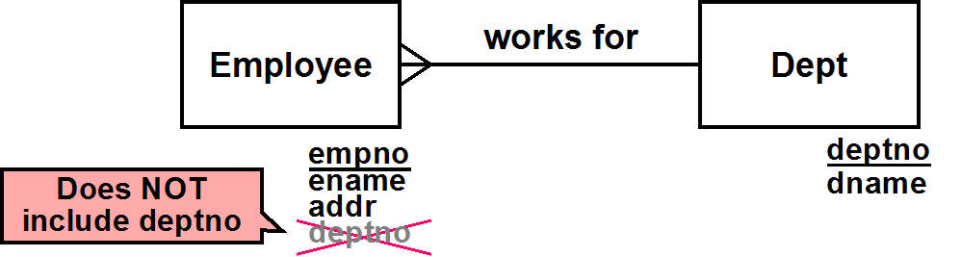

In the diagram above, Employee does not contain an attribute that identifies the Dept it is associated with (i.e. deptno). An employee is certainly associated with a department – but that is represented by the relationship between Employee and Dept.

A deptno attribute in Employee would be an entity attribute (it identifies a Dept entity). This would not only be redundant (with the "works for" relationship), but wrong to include
in a Conceptual Model.

Easy Crow Magnum Diagram
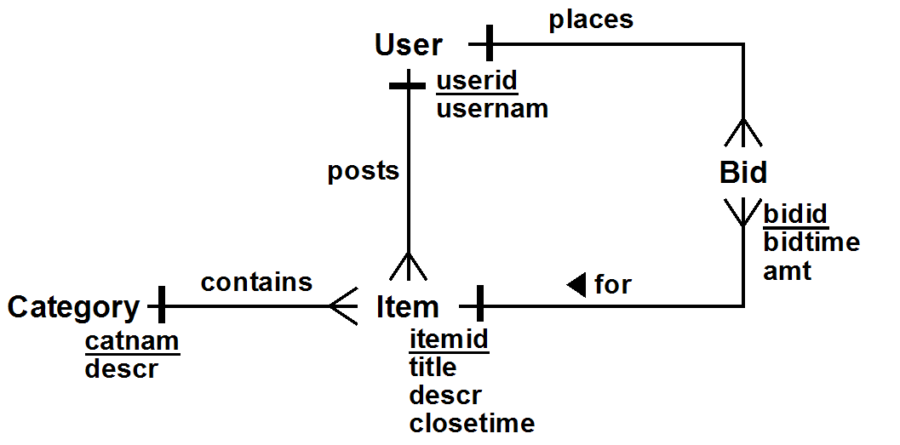

Notes: closetime is the time when the auction closes (i.e. it is never NULL). An auction is closed if closetime is after the current time. bidtime is the time when the users makes the bid (and is also never NULL). User could contain a password field, though I generally prefer to assume that user authentication is handled separately.

Relationships

Categorization: Category contains (*) Item
PostItem: User posts (*) Item
PlaceBid: User places (*) Bid
ItemBids: (*) Bid for Item

The corresponding UML model is

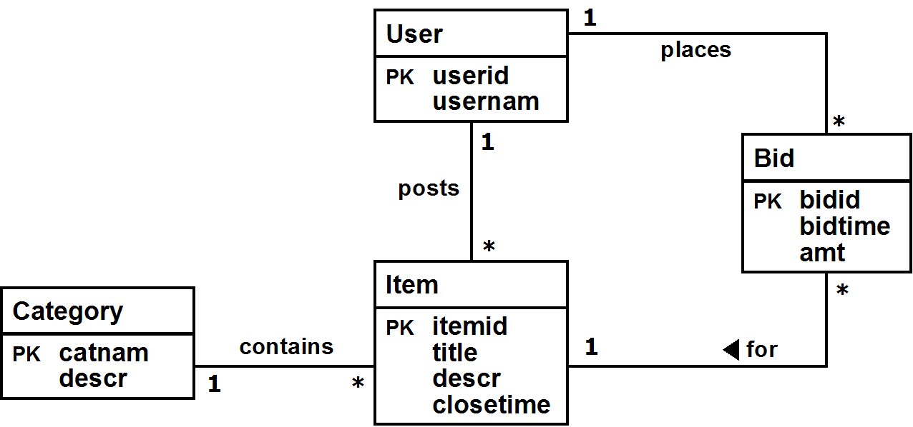

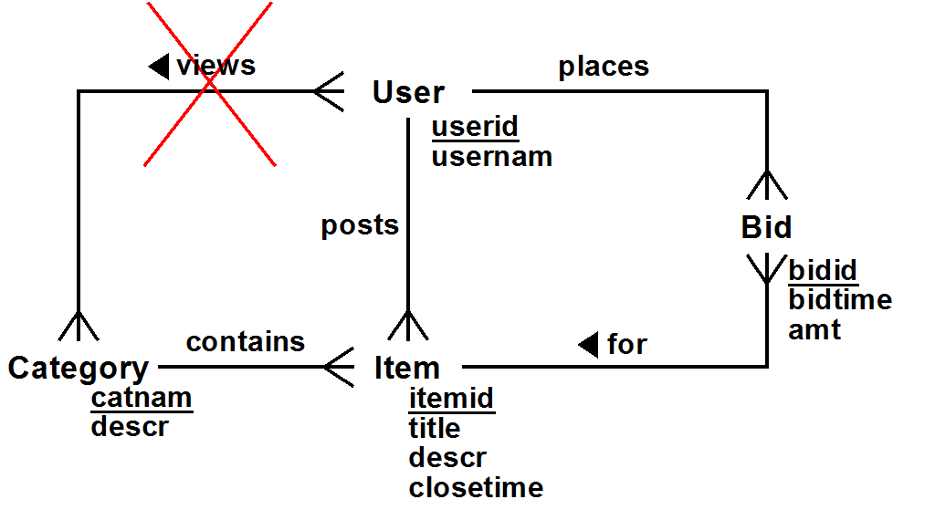
It might be tempting to add an M:N relationship between users and categories as in the diagram below. It certainly is true that users view categories. However, the question is whether information about which user viewed which category needs to be persistently maintained in the database. That is, will it later be necessary to query the database to find out which user viewed which category? If not, then it should not be part of the conceptual model.

A separate entity class could be provided for an Auction, in case the same item is being auctioned off multiples times. That would lead to the ER diagram
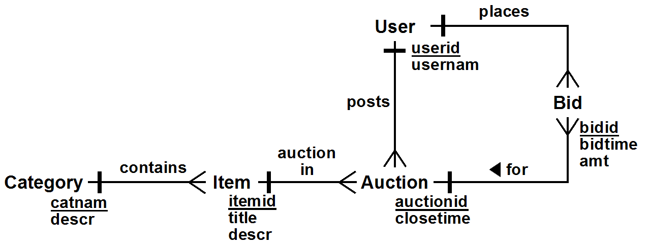

4. Requirements & Database Design [30%]

a) Write requirements for a database application. For an example of reasonable requirements, see those provided above for the Online Auction Application. Write them in clear readable English that can be understood by someone who is not too technical.
b) Draw the corresponding ER diagram. Your ER diagram MUST use Crow Magnum (or Easy Crow Magnum) or UML. The use of other ER modeling languages or tools is not acceptable. It’s fine to draw the ER diagram by hand!

Some additional directions:
- The application requirements and ER diagram must not correspond to anything we have discussed in class or that appears elsewhere in this homework or in your readings.
- The ER diagram must have 4-6 good solid entity classes.

- The ER diagram must show the attributes required or implied by the requirements. Make sure your attributes all have simple types; an attribute which holds a complex set of data generally means that you need to rethink your design, adding more entity classes.
- Every entity class must have a primary key attribute, which is underlined.
- Do NOT use entity attributes. READ THE NOTE ABOVE ABOUT THEM
- ➔ The ER diagram must have at least as many relationships as entity classes -- that is, if it has 4 entity classes, it must have at least 4 (not just 3) relationships, not counting reflexive relationships (like manages)! These must be real and meaningful relationships, and must not be redundant in any way. If you feel that you are "stretching", consider a different design or application.
- All relationships in the ER diagram must be 1:M or M:N, not 1:1.
- Indicate mandatory participation as necessary
- All relationships in the ER diagram must show relationship characterizations. Make the relationship characterizations meaningful (e.g. avoid using "has" or "contains" or "includes")
- An entity class or a relationship only should be included in an ER diagram if it represents information that needs to be persistently stored in a database, because it is later needed. In particular, don't include relationships which simply show what a user can do or keep track of what a user has done, unless it is clear that information will be needed later.

