# **CS 579 Fall 2009**

# **Midterm**

**NAME**: **_Charlie Kim**________________________________________

There are three problems. They each have equal weight.

🡺 Make sure you fill out the **Project Contribution Sheet** on the last page!

**1. Reverse Engineering.** Consider the relational schema below for a database application which keeps track of routes for bus companies.

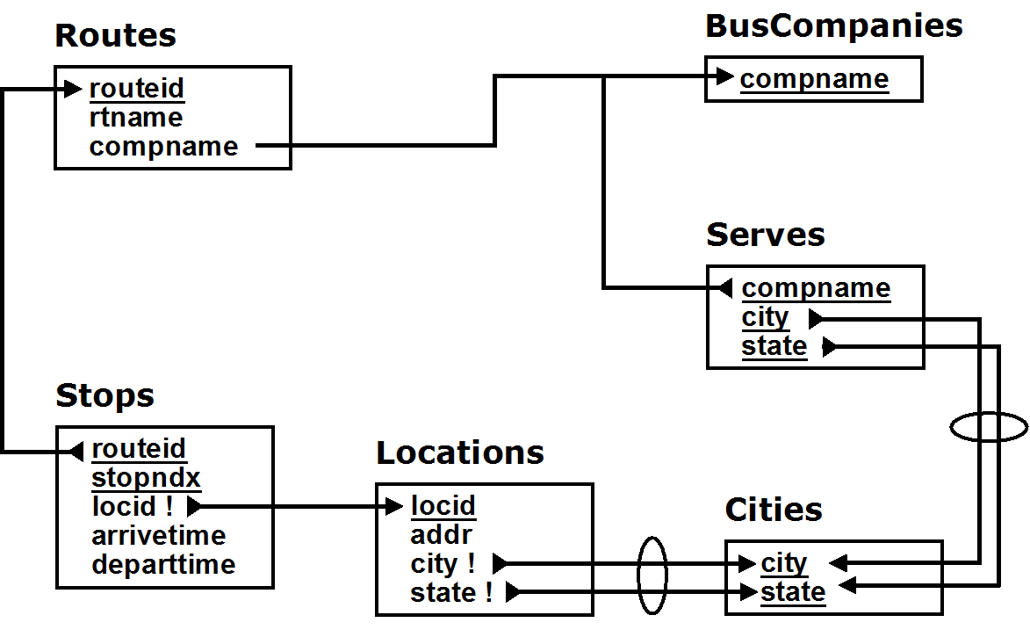

Draw the best corresponding ER diagram, using either UML or (Easy) Crow Magnum

* Show all attributes
* Primary keys and discriminators must be properly identified.
* For each 1:1 or 1:M relationship, carefully consider whether the relationship should be independent, mandatory, dependent, or identifying, and depict it accordingly in your ER diagram.
* Use M:N relationships in preference to bridge entity classes, but only when that is possible

**🡺 For Extra Credit**: Draw the diagram using both UML and (Easy) Crow Magnum.

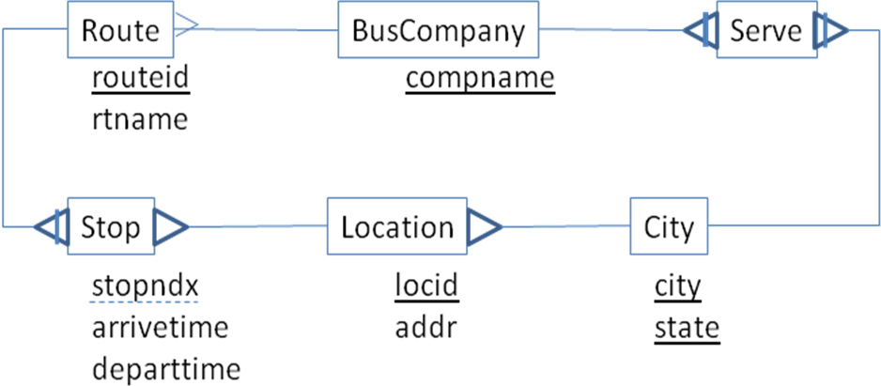

**2. SQL.** Use the relational schema from the previous problem …

a) Create a view NumStops that provides a count off the number of stops in each route. The resulting view must have two columns

1. routeid – the id of the route

2. nstops – the number of stops in that route

**CREATE VIEW NumStops AS**

**SELECT r.routeid,**

**(SELECT count(*) FROM Stops WHERE routeid =r.routeid ) AS nstops**

**FROM Routes r ;**

b) Suppose you want to create a view RoutesToTampa that lists the route ids of all routes which end (i.e. whose last stop) is in Tampa FL. Implement this using joins and no subqueries (Hint, this will be easier to do, and will get more credit, if you use the view NumStops, which you defined above. Keep in mind that in the Stops table, the j'th stop for a route has a stopndx value of j)

b1] Show the Join Diagram (consider treating NumStops as if it were a table)

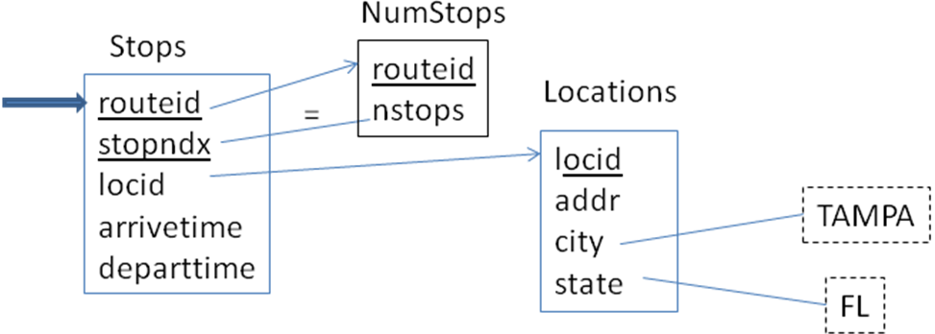

b2] Write the SQL, using joins, and no subqueries

**CREATE VIEW RoutesToTampa AS**

**SELECT routeid**

**FROM ( Stops NATURAL JOIN NumStops ) NATURAL JOIN Locations**

**WHERE city = ‘TAMPA’ AND state = ‘FL’ AND stopndx = nstops ;**

c) Write the SQL for RoutesToTampa using at least one subquery (but DO NOT use inline, factored or defined views – ASK if you do not understand the difference). Extra credit if you do not use any joins at all.

**CREATE VIEW RoutesToTampa AS**

**SELECT s.routeid**

**FROM Stops s**

**WHERE stopndx = (SELECT count(*) FROM Stops WHERE routeid = s.routeid) AND locid = ( SELECT locid FROM Locations WEHRE city = ‘TAMPA’ AND state = ‘FL’ );**

**3. Conceptual Design**

Consider a database that keeps track of the following information

A wholesale grocer assigns salesmen to stores, which they visit with a specified frequency. A store orders products from the wholesale grocer through a salesman. For each order, the database keeps track of the salesman, the date of the order, the items purchased, and for each item, the quantity and price agreed on.

Draw an ER diagram, using either (Easy) Crow Magnum or UML, of the database that manages this information, using at least the entity classes: **Store, Salesman,** and **Product**. You may add other entity classes, but only if they are required to satisfy the requirements; don't add extraneous classes. In addition:

* You must show all relationship characterizations
* You must show *all* attributes on the diagram
* Properly identify all primary keys and discriminators
* For each 1:M relationship, appropriately indicate if it is an independent, mandatory, dependent, or identifying relationship.
* For any bridge class, decide what kind of bridge class to use

🡺 Explaining any significant design decisions you made may help your grade.

Suppose that a store MUST make an order through a salesman assigned to the store. **For full credit**, draw the ER diagram so that it inherently enforces this constraint.

**Project Contribution Sheet (Confidential)**

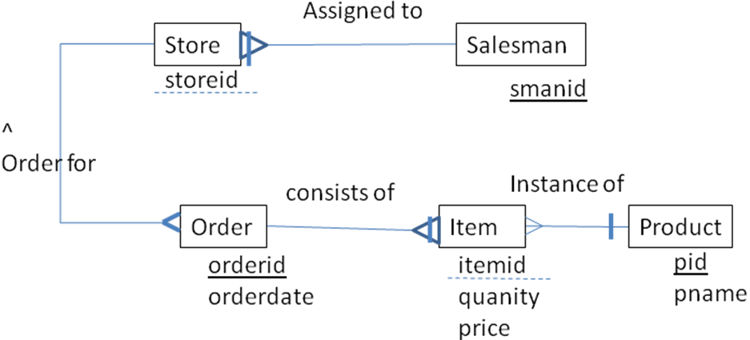

**Project Team Name**: ____________________________________________

|  |  |
| --- | --- |
| Team Members (your name first) | Percent |
| Aaaaaaaaaaaaaaaaaaaaaaaaaaaa |  |
|  |  |
|  |  |

**Instructions**

1) Write your project team name

2) List the names of all the members of your project team (include yourself **FIRST**)

3) Estimate the pct overall contribution of each member of the team (include yourself) to the project since it began

* In considering pct contribution, consider both the quality and the quantity of each member's contribution
* Make sure that the percentages add up to 100%