**Theme: loss of control through passive subordination or aggressive self-righteous**

**Opening:**

* Pre-film intro (influencers have their own intros)
* Curtain opening
* Product placement (via an instagram post)

**Ending:**

* Please like/subscribe, comment/share

**Scene 1:**

*Poll*: What should I clean?

1. Kitchen
2. Fireplace

*Puppets*:

1. Green Cindy, mice, birds
2. Green Cindy, mice, birds

*Action:*

1. Dramatic movement, dancing/swaying while cleaning with mice/birds
2. N/A

*Music:*



**Scene 2:**

*Poll*: Step-mom yelling again

1. Suck it up and mope
2. Take my revenge

*Puppets*:

1. Green Cindy, step mother, mice, birds

*Image*:

[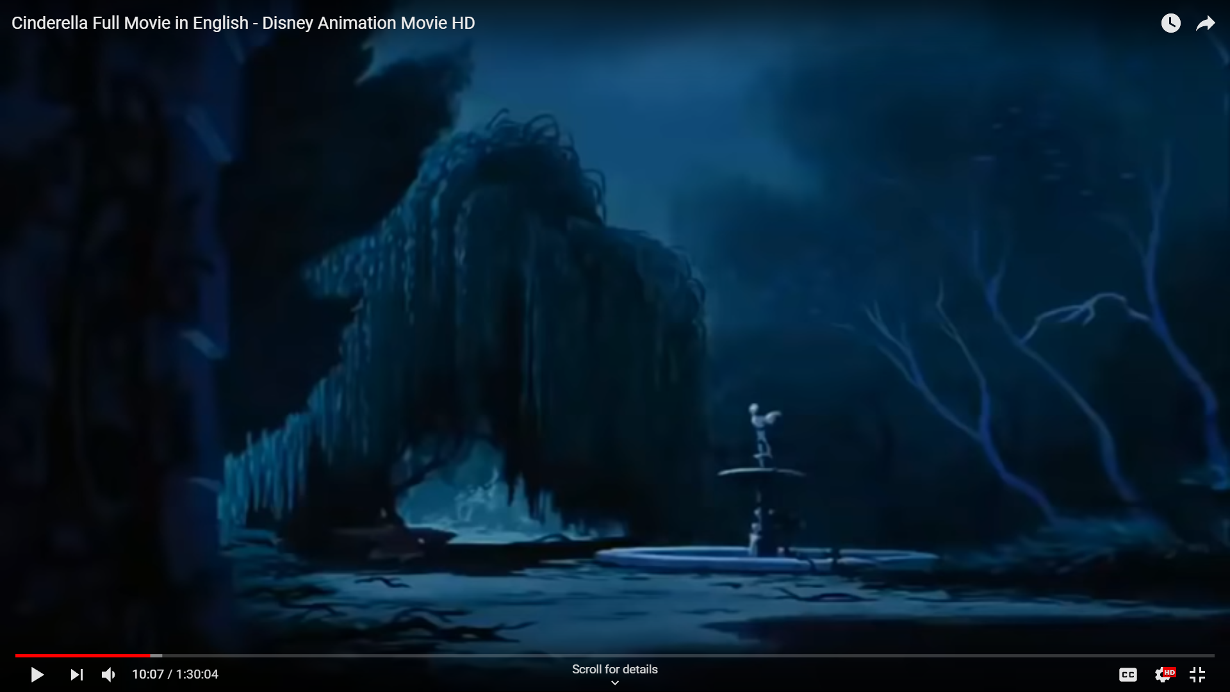](https://youtu.be/rul4vBmVUmM?t=608)

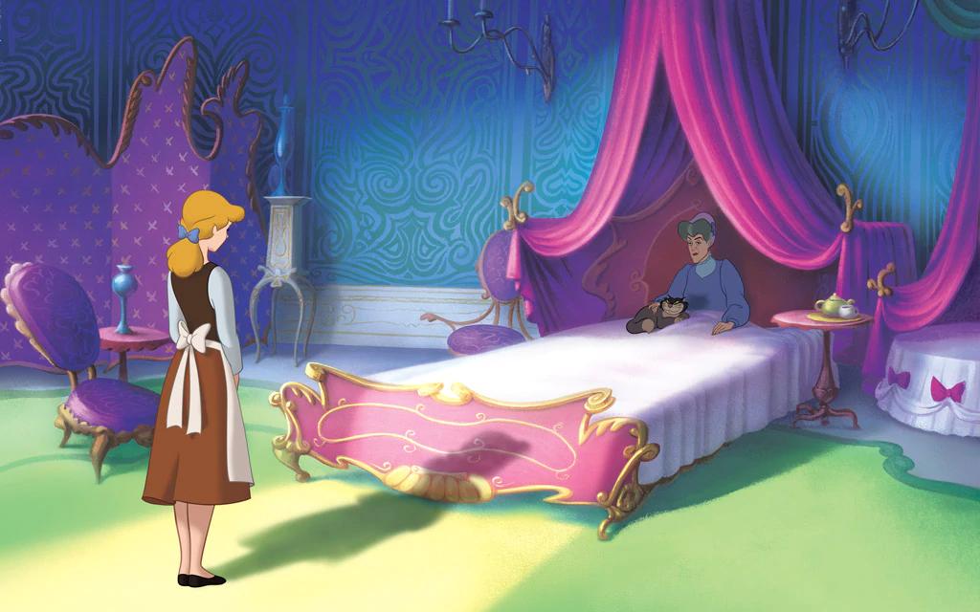

*Action:*

1. Get badgered by the animals to stick up for herself, but she shakes her head no
2. Make the floor slick so the stepmom slips and falls

*Music:*



**Scene 3:**

Make a post on Instagram (8 ways to style your apron; closet organization hacks)

*Puppets*:

1. Green Cindy, phone

*Background*

1. Screenshot or screen recording of the post
2. screenshot/recording of finding a post about the ball

*Action*

1. Take a picture for the post, look at phone to make the post
2. Surprise and excitement when seeing the post about the ball
3. Running around the room,looking at the clothes she could wear, etc.

*Music*

**Scene 3:**

*Poll*: Go to the ball?: 1. Find your prince! or 2. F*ck the Monarchy

*Puppets*:

1. Blue Cindy, prince
2. Green Cindy

*Image*:

[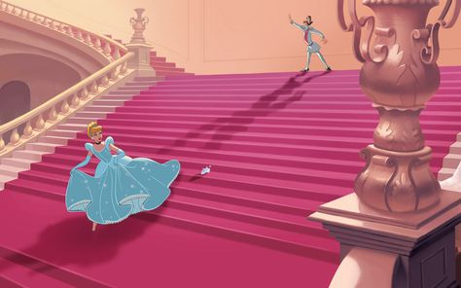](https://www.pinterest.com/pin/457467274624286881)

*Action:*



*Music:*



**Scene 4:**

*Poll*: Step-sisters back at it: 1. REVENGE! or 2. Shun them

*Puppets*:

1. Blue Cindy, sisters, birds
2. Green Cindy, sisters

*Image*:

[](http://bilinick.blogspot.com/2010/07/princess-anastasia-and-drizella.html)

*Action:*



*Music:*