

# Version History

|  |  |  |  |  |
| --- | --- | --- | --- | --- |
| Document Title | Version | Author | Summary | Date |
| Terraform Cloud: Deploy project Workspaces | 1.0 | Robert Tekoh  Cloud Engineer III,  Fredhutch | Initial Draft | April 08, 2024 |
|  |  |  |  |  |

**Terraform Cloud: Deploy project Workspaces.**

**Objective:** This SOP outlines the process for deploying workspaces in Terraform Cloud using the provided configuration files (**terraform.tfvars**, **output.tf**, **variable.tf**, and **main.tf**) downloaded from a specified wiki page.

**Prerequisites:**

1. Access to Terraform Cloud.
2. Permissions to create and configure workspaces within Terraform Cloud projects.
3. Access to the GitLab repository (**gitlab.fhcrc.org/**).
4. Familiarity with Terraform configuration files (**terraform.tfvars**, **output.tf**, **variable.tf**, and **main.tf**).
5. Understanding of Version Control System (VCS) integration with Terraform Cloud.

**Procedure:**

1. **Download Configuration Files:**
   * Download the provided configuration files (**terraform.tfvars**, **output.tf**, **variable.tf**, and **main.tf**) from the link below to your local machine.

<https://wiki.fhcrc.org/download/attachments/691044805/Workspace.zip?api=v2>

* + Unzip, Copy and create these files in your project/workspace directory in your repository.

1. **Upload Files to Project Repository:**
   * Navigate to your project repository in your preferred Version Control System (e.g., GitLab).
   * Upload the downloaded configuration files to your project repository.
2. **Configure Workspace:**
   * Log in to Terraform Cloud.
   * Navigate to your desired organization and project where you want to deploy the workspace.
   * Create a new workspace or select an existing one where you want to deploy the configuration. Within each project, there is a config workspace. Use this workspace to manage the deployment of new workspaces within your organization. For example, **SysEng** will use the ***syseng_project_config_ws*** as seen in the screenshot below.

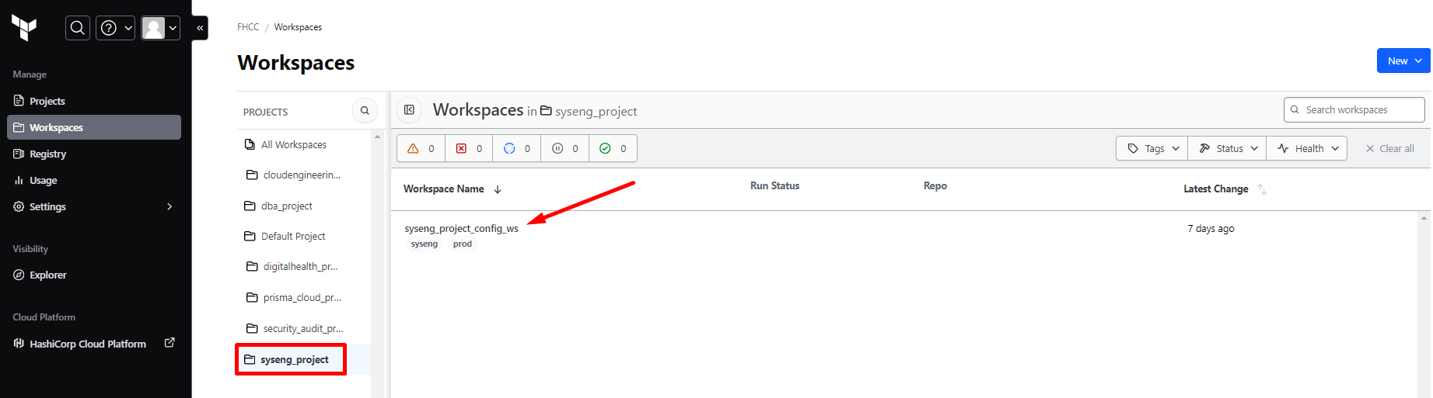

* + Configure the workspace to use the uploaded configuration files from your project repository:
    - Navigate to the workspace settings.
    - Under "**Version Control**", select your Version Control System (e.g., GitLab).

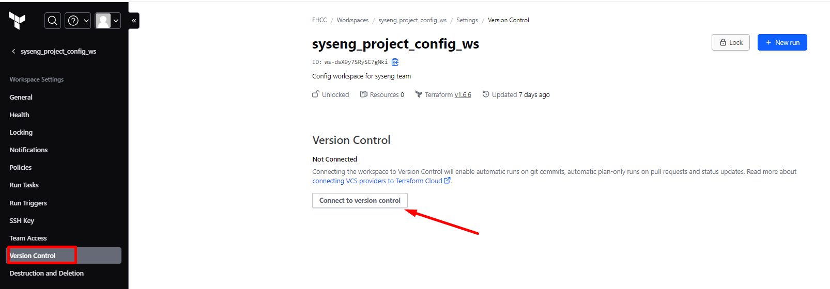

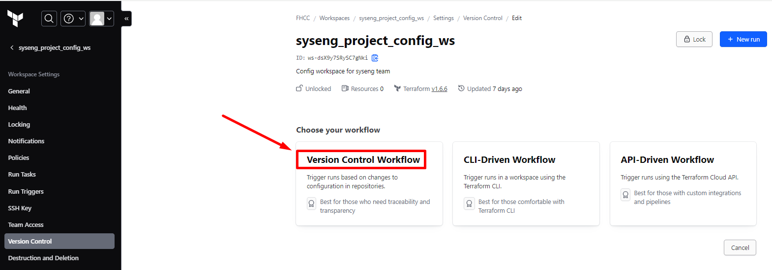

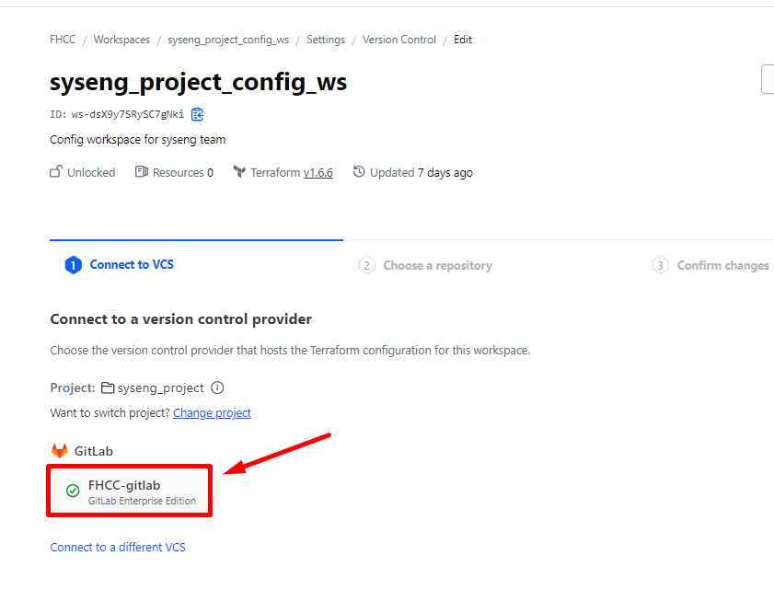

Select your teams’ projects Repository.

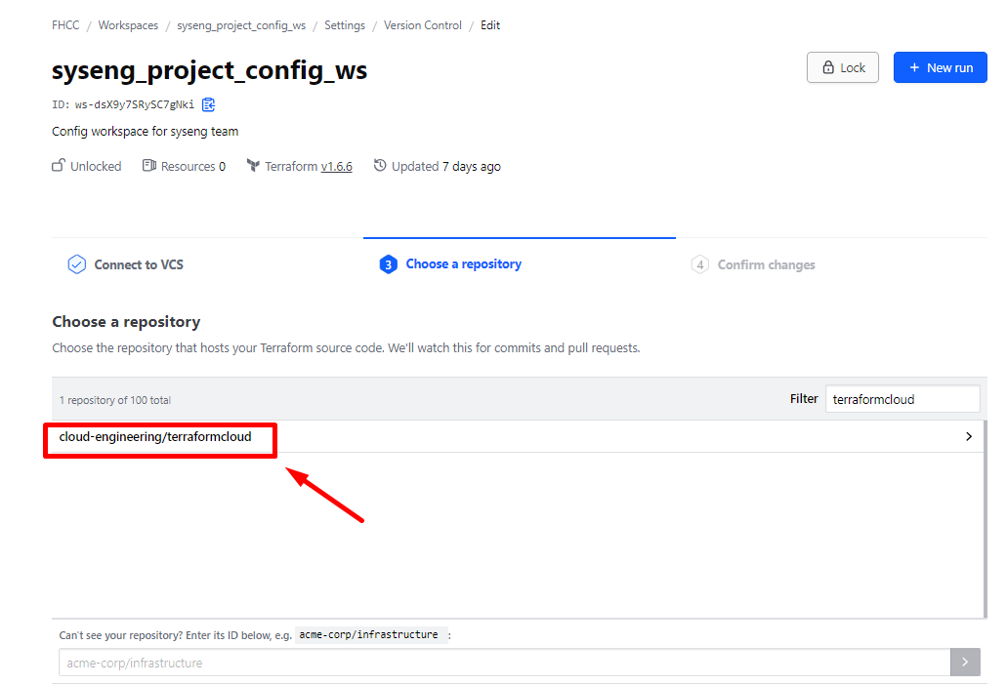

* + - Provide the repository URL (**gitlab.tek.org/cloud/terraformcloud**) and credentials if required.
    - Specify the working Directory and branch or tag containing the configuration files.

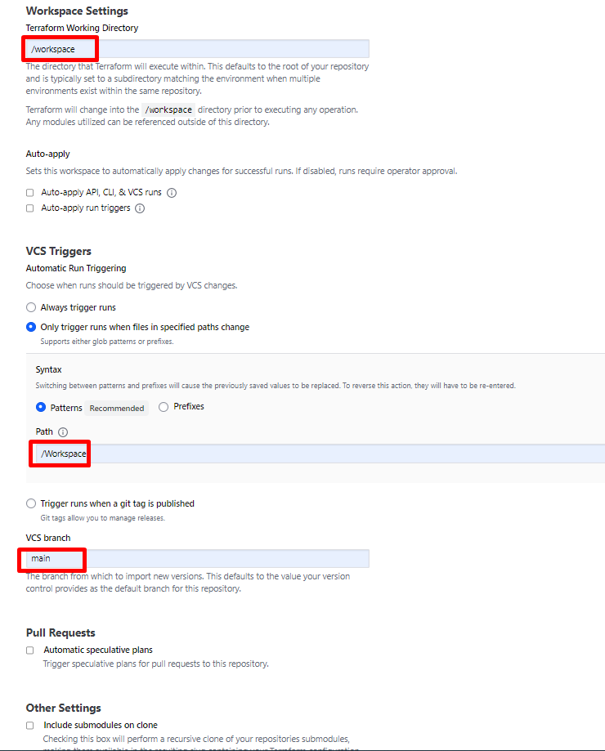

* + - Save the configuration.



1. **Run Terraform Initialization:**
   * After configuring the workspace, Terraform Cloud will automatically detect changes in the VCS repository.
   * Terraform Cloud will initiate a Terraform plan based on the configuration files.

If you choose not to run speculative plan in the step above, then navigate to Workspace overview page and select “**Run**s”. Then click on “**New run**” to run a new plan.

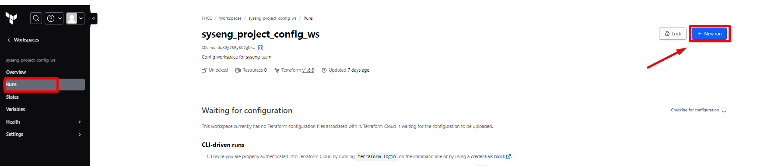

* + Review the plan to ensure it matches your expectations.
  + If satisfied, apply the plan to deploy the infrastructure defined in the configuration files.

1. **Monitor Workspace Deployment:**
   * Monitor the workspace deployment status in Terraform Cloud.
   * Check for any errors or warnings during the deployment process.
   * Address any issues that arise during deployment.
2. **Verify Deployment:**
   * Once the deployment is complete, verify that the infrastructure is provisioned according to the defined configuration.
   * Test the deployed infrastructure to ensure it meets the desired requirements.
3. **Maintenance and Updates:**
   * Regularly review and update the configuration files as needed.
   * Monitor and manage the workspace for ongoing infrastructure changes and updates.

**Note:** Ensure proper access controls and permissions are in place for managing workspaces and accessing configuration files in the VCS repository. Regularly review and update access permissions as necessary to maintain security and compliance standards.

**Conclusion:** By following this SOP, teams can effectively deploy workspaces in Terraform Cloud using the provided configuration files from the specified GitLab repository. This standardized process ensures consistency and reliability in managing infrastructure deployments within Terraform Cloud projects.