Ryan Telesca, Andrew Castle, Jake Flancer 10/27/20

Professor Gallier CIS 515

Project 3 Report

1. n/a
2. First observing both u and w through the drawplfn function, we can see that w is simply a higher frequency wave of u, that is with a frequency of 8x (1/8 the wavelength) of u. Once we use the haar transform function and plot the coefficients of u and w, we can see that before the value of 0.25, both graphs are identical. Between the values of 0.25 and 0.5, w is simply a repetition of the pattern of u within this range. That is, the values of the haar of u are repeated 8 times in the haar of w within this range. This exact phenomenon is seen respectively in the range of the haar values of w between 0.5 and 1.0 as well, where the values are simply the values of the haar of u repeated 8 times.

haar(u)

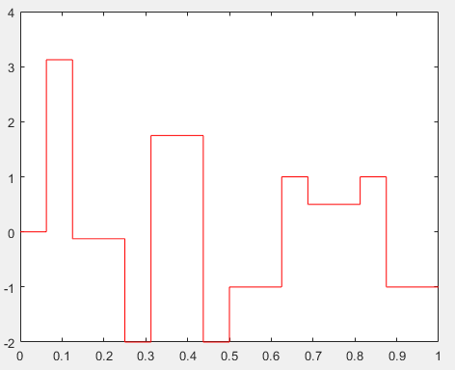

haar(w)

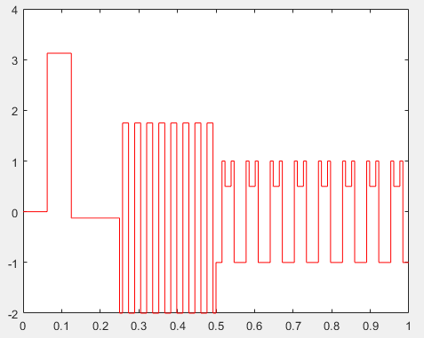

1. When we finally step from 3 rounds of coefficient transformation to 4 round of transformation, the values of the coefficients seem to become bounded by -1 and 1. The values also seem to mimic random noise (despite this obviously not being the case), no longer representing the original graph or values anymore. The extrema (absolute values of the highest magnitude points) also seem to get halved in each subsequent step, with the exception of step 5 to step 6.

haar_step(w, 3)

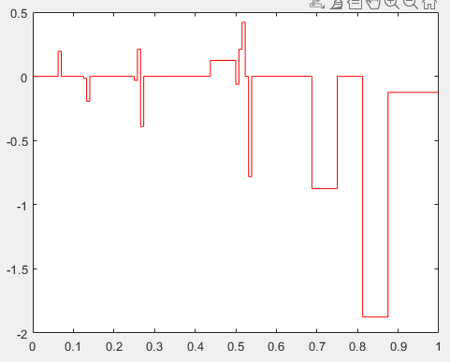

haar_step(w, 4)

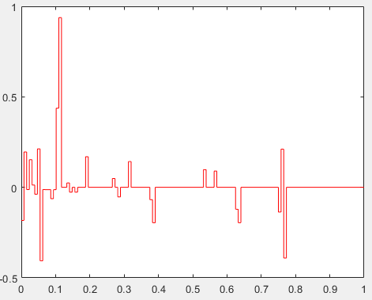

haar_step(w, 5)

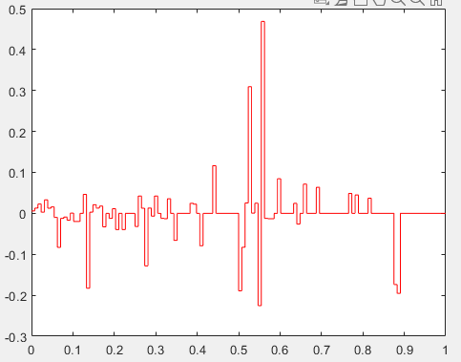

haar_step(w, 6)

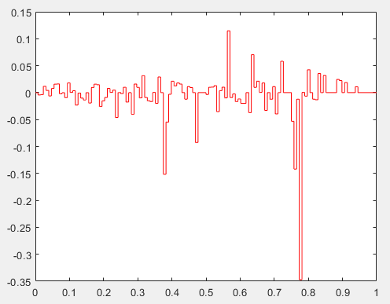

haar_step(w, 7)

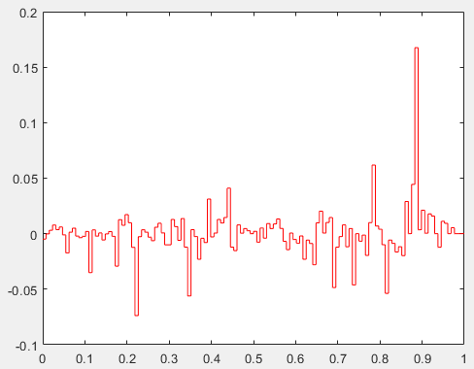

1. n/a