Mobi Agent Feature
UML Design & Architecture Documentation
Software Engineering Reference

This document provides UML diagrams for the Mobi Agent feature, designed to guide software engineers through its implementation from start to finish. It covers use cases, class definitions, sequence flows, state transitions, component architecture, and database schema.

1. Use Case Diagram
The Use Case diagram illustrates the interactions between the Mobi Agent (user) and the system's core functionalities, including potential external integrations.

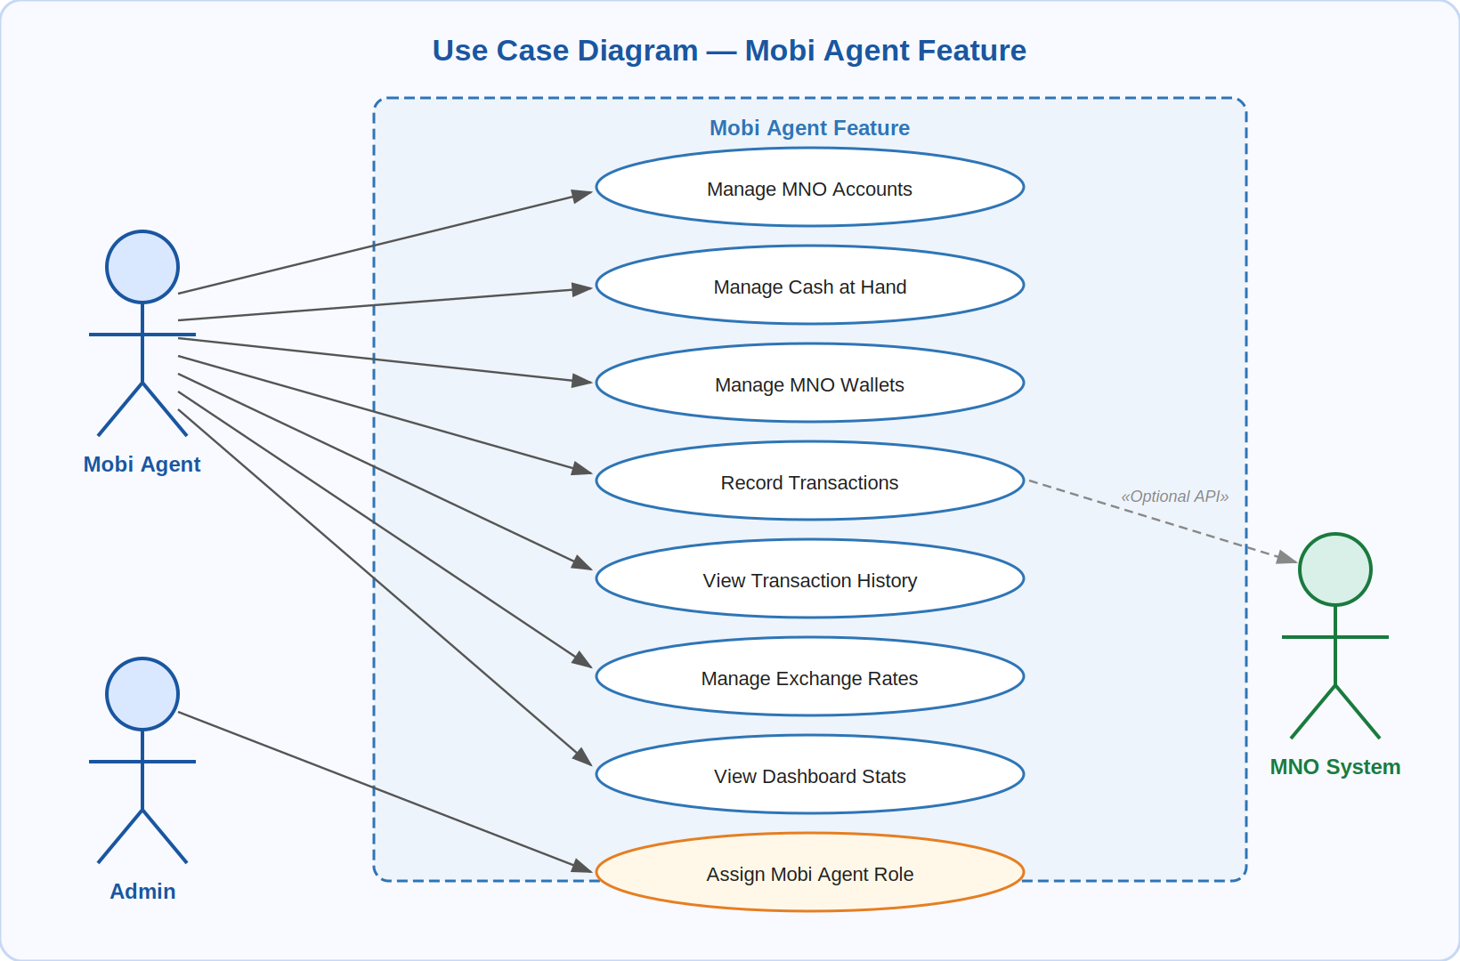
Figure: Use Case Diagram — Mobi Agent Feature

Actors
Actor | Description
Mobi Agent | Primary user who manages accounts, wallets, transactions, and rates
Admin | Assigns the Mobi Agent role to users
MNO System | External Mobile Network Operator system for optional API integration

Use Cases
Use Case | Actor | Notes
Manage MNO Accounts | Mobi Agent
Manage Cash at Hand | Mobi Agent
Manage MNO Wallets | Mobi Agent
Record Transactions | Mobi Agent | Optional MNO API integration
View Transaction History | Mobi Agent
Manage Exchange Rates | Mobi Agent
View Dashboard Stats | Mobi Agent
Assign Mobi Agent Role | Admin

2. Class Diagram
The Class diagram defines the data structures, their properties, and relationships between all entities in the Mobi Agent feature.

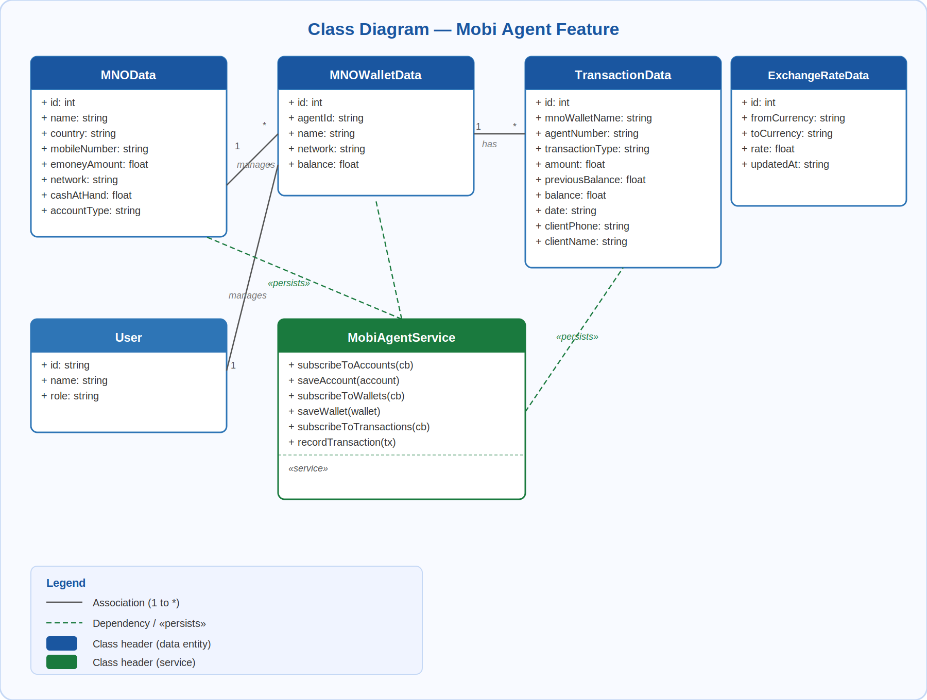
Figure: Class Diagram — Mobi Agent Feature

MNOData
MNOData
+ id: int
+ name: string
+ country: string
+ mobileNumber: string
+ emoneyAmount: float
+ network: string
+ cashAtHand: float
+ accountType: string

MNOWalletData
MNOWalletData
+ id: int
+ agentId: string
+ name: string
+ network: string
+ balance: float

TransactionData
TransactionData
+ id: int
+ mnoWalletName: string
+ agentNumber: string
+ transactionType: string
+ amount: float
+ previousBalance: float
+ balance: float
+ date: string
+ clientPhone: string
+ clientName: string

ExchangeRateData
ExchangeRateData
+ id: int
+ fromCurrency: string
+ toCurrency: string
+ rate: float
+ updatedAt: string

User
User
+ id: string
+ name: string
+ role: string

MobiAgentService
MobiAgentService
+ subscribeToAccounts(callback)
+ saveAccount(account)
+ subscribeToWallets(callback)
+ saveWallet(wallet)
+ subscribeToTransactions(callback)
+ recordTransaction(transaction)

Relationships
User "1" ──── "*" MNOData (manages)
User "1" ──── "*" MNOWalletData (manages)
MNOWalletData "1" ──── "*" TransactionData (has)
MobiAgentService ···> MNOData (persists)
MobiAgentService ···> MNOWalletData (persists)
MobiAgentService ···> TransactionData (persists)

3. Sequence Diagram: Recording a Transaction
This diagram shows the end-to-end process of recording a transaction, including state updates and persistence.

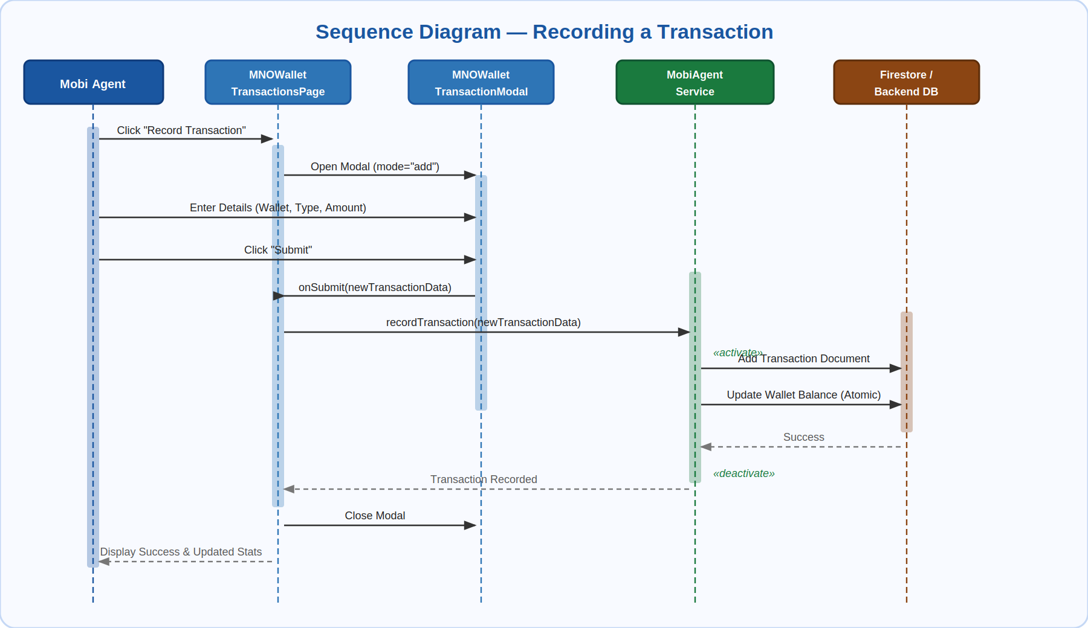
Figure: Sequence Diagram — Recording a Transaction

Participants
Participant | Description
Mobi Agent (User) | The human actor interacting with the interface
MNOWalletTransactionsPage | Main transactions UI page component
MNOWalletTransactionModal | Modal dialog for entering transaction details
MobiAgentService | Business logic and data service layer
Firestore / Backend | Database persistence layer

Interaction Flow
Mobi Agent ──>> UI : Click "Record Transaction"
UI ──>> Modal : Open Modal (mode="add")
Mobi Agent ──>> Modal : Enter Details (Wallet, Type, Amount)
Mobi Agent ──>> Modal : Click "Submit"
Modal ──>> UI : onSubmit(newTransactionData)
UI ──>> Service : recordTransaction(newTransactionData)
[activate Service]
Service ──>> DB : Add Transaction Document
Service ──>> DB : Update Wallet Balance (Atomic)
DB -->> Service : Success
[deactivate Service]
Service -->> UI : Transaction Recorded
UI ──>> Modal : Close Modal
UI ──>> Agent : Display Success & Updated Stats

4. State Machine Diagram: Transaction Lifecycle
This diagram illustrates the possible states of a transaction from initiation to completion.

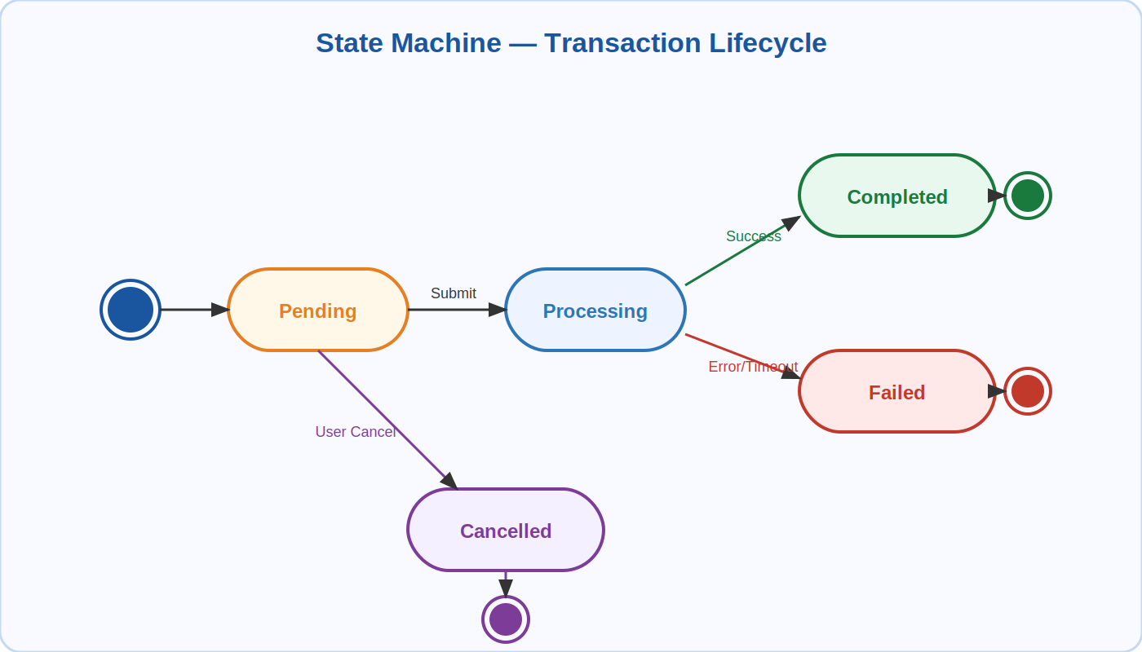
Figure: State Machine — Transaction Lifecycle

State Transitions
From State | Trigger / Event | To State
[Initial] | — | Pending
Pending | Submit Transaction | Processing
Processing | Success | Completed
Processing | Error / Timeout | Failed
Pending | User Cancel | Cancelled
Completed | — | [Final]
Failed | — | [Final]
Cancelled | — | [Final]

5. Component Architecture
A high-level view of the frontend component hierarchy and data flow, showing how pages, modals, shared components, and services relate.

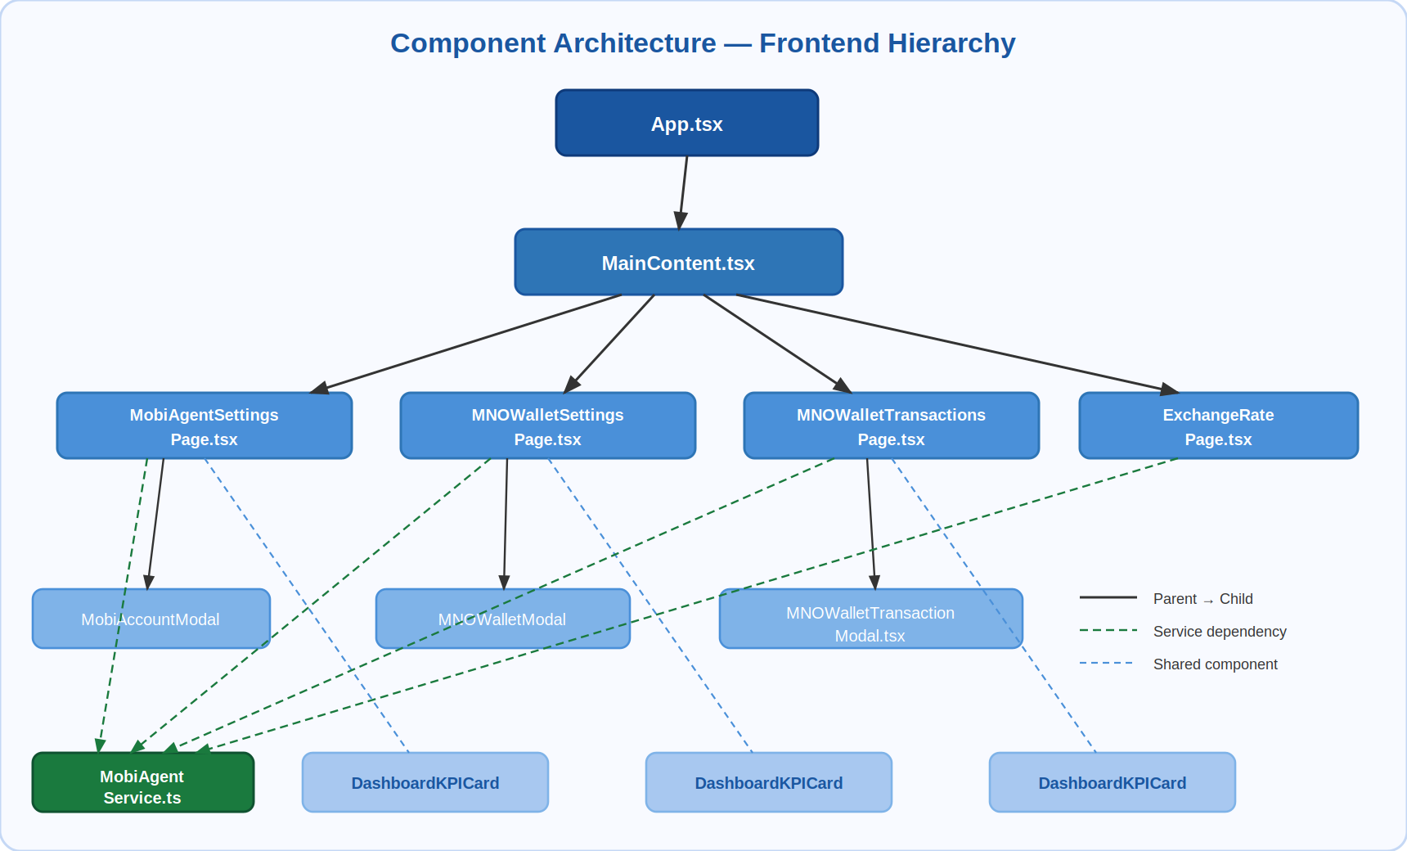
Figure: Component Architecture — Frontend Hierarchy

Component Hierarchy
App.tsx
└── MainContent.tsx
├── MobiAgentSettingsPage.tsx
│ ├── MobiAccountModal.tsx
│ └── DashboardKPICard.tsx
├── MNOWalletSettingsPage.tsx
│ ├── MNOWalletModal.tsx
│ └── DashboardKPICard.tsx
├── MNOWalletTransactionsPage.tsx
│ ├── MNOWalletTransactionModal.tsx
│ └── DashboardKPICard.tsx
└── ExchangeRatePage.tsx

Component Descriptions
Component | Responsibility
MobiAgentSettingsPage | Displays and manages MNO account list
MNOWalletSettingsPage | Displays and manages MNO wallet list
MNOWalletTransactionsPage | Shows transaction history and recording UI
ExchangeRatePage | Displays and edits exchange rates
MobiAccountModal | Form modal for creating/editing MNO accounts
MNOWalletModal | Form modal for creating/editing wallets
MNOWalletTransactionModal | Form modal for recording transactions
DashboardKPICard | Shared KPI summary card used across pages
MobiAgentService | Shared service layer for all data persistence

6. Database Schema (Firestore)
Recommended Firestore collection structure for the Mobi Agent feature.

mnoAccounts
Collection: mnoAccounts
id — Document identifier
name — Account holder name
country — Country of the account
mobileNumber — Mobile number linked to account
emoneyAmount — E-money balance
network — Mobile network (e.g. MTN, Airtel)
accountType — Type of account
userId — Reference to owning user

mnoWallets
Collection: mnoWallets
id — Document identifier
agentId — Reference to MNO account
name — Wallet display name
network — Mobile network
balance — Current balance
userId — Reference to owning user

mnoTransactions
Collection: mnoTransactions
id — Document identifier
walletId — Reference to MNO wallet
mnoWalletName — Denormalized wallet name
agentNumber — Agent mobile number
transactionType — Type (deposit / withdrawal / etc.)
amount — Transaction amount
previousBalance — Balance before transaction
balance — Balance after transaction
date — Timestamp of transaction
clientPhone — Client's phone number
clientName — Client's name
userId — Reference to owning user

exchangeRates
Collection: exchangeRates
id — Document identifier
fromCurrency — Source currency code
toCurrency — Target currency code
rate — Exchange rate value
updatedAt — Last updated timestamp

Mobi Agent Feature — UML Documentation

