Build a Simple Toaster Oven Temperature Profile Controller
(Or Anything Else You Want!)
by Rich Testardi (rich@testardi.com)

Introduction
Using a highly-integrated microcontroller running “StickOS BASIC”, it is possible to quickly build a toaster oven temperature profile controller for performing surface mount (SMT) printed circuit board reflow soldering at home. It is also possible to program a large variety of other general-purpose embedded system projects with minimal software effort, using only a terminal emulator and high-level BASIC algorithmic statements to manipulate the microcontroller (MCU) pins and peripherals.

StickOS BASIC is an entirely MCU-resident interactive programming environment, which includes an easy-to-use editor, transparent line-by-line compiler, interactive debugger, performance profiler, and flash filesystem, all controlled thru an interactive command-line user interface (see Figure 1). In StickOS, external MCU pins may be mapped to BASIC “pin variables” for manipulation or examination, and internal MCU peripherals may be managed by BASIC control statements and interrupt handlers. A StickOS-capable MCU may be connected to a host computer via a variety of transports and may then be controlled by any terminal emulator program, with no additional software or hardware required on the host computer. Once program development is complete, the MCU may be disconnected from the host computer and configured to autorun its resident BASIC program autonomously.

terminal emulator

> _
MCU
w/ StickOS BASIC
editor
compiler
debugger
profiler
flash filesystem
Figure 1
embedded system
host computer
StickOS runs on a wide variety of highly-integrated MCUs with 128k or more of flash memory and 8k or more of RAM, and seamlessly manages the MCU pins and peripherals, including BASIC program support for:

- digital input/output
- analog to digital converters
- pulse width modulators (for analog output or servo motor control)
- output compare timers (i.e., frequency generators)
- UARTs and SPI master serial interfaces
- periodic timers
- flash memory (i.e., self-programming)

By its very nature, StickOS supports in-circuit emulation -- all you need is a transport connecting the MCU to a host computer, and you have full interactive control over the target embedded system, just as if you were using an in-circuit emulator; alternatively, you can use the 2.4GHz ZigFlea wireless transport and have full control over the target embedded system with no wires at all.

With StickOS, it is no longer necessary to install a software development environment on the host computer; likewise, it is no longer necessary to connect any kind of flash programmer or debug hardware to the host computer. More importantly, though, with StickOS it is no longer necessary to study a 500+ page MCU Reference Manual in order to use the MCU external pins and internal peripherals -- StickOS manages them all for you.

The bottom line is that using only a terminal emulator program connected to an MCU running StickOS BASIC, the user can easily edit a BASIC program and interactively debug it using breakpoints, assertions, watchpoints, single-stepping, execution tracing, live variable and pin examination and manipulation, edit-and-continue, etc. The user can then save the BASIC program to the internal flash filesystem, and finally set the BASIC program to autorun autonomously when the MCU powers-up.

Hello World!
So what does the “Hello world!” program look like in StickOS BASIC? Well, if the baseline goal for an embedded system is to configure an I/O pin and get an LED to blink, such as LED1 on pin “re2” of the PIC32 on the UBW32 Board, then the “Hello world!” program looks like this (entered text is in bold):

> 10 dim led as pin re2 for digital output inverted
> 20 while 1 do
> 30 let led = !led
> 40 sleep 500 ms
> 50 endwhile
> run
<Ctrl-C>
STOP at line 40!
> _

Line 10 declares a “pin variable” named “led”, then configures the general purpose I/O pin “re2” for inverted (i.e., active-low) digital output, and finally binds the pin variable to the corresponding pin (in traditional BASIC, the “dim” statement is used to “dimension” the shape of a variable prior to use). From then on, any modification of the pin variable is immediately reflected at the I/O pin. Line 20 starts an infinite loop. Line 30 inverts the state of the “re2" digital output pin to blink the LED. Line 40 delays the program for 500 ms. And finally line 50 ends the infinite loop. Type “run” to start the program; press <Ctrl-C> to stop the program.

Of course, if you really just wanted to print “Hello world!” to the terminal, you could just do:

> 10 print "Hello world!"
> run
Hello world!
> _

Hello User!
If you want to use a switch, such as the USER switch on pin “re6” of the PIC32 on the UBW32 Board, to condition the blinking of the LED, so that you can push the switch to stop the blinking, in StickOS BASIC it’s nearly as easy:

> 10 dim led as pin re2 for digital output inverted
> 20 dim switch as pin re6 for digital input debounced inverted
> 30 while 1 do
> 40 if !switch then
> 50 let led = !led
> 60 endif
> 70 sleep 500 ms
> 80 endwhile
> run
<Ctrl-C>
STOP at line 70!
> _

The bulk of the program is like before, with just a few changes. Line 20 declares a “pin variable” named “switch”, then configures I/O pin “re6” for inverted (i.e., active-low) and debounced (i.e., with a low-pass filter) digital input, and finally binds the pin variable to the corresponding pin. From then on, examination of the pin variables results in the current switch state being read. Lines 40 and 60 simply condition the LED blink at line 50 on the switch not being pressed. Type “run” to start the program; press <Ctrl-C> to stop the program.

Hello Toaster Oven!

Procedure
To build the Toaster Oven Temperature Profile Controller you will need the parts listed in Table 1, and a USB host computer (the examples that follow will assume you are running Microsoft Windows, though similar procedures work with Linux and Mac, as well):

Part Name | Manufacturer and Part Number
32 bit PIC32 based USB Bit Whacker | http://www.sparkfun.com/commerce/product_info.php?products_id=8971
K-type thermocouple | TPI (Test Products International) GK11M  http://search.digikey.com/scripts/DkSearch/dksus.dll?Detail&name=290-1911-ND
3V solid-state relay | Teledyne STH24D25  http://www.mouser.com/search/ProductDetail.aspx?qs=cFlnt7DBZX%2FYka4cen6X9Q%3D%3D
Op-amp | National Semiconductor LM358
1k ohm resistor | Xicon 299-1K-RC
100k ohm resistor | Xicon 299-100K-RC
36 pin header (x2) | FCI 68001-236HLF
Table 1

I soldered two 36 pin headers onto the bottom of the UBW32 and mounted it in a solderless breadboard for ease of assembly (see Figure 2), but that is not required. The picture also shows the RS232 Shifter Board Kit, which is also not required.

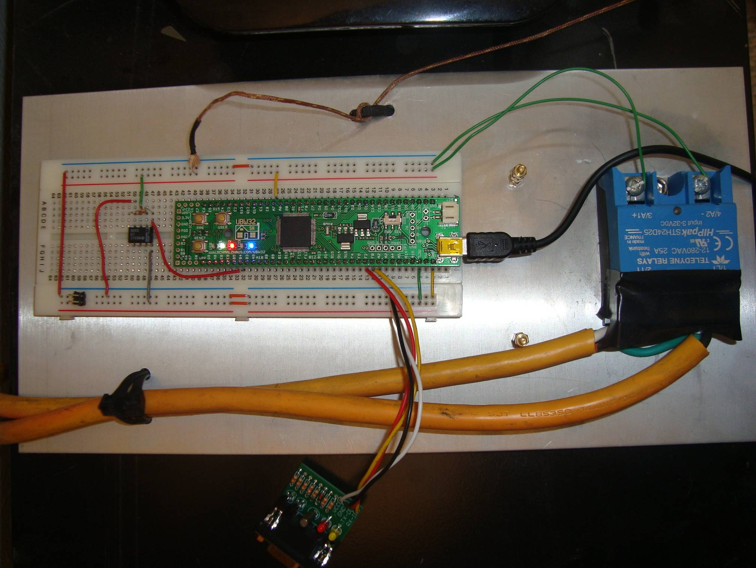
Figure 2

Schematic
The schematic for the Toaster Oven Temperature Profile Controller is shown in Figure 3.

USB
3.3V
GND
RB4
RA7
GND
+V
K-type thermocouple
to 3V solid state relay
UBW32
LM358
100k
1k
yellow
red
Figure 3

Configuration
Once the Toaster Oven Temperature Profile Controller is built, the next step is to install StickOS BASIC on the UBW32 Board. This is achieved as follows:

- hold down the PRG switch on the UBW32 and connect the UBW32 to the host computer USB port; you should see alternating blinking white and green LEDs indicating the UBW32 is ready to download a firmware file
- run the HIDBootLoader.exe application from the zip archive on the UBW32 homepage: http://www.schmalzhaus.com/UBW32/FW/HIDBoot/HIDBoot.zip
- click “Open Hex File” and browse to StickOS.UBW32.v1.50g.elf.hex
- click “Program/Verify”
- press the RESET switch on the UBW32 to start StickOS running; you should see a slowly blinking orange LED indicating StickOS is idle (this LED will blink quickly when StickOS is running a BASIC program)

The next step is to install the USB Virtual COM Port driver on the USB host computer, if it is not there already.

When the MCU is connected to a USB host computer, it will present an FTDI Serial Port function to the host computer. An appropriate signed driver will be loaded automatically from microsoft.com, if needed (and if you are connected to the Internet), or you can manually install the VCP driver from http://www.ftdichip.com/FTDrivers.htm.

Once the driver is loaded, a new virtual COM port (VCP) will be present on your system. This virtual COM port will be visible in Device Manager:

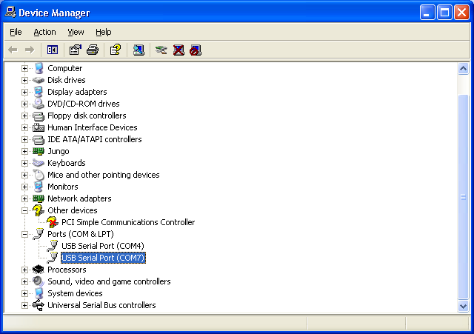

At this point you can use Hyper Terminal to connect to the new virtual COM port. Specify a new connection name, such as “ubw32”, and then select the new virtual COM port under Connect Using; the baud rate and data characteristics in Port Settings are ignored when using the USB Virtual COM Port.

Press <Enter> when you are connected and you should see the StickOS command prompt:

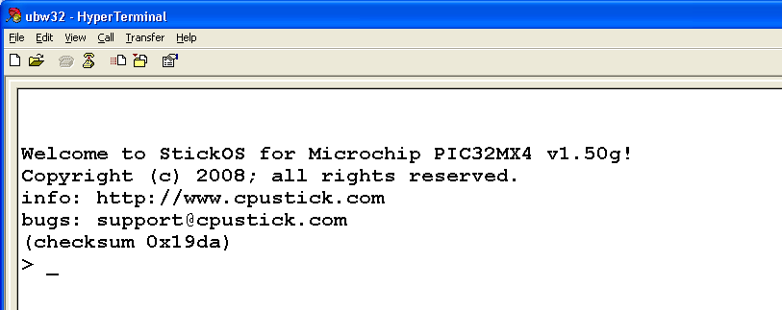

You are now ready to enter StickOS commands and/or BASIC program statements.

Alternatively, you can use an RS232 port on the host computer and a RS232 Shifter Board Kit (such as http://www.sparkfun.com/commerce/product_info.php?products_id=133) to connect the host computer to pins “rf8” (transmit data) and “rf2” (receive data) of the MCU, using 9600 baud, 8 data bits, no parity, 2 stop bits, and xon/xoff flow control.

The BASIC Control Program
Enter the following BASIC control program at the StickOS command prompt to control the Toaster Oven Temperature Profile Controller:

10 dim phase, target, secs
20 dim thermocouple as pin an4 for analog input debounced
30 dim relay as pin ra7 for digital output
40 dim red_led as pin re1 for digital output inverted
50 dim white_led as pin re2 for digital output inverted
60 data 512, 90, 746, 105, 894, 20
70 configure timer 0 for 1000 ms
80 on timer 0 do let relay = thermocouple<target
90 for phase = 1 to 3
100 let white_led = phase&1, red_led = phase&2
110 read target, secs
120 sleep secs s
130 next
140 off timer 0
150 let relay = 0, red_led = 0, white_led = 0

Line 10 declares three simple RAM variables. Line 20 declares a “pin variable” named “thermocouple”, then configures I/O pin “an4” (synonymous with “rb4” on the UBW32 silkscreen) for analog input thru a low-pass filter, and finally binds the pin variable to the corresponding pin. From then on, examination of the pin variables results in the current ADC values being read, in millivolts (mV). Lines 30 thru 50 declare digital output pin variables to manipulate the MCU pins attached to the relay and LEDs. Line 60 contains the temperature profile ramp target and time information:

- 90 seconds at up to 512 millivolts (125 Celsius)
- 105 seconds at up to 746 millivolts (183 Celsius)
- 20 seconds at up to 894 millivolts (220 Celsius)

Line 70 configures a periodic timer to run every second, and line 80 indicates that when the timer expires, the (digital output) value of the relay should be updated to reflect the result of a comparison between the (analog input) value of the thermocouple and the current target of the temperature profile ramp. Lines 90 thru 130 simply cycle thru the temperature profile ramp and update the white and red UBW32 LEDs to indicate the progress. Line 140 unconfigures the periodic timer. And finally, line 150 turns off the relay and LEDs. Then the program ends.

To save the program to the flash filesystem, type:

save

To run the program, type:

run

To set the program to autorun on MCU power-up, type:

autorun on

Diagnostics
What if your program doesn’t work? What if you have a bug in your op-amp or relay circuitry? StickOS supports fully interactive control of the MCU. You can start running the program by typing “run” and then press <Ctrl-C> to stop it after a minute or two and you will see:

> run
<Ctrl-C>
STOP at line 120!

At that point you can print the current value of the thermocouple, in millivolts, with:

> print thermocouple
609

You can turn on the MCU output connected to the relay with:

> let relay = 1

You can then watch the thermocouple voltage increase:

> print thermocouple
644

And turn off the MCU output connected to the relay:

> let relay = 0

And watch the thermocouple decrease:

> print thermocouple
570

You can even continue the program from where it left off:

> cont

You can use breakpoints, assertions, watchpoints, single-stepping, execution tracing, live variable and pin examination and manipulation, and even edit-and-continue as part of the StickOS interactive debugging experience.

More Information
Full StickOS documentation and downloads for various supported MCUs can be found at: http://www.cpustick.com/index.htm

There is also a skeleton source code project with all of the StickOS initialization and pin and peripheral manipulation routines, for those wanting to port their finished BASIC programs to C.

Future Directions
When coupled with an optional Freescale MC13201 ZigFlea Wireless Transceiver, the MCU may be remotely controlled by another MCU, via a telnet/rlogin-like interface, eliminating the need for a direct connection to the host computer altogether. And BASIC programs may trivially remotely access variables on other MCUs, enabling the use of “remote pin variables” or other forms of inter-MCU communication. Wireless embedded systems are made just as easy as wired ones.

You can also download plans for a ZigFlea-enabled “CPUStick” based on the 80 MHz Freescale MCF52252 MCU here:

- user’s guide: http://www.cpustick.com/downloads/cpustick.v2.00.2p.pdf
- schematic and BOM: http://www.cpustick.com/downloads/cpustick.pdf
- Gerber files: http://www.cpustick.com/downloads/cpustick.zip
- firmware: http://www.cpustick.com/downloads/StickOS.MCF52252.v1.50g.elf.S19

Note that you will need some way to flash the CPUStick initially, either with a QSPI programmer or with an M52259DEMOKIT board from Freescale, loaded with the StickOS bits and using the “clone” command to copy them to the new board.

Toaster Oven Tips
Fine pitched SMT reflow soldering can be an intimidating task to the newcomer, but I have found that I can reliably reflow “CPUSticks”, including 0.5mm pitch QFP’s and even 0.5mm QFN’s with just a few tricks:

- To mount a QFN (leadless) package, I first flux the component pins and then tin them with my soldering iron; each pin ends up with a little bump of solder on it. I then flux the board pads and tin them, with a similar and opposing bump (it definitely helps to have a solder mask on the board, but I have done it without). Then I flux everything again and align the bumps on the QFN pads with the opposing bumps on the board, and prepare for reflow using your new Toaster Oven Temperature Profile Controller.
- To mount the QFP (leaded) packages, I use a similar procedure but do not tin the delicate component pins.
- After reflow, if touchup is needed (the typical problem will be “opens”, not “shorts”), I use a generous amount of flux at the pin/pad interface and then drag the ever slightest amount of solder across it with my soldering iron. Note that the flux is critical in this step to avoid any bridging/shorts.
- I used a Weller WES51 soldering iron with an ETP (1/32" screwdriver) tip, 62/36/2 silver solder from Radio Shack (in a convenient 1.5 oz spool), a Kester #2331-ZX water soluble flux pen, and a PanaVise PV Jr. Model 201 (to hold things).

About the Author
Rich Testardi lives in Boulder, Colorado, with his wife and daughter and thinks microcontrollers are the coolest thing; his dream is to make them easy enough to use to introduce into high-school curriculums, since that was where his initial exposure was. Since that time long ago, many forces, notably SMT and ever-increasing MCU integration (and 500+ page reference manuals), have conspired to make these projects less accessible to high-school students; he hopes to reverse that trend with StickOS and CPUStick!

