Hi,

We recently developed a new product that we believe could be of significant value in teaching both high-school and university age students about the capabilities of Freescale microcontrollers. We are hopeful that Freescale might want to help us deliver the product into the hands of students!

The product is a resident “StickOS BASIC” programming environment (including an easy-to-use editor, compiler, flasher, and debugger) that runs entirely within the Freescale MCF52221 ColdFire MCU. In the StickOS BASIC programming environment, external MCU pins are mapped to special “pin variables” for manipulation or examination, and internal MCU peripherals are managed by BASIC control statements and BASIC interrupt handlers. The MCF52221 may be directly connected to any USB host computer that supports an FTDI Serial Port (including Windows and Linux) and may then be controlled by any terminal emulator program, with no additional software or hardware required on the host computer.

In literally minutes, students can be using most of the components and capabilities of the MCU, including:

- digital I/O pins, via the General Purpose I/O Module
- analog input pins, via the Analog-to-Digital Converters
- analog output pins, via the Pulse-Width Modulation Module
- frequency output pins, via the DMA Timer Module
- UART I/O pins, via the UART Modules
- QSPI I/O pins, via the Queued Serial Peripheral Interface Module
- interval timers, via the Programmable Interrupt Timers
- non-volatile storage, via the ColdFire Flash Module

And when the MCU is embedded in a demonstration board, such as the M52221DEMO board, students can almost instantly:

- manipulate LEDs
- examine switches
- examine the potentiometer
- manipulate/examine UARTs
- manipulate/examine the accelerometer

More importantly, students can then write, store, and execute programs to automate usage of all of these components, using a trivial to understand BASIC programming language!

Literally, configuring a digital, analog, frequency, or UART I/O pin takes a single statement in StickOS BASIC; subsequently examining or manipulating the I/O pin is as easy as examining or manipulating the corresponding “pin variable”. Internal timers and UART peripherals can also be configured with a single statement, and interrupts can be configured with just one more. Basically, all of the fundamental concepts of embedded systems programming are literally at the students’ fingertips. And StickOS BASIC also includes a powerful integrated interactive debugger to allow students to really understand what is going on in their programs.

Just as a simple example, the following 13 line program runs on the M52221DEMO board to configure the appropriate digital output pins attached to the accelerometer’s gsel1/2 and wake inputs, and then read and display the x, y, and z axis millivolt (mV) accelerometer values from the an4, an5, and an6 analog input pins, using the analog-to-digital converters:

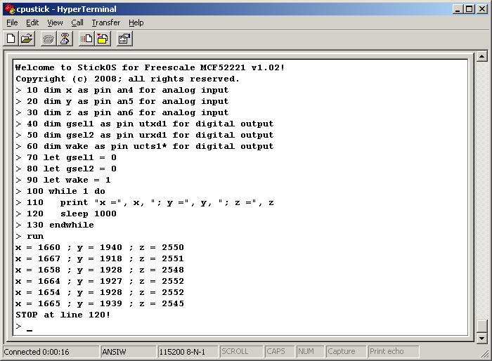
bind variables x, y, and z to MCU analog input pins an4, an5, and an6.
bind variables gsel1, gsel2, and wake to MCU digital output pins utxd1, urxd1, and ucts1*.

set gsel1 and gsel2 digital outputs to logic 0; set wake digital output to logic 1.
print accelerometer millivolt values of x, y, and z analog inputs in a loop, every second.
run the program; press <Ctrl-C> to stop the program.

It’s that easy! Note that the HyperTerminal emulator is talking thru the USB interface directly to the MCF52221 MCU. (By its very nature, StickOS supports in-circuit emulation when it is running in any StickOS-capable MCU -- all you need is three (USB) wires connecting the MCU to a USB host computer, and you have full control over the target embedded system!)

If you are interested, there is more information on StickOS BASIC (and a simple CPUStick for wire-wrap or solderless breadboard use) at http://www.cpustick.com . We would, of course, be thrilled to be able to offer this software pre-installed to users of the M52221DEMO board, or any other target board/MCU that Freescale saw fit.

Thank you for your consideration!

Rich Testardi
303-443-4254
1996 Beacon Ct
Boulder, CO 80302

