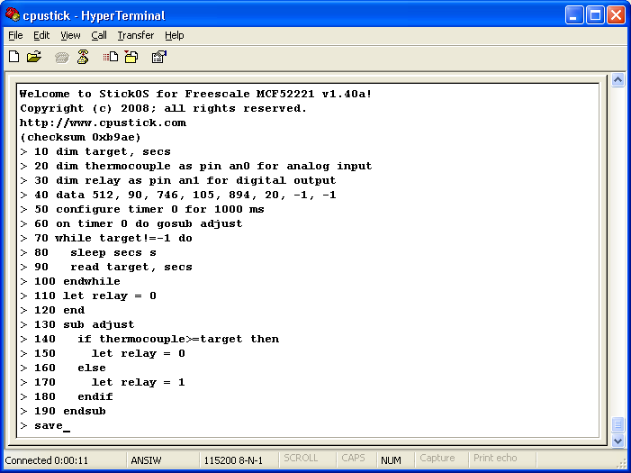
declare two simple RAM variables.
bind variable thermocouple to MCU analog input pin an0; bind variables relay to MCU digital output pin an1.
declare temperature target and delay time pairs for our temperature profile ramp.
configure a timer to run the adjust subroutine every second.
the main program loop: run the temperature profile ramp; then end the program with relay turned off.
the adjust subroutine: if thermocouple has reached the target temperature, turn relay off; otherwise, turn relay on.
save the program to flash

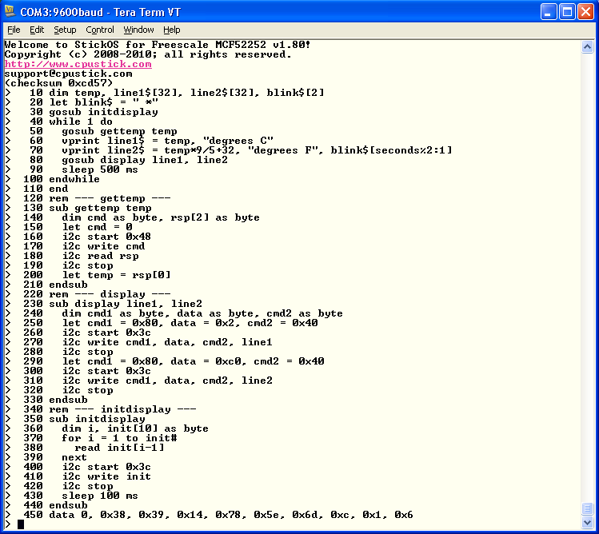
the main program loop: get the current temperature, then format a string for each line of the display, then display the lines, wait 500ms, repeat
the gettemp subroutine: send an i2c command to the temperature sensor and get back the temperature response
the display subroutine: send an i2c command to the LCD display and the first line of text, then another i2c command and the second line of text
the initdisplay subroutine: send the i2c commands to the display necessary for initialization

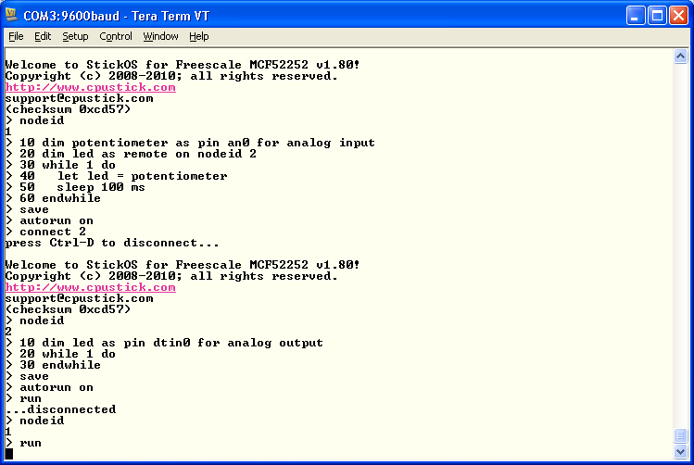
verify we’re on nodeid 1
write the program on nodeid 1
save the program on nodeid 1; set the program to autorun on nodeid 1

remotely connect to nodeid 2
press <Enter> for a prompt; verify we’re on nodeid 2

write the program on nodeid 2
save the program on nodeid 2; set the program to autorun on nodeid 2

run the program on nodeid 1
run the program on nodeid 2
press <Ctrl-D> to disconnect from node 2 and return to node 1; verify we’re on nodeid 1

