Build a 2.4GHz Wireless Programmable Doorbell Chime
(Or Anything Else You Want!)
by Rich Testardi (rich@testardi.com)

Introduction
In just ten minutes you can easily build a 2.4GHz wireless programmable doorbell chime, using just a pair of CPUSticks, a switch, and a buzzer. Each CPUStick contains a highly-integrated microcontroller (MCU) running “StickOS BASIC”, 48 multi-function I/O pins brought out to 0.1” pads (suitable for use in a solderless breadboard), as well as a 2.4GHz ZigFlea wireless transceiver, all of which can be fully programmed using only a host computer with a terminal emulator, and high-level BASIC algorithmic statements.

“StickOS BASIC” is an entirely MCU-resident interactive programming environment, which includes an easy-to-use editor, transparent line-by-line compiler, interactive debugger, performance profiler, and flash filesystem, all controlled thru an interactive command-line user interface (see Figure 1). In StickOS, external MCU I/O pins may be mapped to BASIC “pin variables” for manipulation or examination, and internal MCU peripherals may be managed by BASIC control statements and interrupt handlers.

terminal emulator

> _
MCU
w/ StickOS BASIC
editor
compiler
debugger
profiler
flash filesystem
Figure 1
CPUStick
host computer
2.4GHz
ZigFlea
wireless
USB
A CPUStick may be connected to a host computer via a variety of transports, including USB, UART, and 2.4GHz ZigFlea wireless from another CPUStick, and may then be controlled by any terminal emulator program, with no additional software or hardware required on the host computer. Once program development is complete, the CPUStick may be disconnected from the host computer and configured to autorun its resident BASIC program autonomously.

It is also possible to program a large variety of general-purpose embedded system projects with minimal software effort on a CPUStick.

StickOS BASIC
StickOS BASIC seamlessly manages the MCU pins and peripherals, including BASIC program support for:

- digital input/output
- analog to digital converters
- pulse width modulators (for analog output or servo motor control)
- output compare timers (i.e., frequency generators)
- UARTs and SPI master serial interfaces
- periodic timers
- flash memory (i.e., self-programming)

By its very nature, StickOS supports in-circuit emulation -- all you need is a command-line transport connecting the MCU to a host computer, and you have full interactive control over the target embedded system, just as if you were using an in-circuit emulator; alternatively, you can use the 2.4GHz ZigFlea wireless transport and have full control over the target embedded system with no wires at all.

With StickOS, it is no longer necessary to install a software development environment on the host computer; likewise, it is no longer necessary to connect any kind of flash programmer or debug hardware to the host computer. More importantly, though, with StickOS it is no longer necessary to study a 500+ page MCU Reference Manual in order to use the MCU external pins and internal peripherals -- StickOS manages them all for you.

The bottom line is that using only a terminal emulator program connected to an MCU running StickOS BASIC, the user can easily edit a BASIC program and interactively debug it using breakpoints, assertions, watchpoints, single-stepping, execution tracing, live variable and pin examination and manipulation, edit-and-continue, etc. The user can then save the BASIC program to the internal flash filesystem, and finally set the BASIC program to autorun autonomously when the MCU powers-up.

See the online User’s Guides for full details on configuring the host computer to CPUStick command-line transport at:

- StickOS User’s Guide (software): http://www.cpustick.com/stickos.htm
- CPUStick User’s Guide (hardware): http://www.cpustick.com/cpustick.htm

StickOS transforms a highly-integrated MCU into a true, interactive computer-on-a-chip!

Hello World!
So what does the “Hello world!” program look like on a CPUStick? Well, if the baseline goal for an embedded system is to configure an I/O pin and get an LED to blink, such as the pre-wired LED E2 on pin “fec_txd0” of the MCU, then the “Hello world!” program looks like this (entered text is in bold):

> 10 dim led as pin fec_txd0 for digital output inverted
> 20 while 1 do
> 30 let led = !led
> 40 sleep 500 ms
> 50 endwhile
> run
<Ctrl-C>
STOP at line 40!
> _

Line 10 declares a “pin variable” named “led”, then configures the general purpose I/O pin “fec_txd0” for inverted (i.e., active-low) digital output, and finally binds the pin variable to the corresponding pin (in traditional BASIC, the “dim” statement is used to “dimension” the shape of a variable prior to use). From then on, any modification of the pin variable is immediately reflected at the I/O pin. Line 20 starts an infinite loop. Line 30 inverts the state of the “fec_txd0" digital output pin to blink the LED. Line 40 delays the program for 500 ms. And finally line 50 ends the infinite loop. Type “run” to start the program; press <Ctrl-C> to stop the program.

Of course, if you really just wanted to print “Hello world!” to the terminal, you could just do:

> 10 print "Hello world!"
> run
Hello world!
> _

Hello Doorbell!

Circuit
To build the 2.4GHz wireless programmable doorbell chime, wire two CPUSticks as follows:

MCU
2.4
GHz
USB
CPUStick
nodeid 1
(transmitter)
GND
dtin3
MCU
2.4
GHz
USB
CPUStick
nodeid 2
(receiver)
GND
dtin0
switch
3V buzzer
GND
+3V
GND
+3V
pcb antenna
pcb antenna
2.4GHz
ZigFlea

On CPUStick #1 (nodeid 1), wire CPUStick pin dtin3 to one end of the switch, and the other end of the switch to ground.

On CPUStick #2 (nodeid 2), wire CPUStick pin dtin0 to one end of the 3V buzzer, and the other end of the 3V buzzer to ground.

Assembly
You can solder male-male headers on the CPUStick I/O pins and install them in solderless breadboards, as shown below. Alternately, you can solder directly to the CPUSticks for a more permanent installation. I used CR-2 batteries for testing, though some other form of power is required for permanent installation.

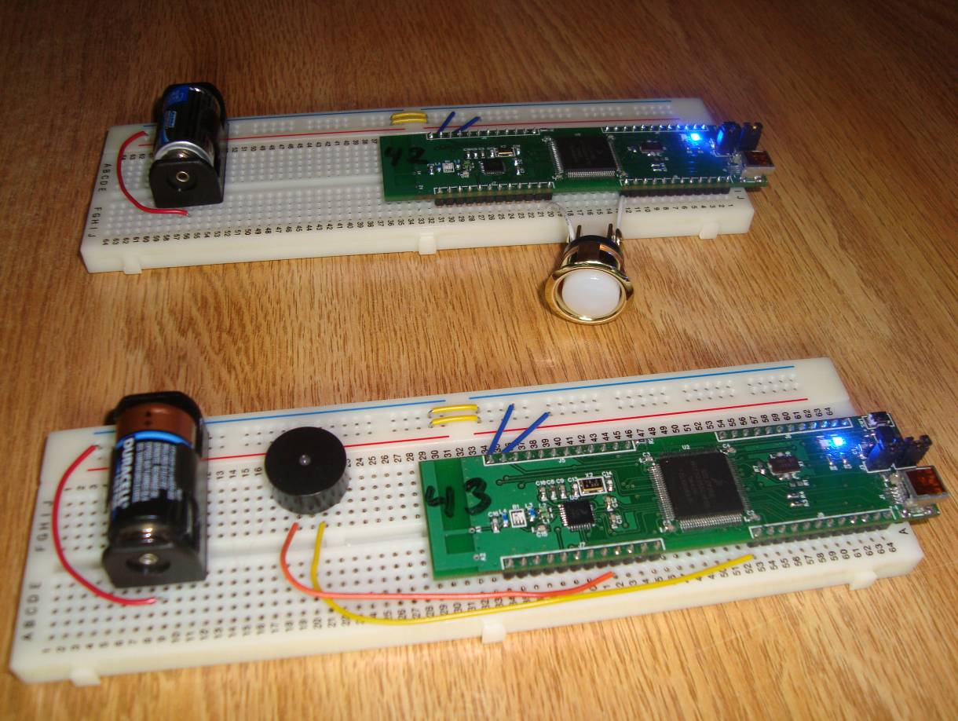

Note that the top CPUStick is nodeid 1 connected to the doorbell switch, and the bottom CPUStick is nodeid 2 connected to the doorbell buzzer. They communicate with each other via 2.4GHz ZigFlea wireless, all under BASIC program control.

Configuration

nodeid 1
To configure nodeid 1, connect it to the host computer’s USB port, allow signed drivers to install from the Internet for Windows, and connect to it via the terminal emulator as described in the StickOS User’s Guide. Then enter the following:

Welcome to StickOS for Freescale MCF52252 v1.70e!
Copyright (c) 2008-2009; all rights reserved.
http://www.cpustick.com
support@cpustick.com
(checksum 0xe62b)
> nodeid 1
> 10 dim i
> 20 dim notes[9]
> 30 dim switch as pin dtin3 for digital input debounced inverted
> 40 dim buzzer as remote on nodeid 2
> 50 rem major scale starting at a-440
> 60 data 440, 494, 554, 587, 659, 740, 831, 880, 0
> 70 for i = 0 to 8
> 80 read notes[i]
> 90 next
> 100 rem our song
> 110 label song
> 120 data 3, 0, 1, 0, 8, 2, 3, -1
> 130 rem main loop
> 140 while 1 do
> 150 rem if the switch is pressed...
> 160 if switch then
> 170 rem play the song
> 180 restore song
> 190 do
> 200 read i
> 210 rem if the song is not over...
> 220 if i!=-1 then
> 230 rem play the note on the remote cpustick
> 240 let buzzer = notes[i]
> 250 sleep 200 ms
> 260 endif
> 270 until i==-1
> 280 let buzzer = 0
> 290 endif
> 300 endwhile
> save doorbell1
> autorun on
> _

This program simply configures a variable named “switch” that is bound to the dtin3 pin, which is configured for inverted digital input. It then configures a remote variable on the other CPUStick named “buzzer”. Next, it defines the frequencies of a major scale in the “notes” array, and then finally plays the specified song (i.e., the specified sequence of notes) on the other CPUStick’s doorbell buzzer whenever the doorbell switch on this CPUStick is depressed.

nodeid 2
To configure nodeid 2, connect it to the host computer’s USB port, allow signed drivers to install from the Internet for Windows, and connect to it via the terminal emulator as described in the StickOS User’s Guide. Then enter the following:

Welcome to StickOS for Freescale MCF52252 v1.70e!
Copyright (c) 2008-2009; all rights reserved.
http://www.cpustick.com
support@cpustick.com
(checksum 0xe62b)
> nodeid 2
> 10 dim buzzer as pin dtin0 for frequency output
> save doorbell2
> autorun on
> _

This program simply configures a variable on nodeid 2 named “buzzer” that is bound to the dtin0 pin, which is configured for frequency output. The program then ends and the CPUStick simply waits for the other CPUStick (nodeid 1) to manipulate the pin variable, and hence manipulate the dtin0 pin.

Customization
The song that is played can be customized by changing the data statement at line 120 on nodeid 1; the values 0-7 correspond to the notes a-g; the value 8 is a rest.

Run
Once both CPUSticks are set to autorun, when they power on, they start running their programs immediately. Pressing the doorbell switch on CPUStick #1 will cause the song to be played on the buzzer connected to CPUStick #2.

Diagnostics
What if your program doesn’t work? What if you have a bug in your switch or buzzer circuitry? StickOS supports fully interactive control of the MCU.

You can start running the program on nodeid 1 by typing “run” and then press <Ctrl-C> to stop it and you will see:

> run
<Ctrl-C>
STOP at line 160!

At that point you can print the current value of the switch, with:

> print switch
0

If you press the switch and print the value again, you’ll see:

> print switch
1

You can (remotely) turn on the buzzer on nodeid 2 with:

> let buzzer = 1000

You can (remotely) turn it off again with:

> let buzzer = 0

You can even continue the program from where it left off:

> cont

You can use breakpoints, assertions, watchpoints, single-stepping, execution tracing, live variable and pin examination and manipulation, and even edit-and-continue as part of the StickOS interactive debugging experience.

More Information
Full StickOS documentation and downloads for various supported MCUs can be found at: http://www.cpustick.com/index.htm

There is also a skeleton source code project with all of the StickOS initialization and pin and peripheral manipulation routines, for those wanting to port their finished BASIC programs to C.

About the Author
Rich Testardi lives in Boulder, Colorado, with his wife and daughter and thinks microcontrollers are the coolest thing; his dream is to make them easy enough to use to introduce into high-school curriculums, since that was where his initial exposure was. Since that time long ago, many forces, notably SMT and ever-increasing MCU integration (and 500+ page reference manuals), have conspired to make these projects less accessible to high-school students; he hopes to reverse that trend with StickOS and CPUStick!

